PROCEDURES FOR ENVIRONMENTAL CLEARANCE OF BORROW SITES AND OTHER DISTURBED AREAS OUTSIDE RIGHT OF WAY

SUCH AS:
HAUL ROADS
BURN PITS
STAGING AREAS
SPOIL SITES

The Local Public Agency (LPA) is responsible for ensuring that all necessary clearances for disturbed areas such as those mentioned above are obtained prior to using these areas for projects. LPA’s and their contractors are encouraged to consider using material from previously disturbed locations (substantial disturbance) or disturbed areas that have been cleared previously, precluding the need to address most, if not all, of the issues described below. The LPA and their contractors should include the federal project number on all correspondence. The primary environmental concerns related to obtaining clearance of disturbed areas such as borrow sites are described next.

Once the LPA or their contractor has obtained all required documentation, it should be provided to the LPA and the MoDOT district contact.

The Endangered Species Act
The U.S. Fish and Wildlife Service (FWS) administers the Federal Endangered Species Act, which protects rare species and their habitats. Violations of this act can result in extensive project delays and severe fines. To determine whether an activity will impact any rare species or their habitats, the LPA or their contractor must contact the FWS and request an official species list. This must be accomplished by accessing the FWS Information, Planning, and Conservation (IPaC) website (http://ecos.fws.gov/ipac/) and submitting the project details. The LPA or their contractor must also request an official species list and a consultation code. If the project may impact any listed species, contact the FWS and provide them with the consultation code for further information:

U.S. Fish and Wildlife Service
Columbia Field Office
101Park DeVille Dr.
Columbia MO 65203-0057
Telephone (573) 234-2131 or FAX (573) 234-2182

To determine if the activity will impact state listed species, submit the project for a Natural Heritage Review at the Missouri Department of Conservation’s (MDC’s) website: https://naturalheritagereview.mdc.mo.gov/. MDC will provide the LPA or their contractor with a report that lists known resources in or near the site, and provides Best Management Practices (BMP’s) and additional instructions. The report is NOT a clearance letter. If there are no known records of rare species or sensitive habitats at the proposed site, and it is unlikely that any will be impacted by the activity, the MoDOT district contact will give the contractor clearance to proceed. However, if rare species are known or likely to occur at the site or known critical habitat exists, further coordination with MDC and the FWS will be necessary. Written concurrence from the U.S. Fish and Wildlife Service for a “not likely to adversely affect” determination may be required before the project can proceed.

Floodplain/Regulatory Floodway
Executive Order 11988, Floodplain Management, and subsequent federal floodplain management guidelines mandate an evaluation of floodplain impacts. The Federal Emergency Management Agency (FEMA) and Federal Highway Administration (FHWA) guidelines 23 CFR 650 have identified the base (1%) flood as the flood having a one percent probability of being equaled or exceeded in any given year. The base floodplain is the area of one percent flood hazard within a county or community. The regulatory floodway is the channel of a stream plus any adjacent floodplain areas that must be kept free of encroachment so that the one percent flood discharge can be conveyed without increasing the base flood elevation more than a specified amount. FEMA has mandated that projects can cause no rise in the regulatory floodway, and a one-foot cumulative rise for all projects in the base (1%) floodplain.

When available, flood hazard boundary maps (National Flood Insurance Program) and flood insurance studies for the project area are used to determine the limits of the base (1%) floodplain and the extent of encroachment. Questions concerning the need for a floodplain development permit or whether, for projects proposed within regulatory floodways, a “no-rise” certificate must be obtained before a Floodplain Development Permit can be issued should be addressed to the local floodplain administrator. Use the menu or map feature under Local Floodplain Administrator on the State Emergency Management Agency website at http://www.sema.dps.mo.gov/programs/floodplain/ to find contact information for your local floodplain administrator.

For projects that involve the state of Missouri, the State Emergency Management Agency (SEMA) issues floodplain development permits. In the case of projects proposed within regulatory floodways, a "no-rise" certificate, if applicable, should be obtained prior to issuance of a permit. Questions regarding floodplain and regulatory floodway for these projects should be addressed to:
SEMA
P.O. Box 116
Jefferson City MO 65102
Telephone (573) 526-9141

Documentation of consultation with the local floodplain administrator or SEMA regarding the presence of base (1%) floodplain/regulatory floodway should be included in the final collection of information to be submitted to the MoDOT district contact.

Federal Emergency Management Agency (FEMA) Buyout Lands
The Flood Disaster Protection Act of 1973, as amended by the Disaster Relief and Emergency Assistance Act of 1988 (The Stafford Act), identified the use of disaster relief funds under Section 404 for the Hazard Mitigation Grand Program (HMGP), including the acquisition and relocation of flood-damaged property. The Volkmer Bill further expanded the use of HMGP funds to “buy out” flood damaged property that was affected by the Great Flood of 1993.

There are numerous restrictions on these FEMA buyout properties. No structures or improvements may be erected on these properties unless they are open on all sides. The site shall be used only for open space purposes, and shall stay in public ownership. These conditions and restrictions (among others), along with the right to enforce same, are deemed to be covenants running with the land in perpetuity and are binding on subsequent successors, grantees, or assigns. Any decision involving these properties should take into consideration that 2–3 years is needed to obtain an exemption from FEMA to use these parcels. This exemption would likely be a permanent easement rather than a transfer of property. If any proposed site is located on a FEMA buyout property, an alternative site should be chosen.

Farmland Protection
The Farmland Protection Policy Act (FPPA) seeks to minimize federal programs' contributions to the unnecessary and irreversible conversion of farmland caused by nonagricultural uses. FPPA compliance can be achieved through coordination with United States Department of Agriculture’s (USDA’s) Natural Resources Conservation Service (NRCS) and completion of Form AD-1006 Farmland Conversion Impact Rating. Form AD-1006 can also be obtained by calling the NRCS State office in Columbia at (573) 876-9411. An aerial map of the site or sites will be needed, with the area to be disturbed identified on the map. This aerial map can be obtained from the local NRCS office. In some areas of the state, this office may be located in an adjoining county.

The LPA or their contractor will need to complete Parts I and III on the Form AD-1006. The form should then be sent to the NRCS State Office for completion of Parts II, IV and V. The address for the NRCS State Office is:

Natural Resource Conservation Service
State Soil Scientist
601 Business Loop 70 West
Parkade Center, Suite 250
Columbia, MO 65203-2546
Telephone (573) 876-0907

After the NRCS office returns the form, the contractor fills out Parts VI and VII and provides a copy of the completed form to the MoDOT district contact for documentation of compliance with the Farmland Protection Policy Act.

Wetlands
Federal executive order has decreed a national policy of "no net loss of wetlands." Under this policy, impacts to wetlands must be avoided if at all practical. Where wetlands are impacted, these impacts must be mitigated by construction or enhancement of a like quantity and quality of new wetlands. For these reasons, avoiding impacts to wetlands is a primary goal.

To determine whether wetlands occur on a site, contact the NRCS. The NRCS has identified and mapped wetlands as a requirement under the Food Security Act. These maps are available from county NRCS offices, usually located in the county seat. If wetlands are identified on Food Security Act wetland maps, a site visit may be needed to confirm the location of wetlands. If there are no wetland impacts, no other action need be taken.

If there are any questions about the extent of wetlands in the event that wetlands cannot be avoided, contact the U.S. Army Corps of Engineers (COE). If wetlands cannot be avoided, the appropriate COE district would process a COE Section 404 permit. There are five COE districts in Missouri. The locations, addresses, and phone numbers of their offices are on the following map.
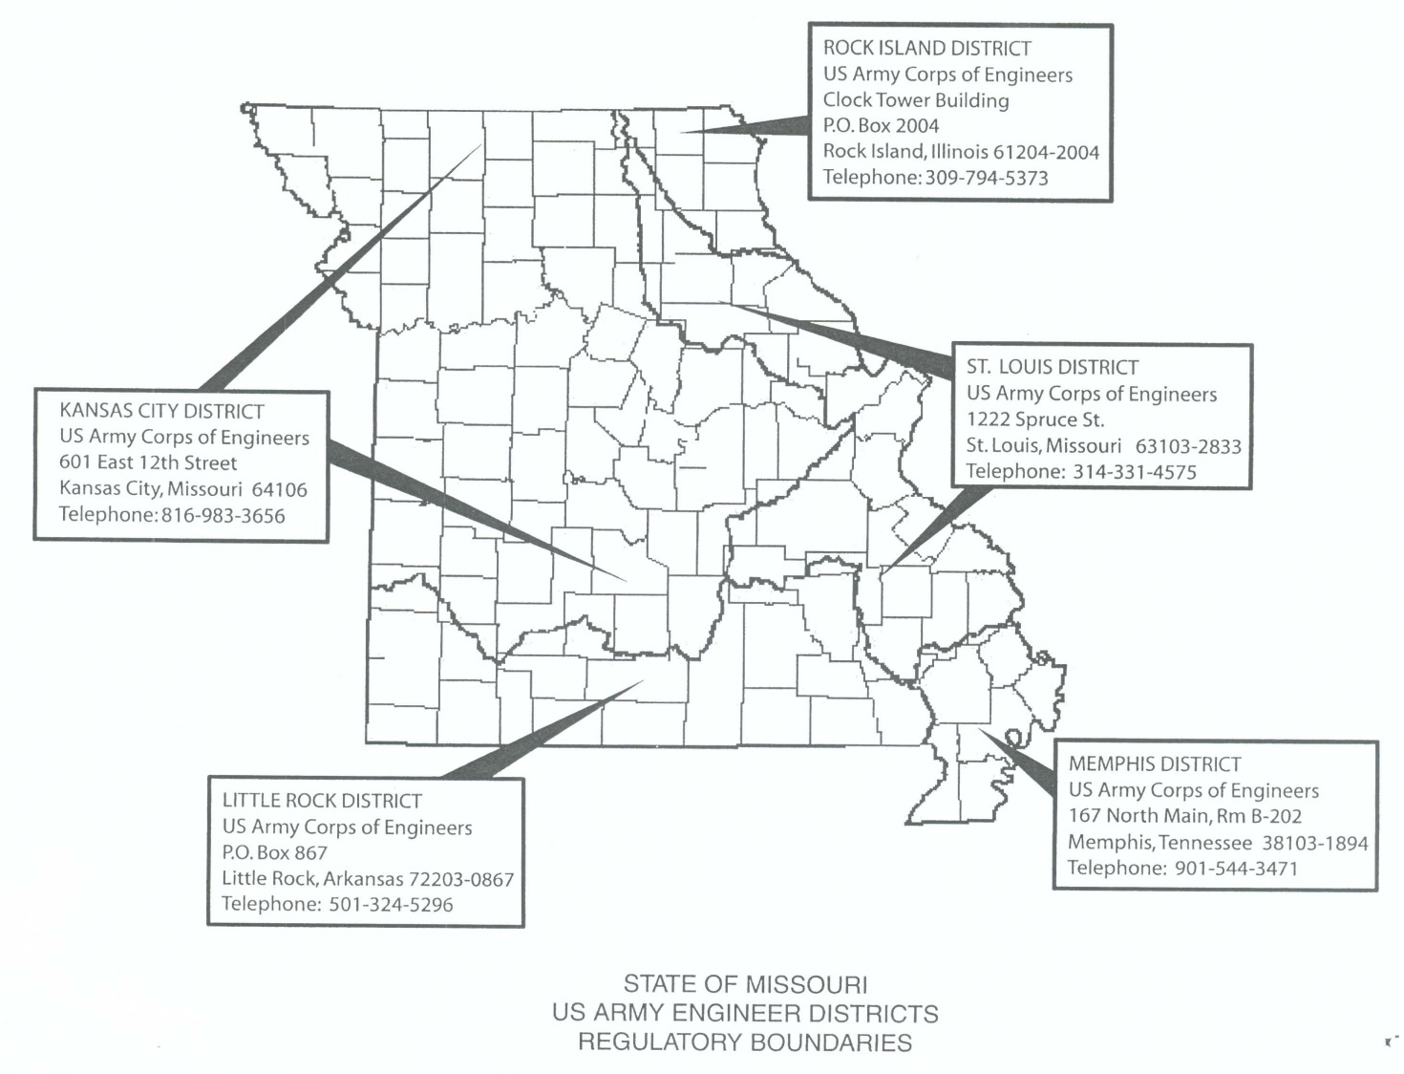

Water Quality/Land Disturbance
If the LPA does not have a valid general National Pollutant Discharge Elimination System (NPDES) permit for storm water runoff and the site to be disturbed is 1 acre or more in size, a specific NPDES permit from DNR is required. If the site to be disturbed is entirely within MoDOT right of way, the LPA may use MoDOT’s general permit for land disturbance but must follow all conditions in the permit and stormwater pollution prevention plan. A pollution prevention plan may be required with the NPDES application. Permits may be obtained from the Department of Natural Resources at (573) 751-1300. These permits are necessary even if the runoff is directed into a basin.

Hazardous Waste Sites
More than likely, areas to be disturbed will be located in rural areas that have been used for agriculture or similar purposes. Hazardous wastes are most typically associated with commercial or previously industrial properties.

If the proposed area is basically farmland or pasture and has not been used for any commercial activity or dumping, hazardous wastes are unlikely. The LPA or its contractor should simply document the existing and historic land use of the parcel and tell how this assessment was obtained.

In non-rural, suburban or commercial areas a non-intrusive investigation may be used to "diagnose" the environmental conditions of a selected site. The following is a non-inclusive list of suggested items for a cursory nonintrusive investigation.

Examine any noticeable contamination in the form of surface staining, oil sheen, odors, stressed vegetation, spills, leaks, illegal dumping, etc.

Conduct interviews of local citizens and current owners to identify past land use practices and hazardous waste management practices.

Consult with local and state [Missouri Department of Natural Resources, Hazardous Waste Program, (573) 751-3176] environmental regulatory agencies to identify whether any past problems (complaints, citations, etc.) have occurred at the site, any permits/licenses have been filed for the site, or enforcement actions have occurred.

If the above analyses produce negative results, the contractor should provide documentation to the MoDOT district contact regarding who was contacted and the results of the contact. However, if potential problems are identified through the search for information described above, it would be wise to locate another site.

The potential to encounter wastes from sites that are unknown should always be a consideration. Any unknown sites that are found must be handled in accordance with federal and state laws and regulations.

Historic Preservation
All jobs receiving federal funds and/or permits must comply with Section 106 of the National Historic Preservation Act. A letter from the State Historic Preservation office (SHPO), Department of Natural Resources indicating Section 106 compliance for all activities within the footprint of the project (existing & new right-of-way and temporary & permanent easements) should already have been received by the project’s sponsor. Section 106 compliance for earth-disturbing activities outside of this foot print is the responsibility of the LPA or their contractor. To initiate SHPO's review and clearance for activities outside of the previously cleared foot-print, the contractor should complete a Section 106 Project Information Form and submit it to SHPO along with a copy of a United States Geological Survey (USGS) topographic map indicating the location of the project. In addition, photographs of any structures that will be impacted must be provided. The Section 106 Project Information Form also can be requested from the SHPO at:
Missouri Department of Natural Resources
State Historic Preservation Office
Attn: Section 106 Review
P.O. Box 176
Jefferson City, MO, 65102-0176
Telephone (573) 751-7858

Based on the information supplied, SHPO may clear the project at that time or request that the LPA or their contractor acquire the services of an archaeological consultant to conduct a historic preservation survey of the proposed area. A list of currently acceptable and available archaeological consultants who can complete a survey if required can be accessed at the SHPO’s website at http://www.dnr.mo.gov/shpo/profqualifications.htm. Any questions can be directed to MoDOT’s Historic Preservation Section at (573) 751-0473.

Public Land
If borrow sites are proposed on any publicly owned land, contact MoDOT’s Environmental Section at (573) 526-6678 before proceeding. Section 4(f) of the Department of Transportation (DOT) Act of 1966 (now codified as 49 U.S.C. 303 and 23 U.S.C. 138) protects certain public lands. Section 4(f) requires that all U.S. DOT-funded transportation projects must avoid impacts to public parkland and wildlife refuges (and cultural resources deemed eligible for the National Register of Historic Places), unless it is successfully demonstrated that no feasible and prudent alternative exists that avoid “use” or impacts to the park or refuge. It is strongly recommended that public lands not be considered as potential borrow sites.

