Fig. 806.8.9

Example Erosion/Sediment Control Site Plans

(Note: Notice the legend, color coding, indemnifying statement and the date of installation and removal of BMPs. Don’t forget to label outfalls!)

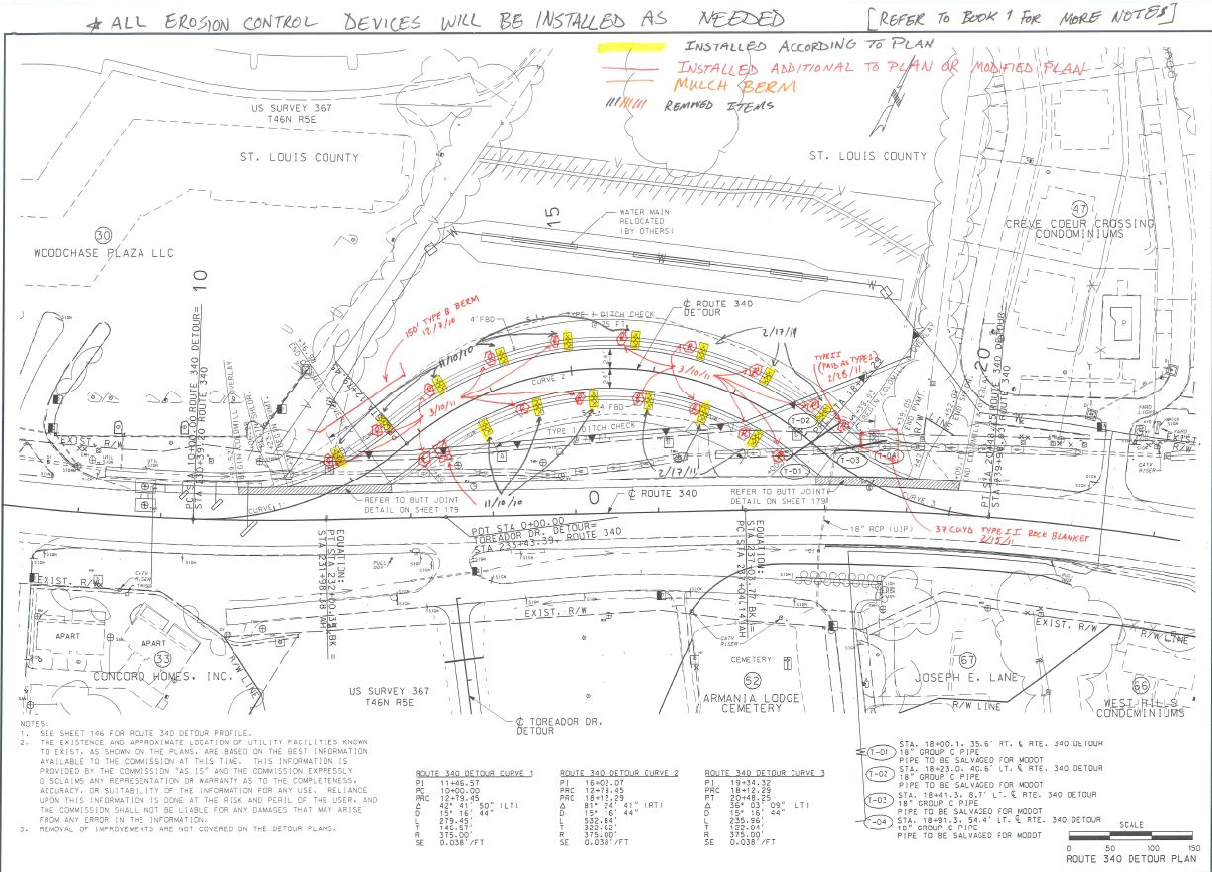
SAMPLE
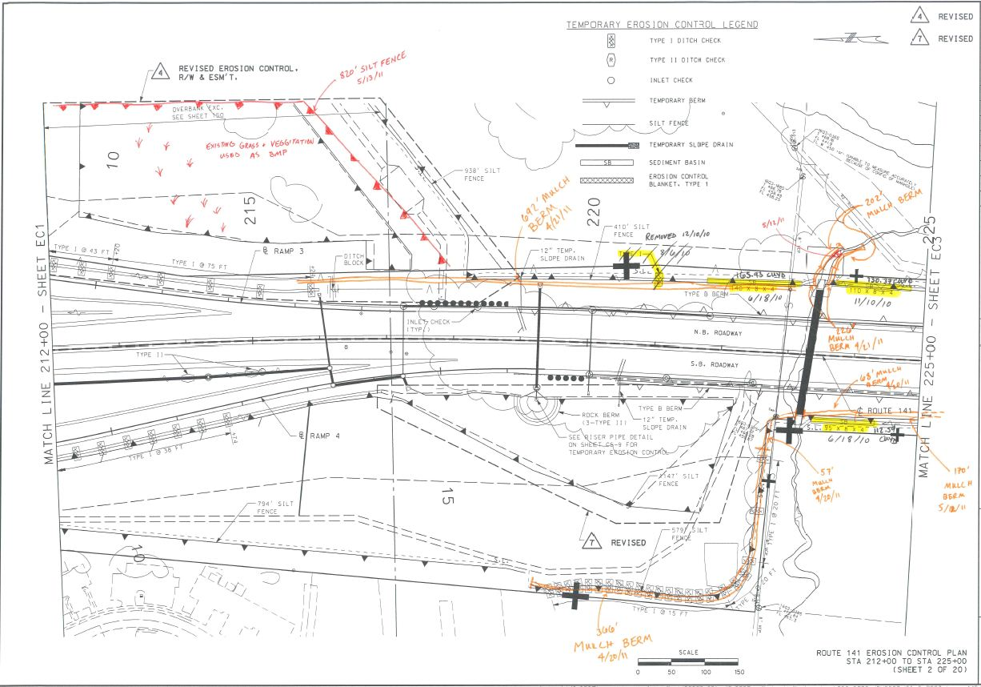
SAMPLE
