03/19 | Job No.
 | Replaces Bridge No.

Missouri Department of Transportation

Bridge Survey Location Request

Page 1 to be completed by District staff.

Bridge over |  |  |  |  |  |  |  |  |  |  |  |  |  |  | Route
County |  |  |  |  | Sec. |  | Twp. |  |  | Rg. |  |  | ; |  |  | miles |  |  | ☐N ☐E ☐S ☐W of
 |  |  |  |  |  |  |  |  |  |  |  |  |  |  |  |  | Route
On road from |  |  |  | Adjacent Town |  |  |  |  | to |  | Adjacent Town |  |  |  |  |  | Latitude
 |  |  |  | West or North of site |  |  |  |  |  |  | East or South of site |  |  |  |  |  | Longitude
District Contact: |  |  |  |  |  |  |  |  |  |  |  |  |  |  | Date

HIGH WATER ELEVATIONS AT PROPOSED BRIDGE SITE
Recorded high water elevations or elevation of high water marks

Extreme High Water (EHW) (Give date(s) of occurrence)
Elevations and date(s) of same | Location |  | Source of information
Existing Bridge Overtopped ☐ Yes ☐No ☐Unknown |  | Existing Roadway Overtopped ☐ Yes ☐No ☐Unknown
 |  | Approx. Overtopping Location(s):

LOCATION OF NEW BRIDGE
Replace in Existing Location | ☐ | Provide details of any proposed changes to profile grade below or as an attachment.
Relocation (near existing Structure) | ☐ | Provide details of proposed location and grade of the roadway across the floodplain, any proposed/potential channel changes or modifications, etc. below or as an attachment.
New Route | ☐
Other: | ☐

Additional Information:
Page 2 & subsequent pages to be completed by Bridge Division
Note: Proposed elevations, distances, etc. are based on the best available data at the time the form was completed. Actual field conditions or recently acquired data may require deviation from the proposed values. Please contact the Bridge Division with concerns regarding the proposed values or if large deviations from these values are required.
Note: The information below supplements the survey requirements noted in the EPG, please consult EPG 238 for additional surveying requirements.

Bridge Contact: Name, Phone No. & email

Survey Type: 2D Survey

Stream Crossing Survey Location Details (1D)
Item |  | Requirement | Standard Guidance |  |  |  | Specific Guidance
Profiles*  (EPG 238.3.36.1.3) | C/L Profile | Terminal Point | Limit of Longest offset Profile |  |  |  | Use Standard Guidance
 | Upstream Offset Profile | Terminal Point | Same as Valley Sections |  |  |  | Elevation =
 |  | Offset Distance | On Natural Ground |  |  |  | Distance =
 | Downstream Offset Profile | Terminal Point | Same as Valley Sections |  |  |  | Elevation =
 |  | Offset Distance | On Natural Ground |  |  |  | Distance =
 | Special
Streambed Profiles** (EPG 238.3.36.3.6) |  | Length | Natural  Stream |  | Section limits (Min. of 1000’ each side of crossing.) |  | Use Natural Stream Guidance
 |  |  | Drainage  Ditch |  | 500’ Each Side of Crossing
 |  | Elevation Intervals | Within 1000’ of Crossing |  | Nat. Stream 25’ |  | Use Natural Stream Guidance  (see EPG 238.3.36.3.6 if a significant slope change is encountered)
 |  |  |  |  | Drain. Ditch 50’
 |  |  | Beyond 1000’ from Crossing |  | At Vertical and Horizontal Break Points (200’ max.)
Water Surface Profile  (EPG 238.3.36.3.7) |  | Locations with flowing water | Drainage Ditch | 100’ and 200’ each side of Crossing |  |  | Needed? ☐ Yes ☐ No
Valley Sections  (EPG 238.3.36.3.8),  (EPG 750.3.1.1) |  | Terminal Point | Natural Stream | 5’ above EHW |  |  | Elevation =
 |  |  | Drainage Ditch | 25’ Beyond Bankside Toe of Levee |  |  | Distance = | N/A
Typical Channel Sections  (EPG 238.3.36.3.9) |  | Within 300’ each side of Centerline | Provide when Needed  (i.e., Culvert on Perennial and Intermittent Stream) |  |  | Needed? ☐ Yes ☐ No
Other Bridges  (EPG 238.3.36.3.10) |  | Other Bridger Data Needed? ☐ Yes ☐ No
 |  | Description | Provide General Description |  |  | N/A
 |  | Location | C/L Structure |  |  | N/A
 |  | Terminal Point | 5’ above EHW |  |  | Elevation = |  |  | N/A
* additional profiles may be needed for relocated routes
** at confluent streams provide proposed data for both streams as appropriate.

Additional Information:

Additional Documents Provided: Image & kmz file showing Valley Section Locations.

Page 2 & subsequent pages to be completed by Bridge Division
Note: Proposed elevations, distances, etc. are based on the best available data at the time the form was completed. Actual field conditions or recently acquired data may require deviation from the proposed values. Please contact the Bridge Division with concerns regarding the proposed values or if large deviations from these values are required.
Note: The information below supplements the survey requirements noted in the EPG, please consult EPG 238 for additional surveying requirements.

Bridge Contact: Name, Phone No. & email

Survey Type: 2D Survey

Stream Crossing Survey Location Details (2D)
Item | Requirement |  | Standard Guidance |  | Specific Guidance
LIDAR Data (EPG 238.3.36.3.5.1) | Elevation |  | 5’ min. Above Extreme High Water |  | Minimum Elevation =
 | Upstream & Downstream Distance |  | Contraction and Expansion Limits of Existing/Proposed Crossing |  | Use Upstream and Downstream Limits shown in Image and kmz files
Bathymetric Survey Data  (EPG 238.3.36.3.5.2) | Detailed Area (at Crossing Location) | Interval | Conventional Survey Methods | Bathymetric Channel Sections at 25’ max. | Use Detailed Area Standard Guidance
 |  |  | Sonar Survey Methods | Data Points at 25’ max. up and downstream, and 15’ max’ (min of 5 points) transverse
 |  | Distance | All Survey Methods | 200’ min. each side of crossing. | Use Detailed Area Standard Guidance
 |  | Bridge Section  (EPG 238.3.36.5.3) | All Survey Methods | Ground points for full length under existing structure at its C/L (stream portion can be equivalent sonar) | Use Detailed Area Standard Guidance
 |  | Other Bridges | See “Other Bridges” section(s) on following page for additional detailed bathymetry locations.
 | Upstream & Downstream Areas | Interval | Conventional Survey Methods | Bathymetric Channel Sections at 200’ max | Use Upstream & Downstream Areas Standard Guidance
 |  |  | Sonar Survey Methods | Data Points at 200’ max. up and downstream, and 15’ max’ (min of 5 points) transverse
 |  | Upstream Limit | All Survey Methods | Upstream of Contraction Limits | Up | Lat.
 |  |  |  |  |  | Long.
 |  | Downstream Limit | All Survey Methods | ½ to 1 times Floodplain Width Downstream of Contraction Limits | Down | Lat.
 |  |  |  |  |  | Long.
 | Data at Stream Junctions Needed? ☐ Yes ☐ No
 | Stream Junctions |  | Conventional Survey Methods | Bathymetric Channel Sections for Each Leg of Junction | Location(s):
 |  |  |  |  | Use Standard Guidance - See Diagram Below for Details

Item | Requirement |  | Standard Guidance |  | Specific Guidance
Other Bridges  (EPG 238.3.36.3.6) | Other Bridge Data Needed? ☐ Yes ☐ No
 | Description |  | Provide General Description |  | N/A
 | Detailed Bathymetric Data | Interval | Conventional Survey Methods | Bathymetric Channel Sections at 25’ max. | Use Detailed Data Standard Guidance
 |  |  | Sonar Survey Methods | Ground Points at 25’ max. up and downstream, and 15’ max’ (min of 5 points) transverse
 |  | Distance | All Survey Methods | 200’ min. each side of crossing. | Use Detailed Data Standard Guidance
 |  | Bridge Section  (EPG 238.3.36.5.3) | All Survey Methods | Data points for full length under existing structure at its C/L (stream portion can be equivalent sonar) | Use Detailed Data Standard Guidance

Item | Requirement | Standard Guidance |  | Specific Guidance
Water Surface Profile  (EPG 238.3.36.3.7) | Water Surface Profile Data Needed? ☐ Yes ☐ No
 | Locations with flowing water | Drainage Ditch | 100’ and 200’ each side of Crossing | Use Water Surface Profile Standard Guidance

Item | Requirement | Standard Guidance |  | Specific Guidance
Centerline and Offset (3 Line) Profiles  (EPG 238.3.36.1.3 & EPG 747.2.3.4.1) | Centerline and Offset (3-Line) Profiles Needed? ☒ Yes
 | C/L Profile | Terminal Point | Sufficiently Past End of Bridge | Use Standard 3-Line Profile Guidance
 | Upstream Offset Profile | Terminal Point | Sufficiently Past End of Bridge | Use Standard 3-Line Profile Guidance
 |  | Offset Distance | On Natural Ground | Distance =
 | Downstream Offset Profile | Terminal Point | Sufficiently Past End of Bridge | Use Standard 3-Line Profile Guidance
 |  | Offset Distance | On Natural Ground | Distance =
 | Special

Additional Information: Merg 3rd party LIDAR, MoDOT survey data (conventional or LIDAR) & Bathymetric data into single terrain file.

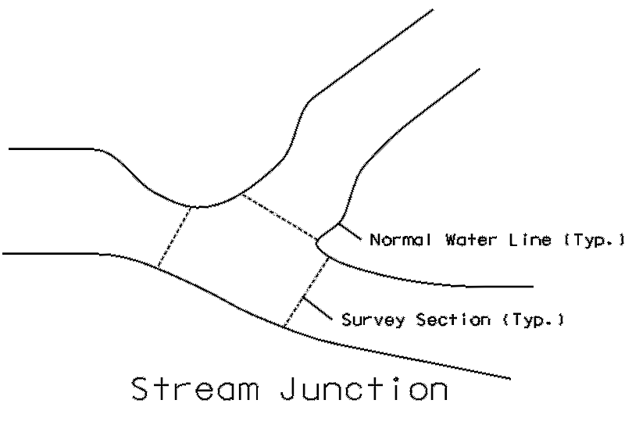

Bathymetric Channel Sections at Junctions:

Additional Documents Provided: Image & kmz file showing LIDAR and Bathymetric Data Limits.

Roadway Design Notes for Bridge Survey: Additional profile sheets or a Contracted Profile sheet showing the Proposed Centerline will be needed when the Centerline Profile extends beyond the limits of the 3-Line Profile.

Bridge Design Notes:

