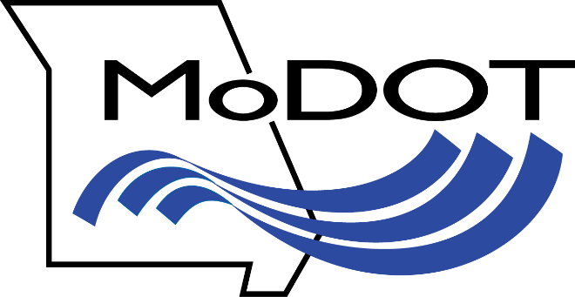

Notice of Opportunity to Comment, I-70 Missouri River Bridge at Rocheport

Boone County –

MoDOT is in the process of completing a re-evaluation under the National Environmental Policy Act (NEPA) of the 2005 Finding of No Significant Impact (FONSI) for the Second Tier Final Environmental Assessment (EA) and Final Section 4(f) Evaluation of Independent Utility 3 for the replacement of I-70 Missouri River Bridge at Rocheport. It is anticipated that the NEPA re-evaluation will be completed by February 2020.

MoDOT is currently seeking public comment on the project. Previously completed documents may be reviewed by going to the project website: http://www.improvei70.org/environmental_3.htm

Individuals and organizations wishing to comment may submit them to MoDOT’s Central District in the following ways:

- Website: www.modot.org/modot-central-district
- E-mail: brandi.baldwin@modot.mo.gov
- Facebook: www.facebook.com/MoDOTCentral
- Twitter: www.twitter.com/MoDOT_Central
- Phone: (888) 275-6636

Comments will be taken until Wednesday, October 9, 2019.

END

For more information, call MoDOT in Jefferson City at 888-275-6636 or visiting
www.modot.org/modot-central-district

Follow MoDOT's Central District: Facebook | Twitter | YouTube

