Request for Environmental Review (RER)
Local Public Agency (LPA) Program
Instruction Manual

Missouri Department of Transportation



February 2021

Table of Contents
Section 1. Why is a Request for Environmental Review Needed? 1
Section 2. When Should a Request for Environmental Review be Submitted? 1
Section 3. How to Log in to the Request for Environmental Review System. 1
Section 4. How to Create a New Request for Environmental Review. 6
Section 5. Request for Environmental Review Environmental Screenings 16
Section 6. How to Search for an Existing Request for Environmental Review. 18

Figures
Figure 1. Environmental Policy Guide Link to the Local Public Agency Request for Environmental Review Login Page. 2
Figure 2. Local Public Agency Environmental Services Login Page. 2
Figure 3. Company Registration Page. 3
Figure 4. Add Representative and Add Projects. 4
Figure 5. Email Password Reset Request. 5
Figure 6. First-time Login. 5
Figure 7. Create New Request or Request Search. 6
Figure 8. Alternative Project Delivery Method. 6
Figure 9. Project Information Boxes – Required Fields. 8
Figure 10. Existing Condition – Required Fields. 8
Figure 11. Proposed Design Improvements – Required Fields. 9
Figure 12. Program Year – Required Fields. 10
Figure 13. Acres – Required Fields. 11
Figure 14. Land Disturbance – Required Fields. 11
Figure 15. Number of Displacements – Required Fields. 12
Figure 16. Average Daily Traffic – Required Fields. 12
Figure 17. Traffic Impacts – Required Fields. 13
Figure 18. Bicycle / Pedestrian Consideration. 13
Figure 19. National Flood Insurance Program and Hydraulic Design Data – Required Fields. 14
Figure 20. Known Concerns Section. 15
Figure 21. Upload Attachments. 15
Figure 22. Saved Request for Environmental Review Form. 16
Figure 23. Request for Environmental Review Environmental Screenings. 17
Figure 24. Request for Environmental Review Color Codes. 17
Figure 25. Resource Section Comment Boxes. 18
Figure 26. Request for Environmental Review Search Page. 19
Figure 27. Request for Environmental Review Results Page. 19
Figure 28. National Environmental Policy Act Classification. 20

Section 1. Why is a Request for Environmental Review Needed?
The National Environmental Policy Act (NEPA) is a federal law enacted in 1970 that requires federal agencies to consider environmental, cultural, and social impacts when making decisions related to funding, permitting, and constructing projects. Federal Highway Administration (FHWA) funding to local public agency (LPA) projects necessitates NEPA compliance.
The request for environmental review (RER) provides the required NEPA compliance information and NEPA classification for Local Public Agency (LPA) projects so the FHWA, or the Missouri Department of Transportation (MoDOT) on behalf of the FHWA, can meet and document a project’s NEPA requirements.

Section 2. When Should a Request for Environmental Review be Submitted?
The RER must be submitted early in the design process to ensure sufficient time for environmental reviews and clearances. MoDOT suggests a target of no more than 180 days after the LPA is awarded the project. Unlike Request for Environmental Services (RES) submittals, RER submittals are reviewed by MoDOT environmental staff only once, unless significant changes to the project occur. If changes to the project occur after the NEPA classification has been approved, a reevaluation of project impacts may be required.
NEPA classification and approval can be made when the screenings for cultural resources, threatened and endangered species, noise, and public land impacts are cleared by the MoDOT environmental specialist and when the public involvement requirements are met. Coordination with other agencies (State Historic Preservation Office [SHPO], U.S. Fish and Wildlife Service [USFWS], and Missouri Division of State Parks) may be required before these environmental resources can be cleared by MoDOT environmental and historic preservation staff.

Section 3. How to Log in to the Request for Environmental Review System.
LPAs and their consultants can log in to the RER system by using the following steps:
- Click the link “LPA Request for Environmental Review (RER)” link located in the Environmental Policy Guide (EPG) Section 136.6.2 (Figure 1) to access the LPA environmental services login page (Figure 2).
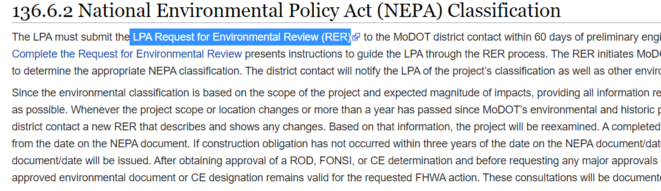
Figure 1. Environmental Policy Guide Link to the Local Public Agency Request for Environmental Review Login Page.
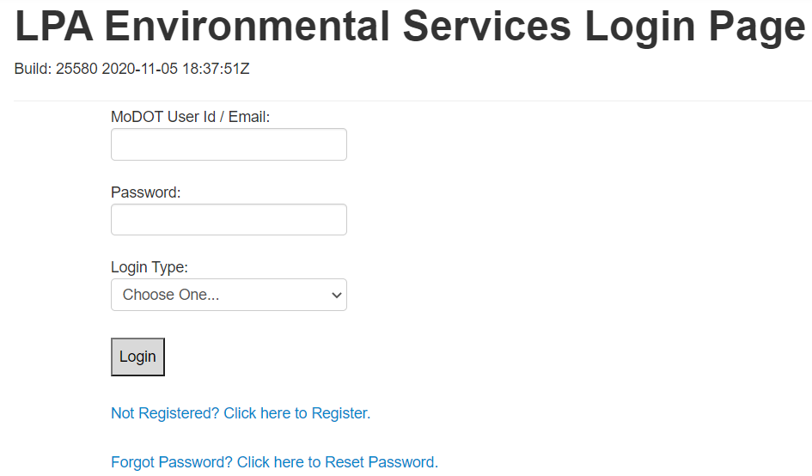
Figure 2. Local Public Agency Environmental Services Login Page.
- If your company has not been registered, please click on the “Not Registered? Click here to Register” link (Figure 2) and complete the registration section for your company (Figure 3). If you are not certain whether your company has been registered, call or email the contacts provided at the end of this manual for further assistance.
- NOTE: If your company has registered in the RER system, contact your company administrator to add you as a representative.
- NOTE: When adding your company to the system for the first time, please select a member to be the administrator of RER system. Entering more than one administrator for a company will confuse the system. Take care to enter your information correctly the first time. The system may not allow for editing the RER forms if the information has been entered incorrectly.
- Enter the company, city, or county information in the “Company Name” box and then fill out the remaining information for the entity and create a password. Click “Register” (Figure 3).
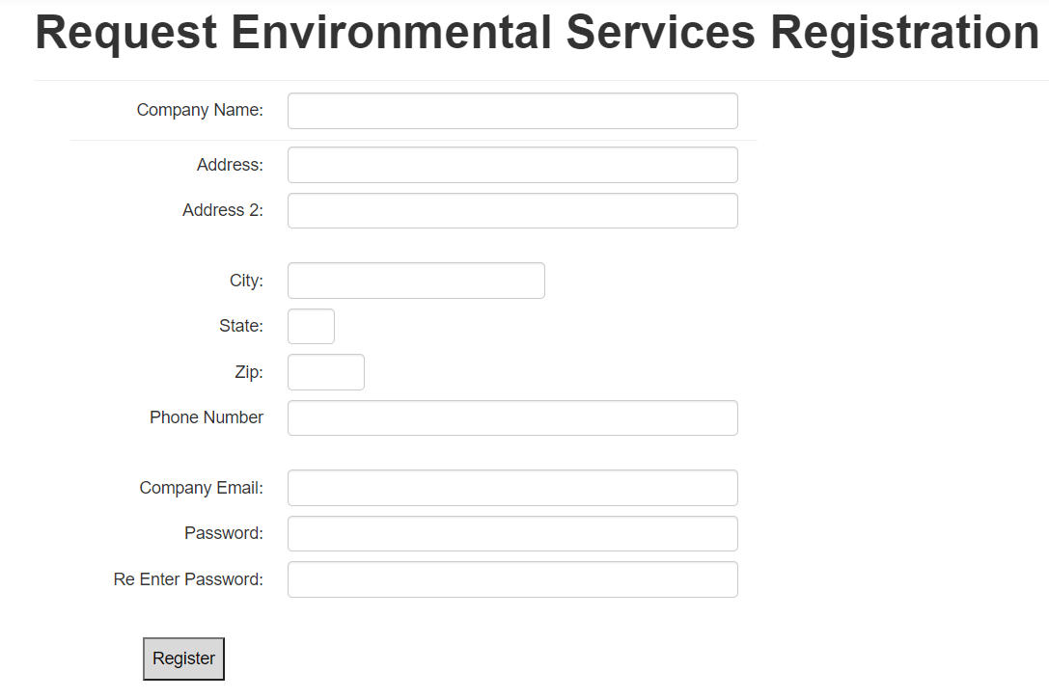
Figure 3. Company Registration Page.
- Within a company, city, or county, individuals working on RERs must be registered as representatives. To add representatives (Figure 4), the administrator must complete the company information and then add the administrator’s name and any other names of representatives who will need access to process, review, and edit projects for submittals to MoDOT. The administrator is required to add representatives here who will edit/view/create the RER form. Even though the administrator is registered, the administrator must be added as a representative and must add projects so the representatives can edit/view/create an RER form.
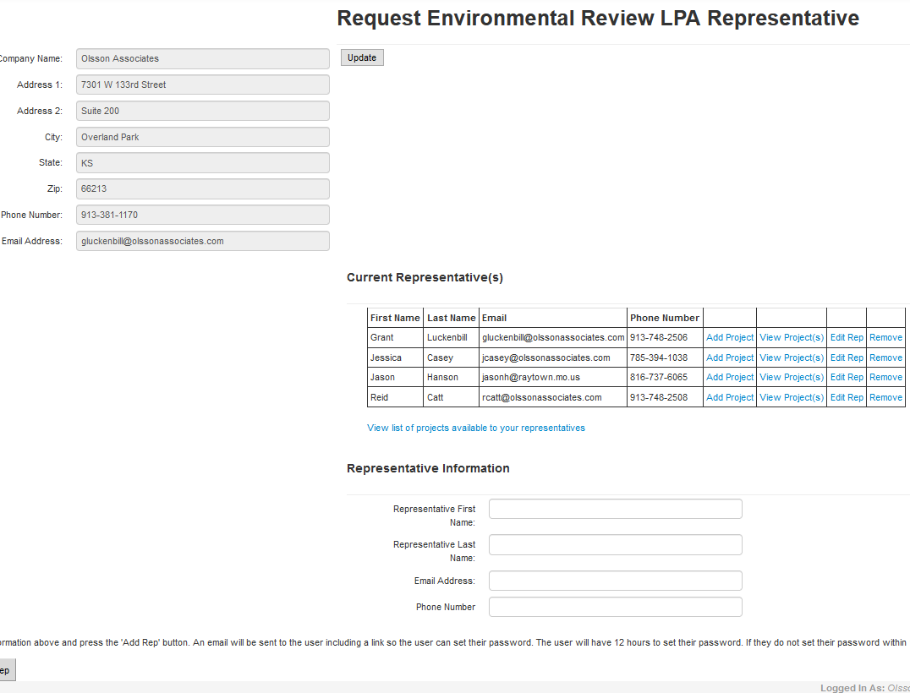
Figure 4. Add Representative and Add Projects.
- Only administrators can add projects to a representative (Figure 4). For example: John and Jane need to view the same project. Therefore, the administrator must add this project under John and Jane as representatives so they both have the ability to edit/view/create the RER form.
  - NOTE: If you create an RER form and do not see the form you created after saving it, you likely have not had the project added under your representative contact on the administration page for your company.
- Once all the representatives are added to the “Current Representative(s)” section (Figure 4), the administrator can log off to exit the system. The administrator must log off as administrator and log back in as a representative to see projects assigned to them.
- Each representative must create a password. When an administrator creates a new representative (as described in the previous steps), the representative will be sent an email with a link to create a password (Figure 5). The link provided in the email will lead the representative to a page that can be used one time to set a new password (Figure 6). The representative cannot log in to the RER system until a new password is created. The link provided in the email will be active for 12 hours after the representative account is created. If a password is not set within the 12-hour window, the representative must use the “Forgot password? Click here to Reset Password” link on the RER login page (Figure 2, above). If the representative’s email is not already in the RER system, the site will refer the representative to the company administrator.
  - NOTE: If an administrator or representative forgets a password, that person can go to the “Forgot password? Click here to Reset Password” link provided on the RER login screen (Figure 2, above). When the administrator or representative requests a new password, a link will be emailed, similar to the email generated to create a password for a new representative (Figure 5). That email will contain a link to a page where the password can be reset. Again, the link will be active for 12 hours. If the individual cannot set a password within that 12-hour window, the person must go to the “Forgot password? Click here to Reset Password” page again to generate another 12-hour link.
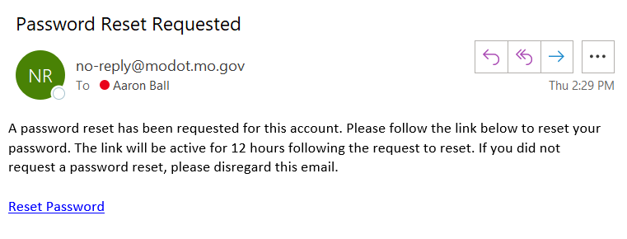
Figure 5. Email Password Reset Request.

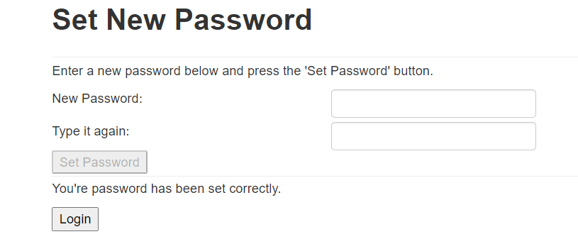
Figure 6. First-time Login.
- Once the representative has successfully created or changed the password, he or she will be able to “Create New Request” or “Request Search” (Figure 7) in the RER system for projects that have been assigned to that representative. Representatives will be able to review and/or edit only projects and RER forms assigned to them (see Step 4).
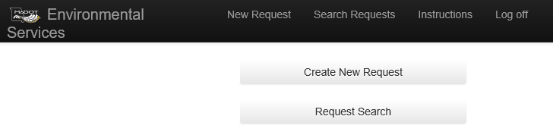
Figure 7. Create New Request or Request Search.

Section 4. How to Create a New Request for Environmental Review.
A new RER can be created in the RER system by either MoDOT or by an external user. Steps outlining how to create a new RER are provided below.
- To create a new RER, log in to the RER system using the steps outlined in Section 3, and select “Create New Request” (Figure 7 above).
- If the RER includes an Alternative Project Delivery Method, check the box shown in Figure 8 to indicate that the project is going to be delivered with an alternative method (e.g., design-build method).
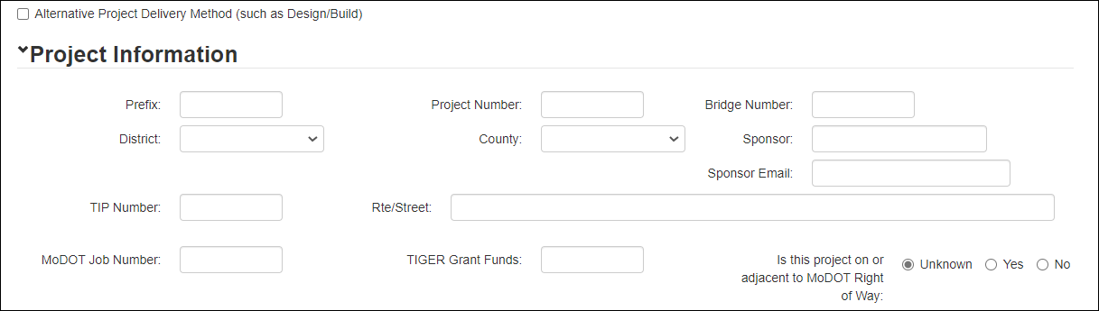
Figure 8. Alternative Project Delivery Method.
- Complete the blank RER Project Information boxes shown in Figure 9 (detailed below).
- Prefix: Enter the LPA program prefix.
  - BRO – Bridge Replacement and Rehabilitation Program
  - CMAQ – Congestion Mitigation and Air Quality Program
  - STP – Surface Transportation Program
  - TAP – Transportation Alternatives Program
  - FLAP – Federal Lands Access Program
  - STBG – Surface Transportation Block Grant
- Project Number: Enter the federal aid project number provided by MoDOT for the project (Figure 9) using only the last seven digits and without any other symbols. For example: B050(30) would be entered as B050030. The project number should pop up when entered and should be selected to auto-populate information for you.
- Bridge Number: If applicable, enter the bridge number as designated by the MoDOT bridge division.
- District: Select the appropriate MoDOT district for the project.
- County: Select the county where the project is located. If more than one county is associated with the job number, select “Various” to indicate multiple counties.
- Sponsor / Sponsor Email: Indicate the project sponsor and provide an email for the sponsor.
- TIP Number: Enter the transportation improvement program (TIP) number.
- Route/Street: Enter the route or street where the project is located.
- MoDOT Job Number: Enter the MoDOT LPA job number that contains prefixes such as BRO or STP.
- TIGER Grant Funds: If funding is provided by the Transportation Investment Generating Economic Recovery (TIGER) discretionary grant, note in the box.
- Is this project on or adjacent to MoDOT Right of way: Indicate whether MoDOT right of way (ROW) is on or adjacent to the project. Additional clearances may be required for work occurring on MoDOT ROW.
- Describe RER project improvements in full detail: Provide a detailed description of all elements of the project, particularly those not described in the auto-populated “TMS Project Description – termini (no stations)” box. The description should contain enough detail to fully understand all aspects of the project.
- District Liaison / Contact / Email: Provide the name of the MoDOT district liaison and a consultant or LPA sponsor contact associated with the project and their emails.
- Date Desired: The date desired is auto-populated based on the submit date (standard time frame is 30 days from RER submittal). Any “Date Desired” less than 30 days from the RER submittal will be flagged as an “Emergency Request” by the RER system.
- Desired A-Date: Indicate the “Desired A-Date” (date of anticipated ROW acquisition) so that environmental staff may prioritize work.

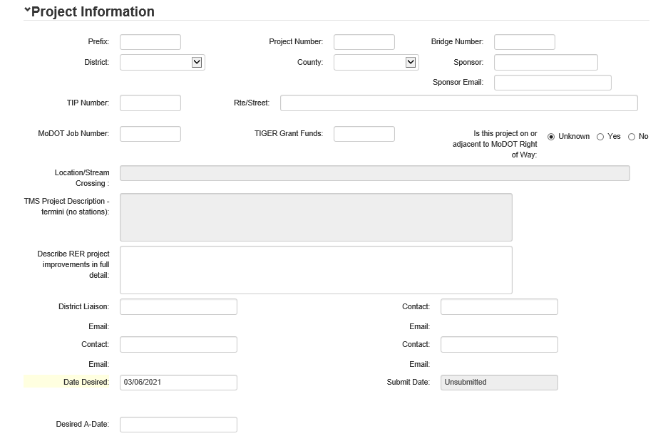
Figure 9. Project Information Boxes – Required Fields.
- Complete the blank RER “Existing Condition” boxes shown in Figure 10 (described below).
- ADT: Enter the average daily traffic (ADT) information for the existing road.
- Number of Travel Lanes: Enter the number of travel lanes for the existing road.
- Shoulder Width: Enter the shoulder width for the existing road.
- Bridge Width: measured from gutterline to gutterline: Enter the existing bridge width from gutterline to gutterline.
- Speed Limit: Enter the speed limit for the existing road.
- Lane Width: Enter the lane width for the existing road.
- Curb and Gutter: Choose “Yes” or “No” whether the existing road has curb and gutter.
- Sidewalks: Indicate if there are existing sidewalks on the left side, right side, or both sides of the existing road. Or select “None” if sidewalks are not present.
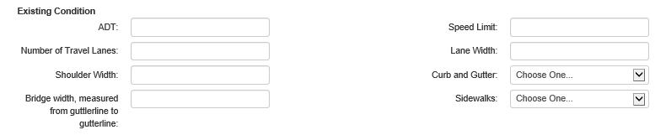
Figure 10. Existing Condition – Required Fields.

- Complete the blank RER “Proposed Design Improvement” boxes shown in Figure 11 (described below).
- ADT: Enter the ADT information for the proposed design improvement road.
- Number of Travel Lanes: Enter the number of travel lanes for the proposed design improvement road.
- Shoulder Width: Enter the shoulder width for the proposed design improvement road.
- Bridge width, measured from gutterline to gutterline: Enter the proposed design improvement bridge width from gutterline to gutterline.
- Bridge Length: Enter the proposed design improvement bridge length.
- Railroad Crossing: Choose “Yes” or “No” whether there is a railroad crossing present.
- Speed Limit: Enter the speed limit for the proposed design improvement road.
- Design Speed: Enter the design speed for the proposed design improvement road.
- Lane Width: Enter the lane width for the proposed design improvement road.
- Curb and Gutter: Choose “Yes” or “No” whether the proposed design improvement has curb and gutter.
- Sidewalks: Indicate whether the proposed design improvements include sidewalks on the left side, right side, or both sides of the road. Or select “None” if sidewalks are not proposed in the design improvement.
- Roadway Length: Enter the proposed design improvement roadway length.
- Drainage District (If Applicable): Choose the drainage district that the project is in or select “none” if the drainage district is not applicable.
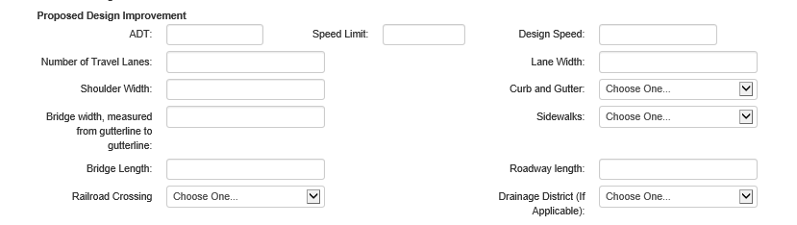
Figure 11. Proposed Design Improvements – Required Fields.
- Complete the blank RER “Program Year” boxes shown in Figure 12 (described below).
  - Preliminary Engineering/Right of Way/Construction: Indicate anticipated dates of preliminary engineering obligations, ROW acquisition, and construction of the project.
  - Independent Utility and Logical Termini: This answer should always be, “Yes.” All FHWA-funded projects must have independent utility and logical termini to satisfy 23 CFR regulations. Projects must also not restrict consideration of alternatives for other reasonably foreseeable transportation improvements.
    - NOTE: Independent utility is determined if a project can be constructed absent the construction of other projects in the area. Logical termini are rational endpoints of a sufficient length for transportation improvements and environmental review. See EPG 127.14.1 for more detail.
  - Project breakout from previous or larger project?: Check this box and provide a detailed explanation if the project is a breakout from a previous or larger project. If checked, also indicate how the project meets the independent utility criteria described above.
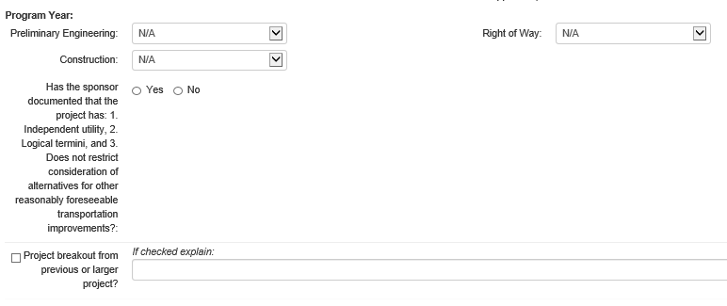
Figure 12. Program Year – Required Fields.
- Complete blank RER “Acres” boxes shown in Figure 13 (described below).
  - Additional ROW (acres) / Temp Easement (acres) / Permanent Easement (acres): Indicate the amount of new ROW, temporary easement, and permanent easement that will be taken. If the exact amounts of ROW and easements are unknown at the time the RER is created, overestimate the acreage of each and then refine these amounts as information becomes available.
  - ROW may be needed, but not yet determined? Choose “Yes” if there is a potential need for new ROW but the need has not been definitively decided at the time of the RER submittal.
  - Is ANY federally owned land affected by the project? This should be checked “Yes” if the project will affect any federally owned land through construction, land acquisition, or other activities.
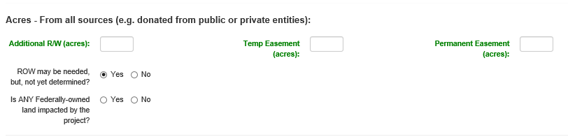
Figure 13. Acres – Required Fields.
- Complete blank RER “Land Disturbance/Stormwater” boxes shown in Figure 14 (described below).
  - Will the project involve 1 acre or more of land disturbance? Check “Yes” if the project will disturb 1 acre of land or more. Projects that disturb 1 acre of land or more must comply with Land Disturbance Permit requirements.
  - Acres of Tree Clearing: Indicate the number of acres of tree clearing associated with the project. Tree clearing is defined as any clearing of woody vegetation with a diameter greater than or equal to 3 inches. The amount of tree clearing indicated in this box must match other documentation associated with the project (e.g., threatened and endangered species assessment). Trees cannot be cleared without MoDOT’s prior written approval.
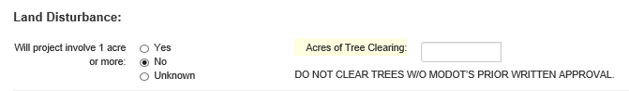
Figure 14. Land Disturbance – Required Fields.
- Complete blank RER “Number of Displacements” boxes shown in Figure 15 (described below).
  - Residential / Commercial Displacements: Choose “Yes” for either of these categories if the project will result in a displacement. If “Yes” is checked for residential or commercial displacements, provide the number of people / number of residences or number of employees / number of businesses affected in the corresponding boxes.
  - Public Hearing/Meeting Information: Provide information about public involvement that has been completed, or is anticipated to be completed, as part of the project. The required level of public involvement is generally related to the anticipated NEPA classification for the project. For examples of acceptable forms of public involvement for different NEPA classifications, refer to the EPG 129 Public Involvement.

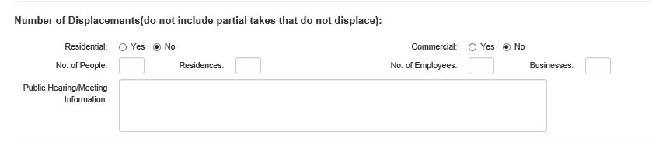
Figure 15. Number of Displacements – Required Fields.
- Complete the blank RER “Average Daily Traffic” boxes shown in Figure 16 (described below).
  - ADT Construction Year: If applicable to the project, indicate the ADT of the roadway for the construction year (see Step 4) that will be affected by the project.
  - ADT Design Year: If applicable, indicate the ADT of the roadway for the design year (see Step 5).
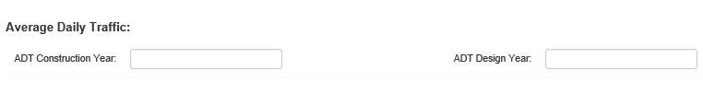
Figure 16. Average Daily Traffic – Required Fields.
- Complete the blank RER “Traffic Impacts” boxes shown in Figure 17 (described below).
  - Road/Bridge Closure Planned: Choose “Yes” if a bridge or road will be closed for any length of time during construction of the project.
  - Detour Info (including use of local roads): Include details about the proposed detour route. Explain the proposed detour route(s) including names of federal and state roadways, number of miles, and approximate length of time to drive the detour route(s). Describe how the public will be notified of the detour and how far in advance of construction they will be notified; how access to residences and businesses will be maintained by the detour; and whether any sensitive populations (minority, linguistically isolated, low-income) could be negatively affected by the road/bridge closure and detour.
  - Days/Months Closed: If applicable, indicate how long the road or bridge will be closed. If length of closure is uncertain at the time of the RER submittal, overestimate the closure length.

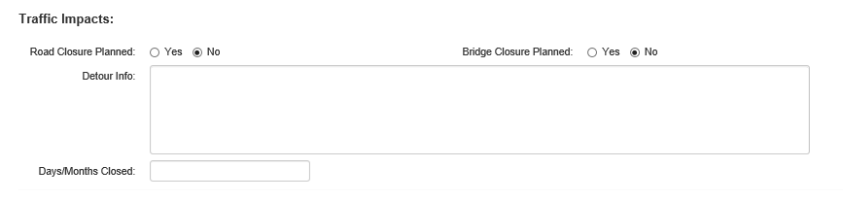
Figure 17. Traffic Impacts – Required Fields.
- Complete the blank RER “Bicycle/Pedestrian Consideration” boxes shown in Figure 18 (described below).
  - Pedestrian facilities considered: Using the drop-down menu, select “Yes” if pedestrian facilities were considered.
  - Bicycle facilities considered: Using the drop-down menu, select “Yes” if bicycle facilities were considered.
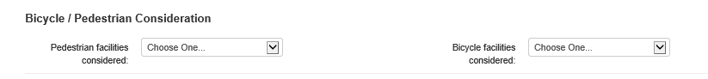
Figure 18. Bicycle / Pedestrian Consideration.
- Complete the blank RER “National Flood Insurance Program (NFIP) and Hydraulic Design Data” boxes shown in Figure 19 (described below).
  - Project is in a FEMA-identified zone “subject to 100-year flooding”: If the project is located in the 100-year floodplain, check this box. Indicate the zone in the box to the right of the check box. If the project is not in the 100-year floodplain, leave this box and fillable box for flood zone blank.
  - Project is in a FEMA-defined “floodway”: Use the drop-down menu to indicate whether the project is (or is not) located in the regulatory floodway.
    - NOTE: Projects that are located in the regulatory floodway are also located in the 100-year floodplain.
  - Project involves land purchased through FEMA Hazard Mitigation Grant Program (Flood buyout property): Check this box and provide details if any portion of the project, including new ROW or easement areas, were acquired or proposed for acquisition through the FEMA/State Emergency Management Agency (SEMA) buyout program. For more details on buyout lands and how they may affect project timelines, see EPG 136.6.4.7.
  - Is ANY construction taking place on MoDOT owned property under this project? Check “Yes” or “No” to indicate whether any portion of the project is on MoDOT-owned property. If you are working in a floodplain on MoDOT ROW additional documentation (e.g., hydraulic analysis) and approvals by MoDOT engineers may be required.
  - Is highway improvement located within 4 miles of an existing airport? Check this box if the project is within 4 miles of an existing and operational airport that is open for public use. If checked, additional clearances from the Federal Aviation Administration (FAA) may be required for the project. This process and clearance information will be added to the “Other” resource box filled out in the RER Environmental Screenings section.
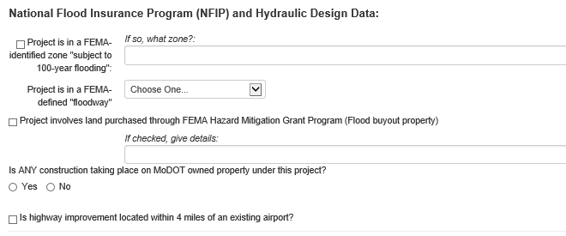
Figure 19. National Flood Insurance Program and Hydraulic Design Data – Required Fields.
- Complete the blank “Known Concerns” boxes, shown in Figure 20, as applicable to the project. This section allows the representative to provide more detailed information about the resources the LPA or consultant has knowledge of in the project area. These boxes are not required fields, but information provided will assist environmental staff in completing a more thorough and timely review of the project.
The LPA comments box allows for additional project information that may be helpful for environmental staff. Examples of the types of information that may be helpful include:
- Details on road closures and detours such as how long the road or bridge will be closed. If length of closure is uncertain at the time of the RER submittal, overestimate the closure length.
- If the project is in a comprehensive or long-range plan (this info would be helpful to us if 4(f) or 6(f) is applicable or for assessing community impacts).
- Other funding sources/other federal funds (e.g., if there are other environmental reviews or requirements, timing on using or obligating those funds)
- Any additional information about the project that would be helpful for MoDOT staff to know.

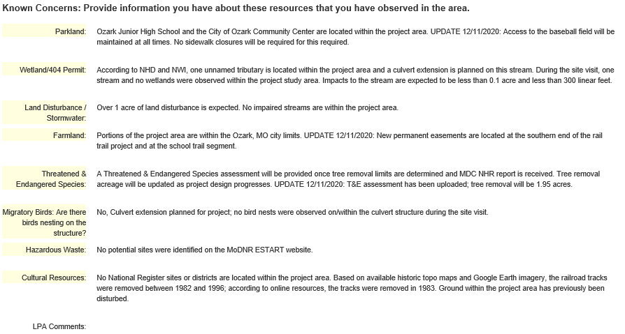
Figure 20. Known Concerns Section.
- Using the “Browse…” button (Figure 21), select plans, maps, pictures, or any other electronic documents for the RER form. After attaching the documents, click the “Upload Attachments” button (Figure 21) to attach the files to the RER form. For efficiency, multiple files can be selected and uploaded at once.
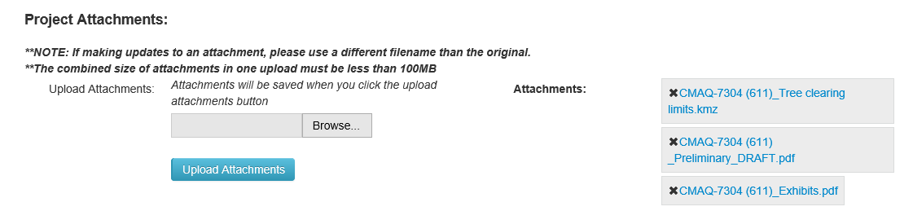
Figure 21. Upload Attachments.
- Click “Submit Request to Env. Services” to submit the RER form (Figure 22) and generate an automated email that will be sent to the appropriate MoDOT environmental and historic preservation specialists assigned to the project. The automated email will provide staff with a link to the RER form. If the RER form is saved and closed but was not submitted, the RER will be considered and saved as a “draft” and will not be sent to MoDOT specialists for review. This allows the representative to return to the RER form to continue editing before submitting the RER form. If after clicking the “Submit Request to Env. Services” button the system does not allow the RER to be submitted, it is usually because some of the required fields are not filled out or completed.
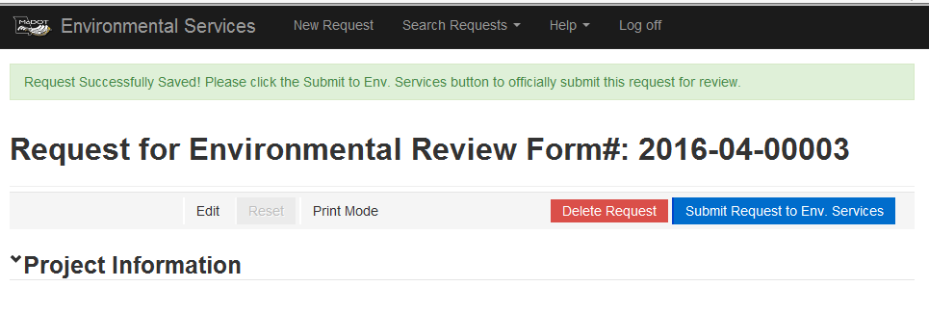
Figure 22. Saved Request for Environmental Review Form.

Section 5. Request for Environmental Review Environmental Screenings
The MoDOT environmental and historic preservation specialists will review the RER environmental resource sections based on the project information submitted (Figure 23).
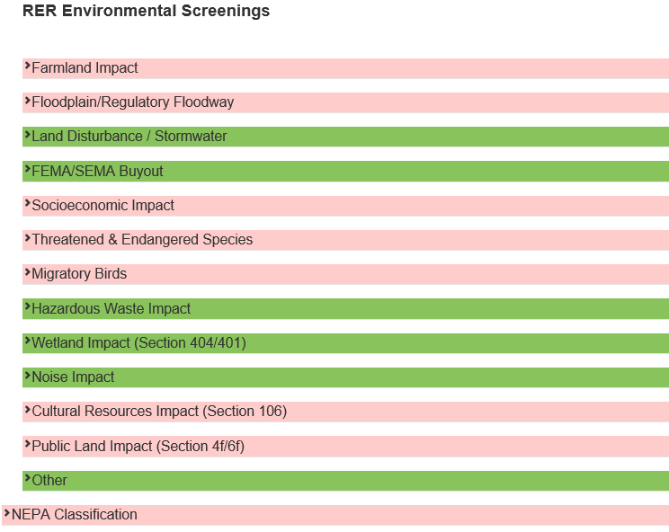
Figure 23. Request for Environmental Review Environmental Screenings.
Each individual resource screening section is color-coded based on the status of the review. Four colors are used in the review process (Figure 24):
- Green – The environmental resource screening has been completed and cleared by MoDOT’s specialist. There may still be commitments that the sponsor would need to ensure are followed.
- Light Blue – The environmental resource is in the process of being reviewed by MoDOT’s specialist.
- Pink/Red – Issues are pending; more information is needed on the project and should be reviewed by the submitter.
- Brown – The environmental resource has not been reviewed by MoDOT’s specialist.
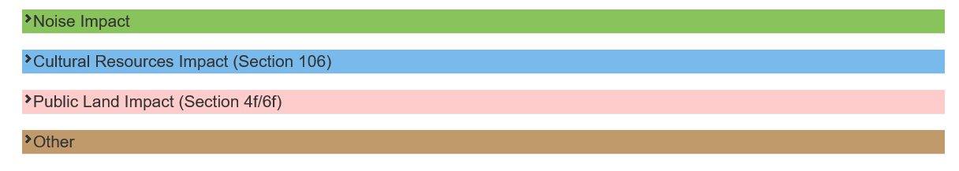
Figure 24. Request for Environmental Review Color Codes.
Additional information and explanations can be found in the comment boxes within each resource screening section (Figure 25). The Environmental Response box explains what tasks have been completed by MoDOT specialists. The LPA Action box indicates what is needed for MoDOT’s specialist to complete the environmental screening (Figure 25).
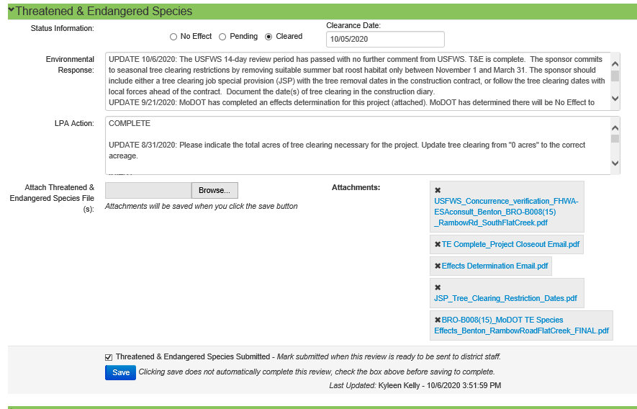
Figure 25. Resource Section Comment Boxes.
After MoDOT specialists have reviewed each resource screening section of the RER, the specialists will choose either the No Effect or Not Applicable, Pending, or Cleared button for each resource screening and click “Save” (Figure 25, above).
After all resource screening sections have been reviewed, the NEPA classification tab will appear at the bottom of the RER form. FHWA, the MoDOT environmental compliance manager, and the MoDOT environmental and historic preservation manager are permitted to approve the NEPA classification for a project. Once all resource screening sections have been reviewed, an email will be sent automatically to the individual who submitted the RER form, the sponsor, and the district liaison. A link provided in the email will take you to the RER system login screen. Log in to the RER system, and the form will open.

Section 6. How to Search for an Existing Request for Environmental Review.
To find an existing RER, follow the link shown in Figure 1 to access the RER system login. Once logged in, click the “Request Search” tab (Figure 7 above).
The RER search page (Figure 26) has multiple ways to search for a project in the RER system including the following:
- Request # – This number, located at the very top of the RER form, is automatically assigned when you create a new RER request.
- Project Number – This is the seven-digit number provided for the project (example: B050030). You must enter the project number with only the last seven digits (example: 5700604 or B068001). If the project is not entered exactly as it appears on the form, the system will not allow you to see the RER submittal in the search engine.
- District – Search by one of the seven MoDOT districts.
- County – Search by any Missouri county.
- Requestor – Search by the name of the person who submitted the RER request.
- Date Submit Start/End – Search by the date the RER was submitted.
- NEPA Approved? – Select to view only RERs that have received NEPA approval.
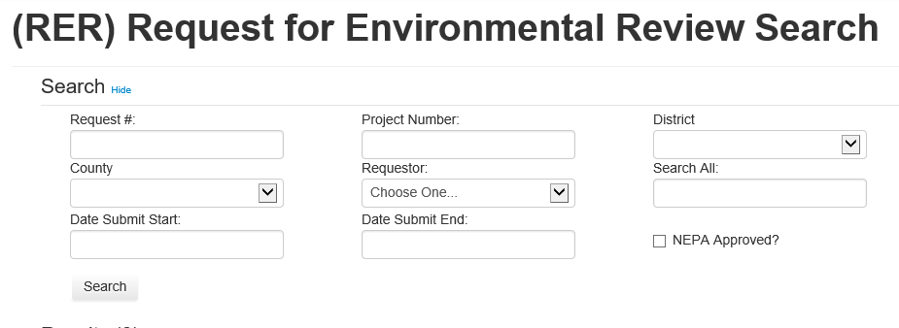
Figure 26. Request for Environmental Review Search Page.
The results of the RER search will be provided on a results page (Figure 27). Select the request number to link to and open the RER.
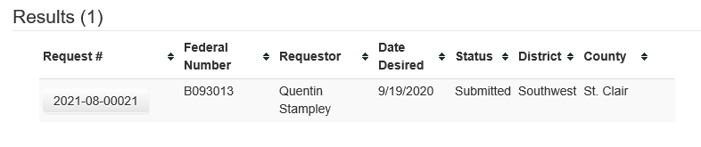
Figure 27. Request for Environmental Review Results Page.
If you are trying to determine the NEPA classification and the clearance dates needed to request an A-date, click on the NEPA classification heading under the RER Environmental Screenings (Figure 28).
The submitter can make edits to the RER after submitting the RER form, but once the NEPA classification is entered as “completed,” the RER is locked and no changes can be made to the RER form for that project. If changes to the project have occurred since the NEPA classification was given, contact the Environmental and Historic Preservation office to determine if the approval is still valid.
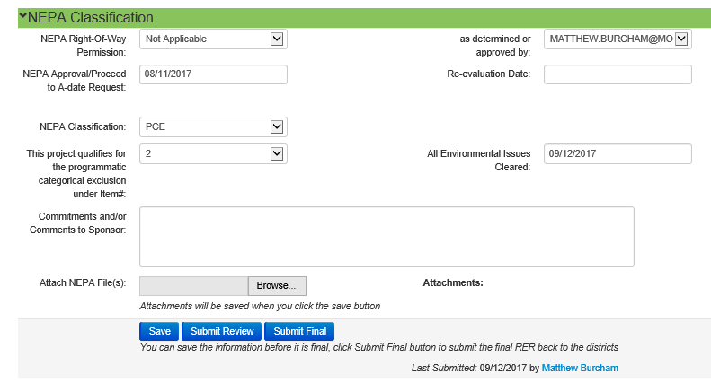
Figure 28. National Environmental Policy Act Classification.
If you need further assistance, contact Melissa Scheperle (573.526.6684), Richard Moore (573.526.2909), or Charlotte Drinkard (573.526.4778).

