Searching the Engineering Policy Guide (EPG)

EPG Search Box

The easiest way to search the EPG is to type one or more search terms in the EPG Search Box and press Enter.

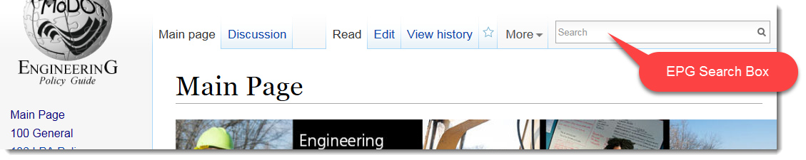

In this example the search term is “concrete” and 325 results were found. Page titles containing the term are listed in the left column. Pages that contain the search term in the text of the page are listed on the right. 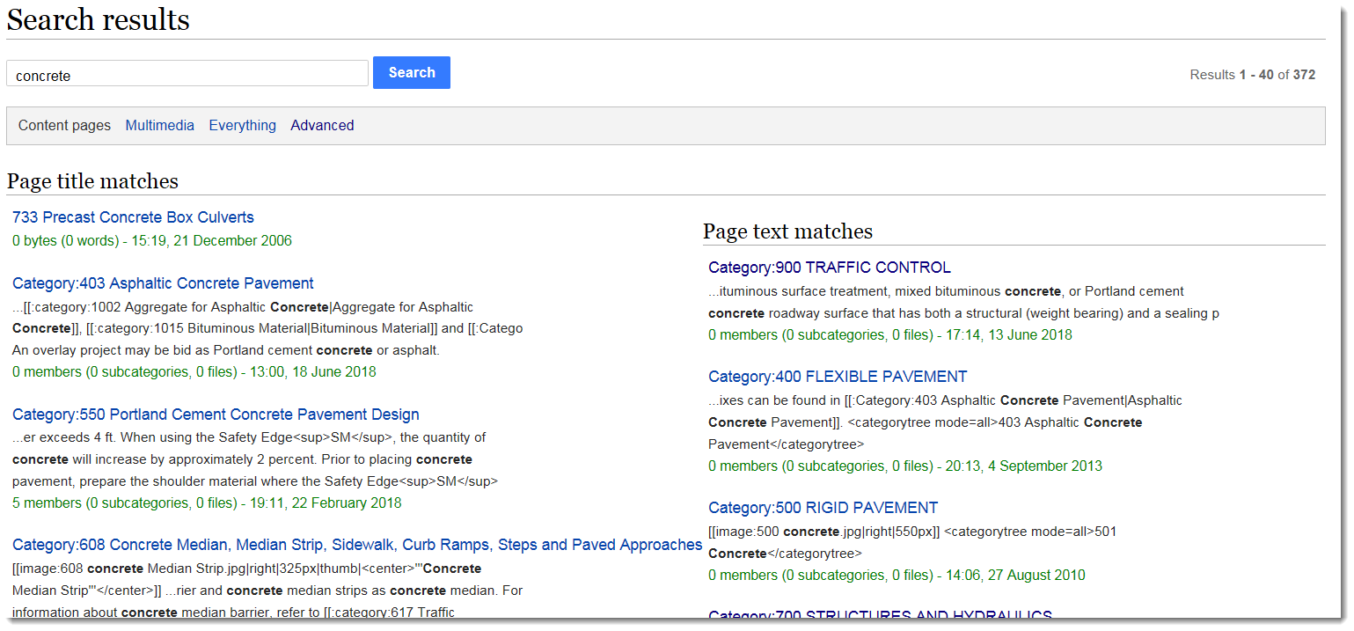

Multiple search terms can be used and required phrases should be enclosed in quotes. The EPG Search Box is the easist way to search but there are more ways to find content in the EPG.

EPG Search Options
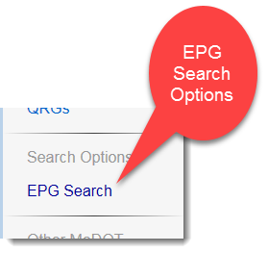
EPG Search Options are found on the left side of the EPG. Clicking this link will open a page providing four different search options.

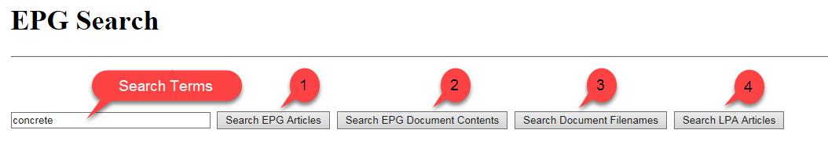
Enter the search terms in the box and click the search option you want to try.

- Search EPG Articles
This search option is exactly the same as the EPG Search Box available on the upper right hand corner of the EPG. If you use this search, press the browser back arrow to get back to the previous EPG page. If you want to perform another search click “EPG Search” again. Your previous search term is saved in the box. All the searches work the same except search option 2 which opens a new tab (Please note: Pages and articles are the same thing and the terms are used interchangeably in wiki documentation.)
- Search EPG Document Contents
Document files such as Adobe Acrobat, Microsoft Word, etc. are available through the EPG. These files are not searched with the regular search. This search utilizes Google searching and looks inside the EPG documents for the search terms. Since this is a Google search it opens in a new tab. If you want to return to the search options just close the browser tab.
- Search Document Filenames
This search looks for files that have been uploaded to the EPG like search option 2 except that only the filenames are searched. Search option 2 does not search the filename. This search will return images as well as all the other document types.
- Search LPA Articles
This search works like the EPG Search box but only for LPA (Local Public Agency) articles. EPG 136 contains information about LPA and is not searched in the EPG search box on the upper right hand corner of the EPG or in search option 1.

Optional Info
There are some options available when you search EPG articles. These options are automatically setup for you when you search and normally don’t need to be adjusted.
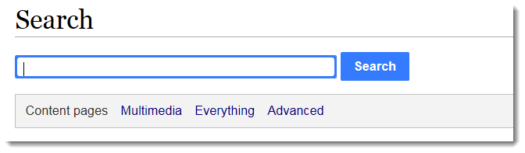
- Content pages: This is the normal EPG article search

- Multimedia: This is the Search Document Filenames search

- Everything: This searches everything in the EPG wiki: articles, document filenames, LPA, Help etc. It does not search the contents of uploaded documents.

- Advanced: This allows you to select what namespaces are searched. Namespaces are the way information is categorized inside the wiki.
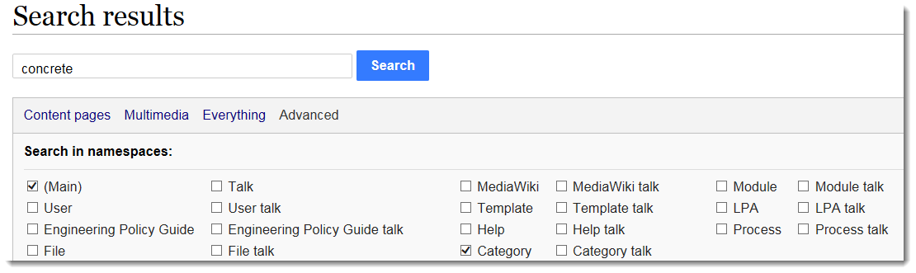
Main: EPG articles
User: Unused
Engineering Policy Guide: Unused
File: Uploaded files, also the same as Multimedia
Any of the Talk namespaces: Unused
MediaWiki: Unused
Template: Don’t search (Underlying format of the articles)
Help: Help files
Category: Categories in the EPG and are also articles
Module: Don’t search (Additional wiki functions)
LPA: LPA articles in the EPG
Process: Unused

