The Missouri Department of Transportation is conducting this survey to better understand how its representatives performed their job of acquiring property rights from you. This will help them know how they are doing and allow them to improve in the future. Please take a few minutes to complete this survey and return it in the self-addressed, stamped envelope provided.
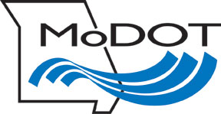
YOUR PARTICIPATION IS GREATLY APPRECIATED!

Project
Route
County
District
Parcel No.

Please rate the following statements: | Outstanding (5) | Very Good (4) | Good (3) | Average (2) | Poor (1)
- The MoDOT representative was respectful, knowledgeable, and professional throughout this process.
- The acquisition process and documents provided by the representative were explained clearly.
- The MoDOT representative addressed my concerns and answered my questions.
- The representatives treated me fairly during the overall property acquisition process.

How can MoDOT improve the property acquisition process? ____________________________________
_____________________________________________________________________________________
_____________________________________________________________________________________

What additional comments would you like to share? __________________________________________ _____________________________________________________________________________________
_____________________________________________________________________________________

☐ Completed by property owner: _______________________________________________________
Signature (optional) Date

☐ Completed by district office: _________________________________________________________
Signature Date

