Quick Reference Guide – Sampling Checklist

The Sampling Checklist presents data on the current test status of items in a contract based on contract sampling and testing requirements. This report contains information on the required number of samples to be taken over the life of a contract, number of samples that should be taken based on the current installed quantities, and the current number samples taken to date. The report can be used to identify discrepancies between the total number of required samples and the number of samples taken based on the current quantity throughout the life of the contract. This article is intended to guide the user in the creation of a Sampling Checklist.

Log on to the system and navigate to Materials Management – Process List.  
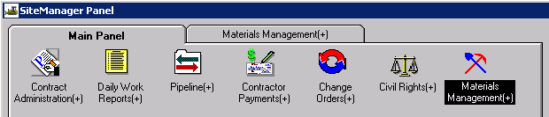

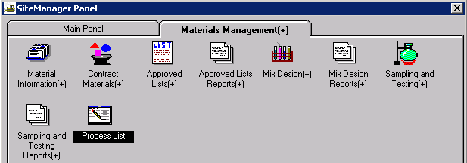

When the Process List window opens, double click “**Process ID**” to open the Confirm Process Submission window.

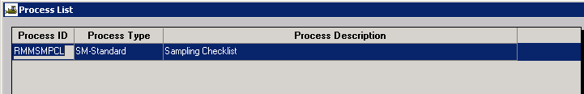

Right click in the window to open the **Filter-Find-Sort** pop-up menu. Select “**Find**.”  
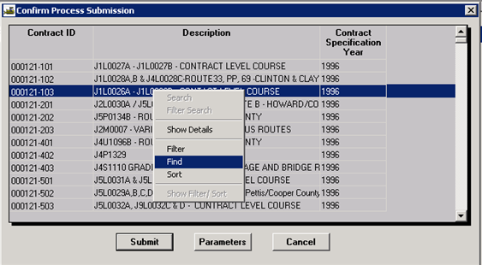

Click the **Insert** button on the right side of the **Find Criteria** window. Select **cont_id** from the **Field** drop down**.** In the **Condition** drop down, “**=**” should be selected. Enter the contract ID in the **Value** field and click the **Find** button.

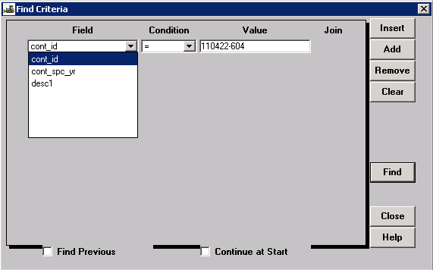

When the contract is retrieved, select the **Submit** button.  
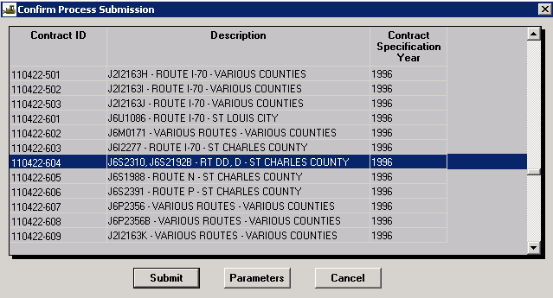

A Client Job Monitor message will indicate the process was submitted. Click **OK**.  
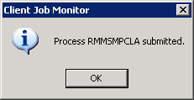

Click **OK** on the DPS Status Monitor message.   


**Note:** Users running in Terminal Services (Remote Desktop Connection) will NOT receive this second message, but may check the status of the report from the **Services - Process Status** drop down menu.

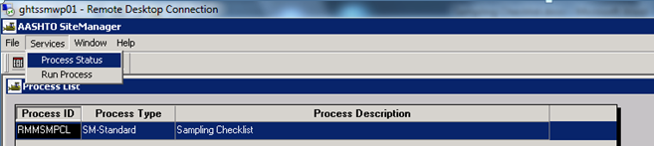

The Process Status window will list all processes that have run over the past 7 days. Double click the Process Name of the process just completed; for the Sampling Checklist, **RMMSMPCLA**.  
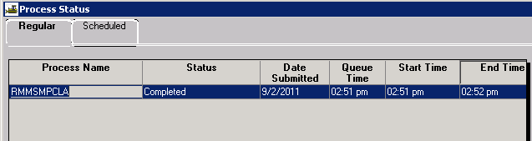

In the Files for Process window, double click **"Output.html"**  
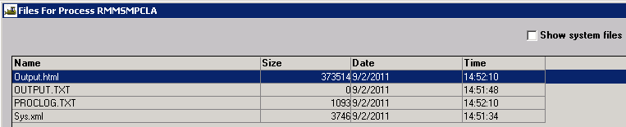

The Sampling Checklist will open in Microsoft Internet Explorer.  
