QRG: Change Orders – Time Adjustment
This article is intended to guide the user in the creation of either an overall contract time adjustment change order or a milestone time adjustment change order.
Navigate to Change Orders – Change Order Maintenance – Header.
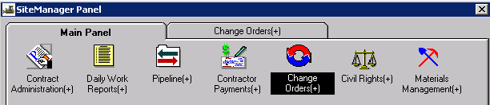
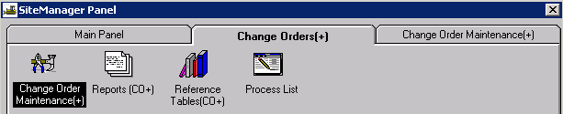
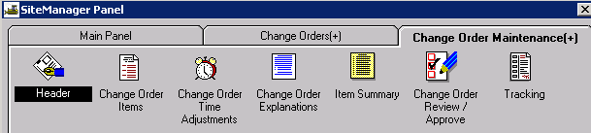

Creating the Change Order Header
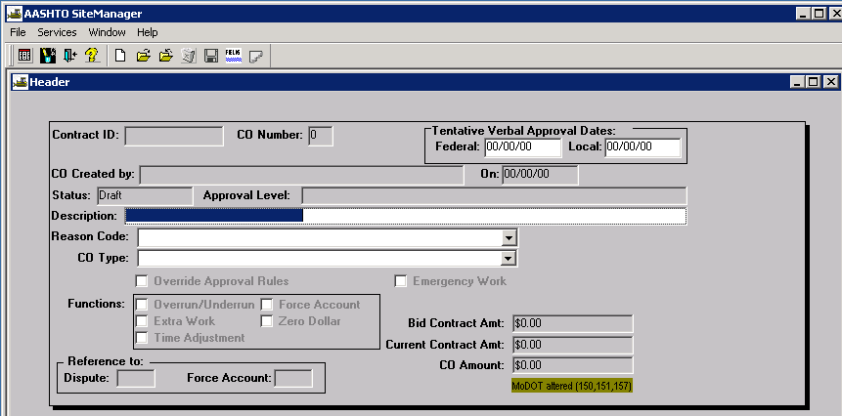
Contract ID: Select Services – Choose Keys to select contract.
CO Number: The system will automatically number the change order.
Tentative Verbal Approval Dates: May be used if it applies. Rush change orders may use these fields.
CO Created By: Automatically entered by system.
On: Date automatically entered by system.
Status: Leave Status as “Draft” until time adjustment and explanation has been entered.
Approval Level: Automatically entered by system based on change order rules.
Description: Enter a description of the change order.
Reason Code: Select “Time Extension” from the drop down list.
CO Type: Time Extension change orders are always Level 3 Approval. Select “Division Approval” from the drop down list.
Override Approval: The user should not have to override a time adjustment change order.
Emergency Work: Does not need to be checked.
Functions: Select “Time Adjustment.”
Reference To: Dispute and Force Account: These fields are not used.

Adding the Time Adjustment and Explanation
There are two ways to add the time adjustment and explanation.
You may access CO Time Adjustments from the Services menu of the Change Order Header,
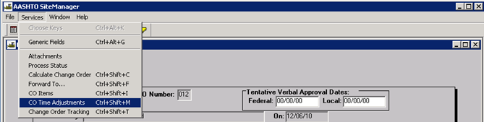

…or you may navigate to the Change Order Time Adjustments icon.
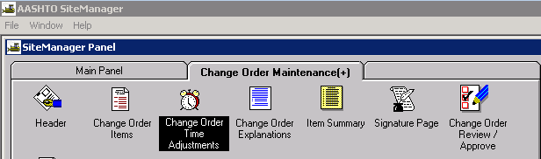
Either option will open the Change Order Time Adjustments window as shown below.
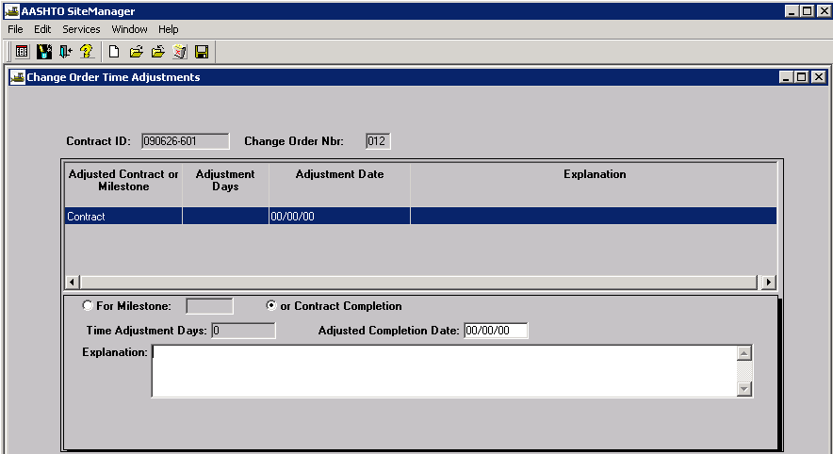

For Milestone: If the change order is for a milestone time adjustment, make sure the “For Milestone” radio button is selected, then select the appropriate milestone from the drop down.
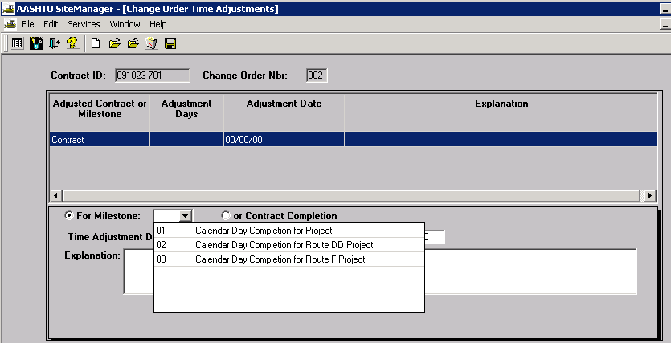
Contract Completion: If the change order is for the overall contract time adjustment, make sure the “Contract Completion” radio button is selected.
Time Adjustment Days: For Available Time or Calendar Time contracts and milestones, enter the number of days being added to the contract or the milestone. The system will automatically calculate an adjusted completion date.
Adjusted Completion Date: For Fixed Completion Date contracts and milestones, enter the new completion date. The system will automatically calculate the adjusted number of days.
Weighted time tables and examples of proper use for determining time extensions are shown in the following links: Table for Contracts With No Time Exclusion and Table for Contracts With Time Exclusion.
Explanation: Enter a detailed explanation for the time extension.
Note: SL District requires a 2-digit code at the beginning of the explanation for all time adjustment change orders. Please reference St. Louis District Reason Codes for Time Extension Change Orders for proper coding.
Once the information entered has been saved, SM will display the information in the upper portion of the window.

Changing the Status of a Change Order
Once the time extension and explanation has been added to the change order, the user must navigate back to the Header. User may choose to “Calculate Change Order” from the Services drop down menu to make sure the user-selected CO Type matches the system calculated Approval Level. The system will calculate Change Order Approval Level 3.
Change the status from “Draft” to “Pending” and save. Make the appropriate selections for each approval level, and then click OK.
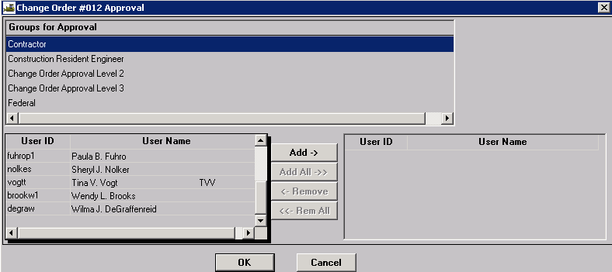

Printing the Change Order
Print the appropriate ReportNet report – either “Official MoDOT TIME EXTENSION Change Order Report” or “Official MoDOT MILESTONE ADJUSTMENT Change Order Report.” See Change Order Reports for guidance.

Saving the Change Order
All change orders must be saved in .PDF format to the V: drive in the following path for your district and org code: V:\Contract Information Archive\District # \ ORG # \ Contract ID \Change Orders\Pending. (See Note below.) File name should include the change order number placed within the file name so the change orders will sort properly when listed in the folder. See example below:
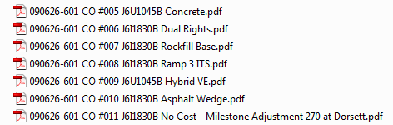

Once the change order has been approved at all levels, it shall be saved with all attachments in a single file to V:\Contract Information Archive\District # \ ORG # \ Contract ID \Change Orders\Completed.
Note: When distributing a change order electronically for signature, it should be stored with all attachments in a single file in the “Completed” change order folder and linked from there. Once the last digital signature is applied, the process is complete. No further action is necessary on the part of the project office, that is, there is no movement of the document from one folder to another.

