MoDOT Work Zone Impact Analysis Spreadsheet Instructions

The following steps will describe the process of running the capacity program and review the output for the MoDOT Work Zone Impact Analysis Spreadsheet.

Enable Content
Upon launching the program, there may be a popup box that looks similar to the image below.

You will need to enable to content in order to use the macros in this spreadsheet.

If this popup warning does not appear, the macros may have already been enabled previously.

Navigating the Spreadsheet
There are four steps that this spreadsheet uses to guide users through the Work Zone Impact Analysis.

- Step 1 – Introduction
- Step 2 – Facility Data Inputs
- Step 3 – WZ Analysis
- Step 4 – Synopsis Sheet

Each Step is located on a different TAB, usually located near the bottom of the spreadsheet.

The user can select any of these tabs throughout the process.

Entering Information
The cells that require the user to input data are highlighted. The highlight color attempts to indicate the type of data that is desired.

- BLUE cells indicate information needed regarding the Base Conditions.
- ORANGE cells indicate information needed regarding the Work Zone.
- YELLOW cells are optional inputs. Leave these BLANK if you want to use the spreadsheets defaults.

Step 1 - Introduction
This tab of the spreadsheet contains some of the pertinent information for users to successfully utilize the spreadsheet.

The items discussed above are included in this section as well as links to the EPG Article that discusses Work Zone Capacity, Queue, and Travel Delay.

Any questions regarding the spreadsheet can be directed to the contact persons located on this page.

Step 2 – Facility Data Inputs
This tab is of the spreadsheet is where the characteristics of the existing system are inputted.

The Background Information located in the top row of data is to identify the location of the work zone.

Please note that this spreadsheet only evaluates one direction at a time. Data inputs for volumes, truck percentage, climbing grades, etc, must be specific for that particular direction.

Existing Roadway Data
The information required to identify the existing facility can be found using the ARAN Viewer.

To access the ARAN Viewer, launch Internet Explorer and navigate to MoDOT’s main SharePoint site. From this location, you can select the icon for TMS, circled in RED below. A link to the TMS website is also provided in the spreadsheet.
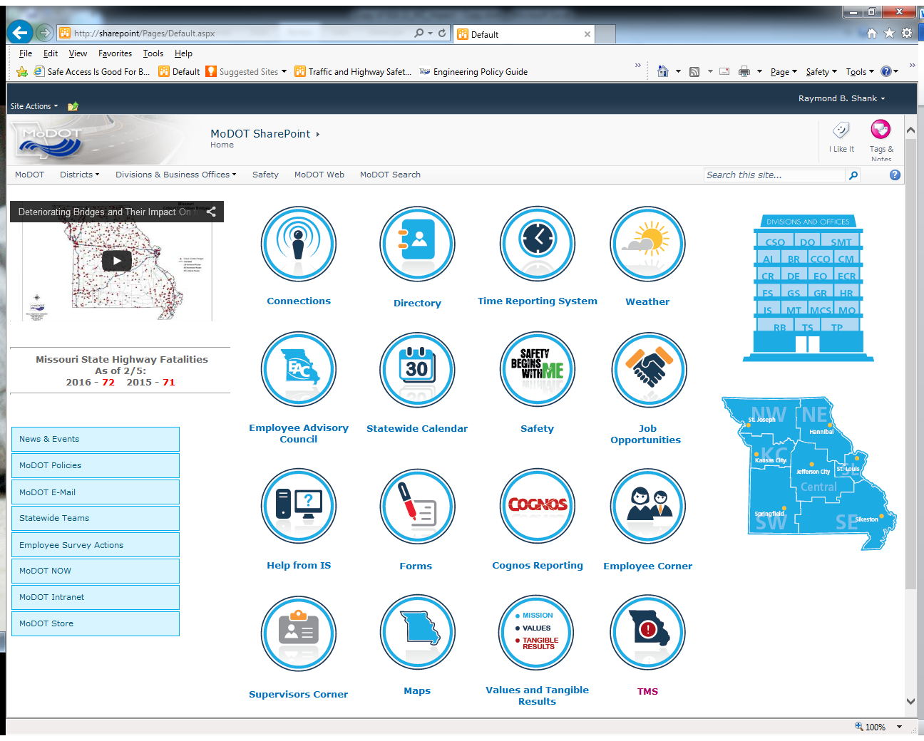

From the TMS website, an icon to access the ARAN viewer is located in a column on the right hand side, circled in RED in the image below.

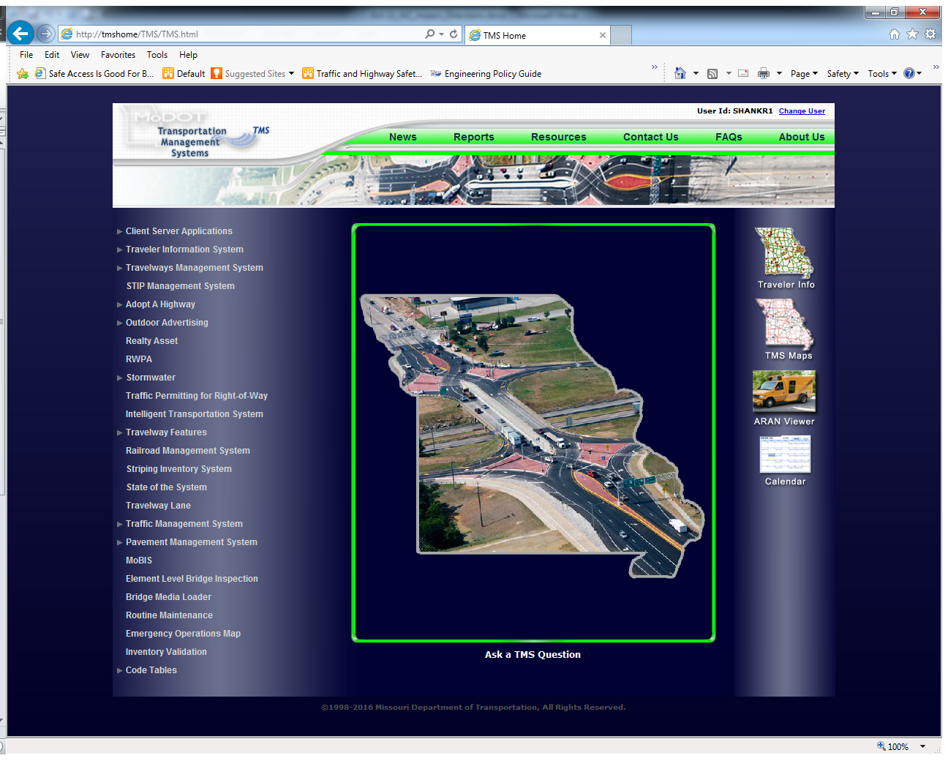

These instructions do not cover how to use the ARAN Viewer only where to find the existing facility data required to use the Work Zone Analysis Spreadsheet.

On the right hand side of the ARAN Viewer there are several drop down boxes that can select various data for the roadway segment. To obtain information for the spreadsheet we are interested in the following data types.

- NUMBER_OF_LANES
- COM_VOL_BY_DIR
- AADT
- GRADE
- SECTION_BEGINLOG / SECTION_ENDLOG

Below is a screenshot showing these data types selected.
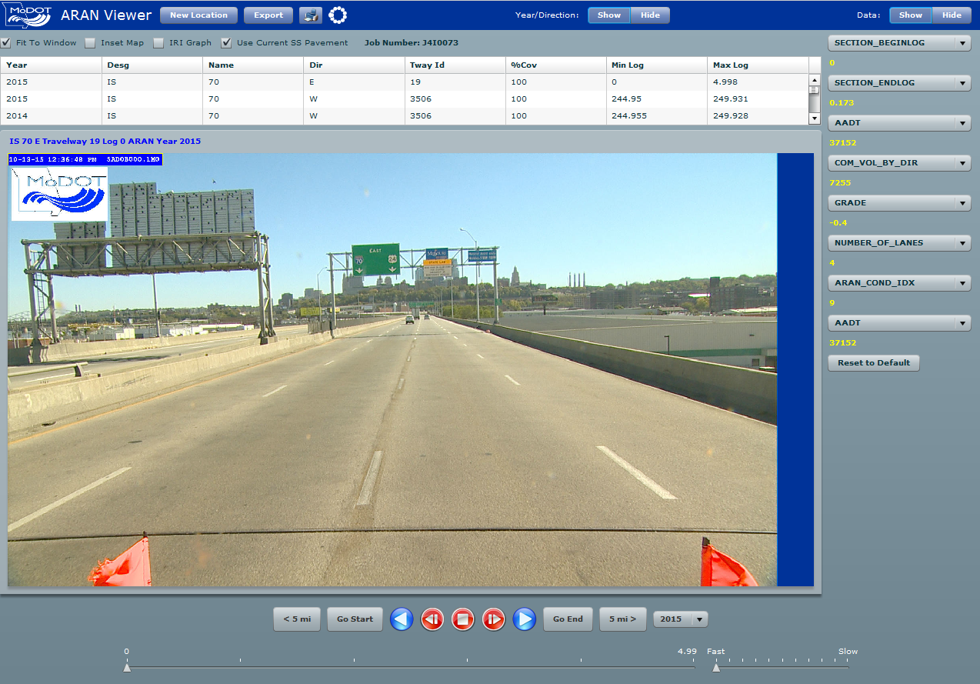

Number of Lanes – This is the number of lanes available for travel (no work zone). This can be visually seen from the ARAN Viewer Image or obtained from the NUMBER_OF_LANES data box.

Large trucks, buses, and RVs in traffic cannot be compared with passenger vehicles (cars/small trucks) because of the length and weight of the trucks/buses/RVs. The next three inputs (Daily Truck Percentage, Climbing Grade, and Length of Incline Grade) are used to account for the impact of larger vehicles on the capacity of the work zone.

Daily Truck Percentage – This percentage can be obtained by dividing the number of commercial vehicles (COM_VOL_BY_DIR) by the total volume along the roadway (AADT). This method works for divided roadways. For undivided roadway, this method may need to be scrutinized for accuracy.

Climbing Grade – This is the average of the longest/steepest grade in the segment. To obtain this value, the user should observe the various GRADE data, stepping through each roadway segment through the work zone location. For a conservative analysis, applying the maximum grade over the overall segment is suggested. This grade can be revised for a more fine-tuned analysis should it be required. For segments that only contain downgrades, a climbing grade of <2% should be selected.

Length of Incline Grade – This is the total length of the incline where the climbing grade applies. This length can be obtained by recording the difference of the SECTION_BEGINLOG and SECTION_ENDLOG values that contain the total length of incline. This length should start from a level location, extend through the incline grade, and end when it levels out again. For segments that are level or only contain downgrades, a value of zero can be used for the length of incline grade.

User Cost – This is the value of a driver’s time and operational costs for running a vehicle. The default values were provided by MoDOT’s Planning Office, but location specific data may be applied, if available. In most instances, this value will not be modified.

Traffic Volume Data – This hourly volume data can be obtained from a variety of sources. Typically, the TMS Traffic Segment Hourly Volume (TSHV) Application will be used to obtain this data. Links to TMS and Instructions on how to use the application can be found in the spreadsheet. Use this application to obtain the desired evaluation period for the work zone location.

Please note that the projected volume data provided by this application is not specific to a particular day. The volume data reported are a typical week within a given month. That is to say, every Monday will have the same volume data within the same month. This 24 hour flow curves used to develop the hourly volumes are based on weekday flows. If a work zone is planned to occur over a weekend, the volumes may want to be further scrutinized.

Once data is exported from the TSHV application it can be copied and pasted into the Work Zone Impact Analysis Spreadsheet.

The Day of Week will update automatically to match the specific Date of Count.

A graph of the inputted traffic flows can be found beneath the volume inputs. This can be used as a double check to confirm the volume inputs.

Step 3 – WZ Analysis
The inputs for this tab involve details specific to the work zone. There are seven areas that require work zone inputs, one for each day of volume data inputted during Step 2. The specific day of week that the work zone data will apply can be found on the left side of the spreadsheet, circled in RED below. Should the same work zone characteristic apply to each day being evaluated, a macro has been developed to auto-populate the top work zones details to all scenarios. This macro can be activated by selecting the “Copy Top Work Zone Details to All Scenarios” Button in the upper right hand corner, circled in GREEN below. Next to this button is another that will reset the work zone data to its defaults, i.e. no work zone.

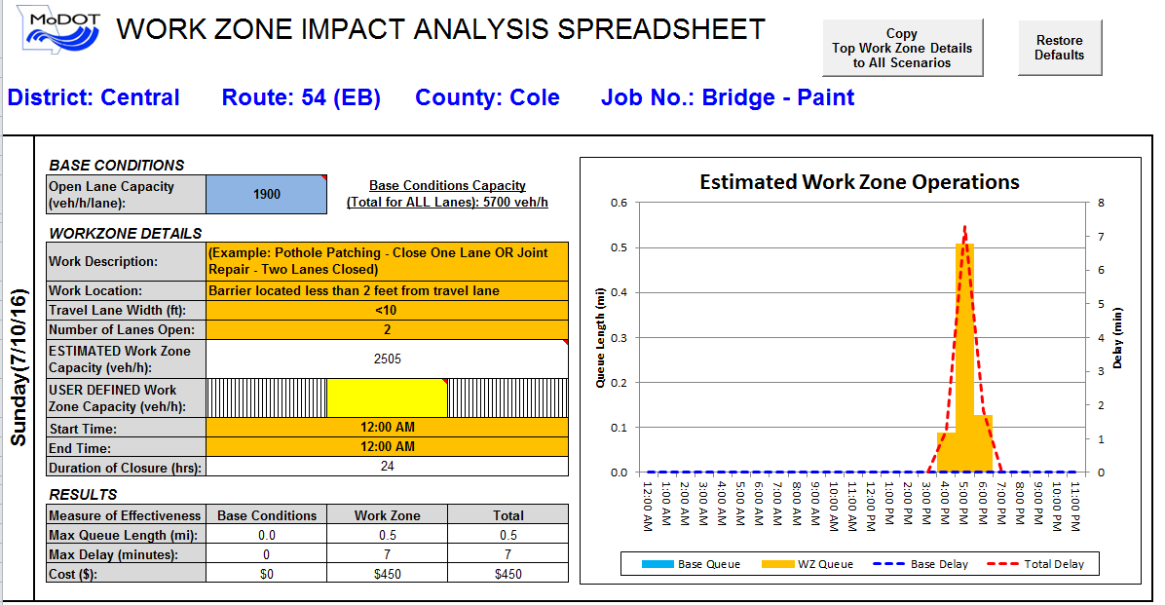

BASE CONDITIONS
Open Lane Capacity – This section allows the user to input a location’s specific capacity when no work zone is present. The base capacity mostly impacts the rate of queue dissipation should there be residual queues after the work zone has been removed. This value is critical for locations where the existing facility is at or over capacity during certain times of day. For locations that currently operate over capacity, this value can be adjusted by the user, to match the delay and queue outputs to existing field data.

WORK ZONE DETAILS
Work Description – This section allows the user to input specific information about this work zone to help differentiate it from other scenarios.

Work Location - The relative location of workers and/or equipment to the traveling public has been shown to affect the capacity of the travel lane through the work area. The work location shows no work zone present to assist with calibrating the existing conditions. When a work zone type is selected, several cells will change their color to ORANGE indicating that this is an input required to estimate the capacity of the work zone.

The Highway Capacity Manual 2010 states the base work zone capacity is approximately 1600 passenger cars per hour per lane for “normal” work zone activity. If the work area is located close to the travel lane, the capacity is adjusted as much as 10% due to closeness of vehicles and people, rubbernecking, etc. If the work area is located some distance from the travel lane, the capacity may increase as much as 10% due to less activity along the travel lane.

Travel Lane Width - At times the travel lane width may be reduced due to the type of operation, size of work equipment, etc. Restricting travel lane width has shown in studies that free-flow speed is reduced, which in turn will decrease the capacity.

Number of Lanes Open – Number of travel lanes that will be open to the traveling public.

ESTIMATED Work Zone Capacity – This is the estimated capacity of the work zone based on the Work Zone Location, Travel Lane Width, and Number of Lanes Open. This estimated work zone capacity will be used by the spreadsheet during the time specified that the work zone is active. The estimated work zone capacity can be superseded by a User Defined Work Zone Capacity.

USER DEFINED Work Zone Capacity – The user has the ability to override the Estimated Work Zone Capacity. The estimated capacity may want to adjusted based on a variety of reasons, such as:

- Historical use of the spreadsheet. If the spreadsheet has previously underestimated the capacity of the work zone, the user can input an increased capacity to more accurately reflect previous work zone capacities in the area.

- Implementing strategies to improve capacity. If certain work zone layouts or ITS solutions are used with the project (such as zipper merge), capacities could be increased.

- Sensitivity Analysis. Depending on the project, a sensitivity analysis may be conducted. The user could see what kind of impact is anticipated when the capacity is reduced by a certain percentage. A reduced capacity could be the result of weather, incidents, and more conservative drivers. This helps assess the risks associated with the work zone.

Start Time – This is the time of day that the work zone is scheduled to begin.

End Time – This is the time of day that the work zone is scheduled to end.

For work zones active 24 hours a day, the Start Time and End Time should have the same value.

RESULTS
The results include three data types: Base Conditions, Work Zone, and Total. The measures of effectiveness were broken down to ensure delays and queues potentially caused by the Base Conditions were not attributed to the impact of the work zone.

Max Queue Length – This is the maximum length of stopped vehicles throughout the duration of the work zone. This length assumes vehicles will be equally distributed between the available upstream lanes. If lane imbalance occurs, the maximum queue length could be longer. Also, the Max Queue Length does not account for where vehicles are slowed; it only anticipates the stopped queue.

Max Delay – This is the maximum delay for a single vehicle to transverse the work zone. Similar to the Max Queue Length, the maximum delay does not account for when a vehicle is slowed; it only assesses delay when a vehicle is expected to stop.

Cost ($) – This is the User Cost attributed to the public as a result of the work zone. This cost accounts for the value of a person’s time as well as the running and maintenance costs of running the vehicle for additional time.

Estimated Work Zone Operations
This chart plots the estimated operations for the work zone. This chart will automatically update based on the values inputted into the cells adjacent to them. Two data types are plotted on this graph: Delay and Queue. Two different Y-Axis are provided to plot the data. Queue Length is located on the Left Y-Axis and Delay is located on the Right Y-Axis.

Please note that the scale of the Y-Axis will automatically update. This means that a visual comparison between various graphics on this page may not be applicable. A Synopsis Sheet, located in Step 4, is provided to make this direct comparison.

Step 4 – Synopsis Sheet
This tab contains a printable graphical representation of the queue and delay of the work zone. The entire week is graphed to see the trends of the work zone concerns of queue and delay.

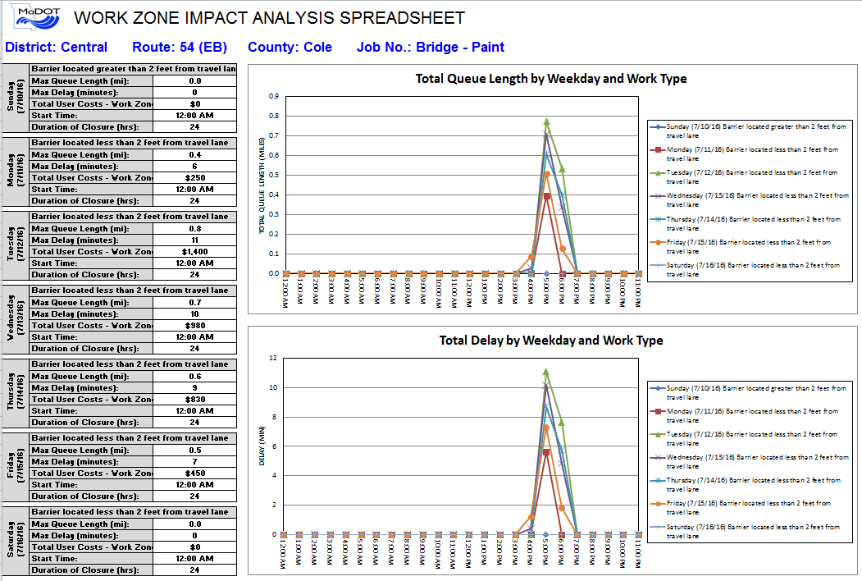

Methodology
The following is a description of the methodology used to determine the Queues and Delays for the work zone. These calculations are performed on a hidden tab named WZ Analysis (Worksheet). To view this worksheet, right click on a tab located at the bottom of the spreadsheet. Select Unhide and then select the sheet desired to be shown.

The hourly traffic volumes inputted in Step 2 are utilized as the DEMAND for the facility. The Demand information is normally populated from the Transportation Management System (TMS) database. Data from the TMS is calculated from field data and updated every 1-3 yrs, dependent on roadway type. The Demand field can be populated by actual field data.

The Demand volume is used to determine the TOTAL ARRIVALS, which is a running count of the number of vehicles entering the work zone.

The TOTAL DEPARTURES is a running count of the number of vehicles that leave the work zone based on the maximum capacity.

QUEUED VEHICLES are the difference of vehicle arrivals versus departures. Below is an example of the work zone calculations for Queue Length and Delay.

The work zone data provided below has a capacity of 1,240 vehicles/hour. At 7:00 a.m., 1,371 vehicles arrive, but only 1,240 vehicles can travel through the work zone. There are 131 vehicles that cannot enter the work zone for that particular hour and must wait their turn. If the number of arriving vehicles is greater than the capacity of the work zone lane closures, then the work zone will see a queue and delay.

The QUEUE LENGTH output calculates the length (miles) of the queue based on the percentage of passenger vehicles and trucks. The length of vehicles for this example is 25 feet for passenger vehicles and 50 feet for trucks.

For example at 7:00 a.m. there are 131 queued vehicles of which 25 percent (0.25) are trucks. (131 vehicles)*(0.75 percent cars)*(25 feet per passenger vehicles) + (131 vehicles)*(0.25 percent trucks)*(50 feet per trucks) = (2,456.25 feet + 1,637.5 feet) / (2 lanes of open lane) * (5,280 feet/mile) = 0.39 mile queue.

The DELAY output is the calculation of the queued vehicles, capacity, and conversion from hours to minutes. For 7:00 a.m. example, (131 vehicles)*(60 minutes/hour)/(1,240 vehicles/hour) = 6.34 minutes.

SATURDAY |  | TIME | DEMAND | CAPACITY | TOTAL ARRIVALS | TOTAL DEPARTURES | QUEUED VEHICLES | QUEUE LENGTH | DELAY
0 | AM | 0:00 | 364 | 1240 | 364 | 364 | 0 | 0.00 | 0.00
1 |  | 1:00 | 331 | 1240 | 695 | 695 | 0 | 0.00 | 0.00
2 |  | 2:00 | 296 | 1240 | 991 | 991 | 0 | 0.00 | 0.00
3 |  | 3:00 | 337 | 1240 | 1328 | 1328 | 0 | 0.00 | 0.00
4 |  | 4:00 | 395 | 1240 | 1723 | 1723 | 0 | 0.00 | 0.00
5 |  | 5:00 | 621 | 1240 | 2344 | 2344 | 0 | 0.00 | 0.00
6 |  | 6:00 | 1024 | 1240 | 3368 | 3368 | 0 | 0.00 | 0.00
7 |  | 7:00 | 1371 | 1240 | 4739 | 4608 | 131 | 0.39 | 6.34
8 |  | 8:00 | 1331 | 1240 | 6070 | 5848 | 222 | 0.66 | 10.74
9 |  | 9:00 | 1095 | 1240 | 7165 | 7088 | 77 | 0.23 | 3.73
10 |  | 10:00 | 1238 | 1240 | 8403 | 8328 | 75 | 0.22 | 3.63
11 |  | 11:00 | 1196 | 1240 | 9599 | 9568 | 31 | 0.09 | 1.50
12 | PM | 12:00 | 1276 | 1240 | 10875 | 10808 | 67 | 0.20 | 3.24
13 |  | 13:00 | 1216 | 1240 | 12091 | 12048 | 43 | 0.13 | 2.08
14 |  | 14:00 | 1317 | 1240 | 13408 | 13288 | 120 | 0.36 | 5.81
15 |  | 15:00 | 1326 | 1240 | 14734 | 14528 | 206 | 0.61 | 9.97
16 |  | 16:00 | 1310 | 1240 | 16044 | 15768 | 276 | 0.82 | 13.35
17 |  | 17:00 | 1222 | 1240 | 17266 | 17008 | 258 | 0.76 | 12.48
18 |  | 18:00 | 1091 | 1240 | 18357 | 18248 | 109 | 0.32 | 5.27
19 |  | 19:00 | 847 | 1240 | 19204 | 19204 | 0 | 0.00 | 0.00
20 |  | 20:00 | 859 | 1240 | 20063 | 20063 | 0 | 0.00 | 0.00
21 |  | 21:00 | 695 | 1240 | 20758 | 20758 | 0 | 0.00 | 0.00
22 |  | 22:00 | 601 | 1240 | 21359 | 21359 | 0 | 0.00 | 0.00
23 |  | 23:00 | 492 | 1240 | 21851 | 21851 | 0 | 0.00 | 0.00

