CRE2O – Contractor Reporting Excel2Oracle – MoDOT QRG
This QRG provides basic instruction for MoDOT persons on how to use the CRE2O system. The contractor instructions companion to this QRG is found on the Quality Management website along with video tutorials that may be helpful in understanding the more specific functions of the sheets.

General Information: The CRE2O is an extension to the Excel2Oracle system MoDOT has used for a decade. The system uses Microsoft Excel forms with coding to allow contractors to submit testing information directly into MoDOT’s SiteManager Oracle database.
Differences include:
- Files are obtained by the contractor from the www.modot.org/quality. MoDOT inspectors can obtain the files from either the website or the V: as before.
- Files are submitted back in using FTP to MoDOT’s webserver; NOT to the V: as before.
- All the sheets follow a standard format.
- There is significantly more error checking prior to submittal to prevent most rejections.
- The picklist publishing has been automated to a two hour cycle.
- There is a news broadcasting system built into the sheets to allow HQ to tell users of updates or other important system notices.
- All actions that need an Internet connection have been consolidated to one tab.

Software Requirements:
The sheets are designed around Microsoft Excel 2010 and newer. The coding in the sheet that interfaces with MoDOT’s website uses base features found in every Microsoft operating system. At this time, other operating systems are not supported. Microsoft Office has become available for both Android and Apple platforms recently and it is our intention to eventually support all three platforms.
ActiveX Controls and Macros need to be enabled in the Excel Trust Center settings for the extensive programming in the sheets that needs to execute.
CS&TR. In general under Quality Management, the QC records will contain the contract tab quantity and the QA records will be 0 quantity. As such the CRE2O quantities and tests entered on the forms count towards satisfying the contract sampling and testing requirements that control payment in MoDOT’s system.

Sample ID#s. The CRE2O sheets force the standard MoDOT ID# format. The contractors must keep track of their record #s just like MoDOT has had to do. All records created by CRE2O will have a QM designation in place of the district designation. Each contractor has been assigned an official initials, just like each MoDOT inspector.

Sample Status: There is logic on the sheets that will determine by using the contractors inputs if the record is submitted as COMPLETE or PENDING. When reviewing the report, if the status is PENDING, there might well be an outstanding issue like an NCR that should be resolved before the report is authorized and paid for.

Quantity Tab: This contract area is now fully controlled by picklists. This may slow down entry somewhat, but will prevent the most common cause of rejected reports. The contracts and line numbers shown are filtered to options with that particular material code. Be aware that if the contractor chooses the wrong material code, they likely won’t be able to find their line # as an option to proceed. They will either need to change to the correct material, or you will need to add the correct material to the CS&TR.
When you add a contingent line to a contract, it will automatically be published within two hours. The contractor will need to do the “Update Picklist” to retrieve the contingent lines. They can try to force it in using the “Manual Fill” area, but the chance of rejection goes up significantly.
Please work with your contractors to determine how accurate the quantities need to be. It’ll vary by material and as in the past some items may need to be estimated.

Send/Sync Tab: All functions needing an Internet connection have been consolidated to one area; the Send/Sync tab. Every other tab of the sheets should fully function in standalone mode. This is useful for jobsites that don’t have cell coverage. The contractor can download the sheet at their office, go to the field, fill out the sheet, and then send the sheet once they are back in the office.

Send: Sending a report back to MoDOT is a completely different code than before. The sheet goes from the contractor to our webservers and then to the V: ready to process folder as before. The server is now coded to send emails for either success or rejection. The emails also now go to BOTH the contractor and the one MoDOT person they designated.
It is important to note that reports sent in are NOT AUTHORIZED. It is the responsibility of the MoDOT QA inspector to review the report in SiteManager and authorize it. There is an automated CRETO STATUS report for each RE office on the external Sharepoint site that shows submitted QC reports and whether or not they are authorized.

Rejections: When the server processes a report, it can be rejected for any number of reasons. With CRE2O we’ve tried to prevent this from happening as much as possible, but can’t cover 100% of the possibilities. Rejections are running about 3% which is much better than before for new users. When there is a rejection, please work with the contractor to review their inputs to see if the error can be eliminated. If you believe it is an error in the sheets themselves, please contact Mike Meyerhoff, Lori Greer, or Jonathan Varner.

Allow Updating: As before, “Allow Updating” is available and could be useful in some cases. Note that the contractor can update a sample record that you have already authorized. If that happens the record will need to be reviewed and authorized a second time.

MODOT Inspector Designation: On each CRE2O sheet the contractor is allowed to designate one MoDOT person. That person will get the rejection or acceptance emails. That person will also be listed as the sampler on the basic sample data tab.
Please coordinate with the contractor which inspector should be used.

Security Word: Each contractor has been assigned a random security word for their whole company. This provides a level of minimal security that should hopefully balance the need to keep the records appropriate while keeping the administrative effort small. HQ can assign a new Security Word at the contractor’s request.

Broadcast News: On the Send/Sync tab there is a place at the bottom where information about the CRE2O system is displayed. Each sheet will attempt to automatically retrieve the latest news once a day. There is also a button to force a news retrieve.
There is some filtering in the news system. (IE: The concrete sheets will not display asphalt news)

Sheet Version Check: On the Send/Sync tab there is a place at the bottom where both the sheet version and most current version are displayed. This feature is part of the broadcast news functions and will attempt to automatically check itself once a day. There is also a button to force a retrieve.
If the sheet version is out of date, the versions will highlight red. As with the previous Excel2Oracle systems, sheets that are too far out of date may not process. This is usually indicated by a “major” version change where the first number before the period is advanced.

Overview: This diagram shows how data is passed around to make CRE2O work. MoDOT inspectors directly access our Oracle server using the SiteManager program. The oracle data for picklists are published to the website automatically every two hours. Contractors access the website using the CRE2O sheets. The processing server runs every 10 minutes to take Their CRE2O sheets and input them into the Oracle database.
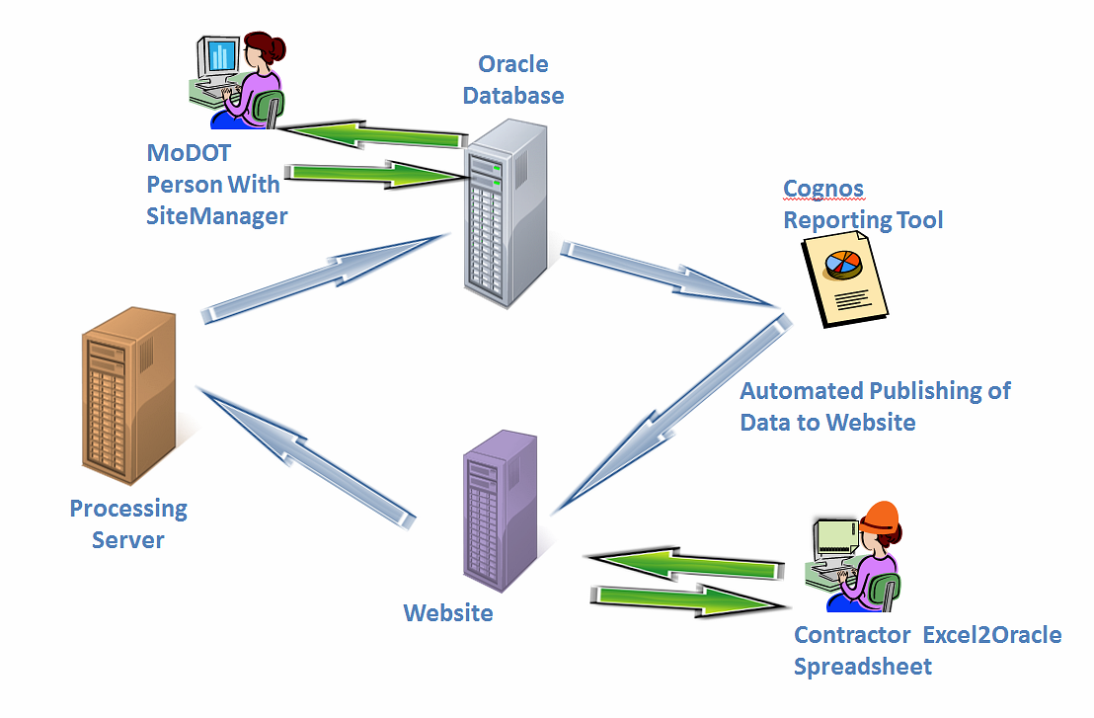

Superpave Sheets: The Superpave CRE2O sheet has been designed to work in conjunction with the new MoDOT Excel2Oracle QA Superpave sheet. When used together, the two will nearly eliminate duplicate data entry. There are some limitations to be aware of
- Each Superpave CRE2O sheet will only handle eight QC sublots. If a contractor has more than eight sublots they can use multiple sheets. Keep in mind that the quantities must not be duplicated when splitting up a lot; either all the quantity should be on one sheet and the other 0s OR the quantity should be divided correctly.
- The new QA Superpave sheet can only import three QC sample records. Additional sheets will be ignored and you will need to calculate the payfactor by hand.
- Combining the above limitations means the absolute most sublots is 24 without resorting to hand calculating payfactors.
A benefit of how the QC and QA sheets work together is that QC can split a lot into two or three reports if they are doing small quantities. This is especially useful when the lot falls across estimate periods. QC can send in the first part of the lot, MoDOT can approve and pay for it, then later QC can send in a second sheet with the rest of the lot, MoDOT can approve and pay for it, and QA PWL it.

