QRG –Liquidated Damage Adjustments
Liquidated damages are created during the estimate generation process. Liquidated damage adjustments may be system generated or entered by the user. This article is intended to guide the user in the creation of Liquidated Damage Adjustments.

Navigate to Contractor Payments – Contract Adjustments – Liquidated Damages.
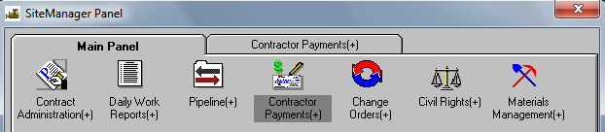
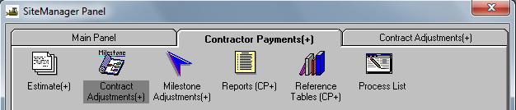
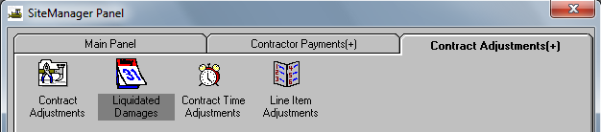

Select the appropriate contract ID from the Authorized Contract List window.
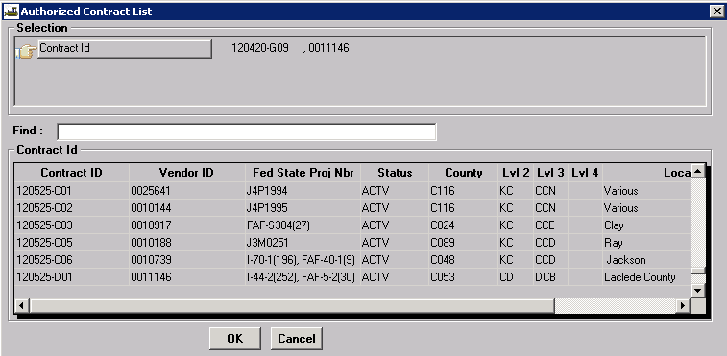
The Liquidated Damages window allows the user to add, modify, or view liquidated damages for all estimates on the contract. Liquidated damages may be system generated or they can be created by the user. Only First Level Approvers (project manager for Progress estimates) can create these adjustments. System generated liquidated damages may only be viewed except for adding remarks on the Descriptions tab and/or adjusting project distribution percentages on the Proj Distribution tab prior to estimate approval. Once the estimate has been approved, liquidated damage adjustments may only be viewed.
The top portion of the Liquidated Damages window will display all liquidated damage adjustments for a contract. The bottom portion of the window displays detail information for a selected liquidated damage adjustment.
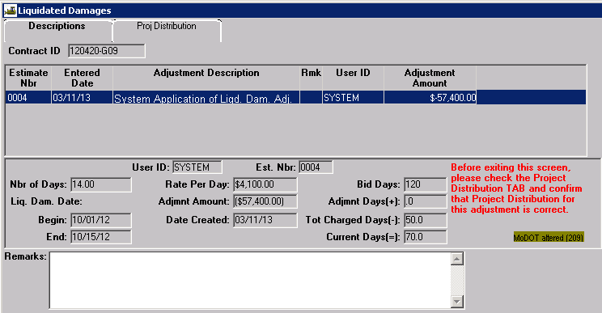
The “Begin” field displays the date liquidated damages began to be assessed. The “End” field displays the date liquidated damage charges ended for the estimate period.
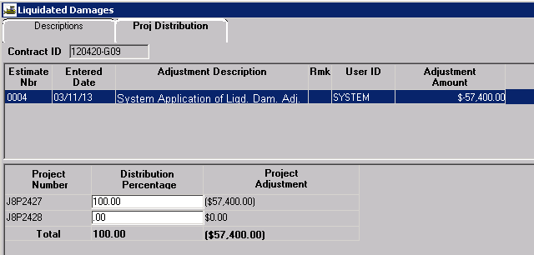
The Proj Distribution tab shows the percentage of the liquidated damage adjustment applied to each project on the contract. If there are multiple projects on the contract, MoDOT policy states that liquidated damages will be evenly distributed on all ACTIVE projects.
Note: System generated liquidated damages are not automatically distributed between projects. Therefore, it will be necessary for the user to make the adjustment on the Proj Distribution tab prior to estimate approval to properly distribute the damages as shown below. Total Distribution Percentage must equal 100%.
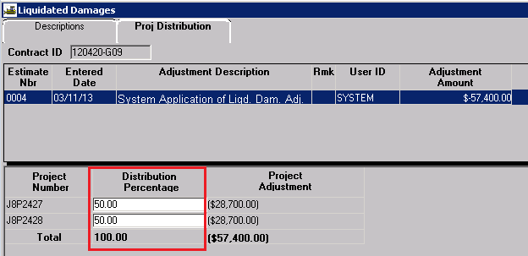

Creating a User Entered Liquidated Damage Adjustment
The system automatically charges liquidated damages based on dates entered in the system. Therefore, the user should only need to create a liquidated damage adjustment to remove liquidated damage charges from an estimate because a time adjustment change order has not yet been approved.
There must be an existing estimate in “Pending” or “Reject” status in order to create a liquidated damage adjustment.
Open the Liquidated Damages window. Select the New icon .
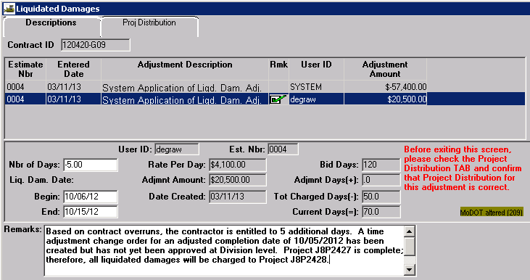
Nbr of Days: Enter the appropriate number of days. If days are being given back to the contractor, this must be a negative number.
Begin: Enter the date liquidated damage charges started.
End: Enter the date liquidated damage charges ended. If liquidated damages are still being assessed, enter the period ending date for the current estimate.
Remarks: Enter a detailed reason and/or documentation for the liquidated damage adjustment.
Select the Save icon.
Always select the Proj Distribution tab to verify percentages are correct for each project.
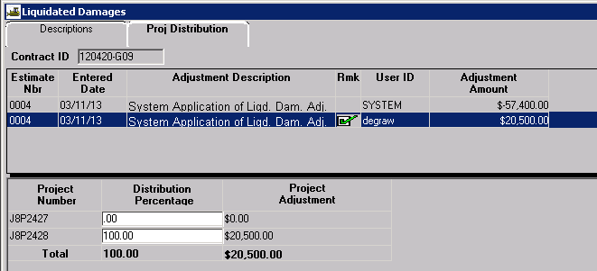

Important: Although system generated Liquidated Damage Adjustments are visible in the Contract Adjustments window, NEVER attempt to reverse liquidated damages from this window. Always use the Liquidated Damages icon!
