Copying Detailing Notes from the EPG to MicroStation Drawings
Locate the note needed in the EPG under 751.50 Standard Detailing Notes, highlight the desired note as shown below.
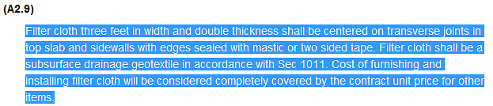

Right click and select copy or hit “Ctrl C” on your keyboard.

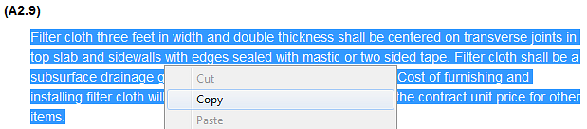

In MicroStation, open the Settings Manager with the “ ” icon, select Small Text (General) to open the Text Editor.

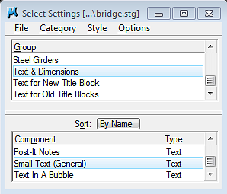

Paste the text copied from the EPG to the Text Editor by right clicking and selecting paste or hitting “Ctrl V” on your keyboard.

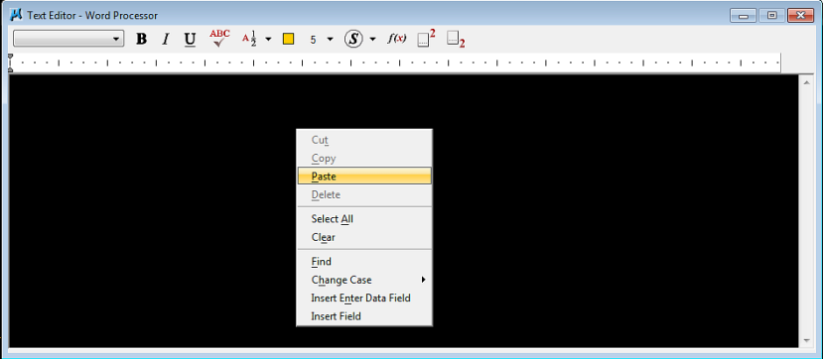

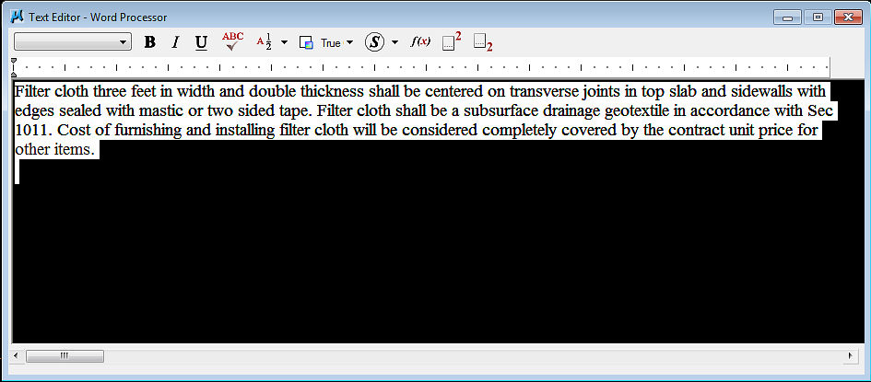

In the Text Editor window set the font type to MoDOT Eng. and the color to 5.

Option 1: Assimilateing text
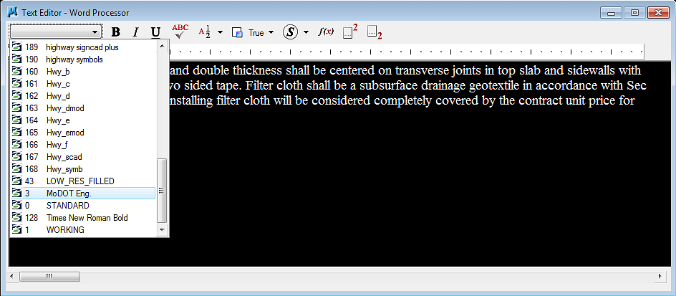

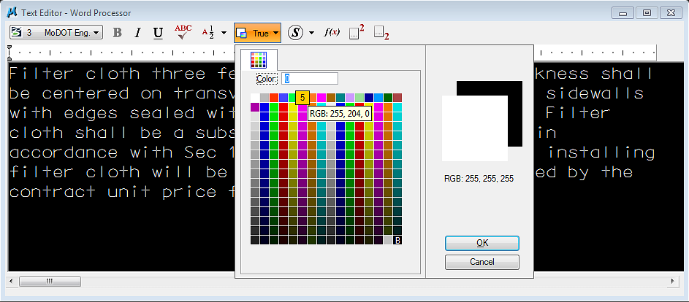

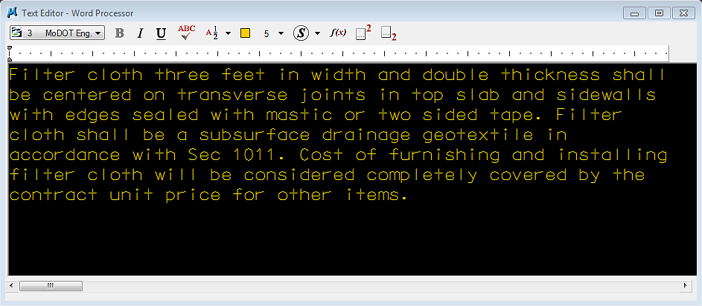

Option 2: Designating Text
You can also use the Change Element Attributes tool “ ” and the Change Text Attributes tool “ ” to change the format of the text copied from the EPG. Use the Change Attributes: SmartMatch tool “ ” to match the general text on the drawing.

Use the Change Element Attributes tool “ ” to change the attributes as shown in the Change Attributes dialog box below.

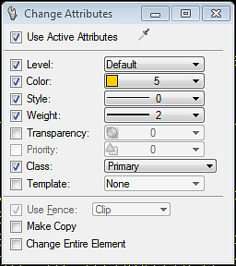

Use the Change Text Attributes tool “ ” to change the attributes as shown in the Change Text Attributes dialog box. below.

