Quick Reference Guide – Daily Work Reports

The Daily Work Report (DWR) is the inspector’s record of work performed on a contract. A DWR must be created each day the prime contractor and/or subcontractors are active and performing work on the contract, regardless of payment for the work performed. This article will guide the user in creating a Daily Work Report (DWR), using a DWR Template, copying a DWR, and creating a material sample from the DWR Work Items window.

Log on to SiteManager and navigate to Daily Work Reports – Daily Work Reports.  
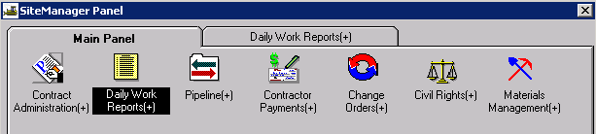

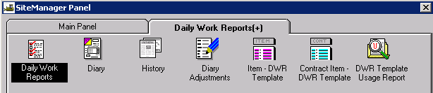

# DWR Info Tab

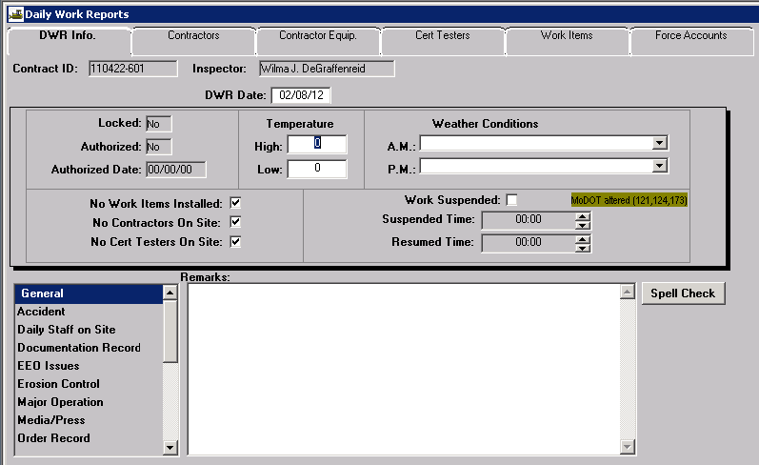

**Contract ID:** Select Services – Choose Keys to select contract.

**Inspector:** Automatically entered by system.

**DWR Date:** The date defaults to the current date. Double click the date field to select a different date using the pop-up calendar.

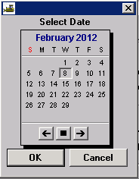

**Locked:** **A**utomatically entered by system.

**Authorized: A**utomatically entered by system.

**Authorized Date: A**utomatically entered by system.

**Temperature:** Enter the **High** and **Low** temperatures for the selected DWR date.

**Weather Conditions:** Select the appropriate **AM** and **PM** conditions from the drop downs.

**No Work Items Installed**: **A**utomatically entered by system.

**No Contractors On Site**: **A**utomatically entered by system.

**No Cert Testers on Site**: **A**utomatically entered by system.

**Work Suspended**: MoDOT does not use this field.

**Suspended Time**: MoDOT does not use this field.

**Resumed Time**: MoDOT does not use this field.

**Remarks**: Select the appropriate “Remarks Type” from the list to the left of the Remarks field. Type any necessary remarks. The DWR Remarks should be a complete, day-to-day account of all significant items relating to the project. The day of the week (Mon., Tues, etc...) is not indicated anywhere on the DWR. Some users record the day of the week at the beginning of each daily entry under General remarks. Multiple “Remarks Types” may be selected and entered for the day. Click the “Spell Check” button to run the spell check for remarks. (Sometimes Spell Check will go to the background when activated. If the DWR appears to be locked after selecting the Spell Check button, select both the “Alt” and “Tab” keys to move to the spell check.)

**Note**: The “Daily Staff on Site” remarks type may be used to document MoDOT personnel physically on the project or at a plant dedicated to the project for the selected date.

Save the information. Once saved, the Daily Work Report cannot be deleted.

# Contractors Tab

Navigate to the Contractors tab to add contractors, supervisors/foremen, and contractor personnel to the DWR. A contractor must be selected if items are to be entered on the Work Items tab.

With the focus in the top panel of the window, click the New icon. Select a contractor from the drop down list who was active on the project for the selected date.

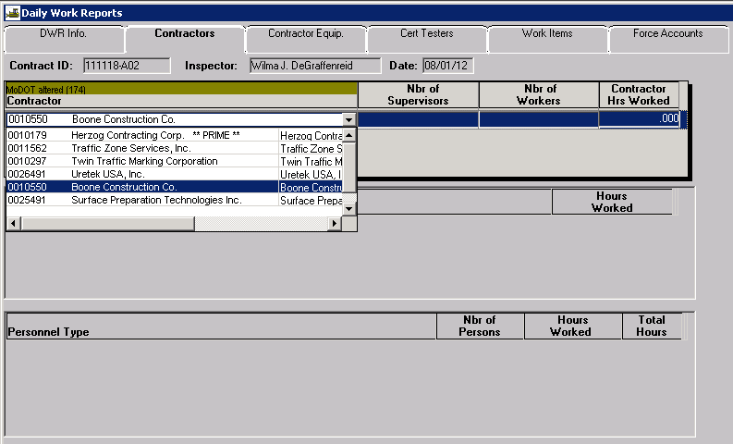

**Note:** If the selected contractor is classified as a DBE and a CUF review date has not been entered, this pop up message will appear to remind the inspector to complete a CUF interview and enter the date on the Description tab of the Subcontracts window.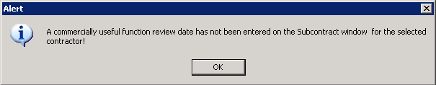   
  
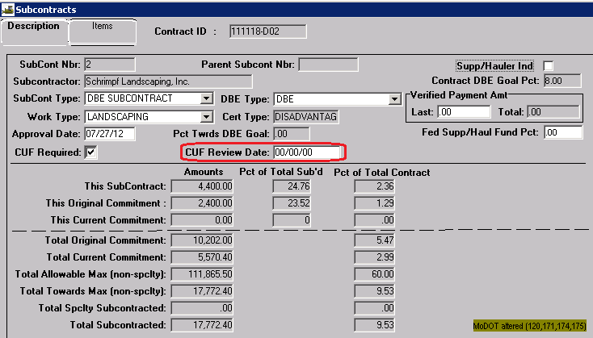

**Note:** It is not required that supervisor/foreman, personnel types, and equipment items be documented in SiteManager unless there is a potential for dispute, work that might warrant additional payment, or a delay in work for which MoDOT might be responsible. (See EPG 105.9.3)   
Proceed as directed below to document supervisors, personnel, and equipment.

**Nbr of Supervisors, Nbr of Workers,** and **Contractor Hrs Worked**: Do not enter anything in these fields. The system will automatically calculate these fields based on data entered in the Supervisor/Foreman Name and Personnel Type panels.

Place focus in the middle panel (Supervisor/Foreman Name) and click the New icon. Select the supervisor/foreman who was active for the selected date. If more than one supervisor/foreman worked, select the New icon to make an additional selection.

**Hours Worked**: It is not necessary to enter the number of hours each supervisor/foreman works unless special circumstances arise associated with possible claims or force account work.

Place focus in the lower panel (Personnel Type) and click the New icon. Select a personnel type (*e.g.*, laborer, operator, etc.) who was active for the selected date.

**Nbr of Persons**: Enter the number of workers for the selected Personnel Type.

**Hours Worked**: It is not necessary to enter the number of hours each supervisor/foreman works unless special circumstances arise associated with possible claims or force account work.

Select the New icon and repeat for each personnel type that was active for the selected date.

When all supervisors/foremen and personnel types have been added for a selected contractor, select the Save icon.

Place focus in the top panel and repeat the steps in this section to add all additional contractors who were active on project for the selected DWR date.

**Note**: The system will not allow a Save if there is a blank line in any area. Should an extra line be inadvertently added, simply highlight the blank line and click the Delete icon.

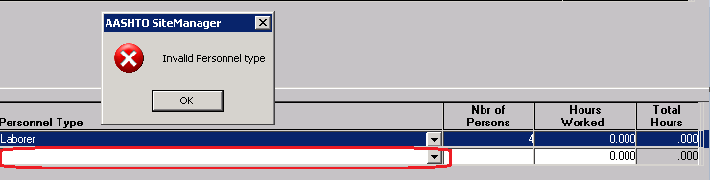

**Note**: Supervisor/foreman, personnel types, equipment items, or certified testers must be added to the Contract Master List before they can be selected. See this [QRG](http://epg.modot.org/files/5/57/Contract_Master_List.doc%20) to create or edit a Contract Master List.

# Contractor Equip Tab

Click the Contractor Equip. tab to add contractor equipment if necessary per EPG 105.9.3.

Select a contractor in the top panel. Place focus in the lower panel and click the New icon. Select a piece of equipment from the drop down list.

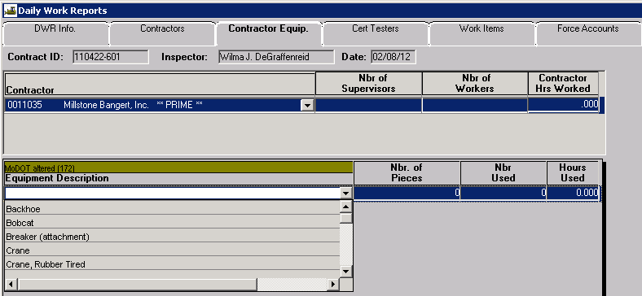

**Nbr. Of Pieces**: Enter the number of pieces of this equipment type on the project.

**Nbr Used:** Enter the number of pieces actually used for the selected date.

**Hours Used:** It is not necessary to enter the number of hours each piece of equipment is used unless special circumstances arise associated with possible claims or force account work.

Select the New icon and repeat for each piece of equipment used for the selected contractor. Save.

If equipment needs to be entered for additional contractors on the project, return focus to the top panel. Select another contractor, and repeat the steps in this section.

# Cert Testers Tab

Click the Cert Testers tab to add certified testing personnel to the contract.

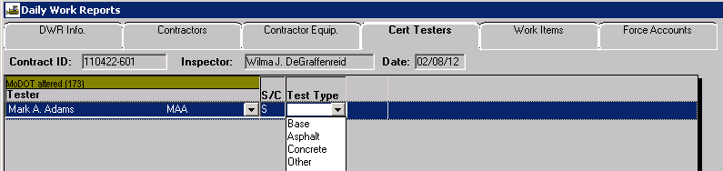

Click the New icon to add personnel, either MoDOT or contractor, who did materials testing for acceptance on the selected DWR date. Click the Test Type drop down to select the type of test.

# Work Items Tab

Click the Work Items. tab to open the list of work items for the contract.

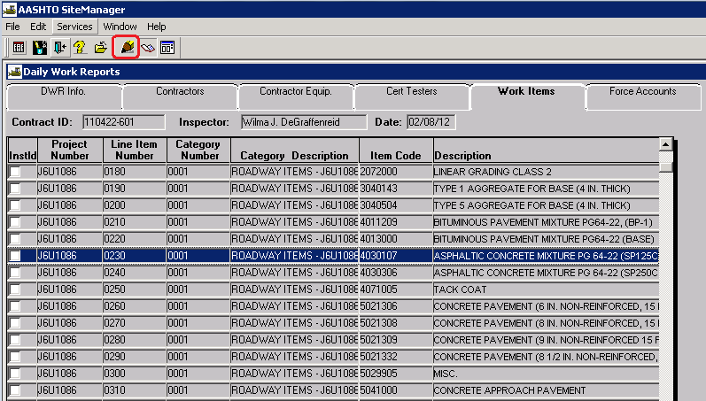

Highlight the item for which payment is to be made and click the “Record Work Item” icon  or simply double click the item. When the Record Work Item window opens, click the New icon.

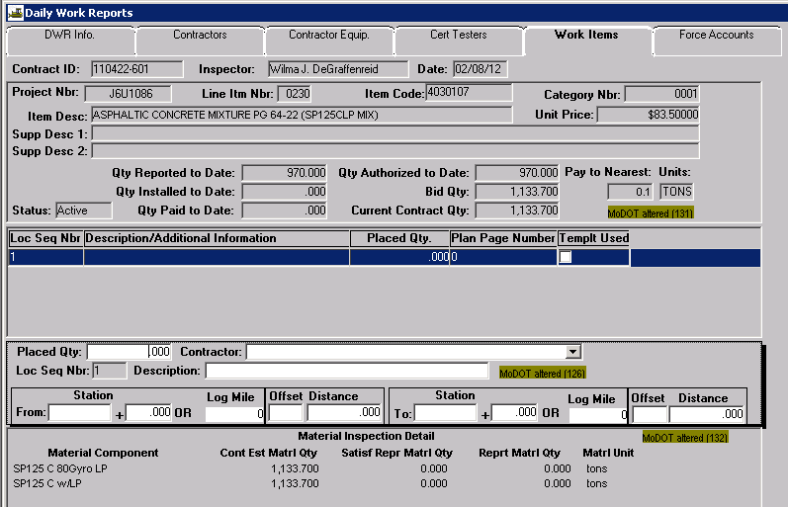

**Placed Qty**: Enter quantity being placed as this location.

**Contractor**: Select the contractor who performed the work from the drop down.

**Loc Seq Nbr**: Automatically entered by the system.

**Description**: Enter a description of where the work was placed.

**From/To (Station or Log Mile)**: Enter station or log mile designations.

**Offset**: Enter as appropriate.

**Distance**: Enter as appropriate.

**Note**: The system will allow a single station or single log mile designation for the placement of a feature that can be reasonably located with a single point, such as a construction sign. For work items that do not seem to have a specific location on the project, enter the project limits; *i.e.*, mobilization payments would apply to the entire job length.

If placement of the same pay item is made at multiple locations, the inspector should select the New icon for each separate entry. As many entries as necessary may be made, as shown below.

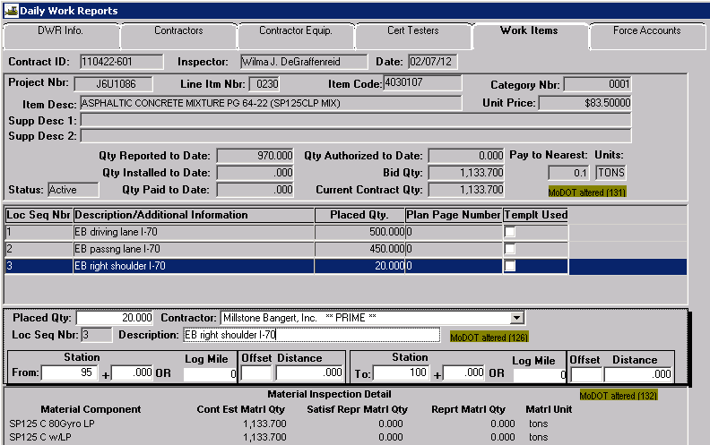

**Qty Reported to Date**: This field will update immediately upon saving.

**Qty Authorized to Date**: This field will update once the DWR is authorized on the Diary.

**Qty Installed to Date** and **Qty Paid to Date**: These fields will update once the contractors pay estimate has been approved.

Click the Select Work Item icon  to return to the list of work items. Repeat the steps in this section to pay for additional items.

# Paying for Construction Signs Using the DWR Template

There is one specialized template for the line items Construction Signs (Item Code 6161005) and Relocated Signs (Item Code 6161010) to help in documenting sign detail and location.   
When your project has Construction Signs or Relocated Signs please use this template.

On the Work Items Tab, select “Construction Signs” (or “Relocated Signs”) from the Select Work Item window.

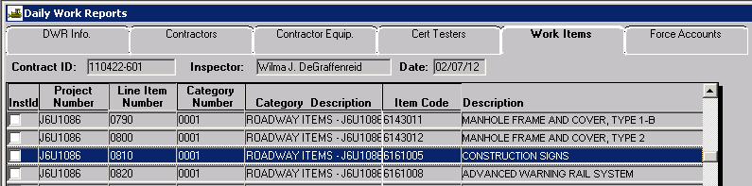

The Record Work Item window is displayed.

Select the Newicon, enter data for the following fields, and Save.  
a) Contractor  
b) Description -- Enter “DWR Template used”  
c) Stationing or Log Miles (this should be inclusive for all items to be entered on the DWR template)

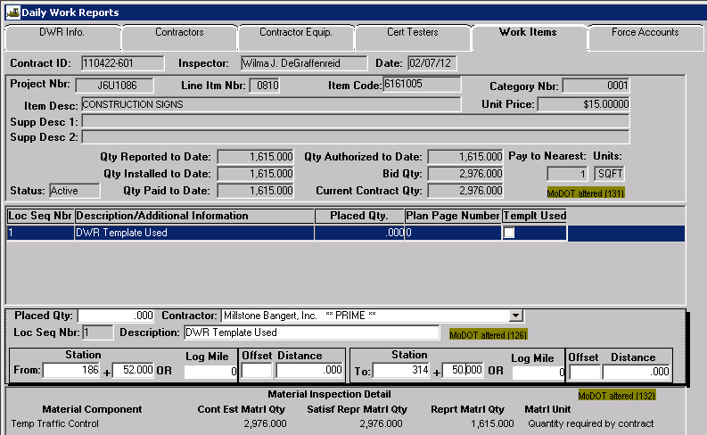

**Note:** Do not enter data in the Placed Qty field. Once data has been entered in the DWR template and saved, this field will be automatically populated.

Select the DWR Template icon.



The DWR Template panel will open to display a list of available templates for the selected item.

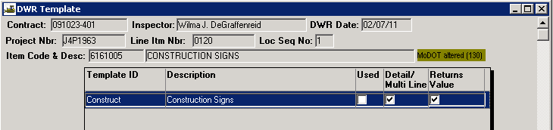

Double click the Construction Signs DWR Template or select the Record Template Data icon .

When the DWR Template opens, enter the appropriate data in the fields.

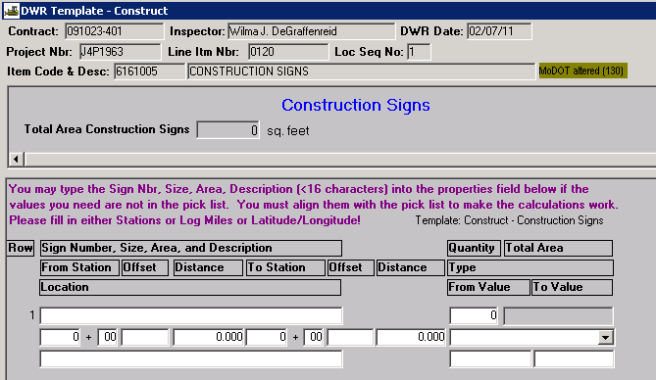

The Construction Signs template has a drop-down list from which to choose.



Select the Newicon [or File - New from the menu bar] to add additional construction signs. Rows may also be deleted by selecting the Delete icon. As each new row of data is added or deleted, the total for the item will automatically update in the DWR Template header.

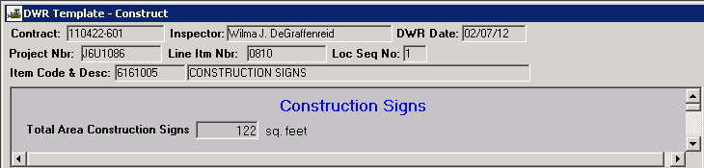

If using Log Mile option, select from the “Type” drop down and enter beginning and ending values in the appropriate “From/To Value” fields. If using GPS to document sign location, select the appropriate option from the “Type” drop down and enter latitude or northing coordinate in the “From Value” field and longitude or easting in the “To Value” field.

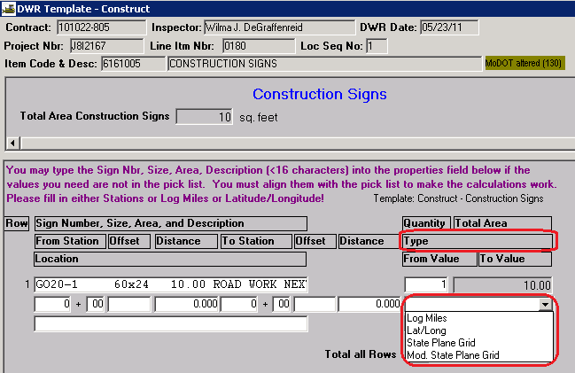

If the desired sign is not in the list, carefully follow the user instructions in **purple** to add the sign. Data must be properly aligned for the calculations to work.



**Hint:** It is helpful to activate the drop down list of signs to help to align information before adding special signs.

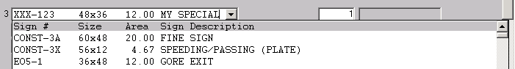

When all data has been entered in the DWR Template, click the Saveicon [or File-Save from the menu bar]. Click the Closebutton [or File-Close from the menu bar] to return to the Record Work Item window. The Placed Qty field is now populated with the value from the DWR Template header and the Templt Used box is checked.

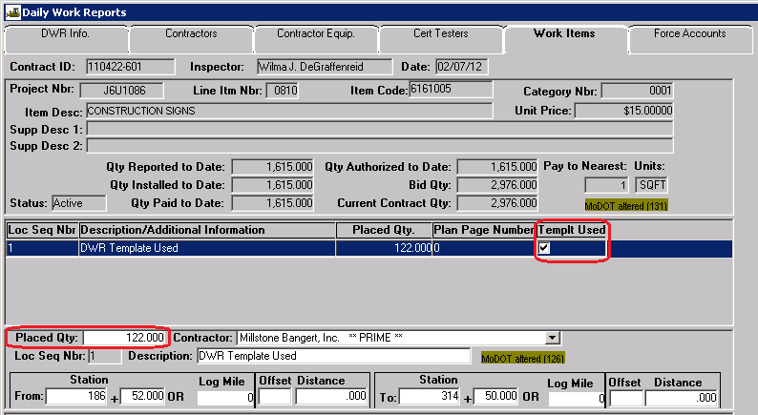

The ReportNet “Estimate Summary for Contract, by Est Nbr with DWR Template Details” will automatically pull DWR template data from SiteManager to meet documentation record requirements. Refer to the ReportNet Estimate Based Documentation Record QRG for additional information on documentation records.

# Material Inspection Detail

A brief Material Inspection Detail is located in the lower portion of the Record Work Items tab of the Daily Work Reports window.

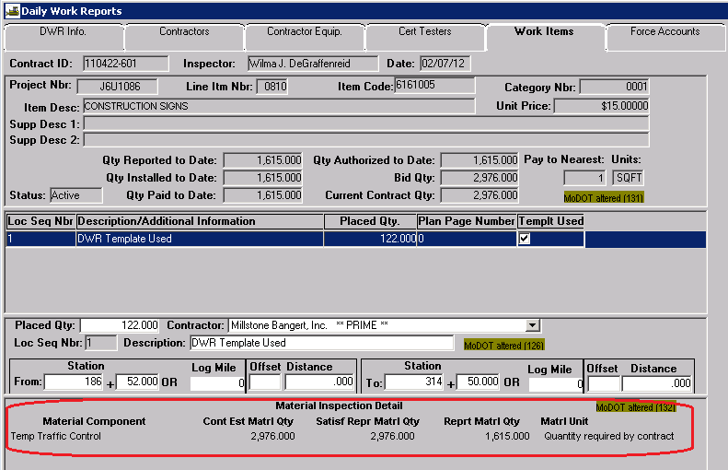

A more in-depth Material Inspection Detail is available by accessing "Open Material Inspection Detail" from the Services drop down menu or clicking the toolbar icon .

The **Material Inspection Detail** window contains the following panels:

1. Contract Item Information
2. Associated Material Components
3. Sampling & Testing Requirements



The Material Inspection Detail window will display contract item information from the DWR Record Work Item tab in the top panel.

The middle panel will display all contract materials associated with the item code. If Contract Sampling and Testing Requirements are defined for the material, the Contract S&T column will be checked. If samples have previously been created from the DWR window for the selected material, the DWR Sample column will be checked.

Selecting a Material Component in the middle panel will display associated sampling and testing requirements in the lower (third) panel. If contract sampling and testing requirements have not been defined for the selected material, this panel will be blank.

## View Material

To view Material Detail, select "View Material" from the Services drop down menu in the Material Inspection Detail window or click the toolbar icon .

The Material Detail window has three tabs – Description, Tests (showing test method and description), and Gradations (if they exist).



## Open Sample Window

To view sample records associated to the selected line item, select "Open Sample" from the Services drop down menu in the Material Inspection Detail window or click the toolbar icon .

If the sample record was created from the DWR Window, the DWR Sample check box will be selected. If the sample record was created from the Maintain Sample Information Window, the DWR Sample check box will be not checked.



Select the appropriate sample from the Select Sample Window and the sample record will open. If no samples have been created from the DWR window for the selected line item, the Select Sample Window will be empty.



# Creating a Sample Record from the DWR Window

To create a Sample Record for the selected item from the DWR window, select "Create Sample" from the Services drop down menu in the Material Inspection Detail window or click the tool bar icon .

SiteManager will open the Maintain Sample Information window for the selected material. Complete the Maintain Sample Information Window as instructed in **.**

**Note:** When creating a sample record from the DWR window, some information will be automatically populated on various tabs of the Maintain Sample Information window from information available in the Material Inspection Detail window as noted below.

* Material and Units on the Basic Sample Data tab



* The line item selected will be associated on the Contract tab. Additional line items may be associated if desired.



* Once test data is entered on the Tests tab, information indicating the sample was created from the DWR Window will be available on the Addtl Sample Data tab



# Force Accounts Tab

Because the Force Account functionality in SM does not meet MoDOT specifications, this tab is not used.

# Copying a Daily Work Report

After creating the first Daily Work Report for a contract, it is easier to copy the existing DWR than to create a new one from scratch.

The DWR to be copied must be selected using the Openicon .

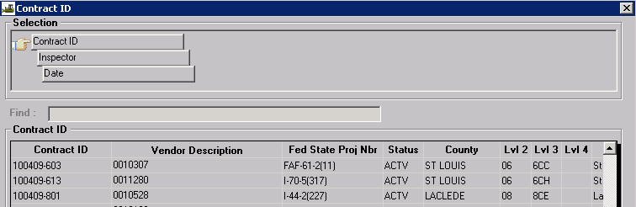

Select the Contract, Inspector, and DWR date for the DWR you wish to copy from the Contract ID selection window.

Double-click the Date field to display the calendar; select the date for the new DWR and click OK. The following message will appear. Click “Yes” to confirm the copy.



Information from the DWR Info tab (temperatures, weather conditions, and remarks), Cert Testers tab, and Work Items tab is NOT copied, as it typically changes from day to day. All data on the Contractors and Contractor Equip tabs will be copied to the new DWR. Any of this data may be edited to reflect changes that may occur from day to day. The inspector should verify that data is accurate before saving.