Request for Environmental Services (RES)

Instruction Manual

Missouri Department of Transportation

August 2022

Table of Contents
Section 1. Why is a Request for Environmental Services (RES) Needed? 1
Section 2. When Should a Request for Environmental Services (RES) be Submitted? 1
Section 3. How to Log in to the Request for Environmental Services (RES) System. 2
Section 4. How to Create a New Request for Environmental Services (RES). 7
Section 5. Request for Environmental Services (RES) - Environmental Screenings. 19
Section 6. How to Search for an Existing Request for Environmental Services (RES). 22

Figures
Figure 1. Environmental Policy Guide Link to the Request for Environmental Services (RES) Login Page. 3
Figure 2. Environmental Services Login Page. 3
Figure 3. Company Registration Page. 4
Figure 4. Add Representative and Add Projects. 5
Figure 5. Email Password Reset Request. 6
Figure 6. Reset Password. 6
Figure 7. Create New Request or Request Search. 7
Figure 8. Create New Request for Environmental Services (RES) – Select Stage. 7
Figure 9. No Previous RES is Available. 8
Figure 10. Alternative Project Delivery Method. 8
Figure 11. General Project Information Boxes – Required Fields. 9
Figure 12. Program Year Boxes – Required Fields. 10
Figure 13. Public Involvement–Required Field. 11
Figure 14. Bicycle/Pedestrian Consideration– Required Fields. 11
Figure 15. Saved RES Form Prior to Submission. 12
Figure 16. Add New Location Popup Box. 12
Figure 17. List of Project Locations included in RES. 12
Figure 18. Acres Boxes – Required Fields. 13
Figure 19. Land Disturbance/Stormwater Boxes – Required Fields. 14
Figure 20. Number of Displacements Boxes – Required Fields. 14
Figure 21. Average Daily Traffic – Required Fields. 15
Figure 22. Traffic Impacts – Required Fields. 15
Figure 23. National Flood Insurance Program and Hydraulic Design Data Boxes – Required Fields. 16
Figure 24. Known Concerns Boxes. 17
Figure 25. Upload Request for Environmental Services (RES) Attachments. 18
Figure 26. Submit Request for Environmental Services (RES) Form. 18
Figure 27. Incomplete submittal and what needs to be done. 19
Figure 28. Request for Environmental Services (RES) Environmental Screenings. 20
Figure 29. Request for Environmental Services (RES) Color Codes. 21
Figure 30. Resource Section Comment Boxes. 21
Figure 31. Link in Email to the Request for Environmental Services (RES) System. 22
Figure 32. Commitments section of the Request for Environmental Services (RES) System. 22
Figure 33. Summary table on the Parent form of the Commitments for each location 22
Figure 34. NEPA section of the Request for Environmental Services (RES) System. 23
Figure 35. Request for Environmental Services (RES) Search Page. 24
Figure 36. Request for Environmental Services (RES) Results Page. 24
Figure 37. National Environmental Policy Act Classification. 25
Figure 38. Missouri Department of Transportation Divisions and Offices. 25
Figure 39. Design Division Page. 26
Figure 40. Environmental and Historic Preservation Page. 26

Section 1. Why is a Request for Environmental Services (RES) Needed?
The National Environmental Policy Act (NEPA) is a federal law enacted in 1970 that requires federal agencies to consider environmental, cultural, and social impacts when making decisions related to funding, permitting, and constructing projects. Federal Highway Administration (FHWA) funding on MoDOT projects necessitates NEPA compliance.
The request for environmental services (RES) provides the required NEPA compliance information and NEPA classification so the FHWA, or the Missouri Department of Transportation (MoDOT) on behalf of FHWA, can meet and document its NEPA requirements.

Section 2. When Should a Request for Environmental Services (RES) be Submitted?
In general, there are four RES submittals for each project. These four RES submittals are summarized in the bulleted list below and are location/conceptual, preliminary plans, right-of-way plan, and final design. The RES submittals are based on major project milestones that require NEPA compliance prior to final design activities and land acquisition tasks. For more details on projects that may not require all four submittals, refer to the MoDOT Engineering Policy Guide (EPG) 127.1.1.2 Process.
- Location/Conceptual: An RES must be submitted at the location/conceptual stage for every project. This RES submittal should occur when the project is in the scoping section stage of MoDOT’s Statewide Transportation Improvement Program (STIP) to allow for optimal planning and prioritization of work. For very simple projects, NEPA approval might occur, for more complicated projects, it may occur during the next stage. Agency coordination may be ongoing at this stage. The district must submit the RES within 60 days of preliminary engineering obligation for all federal-aid projects.
- Preliminary Plans: The preliminary plans submittal is the most important of the four RES submittals and occurs when plans are far enough along for most field work and permitting to begin. At this stage, preliminary plans are approved, and the project moves to more detailed design. However, the district must obtain NEPA approval around 30 percent plan completion.
- Right-of-way Plan: An RES must be submitted at the right-of-way (ROW) plan stage for any projects involving acquisition of new ROW or easements. At this stage, design staff continue to monitor the project for changes in location and scope. The district must obtain NEPA classification before ROW acquisition can begin. At this stage, all permits and/or approvals should have been received or requested.
- Final Design: An RES must be submitted at the final design stage for every project. At this stage, all environmental and historic preservation concerns are addressed, and all permits and/or approvals have been obtained to enable project letting. The final design RES must be submitted at least 60 days before plans, specifications, and estimates (PS&E) are due to enable any last-minute permits or clearances time to be obtained.
NEPA classification and approval can be made when the screenings for cultural resources, threatened and endangered species, noise, and public land impacts are cleared by the MoDOT environmental specialist, and when the public involvement requirements are met. Coordination with other agencies (e.g., State Historic Preservation Office [SHPO], U.S. Fish and Wildlife Service [USFWS], Missouri Division of State Parks) may be required before these environmental resources can be cleared by MoDOT environmental and historic preservation staff.
Each Parent RES must have at least one location form filled out. A separate location form is required for each location that has logical termini and independent utility. For example, if a project number has 3 discreet bridge locations, three location forms are required. If a project has resurfacing but all routes are touching each other, one location form can be filled out. If there are two bridges, but they are directly adjacent to each other, one location could be filled out. Another way to look at the discreet locations is whether you could construct one location independent of the other location.
The program delivery requirement has not changed, projects still require an RES submittal for each job number (Loc/Con and Final at the least, all phases if ROW or easements are required). Jobs in required combination are not influenced by this system.

Section 3. How to Log in to the Request for Environmental Services (RES) System.
Logging in to the RES system is slightly different for MoDOT employees than for those logging in externally (e.g., a consultant). The internal and external login processes are described in detail below.
MoDOT Employee Login:
MoDOT employees will log in with their system user identification and password and will then select “MoDOT” (MoDOT employees do not need to register).

External Login
Non-MoDOT employees can log in to the RES system using the following steps:
- Click the “Request for Environmental Services (RES)” link located in the EPG Section 127.1.1.1 (Figure 1) to access the environmental services login page (Figure 2).
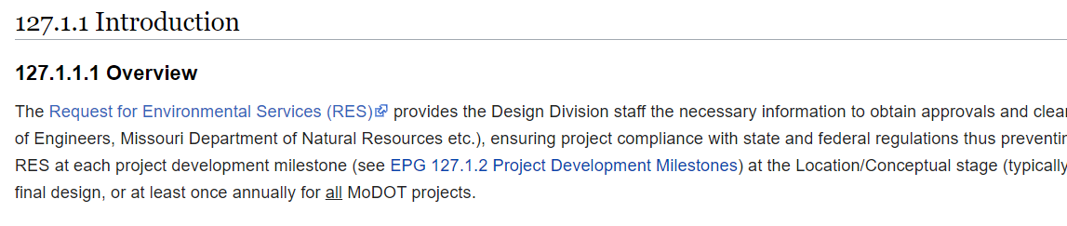
Figure 1. Environmental Policy Guide Link to the Request for Environmental Services (RES) Login Page.

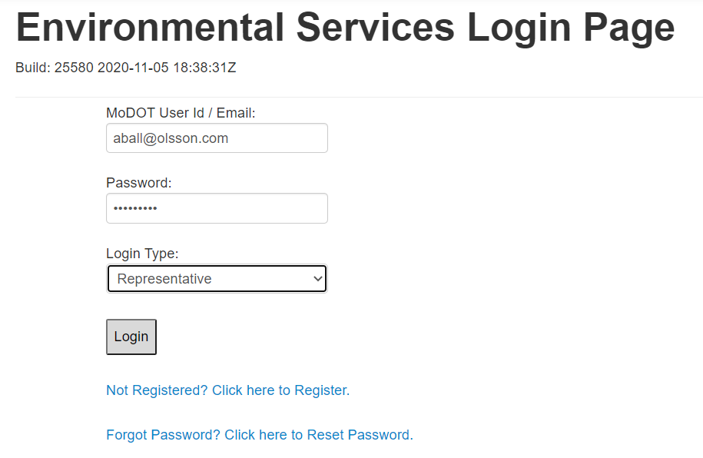
Figure 2. Environmental Services Login Page.
- If your company has not been registered, please click on the “Not Registered? Click here to Register” link (Figure 2) and complete the registration section for your company (Figure 3). If you are not certain whether your company has been registered, call or email the contacts provided at the end of this manual for further assistance.
- NOTE: If your company has registered in the RES system, contact your company administrator to add you as a representative.
- NOTE: When adding your company to the system for the first time, please select a member to be the administrator of the RES system. Having more than one administrator for a company will confuse the system. Take care to enter your information correctly the first time. The system may not allow for editing the RES forms if the information has been entered incorrectly.
- Enter the company, city, or county information in the “Company Name” box and then fill out the remaining information for the entity and create a password. Click “Register” (Figure 3).
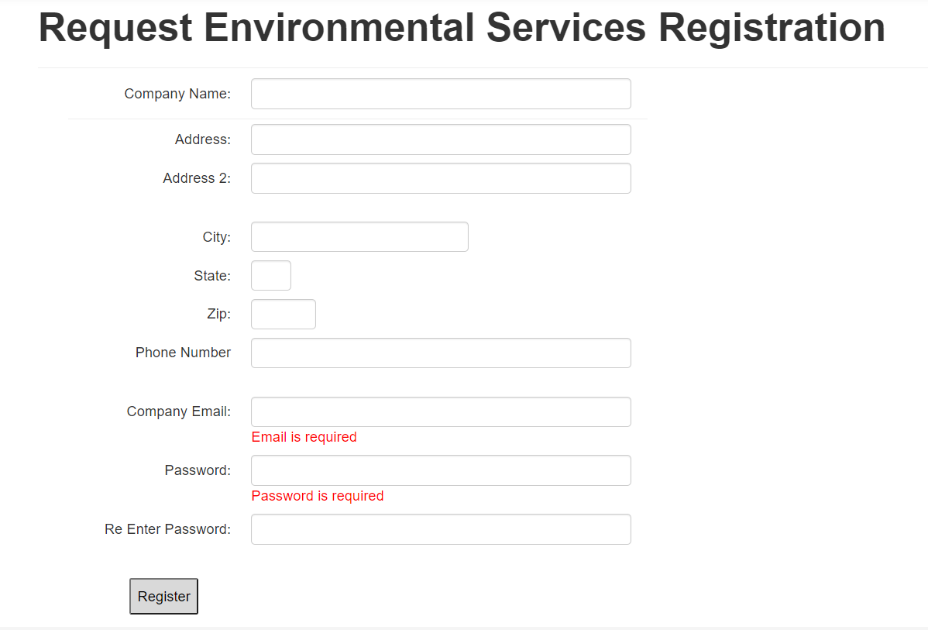
Figure 3. Company Registration Page.
- Within a company, city, or county, individuals working on RESs must be registered as representatives. To add representatives (Figure 4), the administrator must complete the company information and then add themself and any others as representatives who will need access to process, review, and edit projects for submittals to MoDOT. The administrator is required to add representatives here to edit/view/create the RES form. Even though the administrator is registered, they must add themself as a representative and add projects so they can edit/view/create an RES form.

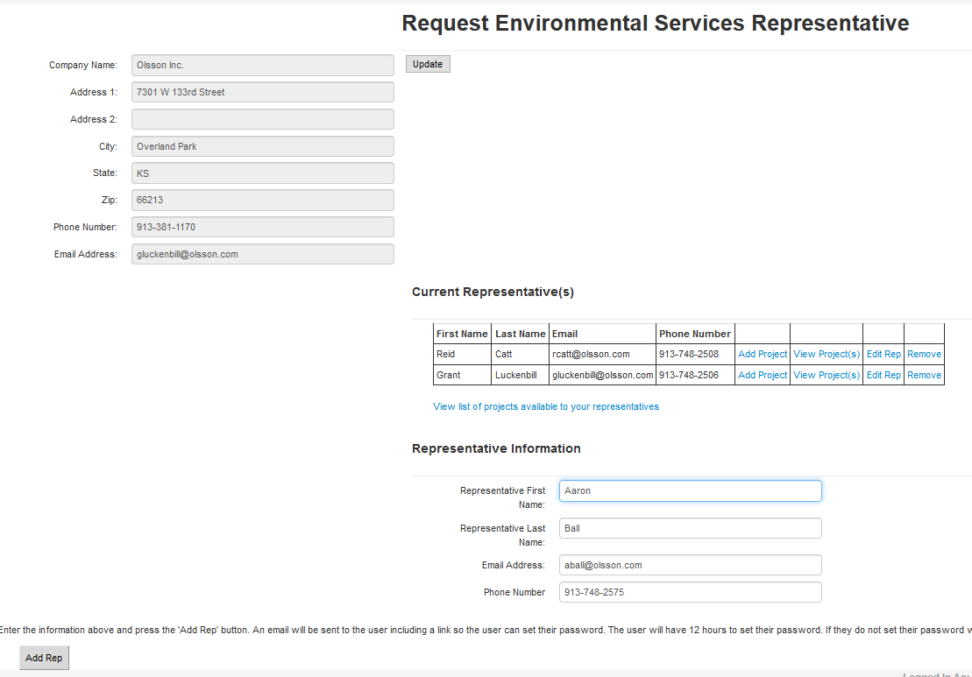
Figure 4. Add Representative and Add Projects.
- Only an administrator can add projects to a representative (Figure 4). For example: John and Jane need to view the same project. Therefore, the administrator must add this project under John and Jane as representatives so they both have the ability to edit/view/create the RES form.
  - NOTE: If you create an RES form and do not see the form you created after saving it, you likely have not had the project added under your representative contact on the administration page for your company.
- Once all the representatives are added to the “Current Representative(s)” section (Figure 4), the administrator can log off to exit the system. The administrator must log off as administrator and log back in as a representative to see projects assigned to them.
- Each representative must create a password. When an administrator creates a new representative (as described in the previous steps), the representative will be sent an email with a link to create a password (Figure 5). The link provided in the email will lead the representative to a page that can be used one time to set a new password (Figure 6). The representative cannot log in to the RES system until a new password is created. The link provided in the email will be active for 12 hours after the representative account is created. If a password is not set within the 12-hour window, the representative must use the “Forgot password? Click here to Reset Password” link on the RES login page (Figure 2, above). If the representative’s email is not already in the RES system, the site will refer the representative to the company administrator.
  - NOTE: If an administrator or representative forgets a password, that person can go to the “Forgot password? Click here to Reset Password” link provided on the RES login screen (Figure 2, above). When the administrator or representative requests a new password, a link will be emailed, similar to the email generated to create a password for a new representative (Figure 5). That email will contain a link to a page where the password can be reset. Again, the link will be active for 12 hours. If the individual cannot set a password within that 12-hour window, the person must go to the “Forgot password? Click here to Reset Password” page again to generate another 12-hour link.

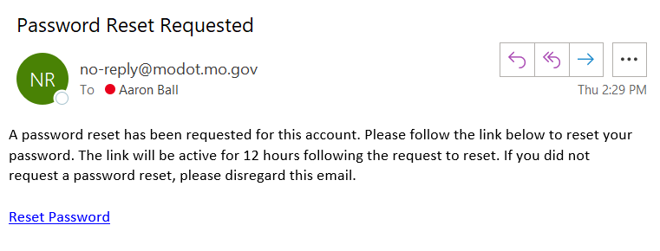
Figure 5. Email Password Reset Request.

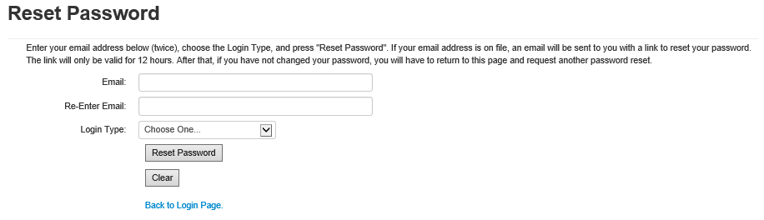
Figure 6. Reset Password.

- Once the representative has successfully created or changed the password, he or she will be able to “Create New Request” or “Request Search” (Figure 7) in the RES system for projects that have been assigned to that representative. Representatives will be able to review and/or edit only projects and RES forms assigned to them (see step number 5).
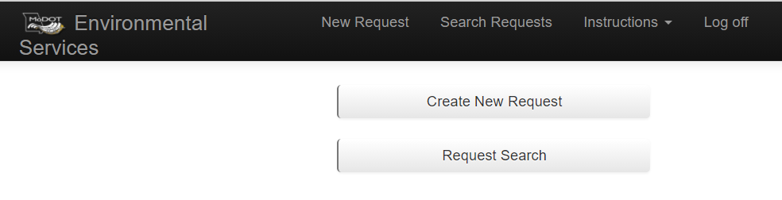
Figure 7. Create New Request or Request Search.

Section 4. How to Create a New Request for Environmental Services (RES).
A new RES can be created in the RES system by either MoDOT or by an external user. Steps outlining how to create a new RES are provided below.
- To create a new RES, log in to the RES system using the steps outlined in Section 3, and select “Create New Request” (Figure 7, above).
- Under “Stage” (Figure 8), select “Location / Conceptual,” “Preliminary Plans,” “Right of Way,” or “Final Design.”
- Under “Job Number” (Figure 8), enter the job number for the RES and click “Find Previous RES”. If there is not a previous RES, then click “Find Previous RES” without typing a Job Number and select “None Found” (Figure 9). 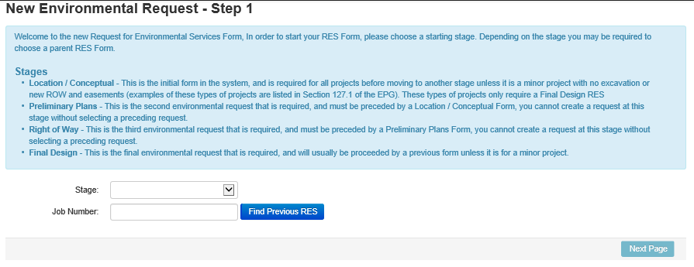
Figure 8. Create New Request for Environmental Services (RES) – Select Stage.
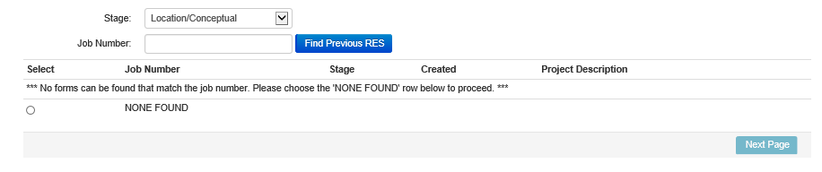
Figure 9. No Previous RES is Available.
- If the RES includes an Alternative Project Delivery Method (such as design/build), check the box shown in Figure 10 indicating the project is going to be delivered with a design-build method instead of design-bid-build method.
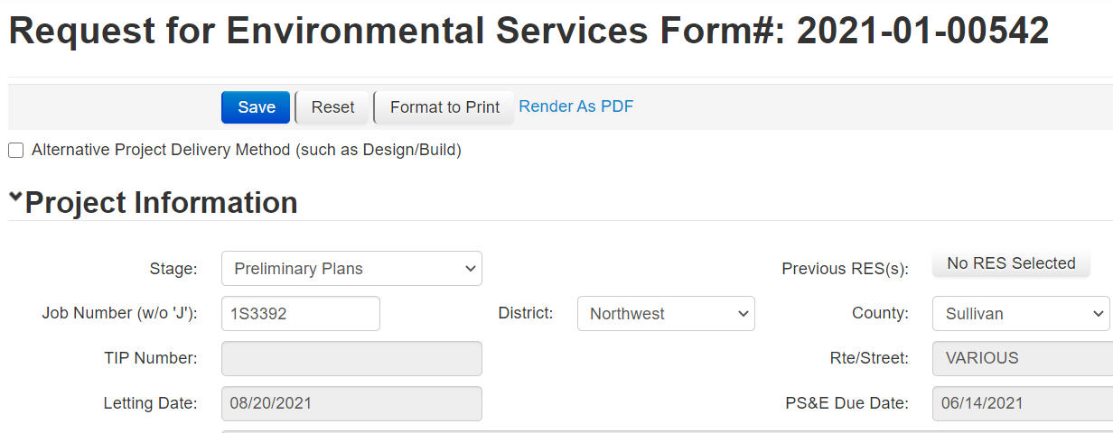
Figure 10. Alternative Project Delivery Method.
- Complete the blank RES Project Information boxes shown in Figure 11 (detailed below). Note: If you entered a previous RES, then the boxes will auto populate.
  - Job Number (w/o ‘J’): Enter the job number (without the “J”) that was provided by MoDOT. The job number should pop up when entered and should be selected to autopopulate information. If the job is currently programmed in the STIP, the information in the grayed boxes in Figure 11 should autopopulate.
Note: If the job number is not currently in MoDOT’s Statewide Transportation Improvement Program (STIP), you can still create a RES by using County/Route (e.g., COLE54E) in the job number box until the job is added to the STIP, then the Environmental office can edit the job number at a later date.
  - District: Select the appropriate MoDOT district for the project.
  - County: Select the county where the project is located. If more than one county is associated with the job number, select “Various” to indicate multiple counties.
  - Contact Information: Provide the names of the MoDOT project manager, MoDOT District Contact, MoDOT Transportation Project Designer (TPD), and Contact (such as consultant) associated with the project.
  - Date Desired/Submit Date: The date desired is autopopulated based on the submit date (standard time frame is 30 days from RES submittal). Any “Date Desired” less than 30 days from the RES submittal will be flagged as an “Emergency Request” by the RES system.
  - Desired A-Date: Indicate the “Desired A-Date” (date anticipated to start the ROW acquisition process) so that environmental staff may prioritize work. Be reasonable about the timeline.
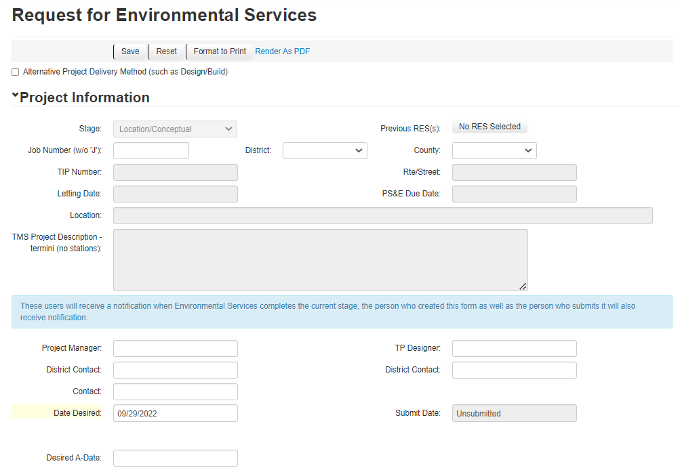
Figure 11. General Project Information Boxes – Required Fields.

- Complete the blank RES “Program Year” boxes shown in Figure 12 (described below).
  - Preliminary Engineering/Right-of-way/Construction dates: Indicate anticipated dates of preliminary engineering obligations, ROW acquisition, and construction of the project.
  - Independent Utility and Logical Termini: This answer should always be “Yes.” All FHWA-funded projects must have independent utility and logical termini to satisfy 23 CFR regulations. Projects must also not restrict consideration of alternatives for other reasonably foreseeable transportation improvements.
    - NOTE: Independent utility is determined if a project can be constructed absent of the construction of other projects in the area. Logical termini are rational endpoints of a sufficient length for transportation improvements and environmental review. See EPG 127.14.1 for more detail.
    - If there is more than one discreet location entered on the location forms, it is assumed the district has documented that each location has logical termini and independent utility.
  - Changes to project since last RES submittal: If yes is chosen, indicate any changes since the last RES submittal and provide a detailed explanation.
  - Cumulative ROW and Easements of all locations (acres): This is a required field and is expected to be the total ROW and easements for the entire project, all locations added together.
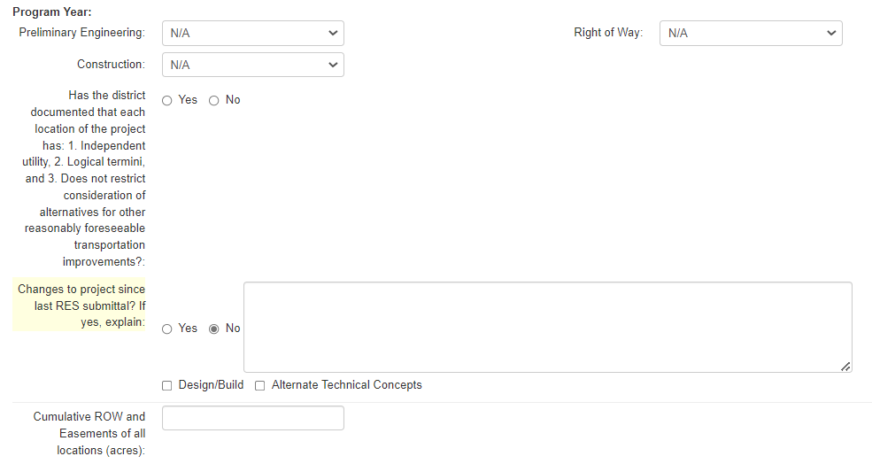
Figure 12. Program Year Boxes – Required Fields.
7. Any Public Involvement Planned or Completed: Provide information about public involvement that has been completed, or is anticipated to be completed, as part of the project. The required level of public involvement is related to the anticipated NEPA classification for the project. For examples of acceptable forms of public involvement for different NEPA classifications, refer to the EPG 129 Public Involvement.
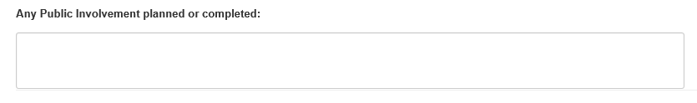
Figure 13. Public Involvement–Required Field.
- Complete the blank RES “Bicycle/Pedestrian Consideration” boxes shown in Figure 18 (described below).
  - Pedestrian facilities considered: Using the drop-down menu, select “Yes” if pedestrian facilities were considered.
  - Bicycle facilities considered: Using the drop-down menu, select “Yes” if bicycle facilities were considered.
Figure 14. Bicycle/Pedestrian Consideration– Required Fields.
- After the PARENT RES form has been completed and saved, the submitter will be returned to the top of the form (Figure 15). Once saved, the RES form will be displayed to the submitter as a draft form, but the form will not be sent to the Environmental Specialists, the “Submit Request to Env. Servies” must be selected for it to be sent. This allows the creator to make additional updates/edits before submitting. If only “Save” is selected, incomplete required fields will not be identified. When “Submit Request to Env. Services” is selected, a popup box will identify any incomplete required fields to the submitter so these can be completed prior to submission. At least one location must be created to submit the form.
  - Attachments can be added to the Parent form that apply to all locations, such as plan sheets or a kmz.

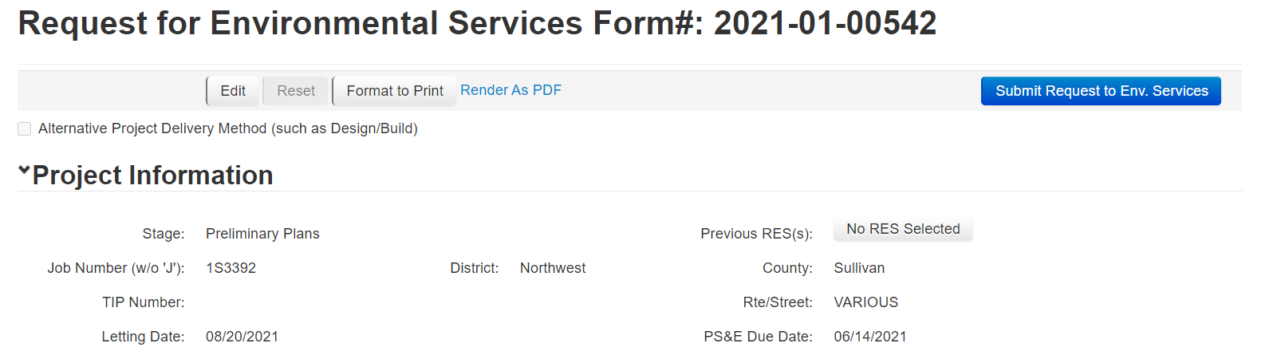
Figure 15. Saved RES Form Prior to Submission.
- Each independent location, with logical termini, is entered at the bottom of the Parent form in the green box by clicking “Add Location to this Request.” A box will popup (see Figure 16 below) where you name the location, hit “Add New Location”. Naming the location using something easily identifiable, like bridge number, makes it easier to track later.
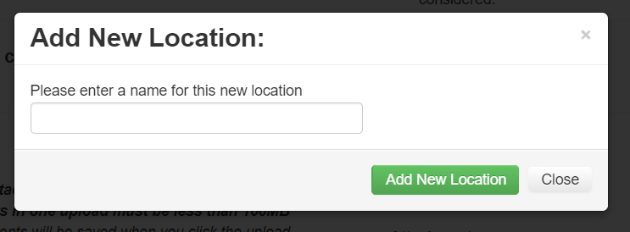
Figure 16. Add New Location Popup Box.
Then the submitter will be returned to the parent form. Scroll to the bottom of the parent form to click on the location just entered (Figure 17). A newly added location will be highlighted yellow, indicating information is missing. You must fill out the location specific form(s) to submit the RES.

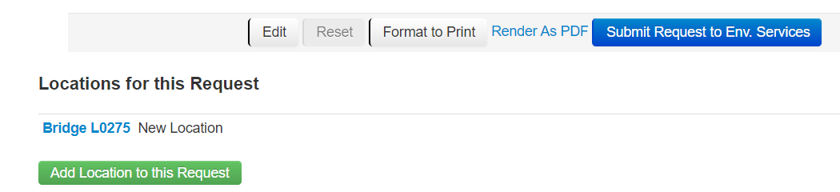
Figure 17. List of Project Locations included in RES.
- Click Edit inside the location form – required fields are highlighted. Attachments can be added on this edit screen and when the form is saved, the attachment will be uploaded.
- Describe RES Project Improvements in Full Detail: Provide a detailed description of the project at the location being entered.
- Project breakout from previous or larger project: Check this box and provide a detailed explanation if the project is a breakout from a previous or larger project. If checked, also indicate how the project meets the independent utility criteria described above.
- Complete blank RES “Acres” boxes shown in Figure 18(described below). This is acres per this specific location, not the total of all locations. If there is only one location, it is the total acreage.
  - Additional ROW/Temp Easement/Permanent Easement: Indicate the amount of new ROW, temporary easement, and permanent easement that will be taken at this specific location. If the exact amounts of ROW and easements are unknown at the time the RES is created, overestimate the acreage of each and then refine these amounts in subsequent RES submittals as the project develops.
  - ROW may be needed, but not yet determined? Choose “Yes” if there is a potential need for new ROW, but the need has not been definitively decided at the time of the RES submittal.
  - Acres of Tree Clearing: Indicate the acres of tree clearing associated with the project. Tree clearing is defined as any clearing of woody vegetation greater than or equal to 3 inches diameter. The amount of tree clearing indicated in this box must match other documentation associated with the project (e.g., threatened and endangered (T&E) species assessment). Trees cannot be cleared without MoDOT’s prior written approval.
  - Is ANY federally owned land affected by the project? This should be checked “Yes” if the project will affect any federally owned land through construction, land acquisition, or other activities. Then identify the agency.
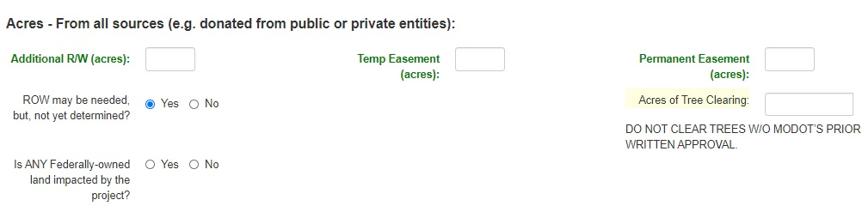
Figure 18. Acres Boxes – Required Fields.
15. Complete blank RES “Land Disturbance/Stormwater” boxes shown in Figure 19 (described below).
  - Will project involve 1 acre of land disturbance? Check “Yes” if the project will disturb 1 acre of land or more. Projects that disturb 1 acre of land or more must comply with Land Disturbance Permit requirements.
  - Define project type: Indicate whether the project is a new development, redevelopment, or maintenance project. Definitions of these three project types are provided in the RES form. If an element of the project is considered new development or redevelopment, then the entire project shall be classified as such.
    - NOTE: New development or redevelopment projects must consider implementing permanent water quality best management practices (BMPs) to treat stormwater runoff due to increased impervious surfaces from the development project.
  - Was coordination with adjacent MS4 communities conducted? Indicate “Yes” if coordination with the adjacent MS4 community has been conducted and provide a description of the coordination in the dialogue box. File:127.29.8 map 2017.jpg - Engineering_Policy_Guide (modot.org)
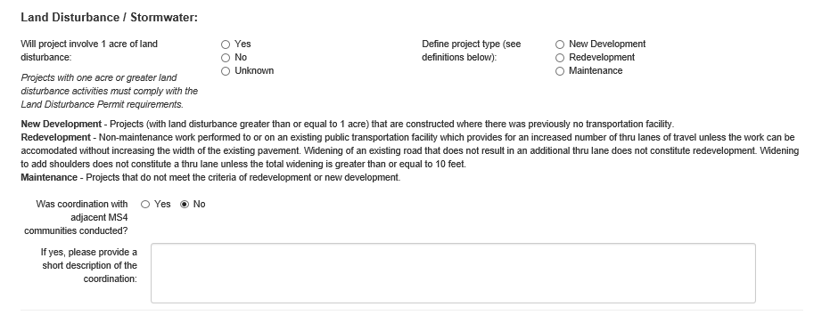
Figure 19. Land Disturbance/Stormwater Boxes – Required Fields.
16. Complete blank RES “Number of Displacements” boxes shown in Figure 20 (described below).
  - Residential and Commercial Displacements: Choose “Yes” for either of these categories if the project will result in a displacement. If “Yes” is checked for residential or commercial displacements, provide the number of people/number of residences or number of employees/number of businesses affected in the corresponding boxes.

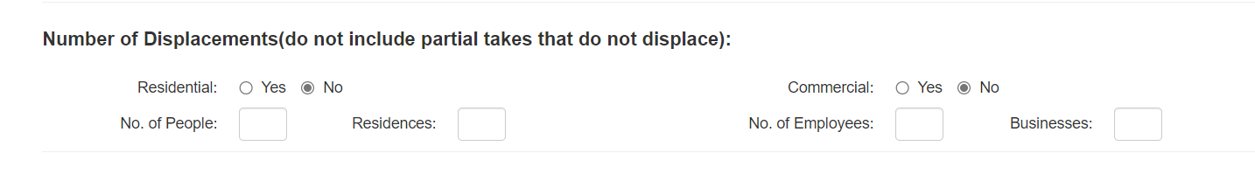
Figure 20. Number of Displacements Boxes – Required Fields.
17. Complete the blank RES “Average Daily Traffic” (ADT) boxes shown in Figure 21 (described below).
  - ADT Construction Year: If applicable to the project, indicate the ADT of the roadway for the construction year (see Step 5) that will be affected by the project.
  - ADT Design Year: If applicable, indicate the ADT of the roadway for the design year (see Step 5).
Figure 21. Average Daily Traffic – Required Fields.
18. Complete the blank RES “Traffic Impacts” boxes shown in Figure 22 (described below).
  - Road/Bridge Closure Planned: Choose “Yes” if a bridge or road will be closed for any length of time during construction of the project.
  - Days/Months Closed: If applicable, indicate how long the road or bridge will be closed including if the units are days or months. If length of closure is uncertain at the time of the RES submittal, overestimate the closure length.
  - Detour > 25 miles rural: Choose “Yes” if there is a detour in a rural area that is greater than 25 miles. The detour routes can include local and state roads.
  - Detour > 5 miles urban: Choose “Yes” if there is a detour in an urban area that is greater than 5 miles. Urban is defined as U.S. Census Bureau designated urbanized area or an urban cluster. The detour routes can include local and state roads.
  - Detour Info (including use of local roads): Include details about the proposed detour route. Explain the proposed detour route(s) including names of federal and state roadways, number of miles, and approximate length of time to drive the detour route(s). Describe how the public will be notified of the detour and how far in advance of construction, how access to residences and businesses will be maintained by the detour, and whether any sensitive populations (minority, linguistically isolated, low-income) could be negatively affected by the road/bridge closure and detour.
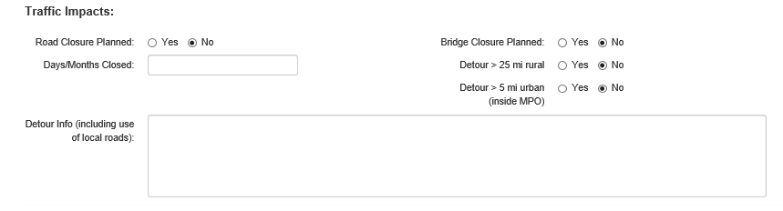
Figure 22. Traffic Impacts – Required Fields.

19. Complete the blank RES “National Flood Insurance Program (NFIP) and Hydraulic Design Data” boxes shown in Figure 23 (described below).
  - Project is in a FEMA-identified zone “subject to 100-year flooding”: If the project is located in the 100-year floodplain, check this box. Indicate the zone in the box to the right of the check box. If the project is not in the 100-year floodplain, leave this box and fillable box for flood zone blank.
  - Project is in a FEMA-defined “floodway”: Use the drop-down menu to indicate if the project is (or is not) located in the regulatory floodway.
    - NOTE: Projects that are located in the regulatory floodway are also located in the 100-year floodplain.
  - Project involves land purchased through FEMA Hazard Mitigation Grant Program (Flood buyout property): Check this box and provide details if any portion of the project, including new ROW or easement areas, were acquired through the FEMA/State Emergency Management Agency (SEMA) buyout program. For more details on buyout lands and how they may impact project timelines, see EPG 127.21.
  - Is highway improvement located within 4 miles of an existing airport? Check this box if the project is within 4 miles of an existing and operational airport that is open for public use. If checked, additional clearances from the Federal Aviation Administration (FAA) may be required for the project. This process and clearance information will be added to the “Other” resource box filled out by the Environmental and Historic Preservation section. Ensure documentation is uploaded to e-Projects.
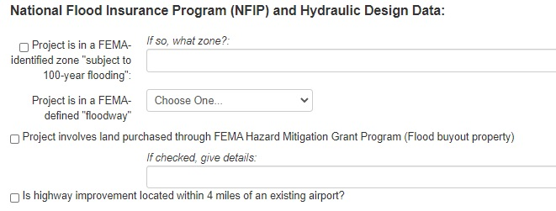
Figure 23. National Flood Insurance Program and Hydraulic Design Data Boxes – Required Fields.
20. Complete the blank “Known Concerns” boxes, shown in Figure 24, as applicable to the project. This section allows the representative to provide more detailed information about the resources the core team has knowledge of in the project area. These boxes are not required fields, but information provided will assist environmental staff in completing a more thorough and timely review of the project.

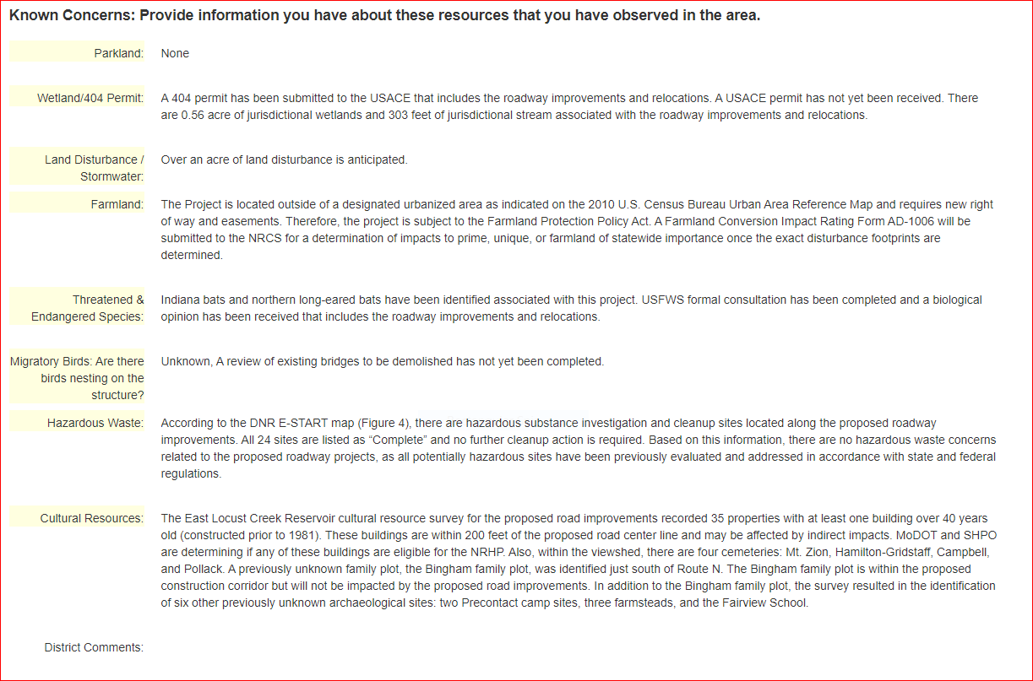
Figure 24. Known Concerns Boxes.
21. Using the “Choose File…” button (Figure 25), select plans, maps, pictures, or any other electronic documents for the RES form. For efficiency, multiple files can be selected at once. Attachments will be saved the same time the form is saved. It is not required to have an attachment on the Parent form, but it IS required on the specific location forms.
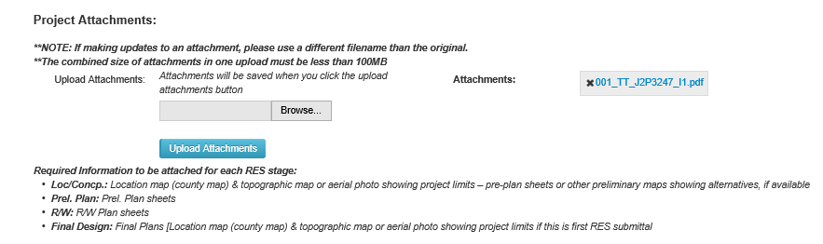
Figure 25. Upload Request for Environmental Services (RES) Attachments.
22. After the RES location form has been completed and saved, the representative will be returned to the top of the location form (Figure 26). If information is missing it will be displayed at the top of the form in a red box.
23. Click “Return to Parent Request” at the top of the location form. Repeat these steps for each discreet location.
24. Click “Submit Request to Env. Services” to submit the RES Parent form (Figure 26) and generate an automated email that will be sent to the appropriate MoDOT environmental and historic preservation specialists assigned to the project. A green box at the top of the RES will be displayed noting the request was successfully submitted. The automated email will provide staff with a link to the RES form. If the RES form is saved and closed but was not submitted, the RES will be considered and saved as a “draft” and will not be sent to MoDOT specialists for review. This allows the representative to return to the RES form to continue editing before submitting the RES form.
Figure 26. Submit Request for Environmental Services (RES) Form.

If after clicking the “Submit Request to Env. Services” button the system does not allow the RES to be submitted, it is usually because some of the required fields are not filled out or completed. A popup box will describe the incomplete items (Figure 27).
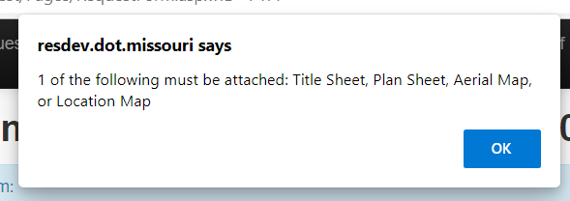
Figure 27. Incomplete submittal and what needs to be done.

Section 5. Request for Environmental Services (RES) - Environmental Screenings.
The MoDOT environmental and historic preservation specialists will review the RES resource sections based on the project information provided by the district and/or consultant (Figure 28).
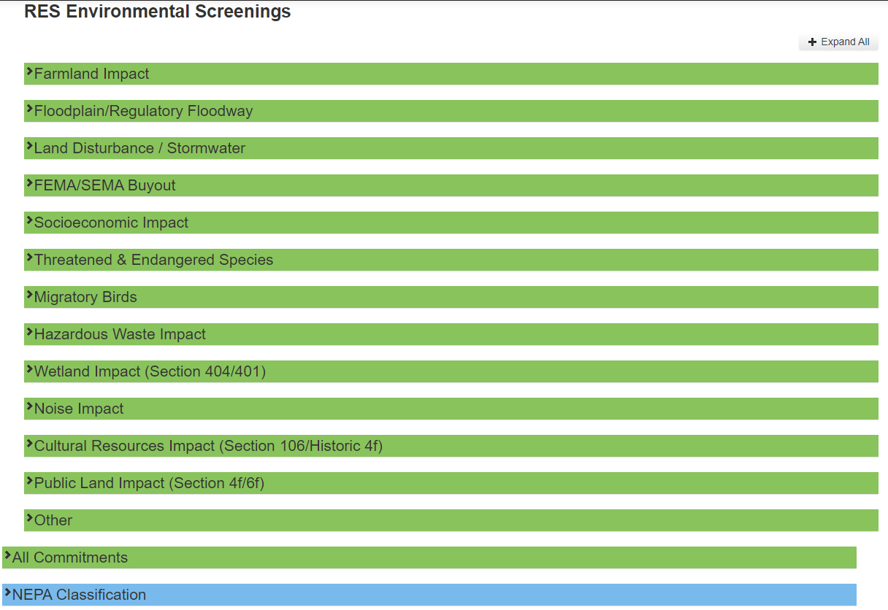
Figure 28. Request for Environmental Services (RES) Environmental Screenings.
Each individual resource screening section is color coded based on the status of the review. Four colors are used in the review process (Figure 29):
- Brown – The environmental resource has not been reviewed by MoDOT’s specialist.
- Pink/Red – Issues are pending; more information is needed on the project and should be reviewed by the submitter.
- Green – The environmental resource screening has been completed and cleared by MoDOT’s specialist. There may still be commitments that need to be followed.
- Light Blue – The environmental resource is in the process of being reviewed by MoDOT’s specialist.
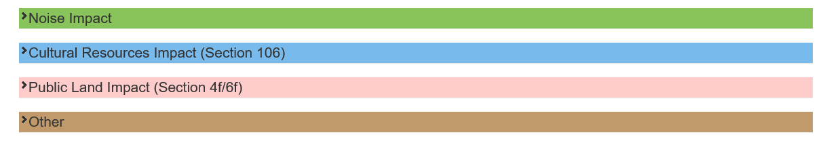
Figure 29. Request for Environmental Services (RES) Color Codes.
Additional information and explanations can be found in the comment boxes within each resource screening section (Figure 30). The Environmental Response box explains what has been completed by MoDOT specialists. The Environmental Action and District Action boxes indicate what is needed for MoDOT’s specialist to complete the environmental screening (Figure 30). The Commitments box indicates there is a commitment to be carried forward, for instance a JSP or dates when trees will be cleared.

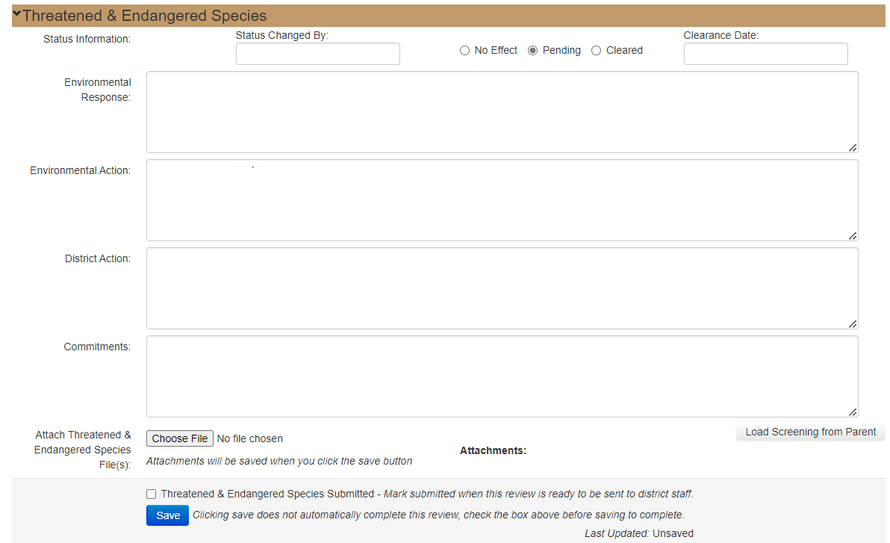
Figure 30. Resource Section Comment Boxes.
After MoDOT specialists have reviewed each resource screening section of the RES, the specialists will choose either the No Effect or NA, Pending, or Cleared button for each resource screening and click “Save” (Figure 30, above).
After all resource screening sections have been reviewed, the NEPA classification tab and Commitments tab will appear at the bottom of the RES form. FHWA, the MoDOT environmental compliance manager, and the MoDOT environmental and historic preservation manager are permitted to approve the NEPA classification for a project. Once all resource screening sections have been reviewed, an email will be sent automatically to the individual who submitted the RES form and to the district contacts with a link specifying which RES project was reviewed. A link provided in the email (Figure 31) will take you to the RES system login screen. Log in to the RES system, and the form will open.
Figure 31. Link in Email to the Request for Environmental Services (RES) System.
The Project Manager should pay special attention to the Commitments section in the RES (Figure 32). These are commitments to be carried into design and/or construction. These can be found under the Commitment tab in each location form or on the Parent form in the summary table.
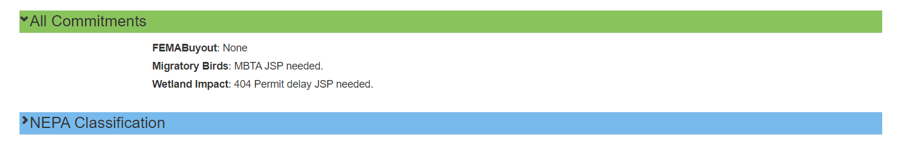
Figure 32. Commitments section of the Request for Environmental Services (RES) System.
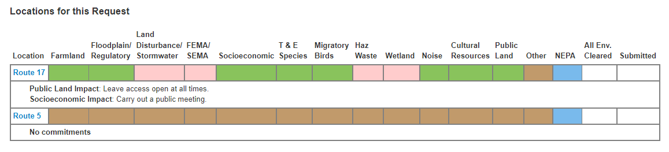
Figure 33. Summary table on the Parent form with Commitments for each location identified.
The NEPA Classification section of the RES (1) provides information for the district to request an A-date, 2) final NEPA approval, (3) all environmental issues cleared (Figure 34).
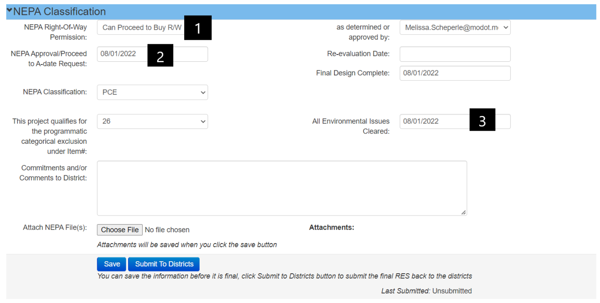
Figure 34. NEPA section of the Request for Environmental Services (RES) System.

Section 6. How to Search for an Existing Request for Environmental Services (RES).
To find an existing RES, follow the link shown in Figure 1 to access the RES system login. Once logged in, click the “Request Search” tab (Figure 7 above).
The RES search page (Figure 34) includes multiple ways to search for a project in the RES system including the following:
- Request Number – This number, located at the very top of the RES form, is automatically assigned when you create a new RES request.
- Job Number –You must enter the job number without the “J” (example: 4S3135).
- District – Search by one of the seven MoDOT district offices.
- County – Search by any Missouri county.
- Stage – Search by the current RES stage (e.g., location/conceptual, preliminary plans, ROW, final design).
- Route – Search by the route identified in the RES.
- Requestor – Search by the name of the person who submitted the RES request.
- Project Manager – Search by the name of the person listed in the RES as project manager.
- Date Submit Start/End – Search by the date the RES was submitted.
- Status – Search by the current project status.
- NEPA Approved? – Select to view only RESs that have received NEPA approval.

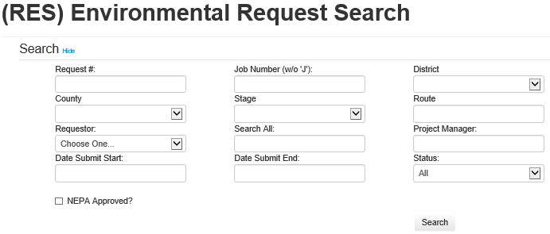
Figure 35. Request for Environmental Services (RES) Search Page.
The results of the RES search will be provided on a results page (Figure 35). Select the request number to link to and open the RES.
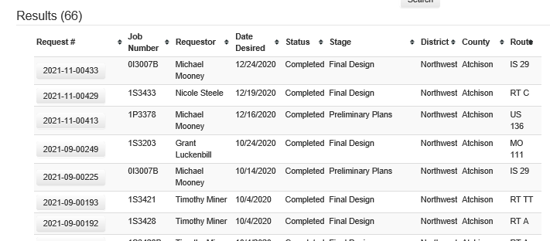
Figure 36. Request for Environmental Services (RES) Results Page.
If you are trying to determine the NEPA classification and the clearance dates needed to request an A-date, click on the NEPA classification heading under the RES Environmental Screenings (Figure 36).
The submitter can make edits to the RES after submitting the RES form, but once the form has been reviewed by all specialists, it is entered as “completed”, the RES is locked, and no changes can be made to the RES form for that project.
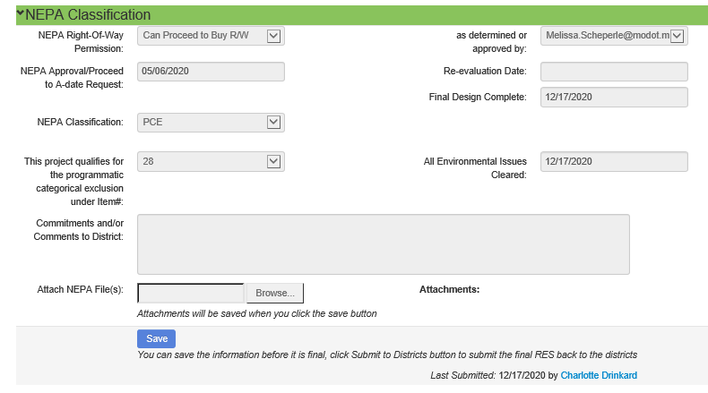
Figure 37. National Environmental Policy Act Classification.
For MoDOT Employees
MoDOT employees can access the RES system through the MoDOT SharePoint page using the following five steps:
- Navigate to the MoDOT SharePoint page.
- Click on the “DE” icon located under Divisions and Offices (Figure 37).
Figure 38. Missouri Department of Transportation Divisions and Offices.
- Locate and click “Environmental & Historic Preservation” under the sections tab of the Design Division SharePoint page (Figure 38).
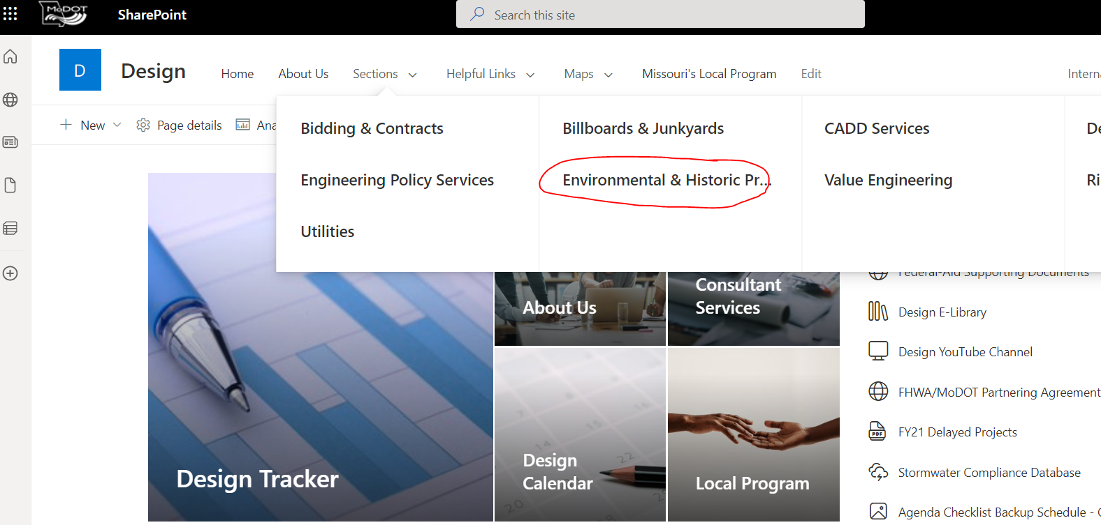
Figure 39. Design Division Page.
- Click on the “RES/RER” icon on the Environmental and Historic Preservation page (Figure 39).
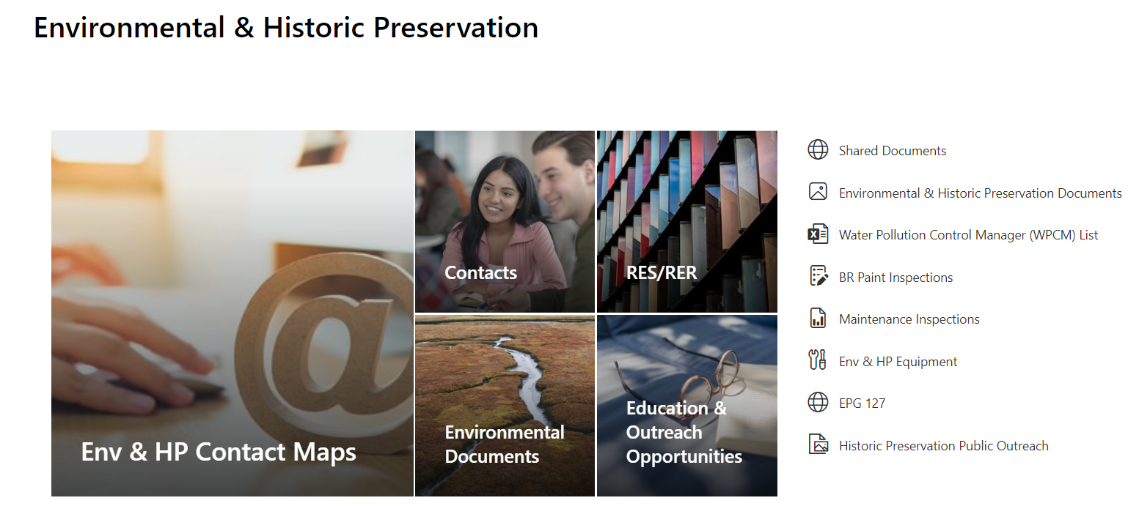
Figure 40. Environmental and Historic Preservation Page.
- Select “New RES Form.”
If you need further assistance, contact Melissa Scheperle (573.526.6684) or Charlotte Drinkard (573.526.4778).

