QRG – Contract Master List
A Contract Master List must be created for the prime contractor and each subcontractor on a project in order for personnel, equipment, supervisors, and certified testers to be selected when creating a Daily Work Report (DWR). This article is intended to guide the user in the creation of a Contract Master List.
Log on to SiteManager and navigate to Daily Work Reports – Reference Tables – Contract Master List.
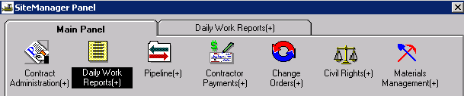
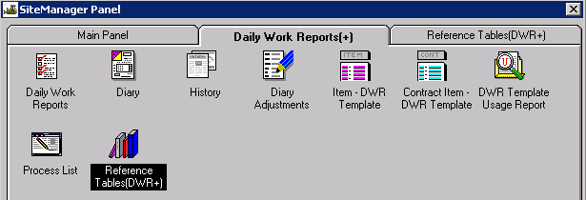

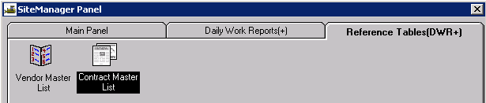
Select the appropriate contract ID from the list. The prime contractor and all approved subcontractors for the selected contract will appear on the Vendor list. Select the vendor for which the contract master list is to be created.
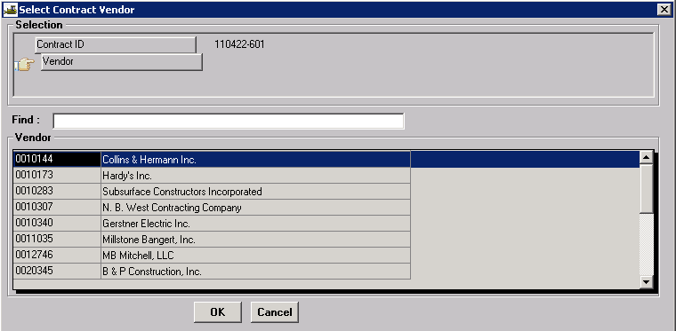
The Contract Master List window will open as shown below. There are two panels for each radio button at the top – a Vendor Master List and a Contract Vendor List. The Vendor Master List is maintained by SiteManager administrators. The Contract Vendor List will be associated to the selected contract ID.
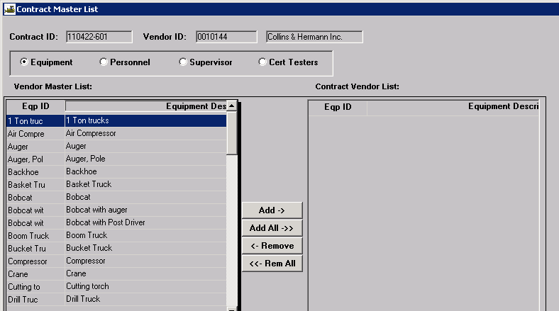
Select the Equipment radio button.
Note: The items in Vendor Master List may be put in alphanumeric order by clicking on the “Equipment Description” heading.
Select the equipment items the contractor will be using, and click the “Add” button to place them on the Contract Vendor List. Items may be added one at a time, or multiple items may be added by holding the Ctrl key while selecting. Do NOT click the “Add All” button unless it is a very small contractor and all items are necessary. This can slow processing time.
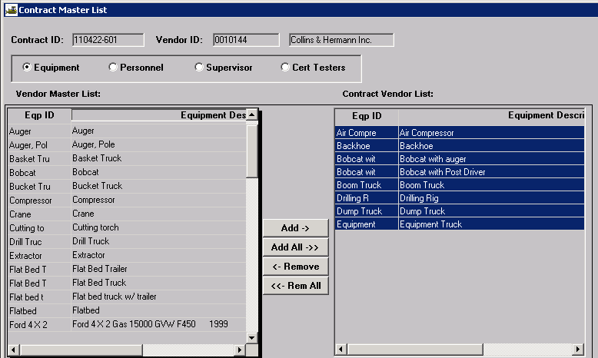
Save the Equipment list.
Select the Personnel radio button to add the work classification types to the contract.
Select the Supervisor radio button to add the contractor’s supervisors to the contract.
Select the Cert Testers radio button to add certified testing personnel, both MoDOT and contractor, who may be doing testing for acceptance on the project.
Important: Prior to adding testers to the list, please verify testers’ names and credentials in SharePoint at the following link: Cert Testers
Once Cert Testers have been added to the first vendor for a contract, they will be shown for all vendors on the contract.
Click the Open icon to create a Contract Master List for other vendors on the contract or exit the window.
Items may be added to a Contract Master List at any time during the life of an active contract.
Note: If you do not find the item you need, submit an email to ReDev requesting a new item be added to the Vendor Master List. Include the following information in the body of the email:
Contractor -- Name of the contractor/subcontractor for which information needs to be added
Vendor ID – Contractor’s vendor ID
Equipment -- List equipment to be added
Personnel -- List labor classification(s) to be added
Supervisor -- List name of supervisor(s) to be added

