Copying Detailing Notes from the EPG to MicroStation Drawings

Locate the note needed in the EPG under 751.50 Standard Detailing Notes. Highlight the desired note as shown below.
Stop the highlight just after the period. If the space after the period is included, the text will retain its indentation (see below for instructions on how to remove indentation if it is retained.)
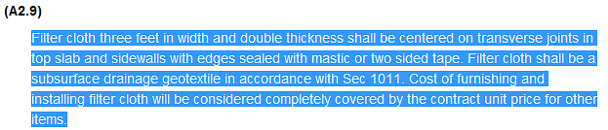

Right click and select Copy, or press <Ctrl> C on your keyboard.

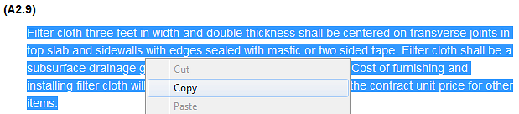

In MicroStation, click on Tasks, and select Small Text (General) to open the Text Editor.

Paste the text into the Text Editor by right clicking and selecting Paste, or by pressing <Ctrl> V on your keyboard.

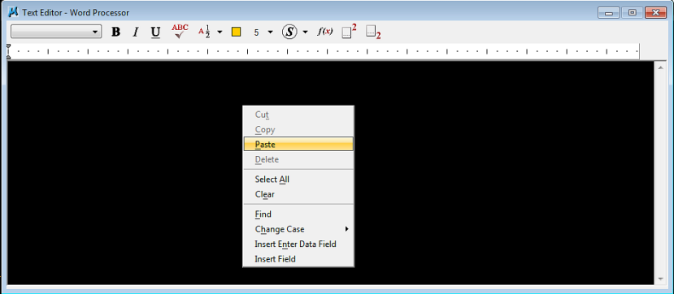

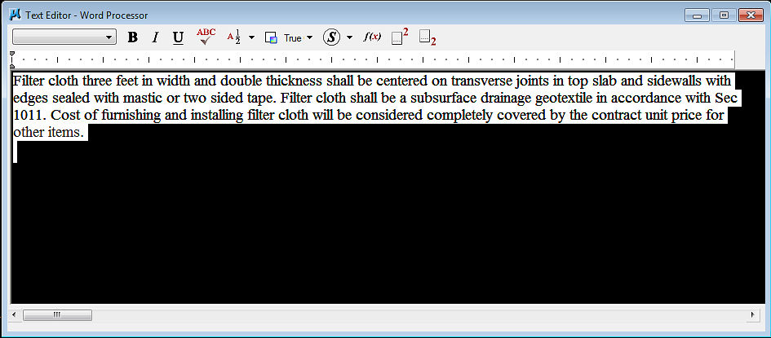

To change the text to the proper text style, click on Tasks again, and select Small Text (Convert EPG notes).

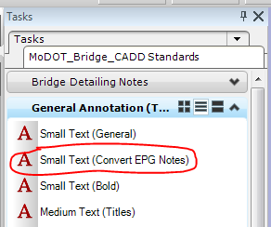
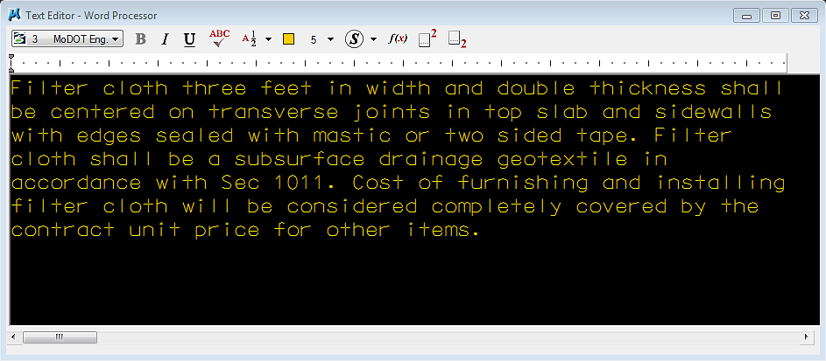

To remove indentation, right click on the margin indicators along the top of the text window.
(When copying notes with more than one paragraph, the indentation will be retained.)

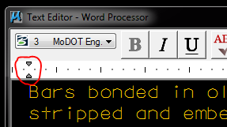

Select Indents and Tabs.

Set First Line Indentation and Paragraph Indentation to zero.
Click OK.
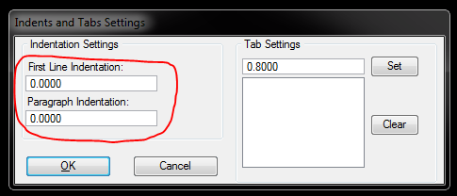

If the note contains underlined text, highlight the underlined text and click on the U icon to remove the underline.

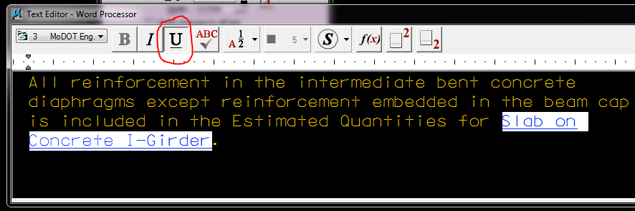

Place the note.

