Quick Reference Guide – SL District Signal Maintenance by Contractor Key Dates
St. Louis District has implemented Signal Maintenance by Contractor key dates in order to notify various MoDOT employees via an automated report that a particular contractor is required to maintain the signal. This QRG gives specific instructions for entering the signal maintenance key date(s) for a contract.
A Signal Maintenance by Contractor key date must be entered when the contractor assumes maintenance of the signalized intersection (e.g., contractor modifies the controller; signal heads, etc.). A separate key date must be entered for each intersection unless there is a series of intersections under contractor maintenance. (See Message Text entry below.)
There are currently twenty (20) SL District Signal Maintenance by Contractor Key Dates. Please contact ReDEV if more are needed.
To enter Signal Maintenance key dates in the system, navigate to Contract Administration - Contract Records - Key Dates.
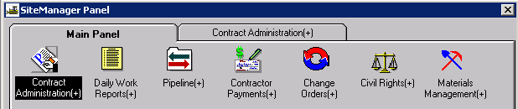
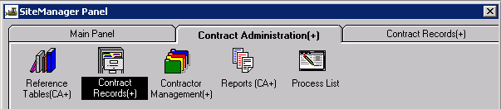
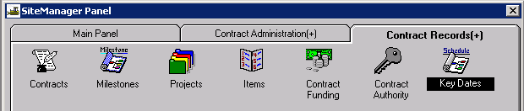

Open the appropriate contract and click the “New” icon.
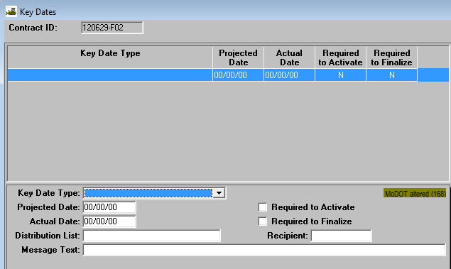
Key Date Type: Select "D6 Signal Maintenance by Contractor 1" from the drop down list. 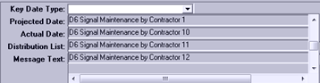
For multiple intersections, increase the type by one for each signal – “D6 Signal Maintenance by Contractor 2,” “D6 Signal Maintenance by Contractor 3,” etc.
Projected Date: Enter the date the contractor assumed maintenance.
Actual Date: Leave this field blank until MoDOT has accepted maintenance from the contractor as defined by Section 902.12.8 or 902.21 of the Missouri Standard Specifications for Highway Construction. At that time, enter the appropriate date.
Required to Activate: Leave this checkbox unselected.
Required to Finalize: Leave this checkbox unselected.
Distribution List: Leave this field blank.
Recipient: Enter the Resident Engineer’s SM userid.
Message Text: Enter the Route number, excluding designation (i.e., Rte., I-, US, etc.), with the lowest route number listed first if signal is located at a multi-route number intersection. The intersecting street or Route will be listed next. The contractor's contact person and 24-hour phone number will follow the intersection details, then the contractor's name (abbreviations are acceptable).
Example for single intersection: 67 and 100. Contact John Doe 314-555-1212, Acme Electric
Note: A series of intersections may be listed, provided all signals within the series are under contractor maintenance. If there is a break, separate entries must be made (see screen shot below).
Example for multiple intersections: 67 from 100 to McCausland. Contact John Doe 314-555-1212, Acme Electric
When complete, the window should look similar to the following:
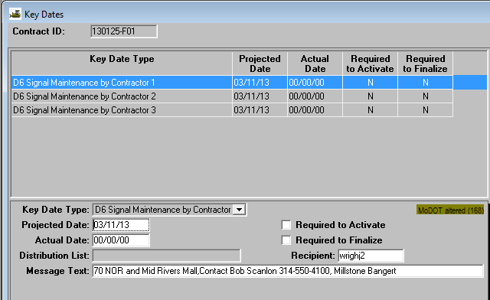
Save and close.

Verify the information on the Cognos 8 “St. Louis District Active Signal Construction Projects” report located at:
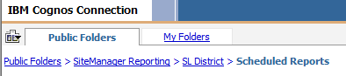
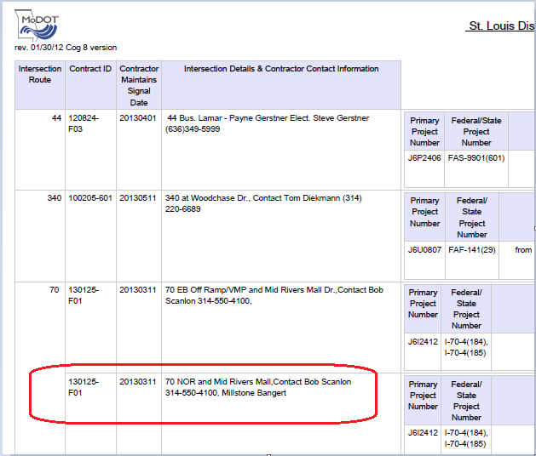
The signal will be removed from the report when MoDOT assumes maintenance, but the user must enter the Actual Date for each of the Signal Maintenance by Contractor key dates in order for this to occur.
When MoDOT assumes maintenance of the signal, open the appropriate Signal Maintenance by Contractor key date and enter the date in the Actual Date field.
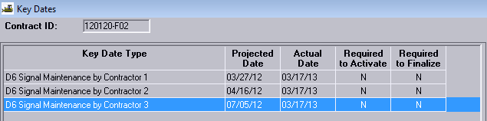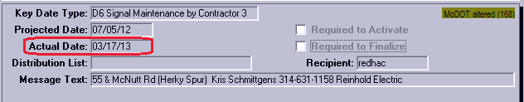
Save the information.
The signal will now be removed from the Cognos 8 Report.

