Quick Reference Guide – Adobe Final Plans Stamp
This article is intended to guide the user in setting up and applying an electronic final plans stamp in Adobe Acrobat X Pro. The advantages of using the Adobe final plans stamp are a much cleaner scanned copy, time savings, and cost savings.

Section 1: Set Up the Final Plans Stamp
This section is typically completed only once by a particular user. Once the Adobe Final Plans stamp is set up, the stamp may be applied according to the instructions in “Section 2: Applying the Adobe Final Plans Stamp.”
- Log on to Adobe Acrobat X Pro.
Note: Adobe Reader will NOT work. If you do not have Adobe Acrobat X Pro installed on your desktop, you must log on in Terminal Services (remote desktop connection) for access.
- Click on Comment and the Add Stamp icon.
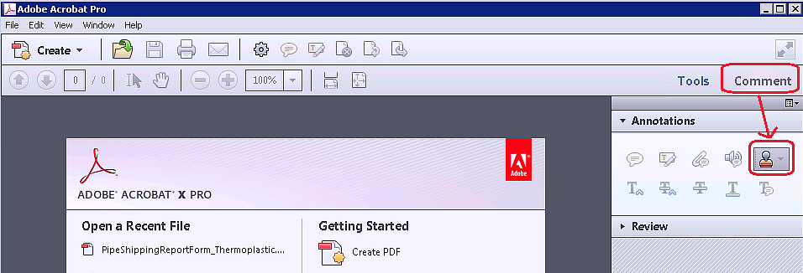
- Click on Custom Stamps and then Create Custom Stamp…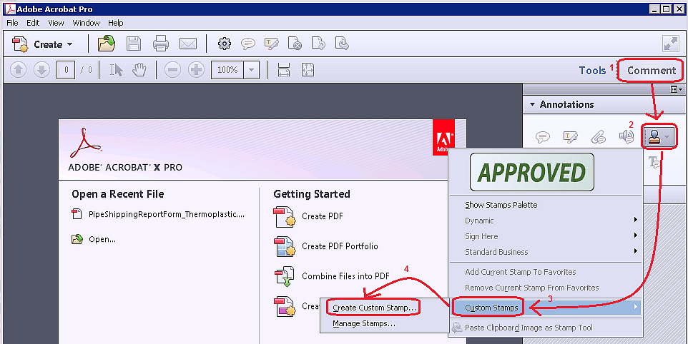
- Click on the Browse button.
- In Terminal Services, click on Computer in the Favorite Links panel. Navigate to V:\Forms and Spreadsheets.
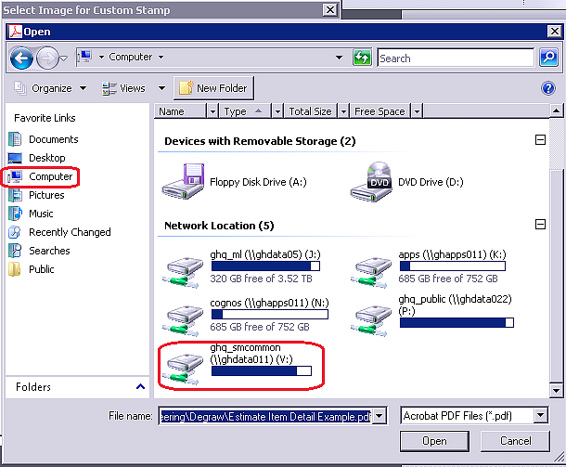
- Change the file type to JPEG. Select Final Plans Stamp.jpg and click the Open button.
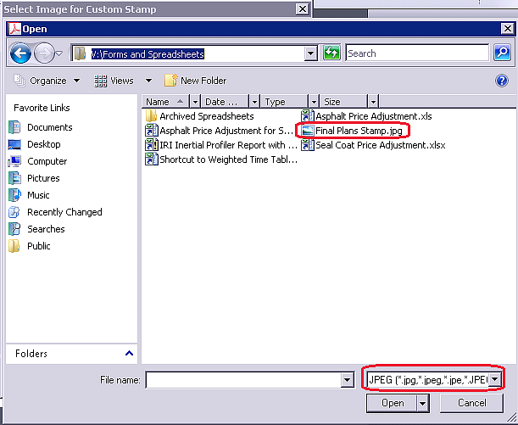
- Click the OK button
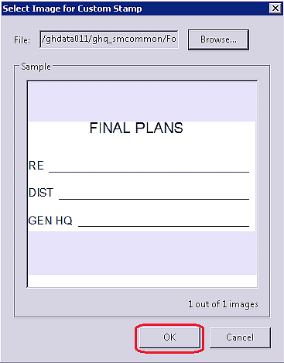
- Select “Sign Here” from the drop down in the Category field and enter “Final Plans Stamp” in the Name field. Click the OK button. Your Final Plans Stamp is now set up.
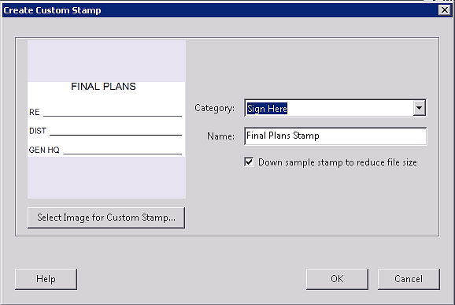

Section 2: Applying the Adobe Final Plans Stamp
- Open your final plans file in Adobe Acrobat X Pro.
Note: Adobe Reader will NOT work. If you do not have Adobe Acrobat X Pro installed on your desktop, you must log on in Terminal Services (remote desktop connection) for access.
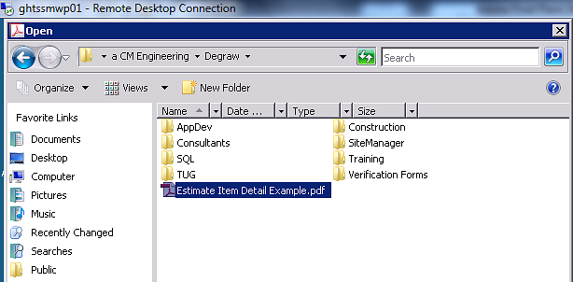
- Once the document is open, place your cursor in the approximate location where the final plans stamp will be placed. Click Comment, then click the Add Stamp icon, then Sign Here, and finally click the Final Plans Stamp image.
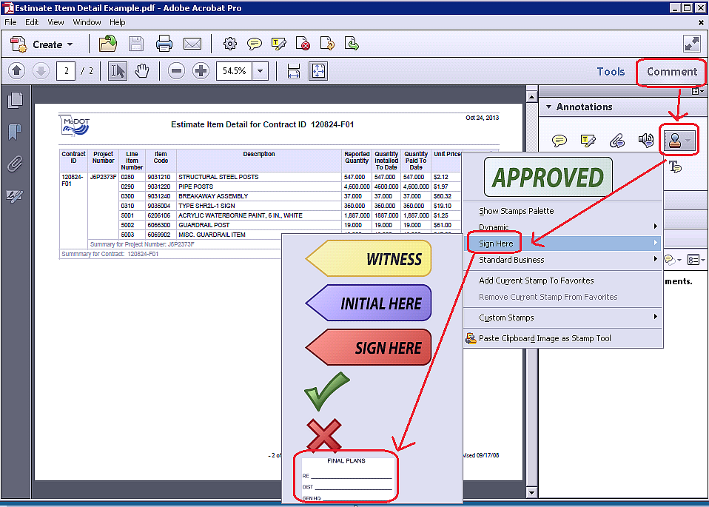
- If the Identify Setup dialog box appears, click the Cancel button.
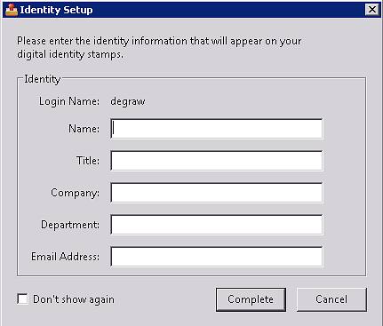
- The Final Plans Stamp can now be move or resized as desired. Once you are satisfied with the placement and size of the stamp, save the file.
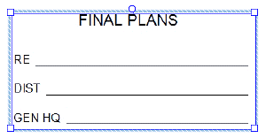
Note: A date is not included on the stamp since the date is automatically added with a digital signature.

