Quick Reference Guide – Diaries
The Diary is used to compile and authorize all Daily Work Reports (DWRs) for a contract and to assess working day charges. A Diary must be created each day during the life of the contract from Notice to Proceed date through Substantial Completion date. Diaries may be created beyond Substantial Completion date in order to track work and process payment to the contractor
Navigate to Daily Work Reports – Diary.
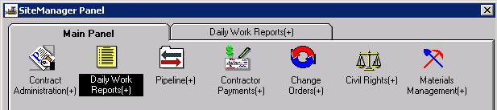
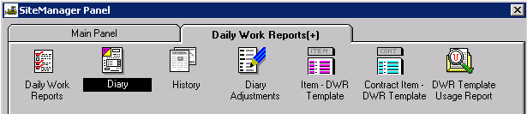

Authorize Tab
The Resident Engineer is required to authorize all DWRs. (This duty may be delegated to the Project Manager, although it is preferred that it be completed by the Resident Engineer.) This function is performed on the Authorize tab.
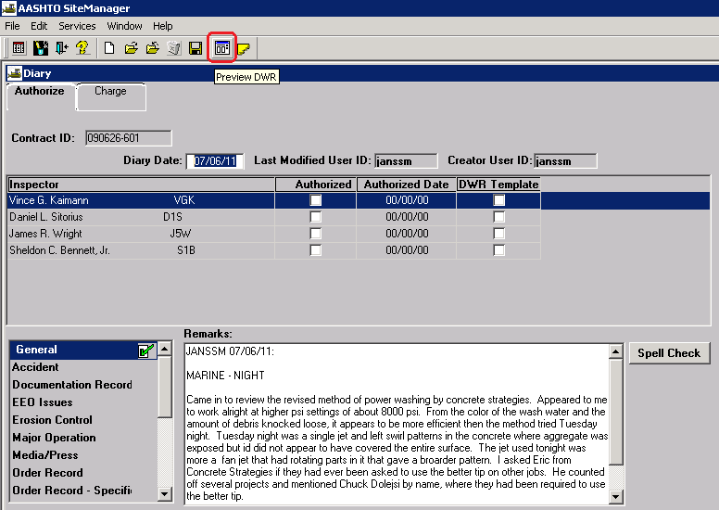
Contract ID: Select Services – Choose Keys to select the contract.
Diary Date: Double click the date field to select a date using the pop-up calendar.
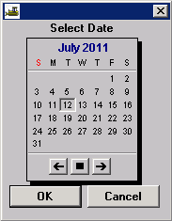
Last Modified User ID: Automatically entered by system.
Creator User ID: Automatically entered by system.
Inspector: Each inspector who created a DWR for the Diary Date will be listed. A selected DWR may be reviewed and/or printed by selecting the Preview DWR icon in the toolbar.
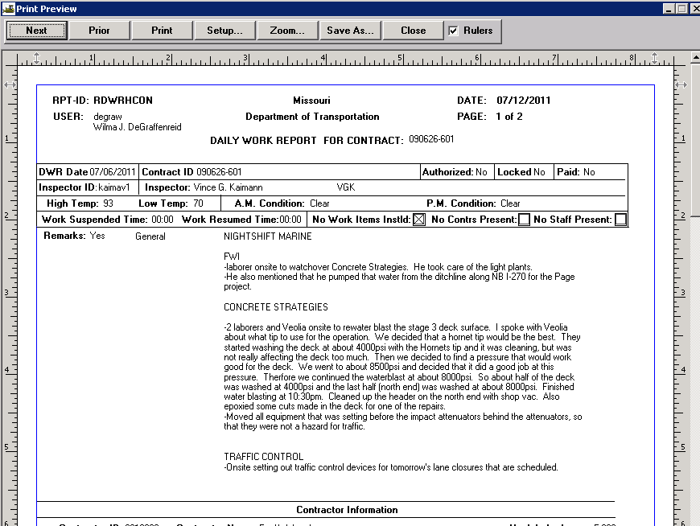
Authorized: If satisfied with the DWR, select the Authorize checkbox
Authorized Date: Automatically entered by system when the Authorized check box is selected.
Remarks: Select the appropriate “Remarks Type” from the list to the left of the Remarks field. Type any necessary remarks. The diary remarks need not repeat the inspector's detailed entries, but may contain only general information about operations or information not covered in the DWRs, e.g., location of stockpiled materials, important verbal instructions to the contractor, discussions with the inspectors, significant events on the job, etc. Multiple “Remarks Types” may be selected and entered for the day. Click the “Spell Check” button to run the spell check for remarks.
Note: Once a DWR has been authorized, no changes can be made to it. However, a DWR may be unauthorized for correction or addition unless it has been included on a pay estimate.
Save the information.

Charge Tab
The Charge tab is used to assess daily charges for contracts and milestones. The system defaults to “Full Day” charge type for all contract types. Every day is always a “Full Day” charge type for Completion Date and/or Calendar Day contracts.
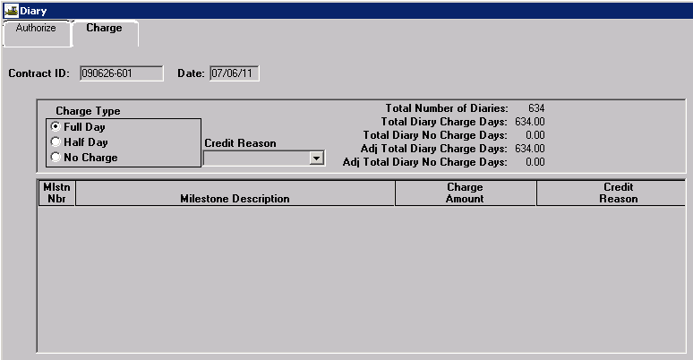
If “No Charge” is to be made for a Working Day contract, a Credit Reason must be selected. MoDOT does not use the “Half Day” charge type.
Because milestones are user entered, the system will not know whether or not to make charges. Once work begins on an Available Time milestone, each day must be charged (either a Full Day or No Charge).
Note: Do not charge days to Completion Date milestones. It is not required to charge days for a Calendar Time milestone since the completion date is automatically calculated by the system.
Place focus in the “Mlstn Nbr” panel in the lower portion of the Charge tab and click the New icon.
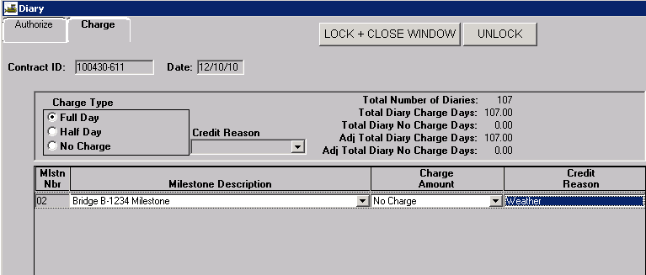
Milestone Description: Select the appropriate milestone from the drop down.
Charge Amount: Select the appropriate charge -- either Full Day or No Charge -- from the drop down. MoDOT does not use half day charges.
Credit Reason: A reason must be selected if there is no charge for the day.
Repeat if charges need to be made for additional milestones.
Save the information entered.
Note: The contractor is notified of the working days charged to the contract and/or milestone during the estimate period on the Estimate Summary to Contractor report.

Diary Adjustments
The Diary Adjustments window allows adjustments to be made for a day that has incorrect charge information recorded and charged on an approved estimate.

Navigate to Daily Work Reports – Diary Adjustments.
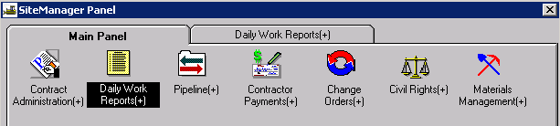
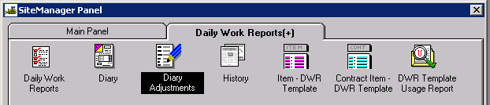

The Diary Adjustments window has two tabs. The Diary tab allows the user to adjust working day charges on a diary that has been included on a paid estimate. Existing adjustments cannot be deleted or updated. Multiple adjustments can be created for the same diary. The top row of data in the window displays contract ID, selected diary date, and the current diary charge information. The lower portion of the window displays any adjustments that have been made.
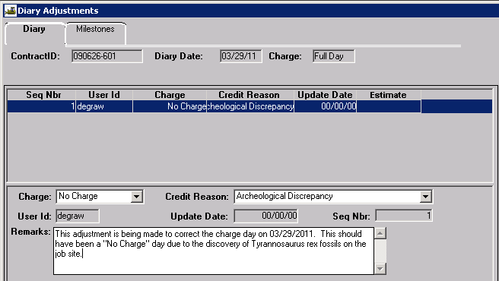
To create a diary adjustment, select the appropriate contract ID and diary date from the Select Diary Adjustment window. Click the New icon.
Charge: Select “No Charge” or “Full Day” from the drop down. MoDOT does not use “Half Day.” The Charge drop down list will not display the current Diary charge value as a selection.
Credit Reason: Select the appropriate reason from the drop down.
User ID: The system will automatically enter user ID of user who enters adjustment.
Update Date: The system will automatically enter date the adjustment was last updated.
Seq Nbr: The system will automatically assign a sequence number to the adjustment.
Remarks: Enter appropriate remarks about this adjustment.
Estimate: This field will be automatically entered by the system when the next estimate is generated.
Save the adjustment.

To create a milestone charge day adjustment, select the appropriate contract ID and diary date from the Select Diary Adjustment window. Select the Milestones tab. If there are multiple milestones, select the one for which the adjustment is to be made and click the New icon.
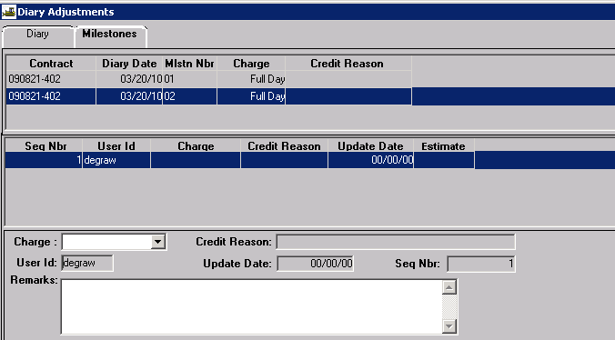
Note: If no charge has been made for the milestone for the diary date, it will not be available to be selected.
Charge: Select “No Charge” or “Full Day” from the drop down. MoDOT does not use “Half Day.” The Charge drop down list will not display the current charge value as a selection.
Credit Reason: Select the appropriate reason from the drop down.
User ID: The system will automatically enter user ID of user who enters adjustment.
Update Date: The system will automatically enter date the adjustment was last updated.
Seq Nbr: The system will automatically assign a sequence number to the adjustment.
Remarks: Enter appropriate remarks about this adjustment.
Estimate: This field will be automatically entered by the system when the next estimate is generated.
Save the adjustment.

