QRG – Land Disturbance Project Information
Recent requirements dictate that disturbed acreage must now be tracked for each project. This article is intended to guide the user on how to enter this required data.

When the contractor payment estimate is generated, a pop-up box will appear. The user should enter the critical dates as necessary. Primary Receiving Waters should be entered. Click the Update button.
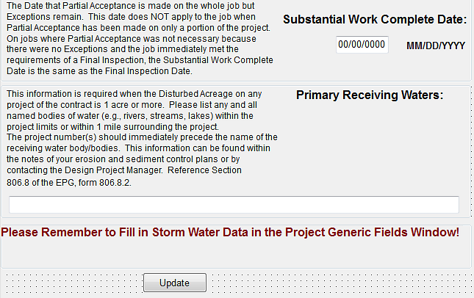

There is also a reminder to enter the storm water data/erodible acreage project data in the Project Generic Fields window.

Navigate to Contract Administration -- Contract Records -- Projects.
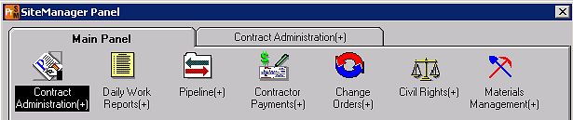
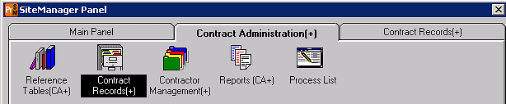
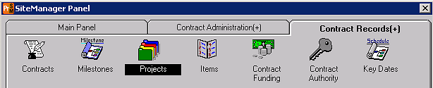
Select (double click) the appropriate Contract ID from the list in the Select Contract Project window. 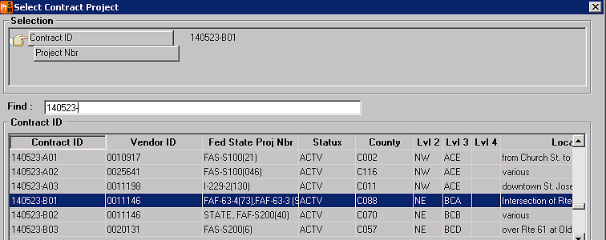
Select the appropriate project from the list.
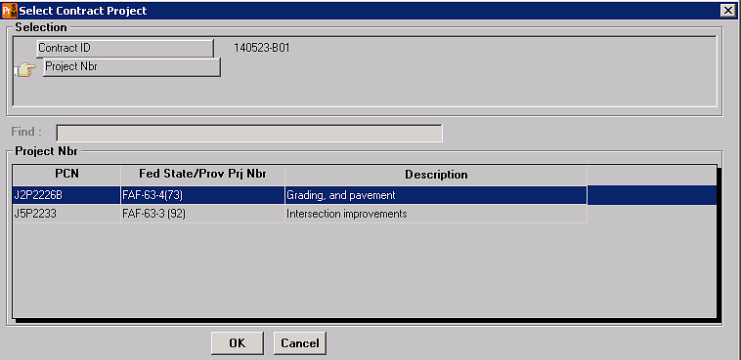
When the Projects window opens, click the Generic Fields icon in the tool bar,
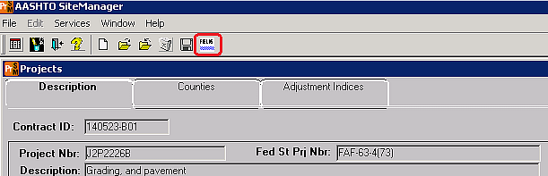
…or select Services, Generic Fields.
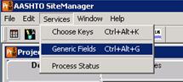

Enter Authorized Acreage, Disturbed Acreage, Open Acreage, Anticipated Date of Disturbance, and Date Consent Decree Penalties On as indicated below.
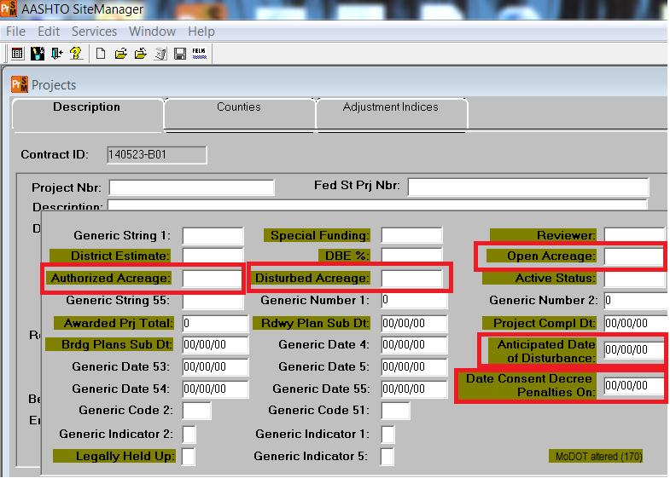
Click on the Generic Fields icon to close the window.
Save the data either by clicking the Save icon , or File – Save from the drop down menu.
For projects let in combination, it vital that the disturbed acreage data is entered for each project.
Select the Open icon (or File – Open from the drop down menu), select another project, and repeat the above steps to enter data for each project in the contract.
