QRG – Digital Signatures (Contractors)
  - These instructions are written for Adobe Acrobat X Pro and may not be applicable to other versions.

Section 1: CAPTURE a Signature Image
This section will typically be completed only once by a particular person.
This process assumes that a user is authorized to sign documents based on the user’s title, or the user has been delegated to sign documents on behalf of the authorized user.
Scan an image of the authorized user’s signature into any software capable of capturing an image or picture. This is most easily done by having the authorized user sign a blank sheet of paper, then scanning the page and sending the scanned image to yourself via email, or whatever method your scanner supports. It may be advisable to sign the page several times and select the best version.
Paper signed…

Scan and send the image to yourself. The image will arrive as an email attachment.
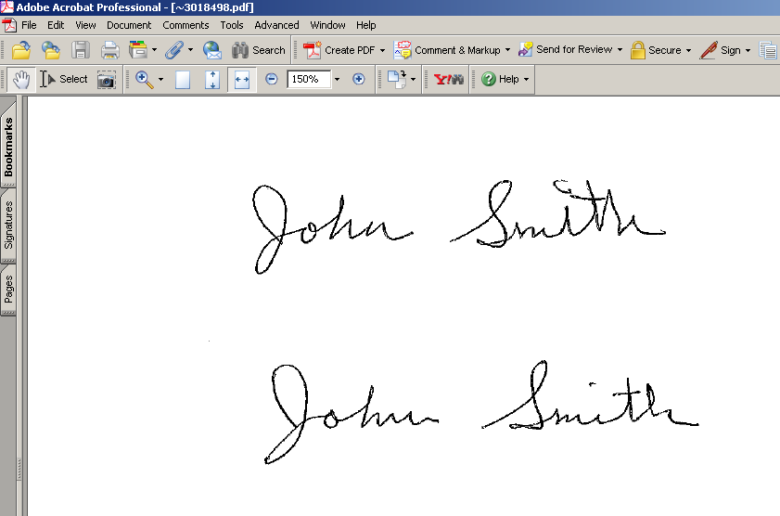
Open the image.
Use PrintScreen to initiate the PrintKey software. Select the Rectangle tool to capture just the signature from the page. You will be returned to the PrintKey software. (Alternate software may be used to capture an image of a signature. See the instructions for that software.) The goal is to create a bitmap file (.BMP) that is an image of the inked signature and ONLY the white space immediately surrounding it.
Select the Edit tool.
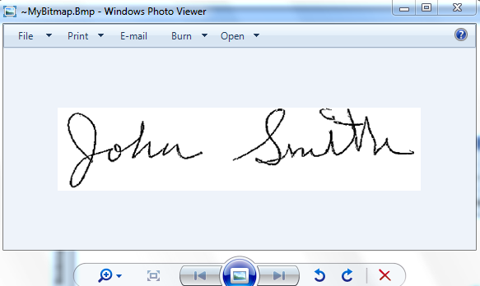

The area captured in step 7 will be displayed in Windows Photo Viewer. From this window, select Paint from the Open drop down menu.

From the Paint drop down menu,
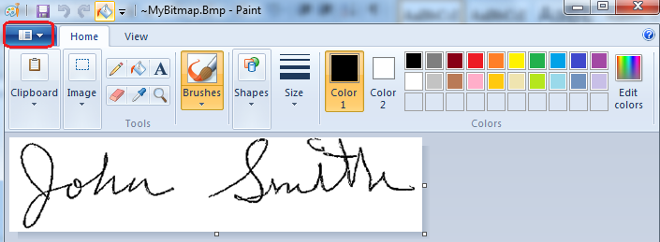
…select Save as – BMP picture.
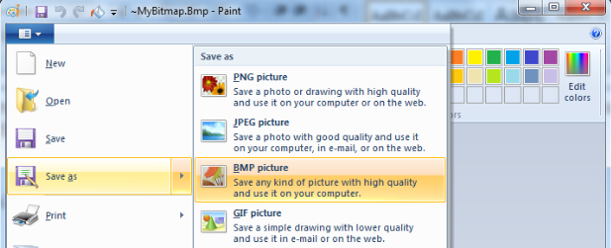
Enter a file name such as “<person’s name>Signature Image” and select a location that can be easily accessed, such as Desktop or My Documents.
Close the bitmap editor “Paint,” Windows Photo Viewer, and the “PrintKey” application.

Open Adobe Acrobat Professional. Select Edit - Preferences.
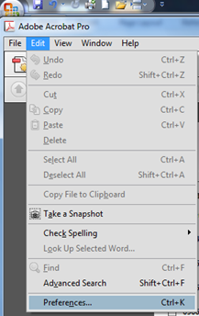

Select Security from the “Categories” column, and click the “New” button.
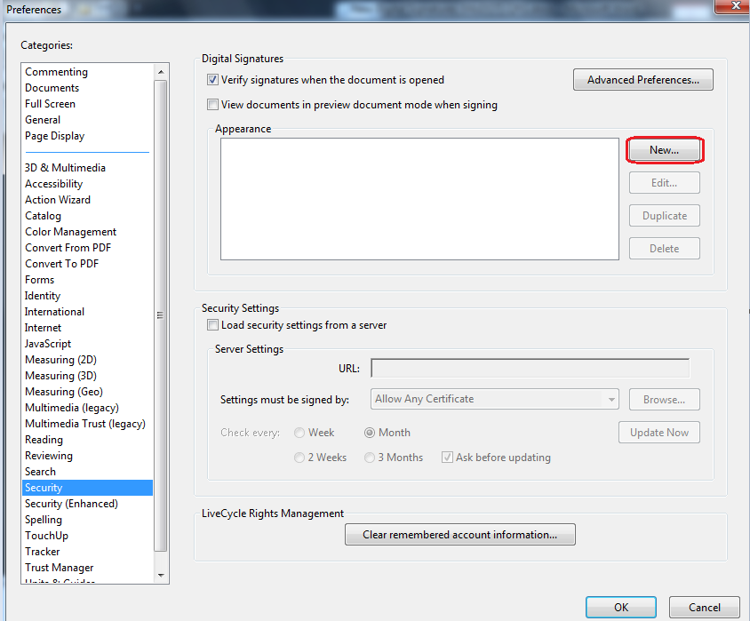

Enter a “Title” for the signature image. The recommended format is to use the person’s name plus the word signature with no spaces. For example, “JohnSmithSignature” as shown below.
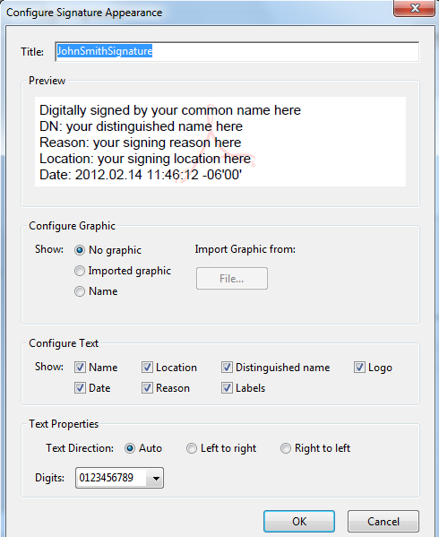
In the Configure Graphic area, select “Imported graphic” and click the “File” button.
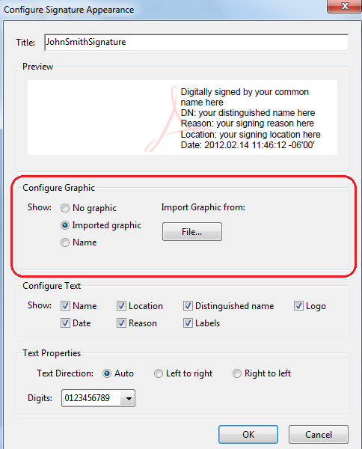

Click the Browse button and navigate to the location where the signature file was saved.
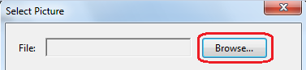

Because the signature file was saved as a .BMP, it is necessary to select .BMP as the file type in the Browse window. Select the signature file name and click the Open button.
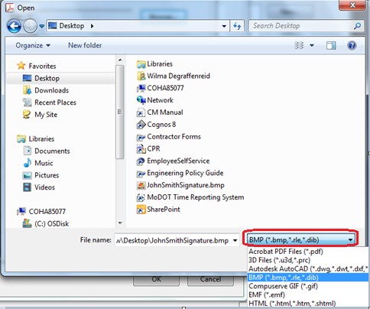
The window will display the signature image. If it is correct, click OK. If the wrong file was selected, browse again.
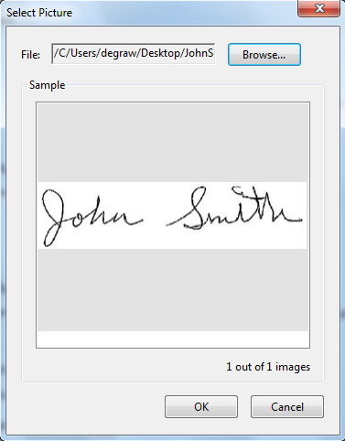

UN-select the “Reason” box and click OK.
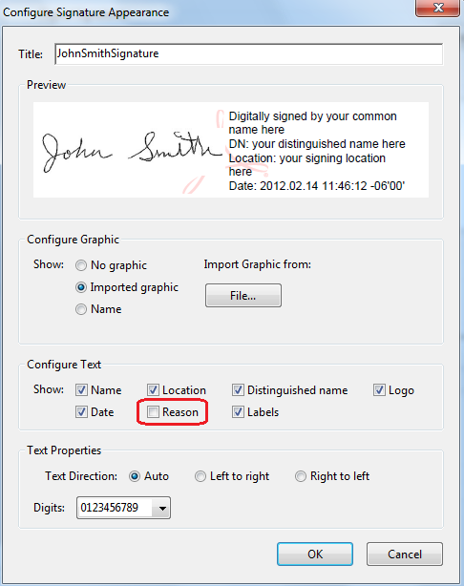

There is now a new item in the Appearance field. Click OK.
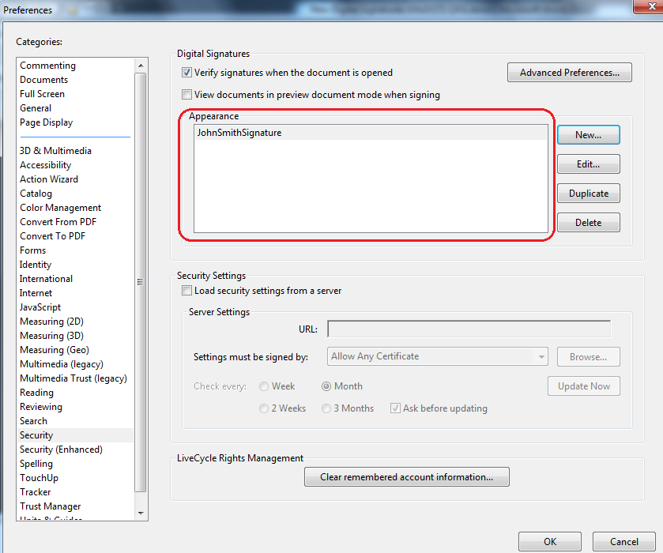

Step one -- to successfully capture the image of a signature that will be incorporated into the digital signature used to sign documents -- is complete. This step is typically done only once.
The next step is to set up the digital signature ID.

Section 2: SET UP an Adobe Digital Signature ID
This section is typically completed only once by a particular person. Once the digital signature ID is set up and a list of authorized signers has been submitted, subsequent digital signatures may be applied according to the instructions in “Section 4 – ROUTINE Adobe Digital Signatures.”
This process assumes that a user is authorized to sign documents based on the user’s title, or the user has been delegated to sign documents on behalf of the authorized user.
Open Adobe Acrobat Professional. Select Tools – Protection – More Protection – Security Settings.
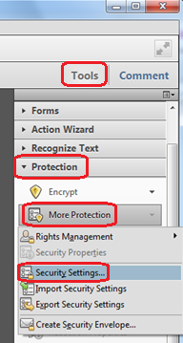

Select “Digital IDs” in the left column, then select “Add ID.”
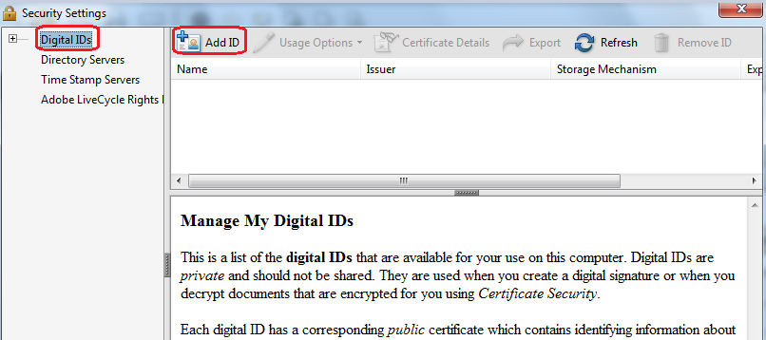

Select “A new digital ID I want to create now.” Click Next.
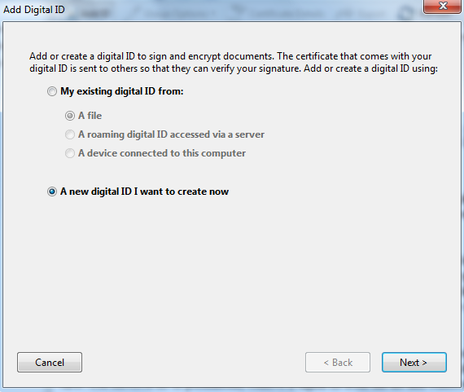

Select “New PKCS#12 digital ID file.” Click Next.
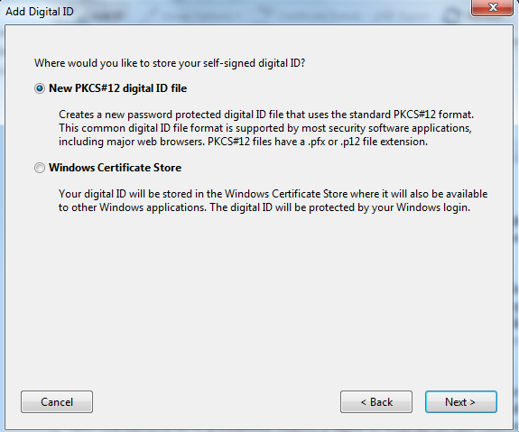

Fill in the first four fields. “Organizational Unit” is optional for contractors. Click Next.
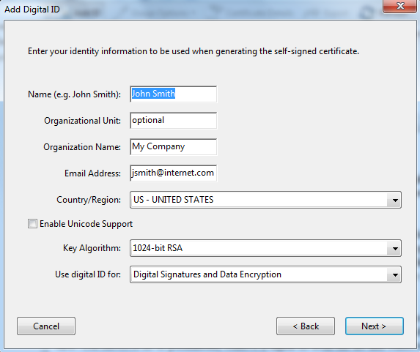

Typically, the user will accept the filename that is automatically provided. Enter a password and enter the same value in Confirm Password. Be certain to remember the password or record it in a secure location. Click Finish.
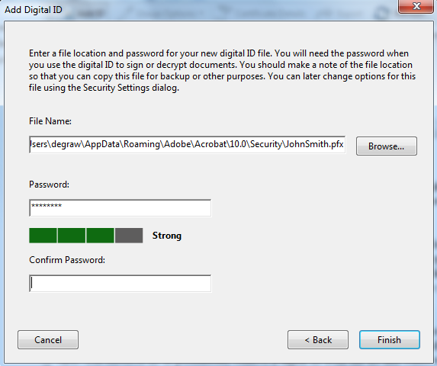

Note: If no “Confirm Password” field is visible, as shown below, the user will receive an error message when the Finish button is clicked. It will appear to the system that the Confirm Password field has been left blank and the passwords will not match.
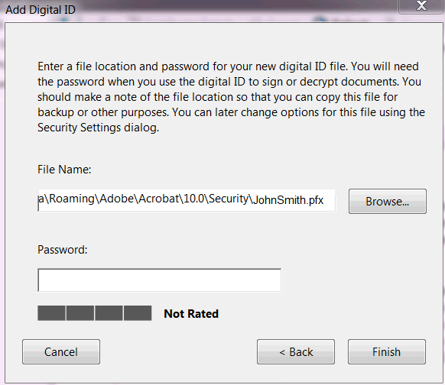
To correct this problem, right click on the Desktop and select Screen Resolution. In the Resolution drop down, change the screen resolution, either up or down, and then work through the password sequence again.
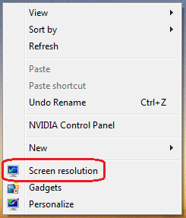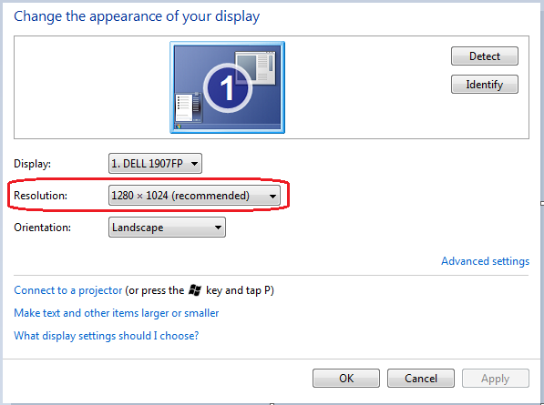

Close the Security Settings window with the “X” in the upper right corner.
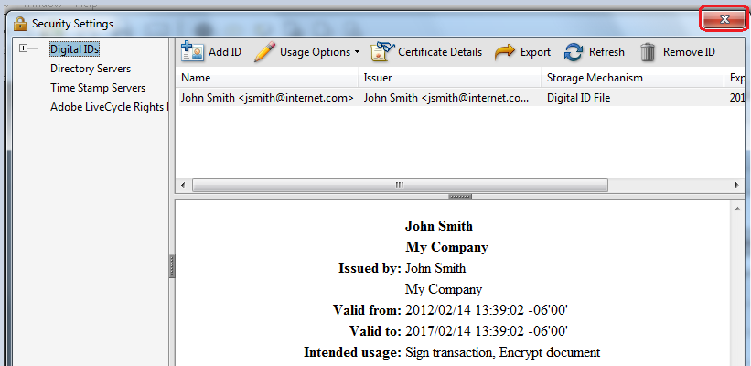

You now have a digital ID. Refer to the next section for submitting a digital signature certificate.

Section 3: SUBMIT a Digital Signature Certificate & List of Signers
Each user will create his/her own digital signature using Adobe Acrobat Pro. (NOTE: Adobe Acrobat Reader will NOT work for this.) This will be done concurrent with the first “signing” of a document. The user will then e-mail a copy of the digital signature file to MoDOT Construction and Materials (attention Tina Vogt), where it will be stored in: V:\Digital Signatures\Contractor FDF files
To submit a digital ID, open Adobe Acrobat Pro. Select Tools – Protection – More Protection - Security Settings. (NOTE: These instructions are for Adobe Acrobat Pro X; other versions may be different, but this function will be available.)

Select the user name (the blue row in the image below), then select “Export.”
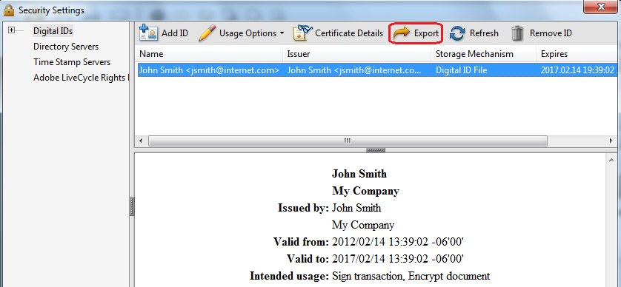

Select “Email the data to someone” and click the Next button.
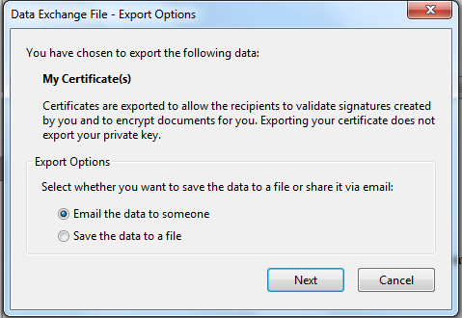
Click the Email button. It is NOT necessary to fill in the “To:” field. The system will transfer the user to the company email which can then be sent to ReDev@modot.mo.gov
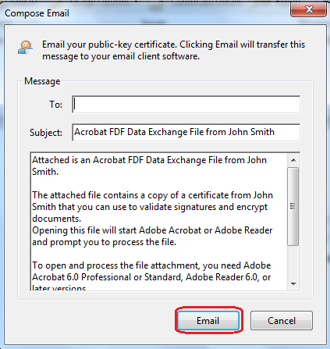
The contractor’s submission of the FDF file is to be accompanied by a letter (see next page) stating that the contractor accepts the prescribed digital signature process in use by MoDOT at the time of the submission.

PFX Files
Folders are also provided for PFX files, however the PFX file is not required except for MoDOT personnel. These files allow users to record their digital ID if it is lost in a computer upgrade or other failure. The file is password protected and cannot be used by any other user.
To submit the PFX file, the simplest process is to Search the C:\ drive for *.PFX. Once the file is found, it can be attached to an e-mail and submitted to MoDOT Construction & Materials by sending the e-mail to ReDev@modot.mo.gov)

Example Letter for Authorized Digital Signers

<Contractor LETTERHEAD>

<date>

Mr. David Ahlvers
State Construction and Materials Engineer
Missouri Department of Transportation
P.O. Box 270
Jefferson City, MO 65102

Mr. Ahlvers:

The individual(s) listed below hereby agree to communicate official approval of contract change orders via electronic means including sending and receiving the change order documents, and signing the documents with a digital signature applied using Adobe Acrobat Pro. We acknowledge that MoDOT will act as the approver of the digital signature and that MoDOT will retain the attached digital signatures on file for comparison if that becomes necessary.

The individual(s) are:
<first and last name – add as many rows as needed> <inked signature>

MoDOT will be notified of any changes to the list as soon as practical.

Sincerely,

<signature>
<name and title>

Section 4: ROUTINE Adobe Digital Signatures
This process assumes that a person is authorized to sign documents based on the person’s title, or the person has been delegated to sign documents for the authorized person. This section may be used as many times as necessary once the user has completed the steps documented in Sections 1-3.
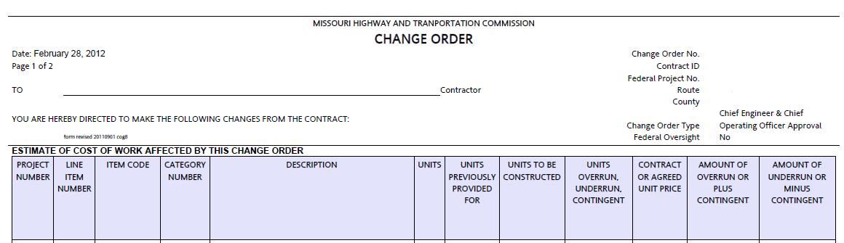
Detach the PDF document from the email by saving from the email system to a hard drive on the computer. Open the document in Adobe Pro. (Part of an example PDF document is shown above. This example is a change order, but digital signatures may be applied to any PDF file.)

Select Tools – Sign & Certify – Sign Document.
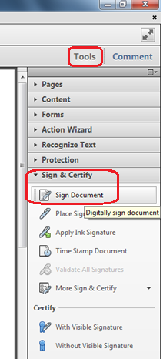

This pop-up may be displayed to remind the user to designate a location on the page for the digital signature. Once familiar with the process, this notification may be suppressed by checking “Do not show this message again.” Click “OK” to continue.

Select the area where the digital signature should appear. On a change order PDF, define the full area of the change order signature line that applies to the signature you are attaching. The selection area will appear as a light blue rectangle. Make the rectangle about the same size as shown below.
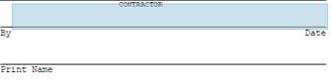
This pop-up may appear. If satisfied that the selected area is adequate, click “Sign;” otherwise, click “Start Over” to reselect the signature area.
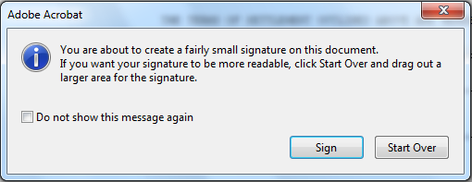

When the mouse button is released, the Sign Document dialog box will appear. Select the appropriate digital ID in the “Sign As” drop down field. If the correct digital ID is not displayed, select “New ID” and refer to Section 2 –SET UP an Adobe Digital Signature ID.
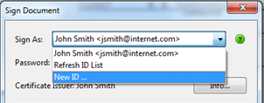
Once the signature file is selected, enter the password established when the digital ID was created.
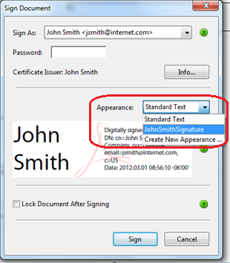
Note: MoDOT will NOT accept the “Standard Text” digital ID. If Appearance defaults to “Standard Text,” make sure to select the digital signature file created when the signature image was captured, as shown below (“JohnSmithSignature” in this example).
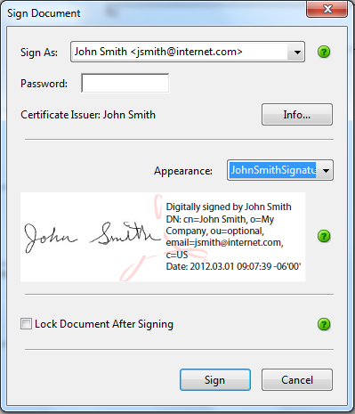
Do NOT select “Lock Document After Signing.” Selecting this option locks all fields, including any remaining signature fields.
Click the Sign button.

Save the signed document. The document will look something like this where it was digitally signed.

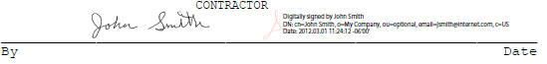

Attach the digitally signed change order (or other document) to an email, and return it to the Resident Engineer.

