QRG – Job Order Contracts
This article will guide the user in creating and printing a job order, creating and authorizing a Daily Work Report (DWR), and generating a contractor’s pay estimate for guard cable, guardrail, or fence repair Job Order Contracts.

Creating the Work Order
To access the Work Order form, navigate to V:\Forms and Spreadsheets\Official Statewide Rail Cable Fence Spreadsheet.xlsx
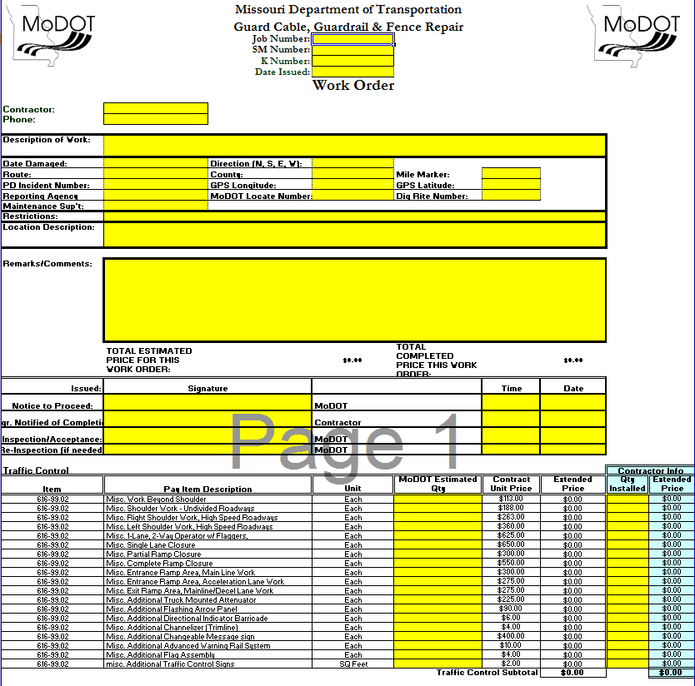
This spreadsheet will be used as the work order to capture and calculate data that will be entered in the Daily Work Report.

Creating the Daily Work Report
Log on to SiteManager and navigate to Daily Work Reports – Daily Work Reports.
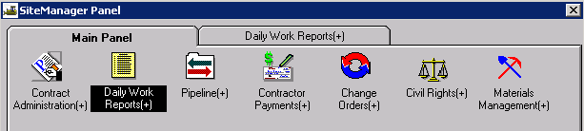
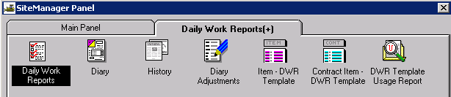

DWR Info Tab
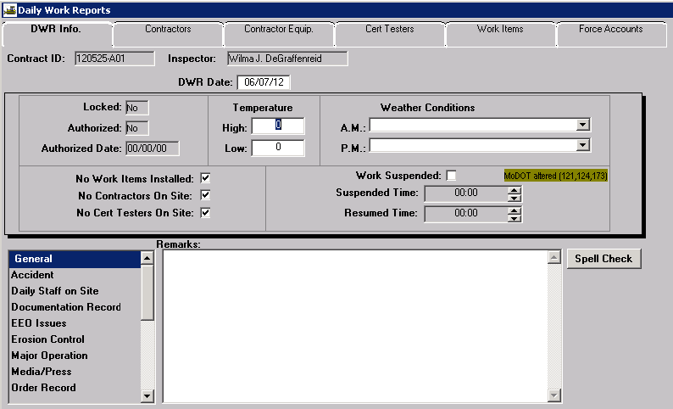
The Daily Work Report (DWR) is the inspector’s record of work performed on a contract. There can be only one DWR per inspector for any given date.
Contract ID: Select Services – Choose Keys to select contract.
Inspector: Automatically entered by system.
DWR Date: The date defaults to the current date. Double click the date field to select a different date using the pop-up calendar.
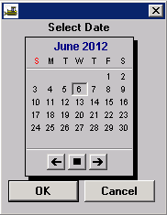
Locked: Automatically entered by system.
Authorized: Automatically entered by system.
Authorized Date: Automatically entered by system.
Temperature: It is not necessary to enter High or Low temperatures for JOC contracts.
Weather Conditions: It is not necessary to enter Weather Conditions for JOC contracts.
No Work Items Installed: Automatically entered by system.
No Contractors On Site: Automatically entered by system.
No Cert Testers on Site: Automatically entered by system.
Work Suspended: MoDOT does not use this field.
Suspended Time: MoDOT does not use this field.
Resumed Time: MoDOT does not use this field.
Remarks: Select the appropriate “Remarks Type” from the list to the left of the Remarks field and enter any necessary remarks. Multiple “Remarks Types” may be selected and entered for the day. Click the “Spell Check” button to run the spell check for remarks.
Note: Occasionally, Spell Check will go to the background when activated. If the DWR appears to be locked after clicking the Spell Check button, select both the “Alt” and “Tab” keys to move to the spell check.
Save the information. Once saved, the Daily Work Report cannot be deleted.

Contractors Tab
Navigate to the Contractors tab to add contractors to the DWR.
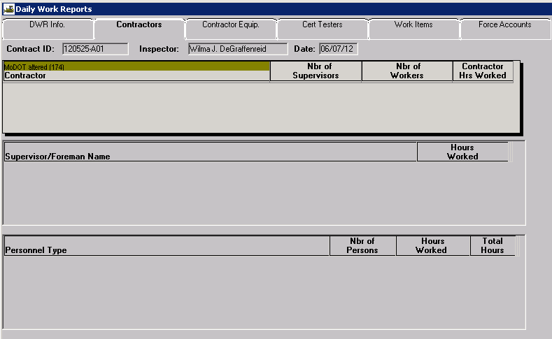
With the focus in the top panel of the window, click the New icon. Select the contractor who was active on the project for the selected date. A contractor must be selected if items are to be entered on the Work Items tab.
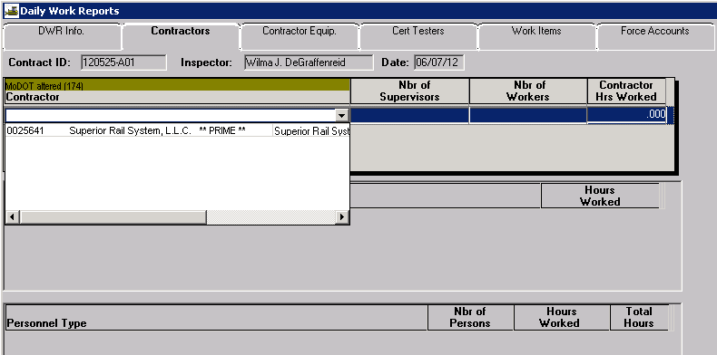
Nbr of Supervisors, Nbr of Workers, and Contractor Hrs Worked: Do not enter anything in these fields. The system will automatically calculate these fields based on data entered in the Supervisor/Foreman Name and Personnel Type panels.
Supervisor/Foreman Name: It is not necessary to enter supervisor/foreman for JOC contracts.
Personnel Type: It is not necessary to enter personnel types for JOC contracts.
Note: The system will not allow a Save if there is a blank line in any area. Should an extra line be inadvertently added, simply highlight the blank line and click the Delete icon.
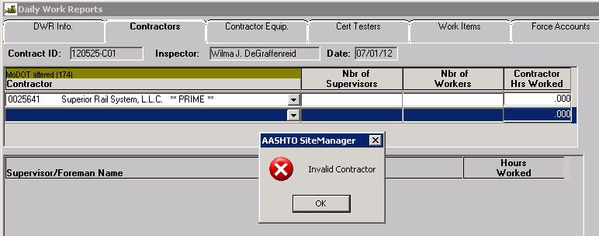

Contractor Equip Tab
This tab will not be used for JOC contracts.

Cert Testers Tab
This tab will not be used for JOC contracts.

Work Items Tab
Click the Work Items tab to access the list of adjustment factors for the contract.
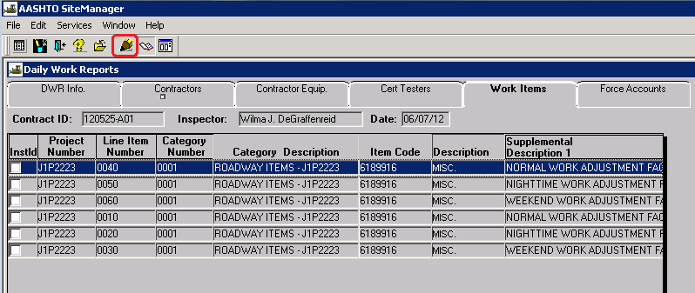
Highlight the adjustment factor for the type of work to be done and click the “Record Work Item” icon or simply double click the item.
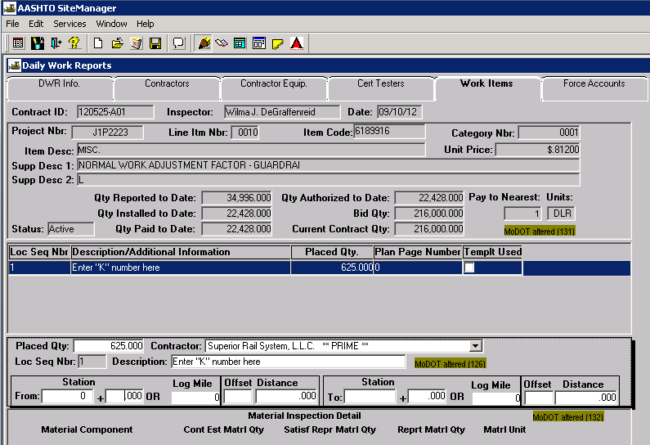
When the Record Work Item window opens, click the New icon, and enter data for the following fields:
- Placed Quantity – Enter the quantity from the Contractor Info Job Order Subtotal field of the spreadsheet, as shown below
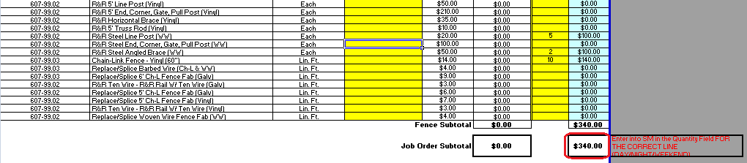
- Contractor – Select the contractor from the drop down
- Description – Enter the property damage claim number (“K” number)
- Stationing or Log Miles – Enter 0 (zero) for station
- Select the Save icon
If additional items need to be entered for the same adjustment factor –
1) Click the New icon to enter a new Loc Seq Nbr
2) Repeat the above-noted steps
If additional items need to be entered for a different adjustment factor or for contingent items, emergency repair, or liquidated damages --
1) Click the Select Work Item icon to select the appropriate work item
2) Click the New icon
3) Repeat the above-noted steps

Authorizing the DWR
Once all final quantities have been entered, the DWR must be authorized prior to payment. Navigate to Daily Work Reports – Diary.
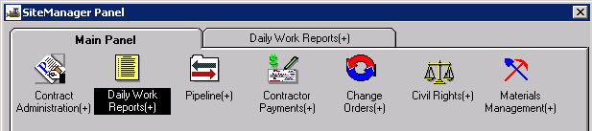
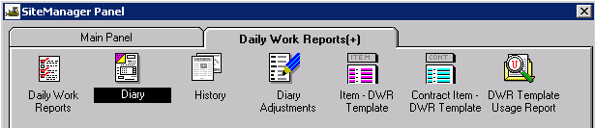
Contract ID: Select Services – Choose Keys to select the contract.
Diary Date: Double click the date field to select a date using the pop-up calendar.
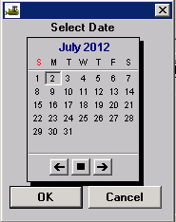
Last Modified User ID: Automatically entered by system.
Creator User ID: Automatically entered by system.
Inspector: The inspector who created the DWR for the Diary Date will be listed. A selected DWR may be reviewed and/or printed by selecting the Preview DWR icon in the toolbar.
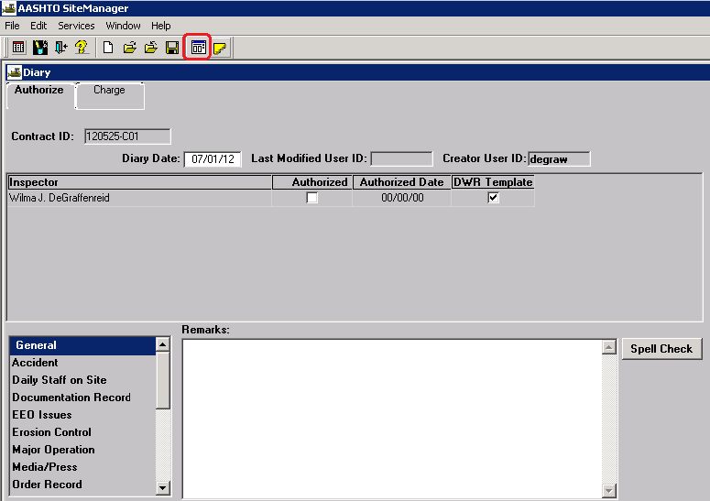
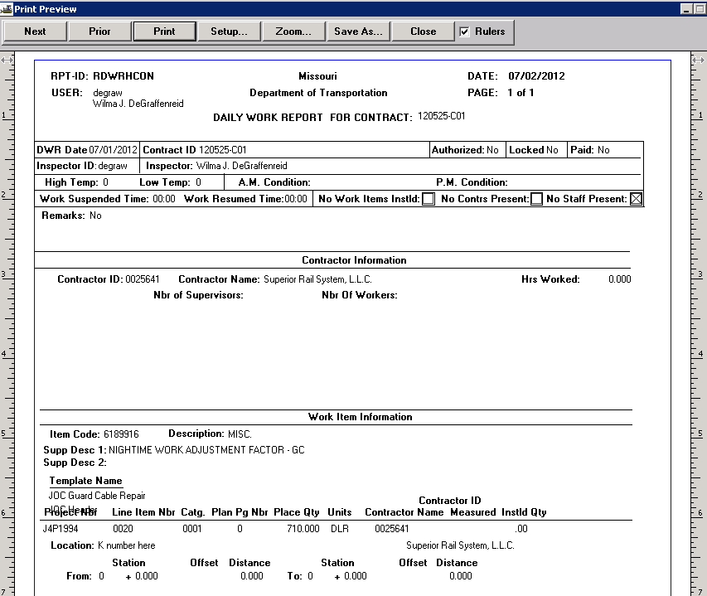
Authorized: If satisfied with the DWR, select the Authorize checkbox
Authorized Date: Automatically entered by system when the Authorized check box is selected.
Remarks: Select the appropriate “Remarks Type” from the list to the left of the Remarks field. Type any necessary remarks. The diary remarks need not repeat the inspector's remarks from the DWR.
Note: Once a DWR has been authorized, no changes can be made to it. However, a DWR may be unauthorized for correction or addition unless it has been included on a pay estimate.
Save the information.
Charge Tab: The Charge Tab will not be used for JOC Contracts.

Generating a Pay Estimate
The Contractor Pay Estimate is generated to provide payment to the contractor for all work performed during the estimate period. The user must be logged on as a Construction Project Manager to generate Progress estimates. The official pay estimates are generated with period ending dates of either the 1st or the 15th (See EPG 109.7.1). Estimates may be generated at any time prior to the estimate ending date in order to check quantities.
NOTE: Estimates can be re-generated without having to delete the previously generated estimate. Should the user need to re-generate an estimate, the system will indicate that an estimate already exists for the period and will prompt, “Would you like to delete?” (meaning to overwrite the existing estimate).
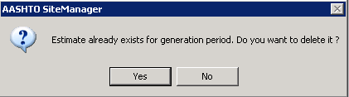
Select "Yes," which will reset the tables and the estimate will be generated with any new data that has been added.
Prior to generating the estimate, verify all DWRs have been authorized in the diary for the estimate period. All pay quantities contained in DWRs for the estimate period that have been authorized on a Diary will be included for payment. Any DWRs that have not been authorized will not be included for payment until such time they are authorized on a Diary.
Navigate to Contractor Payments – Estimate – Generate Estimate.
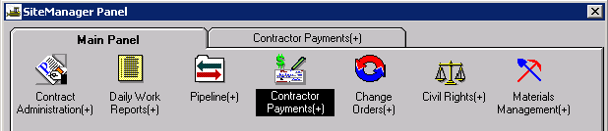
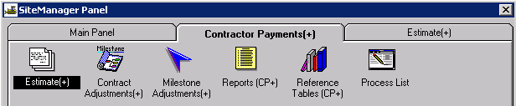
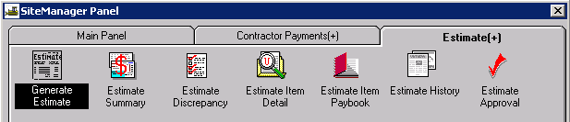

Select the appropriate contract ID from the Contracts Selection window.
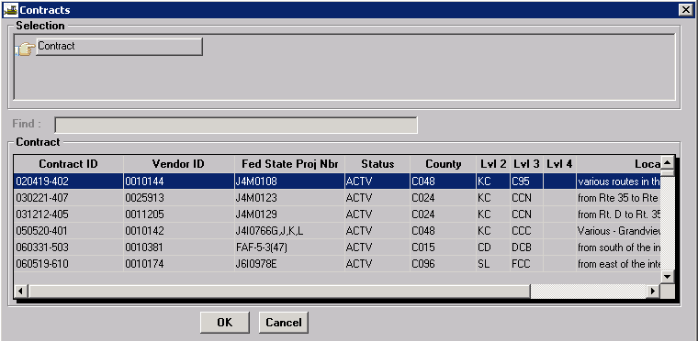

A pop-up box will appear asking for certain information. Read the directions carefully for Critical Dates and populate the date field if the event has occurred. Select the update button. If there are no fields that need to be updated, close the window by selecting the “X” in the upper right hand corner of the window.
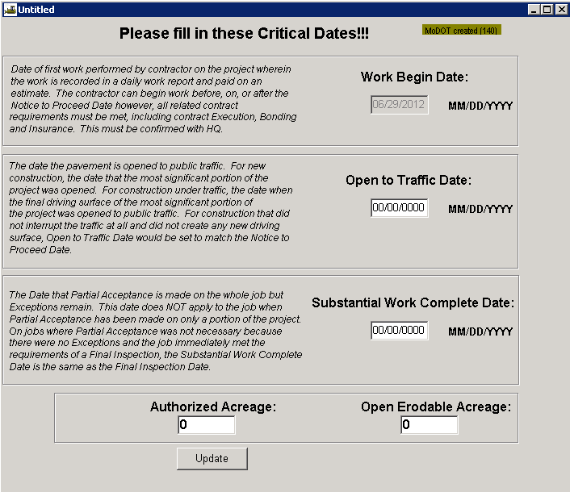
When the Generate Estimate window opens, verify the ending date is correct. If generating an early estimate, select the current date.
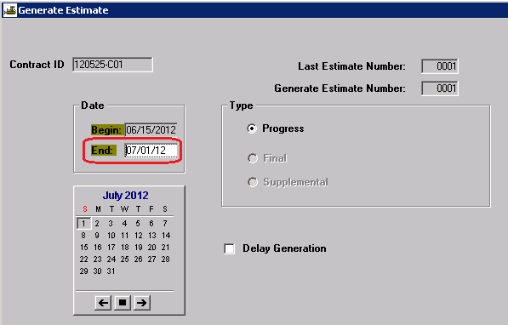
Select the Generate Estimate icon (last icon on the tool bar).
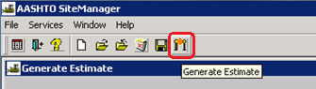
Click OK on the process submission message.
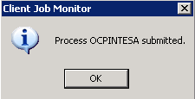
Click OK on the process completion message.
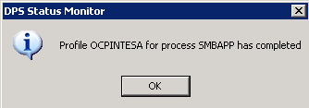
Note: If running in Terminal Services, user will not receive process completion messages. Check process status by selecting “Process Status” from the Services drop down menu.
Once the estimate is generated, navigate to Contractor Payments – Estimate –Estimate Summary.
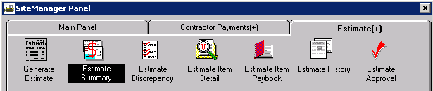
Select estimate just generated.
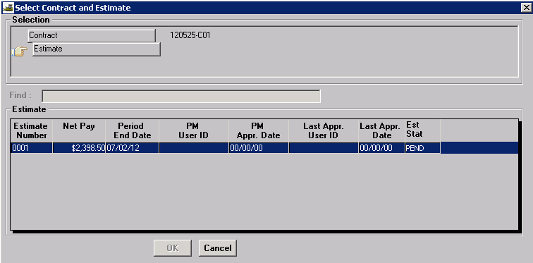
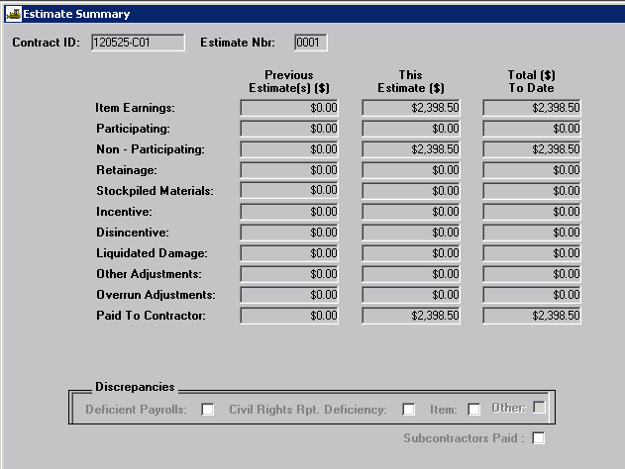
View the Estimate Summary. Once contract amounts are determined to be correct, approve the estimate. A message will be sent to the next reviewer (the Resident Engineer) for approval. The Resident Engineer should review the estimate and approve accordingly. If errors are found at the Resident Engineer level of approval, rejection should be made and the first level approver should correct the estimate and generate/review/approve accordingly.
The last level of approval, Controller's Office, is set in place to ensure generation of all estimates for all active projects statewide, rejection of negative estimates, and creation of the electronic information sent to the Office of Administration in order for the Contractor to receive payment.
Once it is verified that the estimate has been approved at the Resident Engineer level, log on to Cognos 8 and generate the “Estimate Summary for Contract, By Est Nbr with DWR Template Details” report located in the Headquarters > Contract – Estimate folder. This report should be sent to the contractor according to EPG Category 109.7.1.6 and saved as a PDF file in accordance with EPG Category 137.

Note: All documents (JOC Spreadsheet, estimates, etc.) must be saved to the appropriate folders on the V: drive in the following path: V:\Contract Information Archive

