Quick Reference Guide -- Change Orders
This article is intended to guide the user in the creation and approval of a change order.
Navigate to Change Orders – Change Order Maintenance – Change Orders.
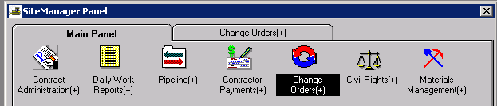
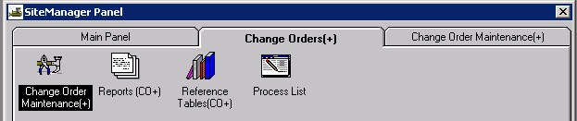
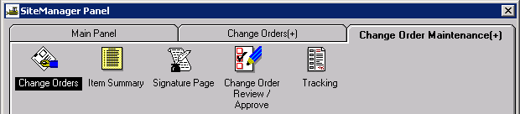

Creating the Change Order Header
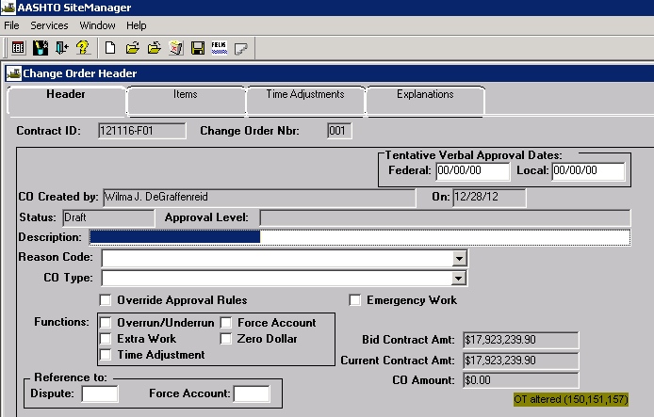
Contract ID: Select Services – Choose Keys to select contract.
CO Number: The system will automatically number the change order.
Tentative Verbal Approval Dates: May be used if it applies.
CO Created By: Automatically entered by system.
On: Date automatically entered by system.
Status: Leave Status as “Draft” until all items and explanations are entered. After all items and explanations have been entered, return to the header tab, change the status to “Pending,” and save. The change order will be forwarded to the appropriate users selected as approvers.
Approval Level: Automatically entered by system based on change order rules.
Description: Enter a brief description of the change order.
Reason Code: Select a reason code from drop down list. “Combination” should be used if multiple reasons apply.
CO Type: Select the appropriate change order type from the drop down list.
Override Approval: Approval rules set up in the system may force higher levels of approval than what is necessary due to the Maximum % of Bid Item Exceeding 999%. When this occurs, the Resident Engineer or delegated representative may override the approval levels and designate the proper level of approval.
Emergency Work: Check if appropriate.
Functions: Selecting the “Overrun/Underrun” function will allow selection of items currently in the contract. Selecting the “Extra Work” function will allow the addition of new line items to the contract. Both functions must be checked if both are applicable to the change order; otherwise, the “New” and/or “Select” icons will not be available on the Items tab.
Note: Do not select the Force Account check box. Force Account functionality in SM is not used because it does not match MoDOT specifications. Force Account items should be treated as “Extra Work.”
The Zero Dollar function is used for change orders with no line items; e.g., Specification changes. This change order type must be overridden to force it to Division approval level (See QRG for Change Orders – Zero Dollar).
Reference To: Dispute and Force Account: These fields are not used.
Bid Contract Amount, Current Contract Amount, and CO Amount: Automatically entered by system based on previously approved change order amounts and current change order amount.

Adding Change Order Items
Navigate to the Items tab. The Items tab allows the user to:
- Select an existing item on the contract for inclusion in the change order
- Add a new item to the contract by including it in the change order

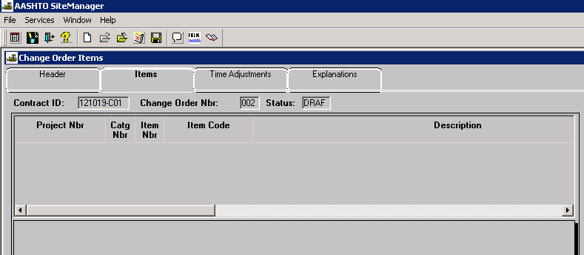

To Add an Existing Contract Item to the Change Order
Click the “Select Item” icon from the tool bar (or Choose “Select Item” from the Services drop down), and select the appropriate item by using the Find function or scrolling to it. Select OK.
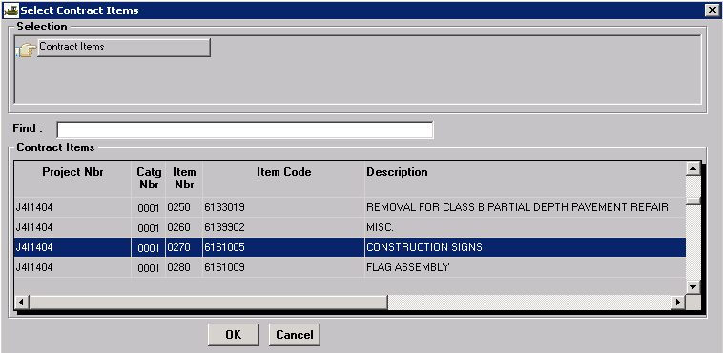
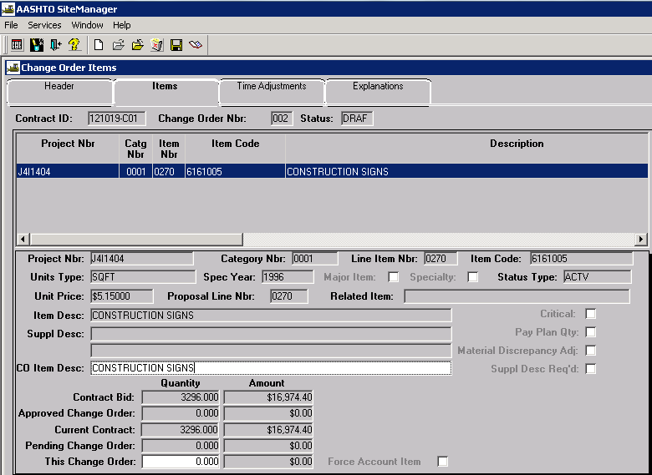
CO Item Description: Automatically entered by the system.
This Change Order Quantity: Enter the quantity of the change. You cannot enter a quantity of zero for a change order item. Underruns must be entered as negative amounts. Save the changes.
This Change Order Amount: Automatically calculated by the system.
Click the Select Item icon and repeat the above steps to add additional existing contract items to the change order.

To Add a New Contract Item to the Change Orde
Click the New icon to add a new line item to the contract.
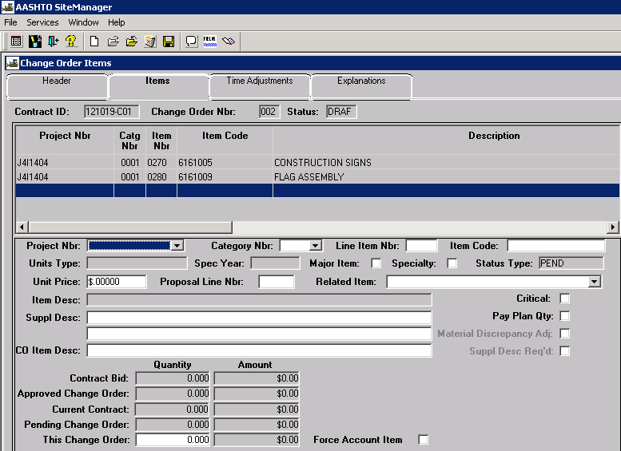
Project Nbr: Select the appropriate project number from the drop down list.
Category Nbr: For funding purposes, select the appropriate category number from the drop down list.
Line Item Nbr: The first instance of a new line item number for the New Contract Item will begin with 5001 for the first project in the contract. If multiple projects are associated to the contract, the line numbering will begin with 5101 for the second project, 5201 for the third project, 5301 for the fourth project and so on. New contract Line Item Numbers shall be sequential per project, regardless of the category.
Note: It is possible for line items to be numbered beyond 5000 on large contracts. In this instance, begin numbering with the next available option, e.g., 6001, 7001, etc.
Contingent Items added to a contract which are due to specification changes, shall be added as one number greater than the original contract line item number. For example, if there was a specification change to contract line item 0050, the new contingent line item number would be 0051.
Item Code: Perform a search and select the appropriate item code. There are some “catch all” item codes, but the units must match or the calculations will be incorrect. If you cannot find an item code that is relatively close by searching the Item Code field, one can be added by the SM Administrator.
Hint: Item codes follow the Standard Specifications. For example, all item codes for earthwork will begin with 200. Find the specification number closest to the item code available from the spec book. Search the Items window by Unit to find all of the Units available for that item. Choose the item code that matches the unit and is as close to the description as possible. There is usually a “Misc.” description that will match. If you cannot find a match, send an email to ReDEV.
Major Item: Check if it applies.
Specialty: Check if it applies.
Unit Price: Enter the unit price for the item.
Proposal Line Nbr: Enter same value as Line Item Nbr.
Related Item: This field is not used.
Critical: Do not check this box. MoDOT does not use “critical” as defined by the system. SM tracks items marked as critical for determining completion percentage; MoDOT tracks the percentage complete based on dollar value.
Pay Plan Qty: Do not check this box. If checked, it will not be possible to overrun this item above this change order amount.
Supplemental Descriptions: Short description for the item if necessary.
This Change Order Quantity: The quantity of the change. You cannot enter a quantity of zero for a change order item. Underruns must be entered as negative amounts. Save the changes.
This Change Order Amount: Automatically calculated by the system.
Force Account Item: Do not select this box.
Once all data is entered, save the information. Repeat the above steps as necessary to add additional contingency items to the change order.

Adding Change Order Explanations
Click the Explanations tab to add change order explanations.
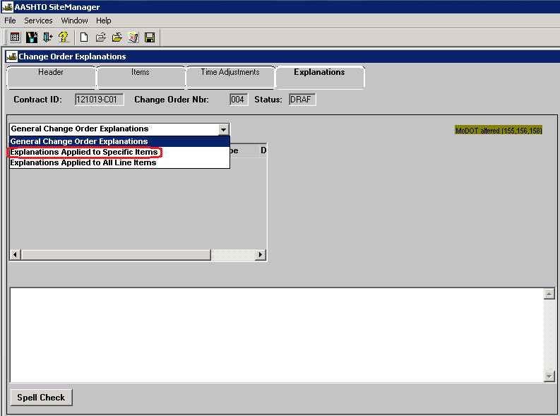
With the exception of Zero Dollar and/or Time Adjustment change orders, Change Order Explanations must be assigned to specific line items. Select "Explanations Applied to Specific Items" from the drop down list. This will open the Change Order Line Items panel on the right side of the window.
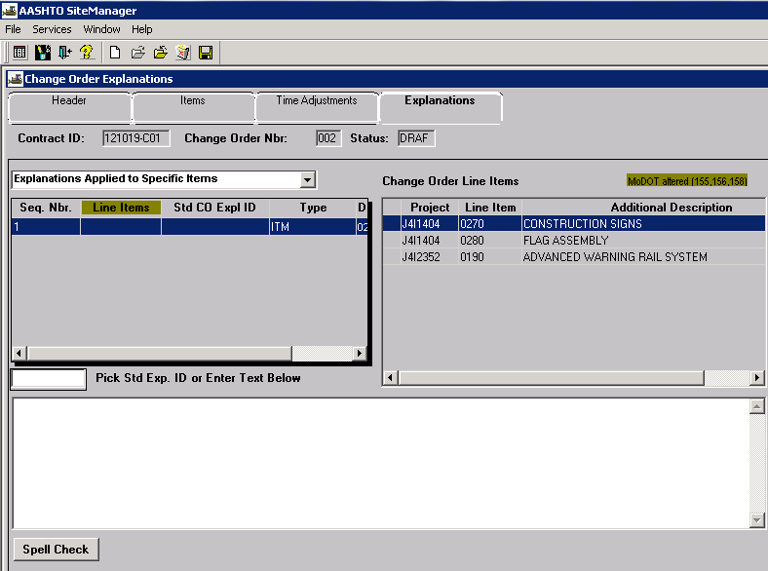
Click the New icon for the first Seq. Nbr. and type the change order explanation in the text field.
Explanations must begin with the following: Reason Code - Line Number - Description - Overrun or Underrun: Reason. For example: RA - Line No. 0010 - Removal of Improvements - Overrun: Begin typing the reason....
The standard Reason Codes to be entered are as follows:
AD | Administrative Decision
AP | Alternate Pavement
AT | Alternate Technical Concept
BV | Best Value
CD | Consultant Design Error
CS | Claim Settlement
DC | Design Change
DE | Design Error
DF | Differing Field Conditions
DS | Differing Site Conditions
IE | Inspection Error
ND | Natural Disaster
PD | Practical Design Value Engineering
PP | Prompt Payment
RA | Routine Adjustment
UD | Utility Delay
VE | Value Engineering

Definitions and examples for the codes may be found at the following link: Change Order Codes
The system will assign a sequence number as shown in the left hand window.
New Feature: Click the Spell Check button to check the spelling of the explanation.
Once the explanation has been typed in the lower window, it must be associated to the appropriate change order line item in the right hand window by double clicking the line number. A green check mark will appear once the explanation is associated to a line number.
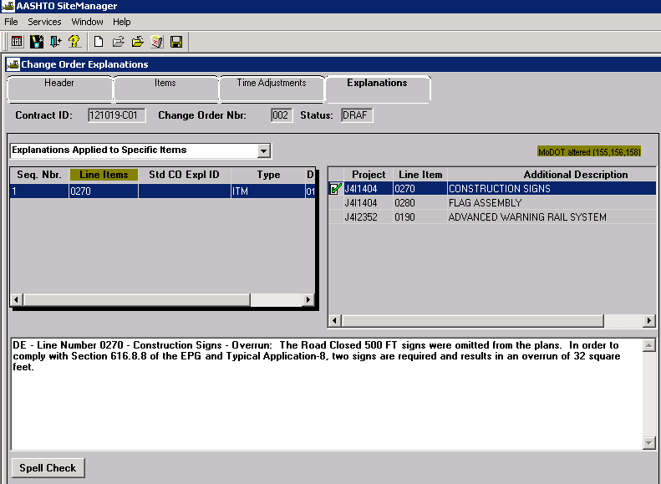
If a new contingent item is added to the change order, enter the "Settlement of Costs" statement at the beginning of the reason, immediately following the item description. For example: AD - Line No. 5002- Flashing Arrow Panel - Extra Work: Settlement of Costs based on the agreed price of $52.50 per each. Begin typing the reason.
Note: Once the reason code is selected for a contingent item, the user shall use the same reason code for any and all subsequent changes to the contingent item of work, including routine adjustments.
Due to the way MoDOT’s reporting software (Cognos 8) works, a change order explanation cannot be associated to multiple line items.
When a change order reason affects multiple line items, a detailed description of the change must be entered for the first line item. All subsequent line items must then be entered. However, the same level of detail is not required and can reference back to the first line item reason. For example:
VE - Line No. 0020 - Class A Excavation - Overrun: The contractor submitted a Value Engineering Proposal henceforth known as VE No. 2. The proposal is to eliminate the Aggregate Base, Stabilized Permeable Base and Edge Drains and substitute 12 inches of Rock Fill Base. This proposal was reviewed by MoDOT's Pavement Engineering experts and met their approval. The Value Engineering proposal was approved August 3, 2007. In order to install 12 inches of rock fill, additional Class A Excavation will be generated.
VE - Line No. 0040 - Compacting in Cut - Underrun: Same as Line No. 0020.
VE - Line No. 0060 - Stabilized Permeable Base (4 In. Thick) - Underrun: Same as Line No. 0020.
VE - Line No. 0070 - Type 5 Aggregate for Base (4 In. Thick) - Underrun: Same as Line No. 0020.

Changing the Status of a Change Order
Once all items and explanations have been added to the change order, the user must return to the Header tab. User may choose to “Calculate Change Order” from the Services drop down menu to make sure the user selected CO Type matches the system calculated Approval Level. If not, change the CO Type to match Approval Level.
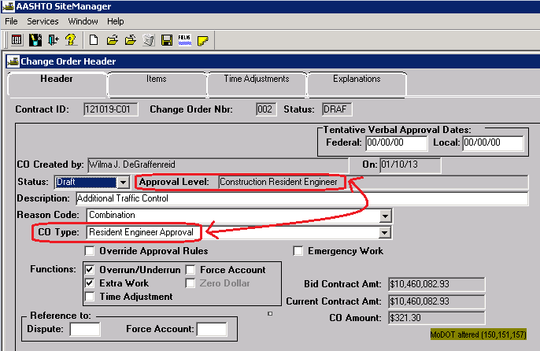
Note: If the system forces a higher level of approval than what is necessary due to rules set up in the system, the Resident Engineer or delegated representative may override the approval levels and designate the proper level of approval.
Change the status from “Draft” to “Pending” and save. Make the appropriate selections for each approval level, and click OK.
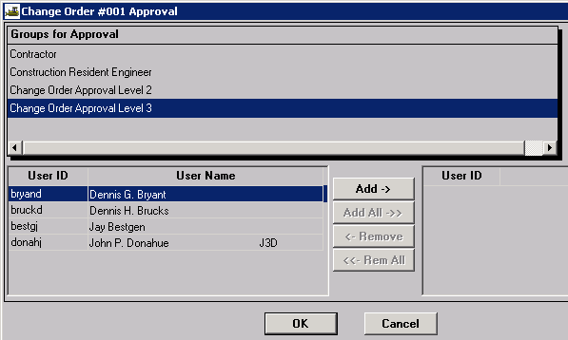
If the approval levels have been overridden, the user will be required to make the appropriate selections for both “Groups for Approval” and users as noted below. Once the selections have been made, click OK.
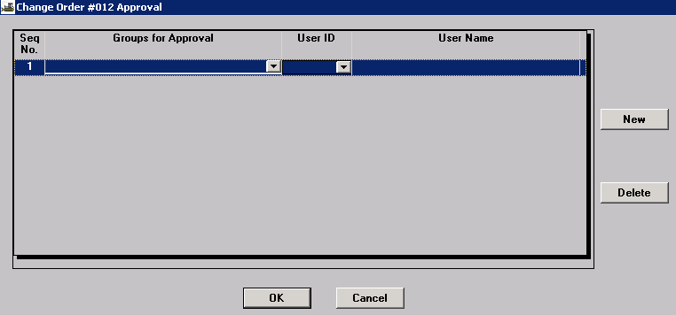

Deleting a Change Order
To delete a change order, the explanations must be deleted first, and then the items must be deleted before the header information can be deleted. A change order which has been approved cannot be deleted.

Printing a Change Order
To print the Change Order report, refer to the Change Order Reports Quick Reference Guide.

Saving a Change Order
The system updates the header information of reports each time an estimate is generated. SM also does not automatically save a report when you close it. If a report is generated on a certain date and the report is not saved, the next time that same report is generated, the header information will be for the date that it is generated. Therefore, you must save the report as either a PSR (PowerBuilder-based SM Report) or as an Adobe PDF. This is required so the header will correctly reflect the contract information at the time of the report was created. Be aware, however, reports with a .PSR extension can only be opened in SM.
Policy: Save SM change orders in .PDF format to the V: drive in the following path for your district and org code: V:\Contract Information Archive\District # \ ORG # \ Contract ID \Change Orders\Pending. (See Note below.) File name should include the change order number placed within the file name so the change orders will sort properly when listed in the folder. See example below:
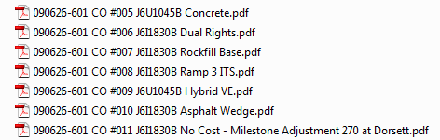

Once the change order has been approved at all levels, it shall be saved with all attachments in a single file to V:\Contract Information Archive\District # \ ORG # \ Contract ID \Change Orders\Completed.
Note: When distributing a change order electronically for signature, it should be stored with all attachments in a single file in the “Completed” change order folder and linked from there. Once the last digital signature is applied, the process is complete. No further action is necessary on the part of the project office, that is, there is no movement of the document from one folder to another.

Approving a Change Order
From the Main Panel, navigate to the change Orders – Change Order Maintenance - Change Order Review/Approve icon.
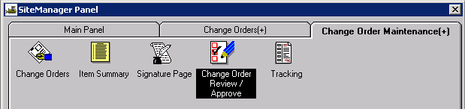
Select the appropriate contract and change order from the Selection windows.
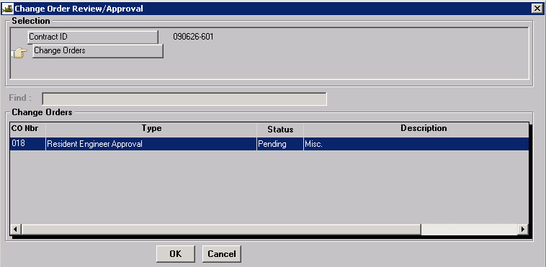
Select either “Approve” or “Denied.” Additional remarks may be added to the Remarks bubble if desired. Select the Save icon. The system will send a message to the SM inbox of the next user in the approval cycle.
