«Commission_Approval»

«VendorName»
«AddressLine1»
«City», «State» «ZipCode»

SUBJECT: Award of Contract and Notice to Proceed
Job #«Job_Numbers», Route «Route», «County» County
Contract I.D. # «Letting_ID»-«Call»

To Whom It May Concern:

The Missouri Highways and Transportation Commission has awarded a contract to you for the above designated project(s) in the amount of $«AwardedAmount», as determined from your bid submitted at the bid opening of «Letting_ID».

MoDOT will send the contract via email to sign electronically through DocuSign to the awarded contractor. After the contract is executed by all parties, MoDOT will email a pdf of the executed contract to the contractor through Bid Express®. The original executed contract will be kept at MoDOT’s Construction and Materials Division in Jefferson City, Missouri. The Contract Agreement pages will be the last pages of the contract.

The Contract Bond and Contract Acknowledgement shall be retrieved from Bid Express® and executed. If an agent or attorney-in-fact signs for either the surety or contractor, a current power of attorney under seal must be provided with each copy. NOTE: The ORIGINAL partially executed contract should be executed no later than (15) calendar days after the date the unexecuted contract was emailed.

If delivered by U.S. Mail, mail to: If delivered by parcel services (such as UPS, FedEx, DHL, etc.), mail to:

Missouri Department of Transportation Missouri Department of Transportation
Attn: Design Division Attn: Design Division
P.O. Box 270 105 W. Capitol Ave
Jefferson City, MO 65102 Jefferson City, MO 65101

Please contact Amanda Haynes at Amanda.Haynes@MoDOT.mo.gov or (573) 751-7460 if you have any further questions.

The date for the Notice to Proceed on this contract will be «Start_Date». You may not proceed to perform any contract work until you have received a notice that the Commission has executed the contract and you have furnished the Commission with appropriate evidence that you have the liability insurance required by Section 107.13 of the Missouri Standard Specifications for Highway Construction.

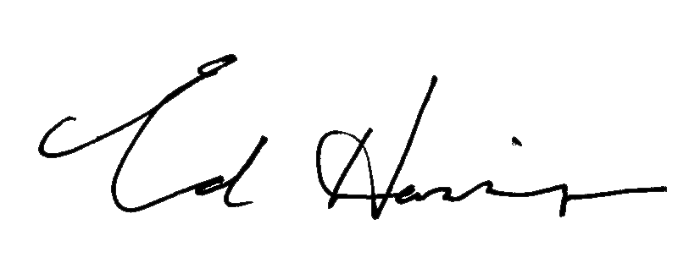
Sincerely yours,

Ed Hassinger, P.E.
Chief Engineer

