Contents Page
Introductions ………………………………………………………. 2
Internal/External Login Page Instructions …………….. 3
Create New Request Instructions ………………….……… 6
Request Search Instructions …………………………………. 8

Or here is a video link that walks through the registration instructions – this video was made for the RER, but instructions are the same for registration to use RES

Request for Environmental Services (RES)
How to Complete the Request for Environmental Services
Why Submit the RES Form?
Every federally funded transportation project must have an environmental NEPA classification.
- Most project receive a categorical exclusion commonly known as a CE
- The form also helps the environmental specialists at MoDOT identify additional clearances that might be necessary.
When Do We Submit the RES Form?
- Submit the RES within 30 days of PE obligation or early in the design phase of the project.
- FHWA must approve the NEPA classification prior to 35% plan completion.
- The Section 106 clearance & NEPA classification must be approved before Right of Way acquisition can begin.
Request for Environmental Services Instructions
MoDOT Employees will login with their system login and password then select “MoDOT” (MoDOT employees do not need to register)

For External Login
- The RES form link in EPG 127.1 will bring you to the new Login Page.
- Click on the “Not Registered? Click here to Register” link and complete the registration for your Company for first time access to the RES system.
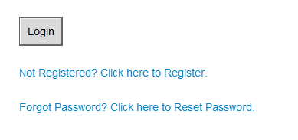

- Enter Company information along with a company email, then create a password for administration access. Click “Continue”
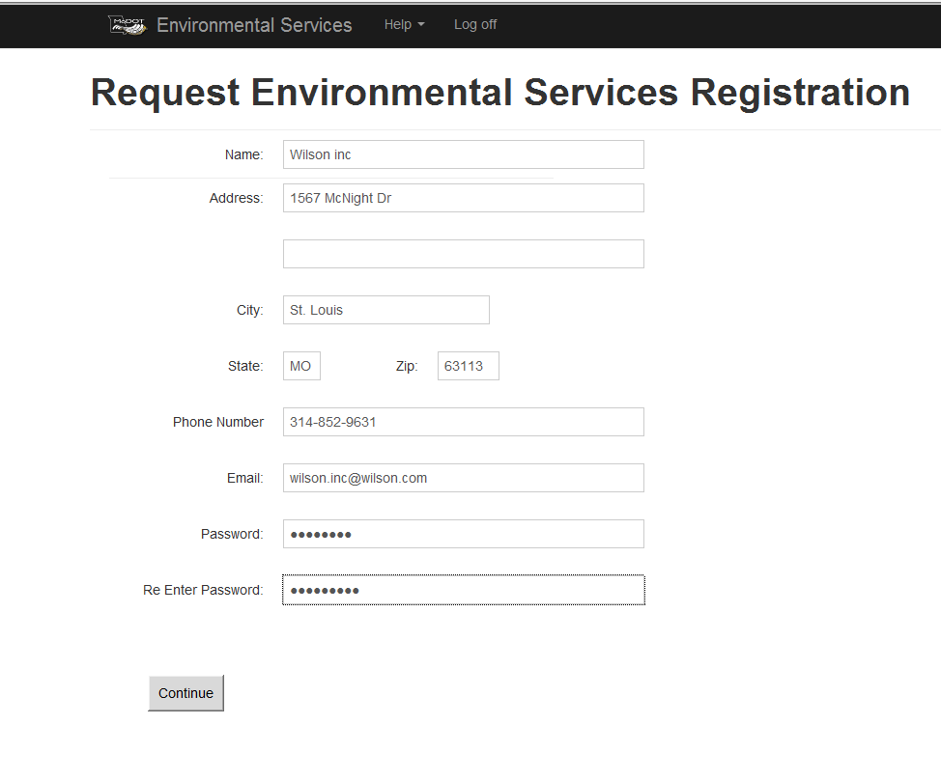

- The next step is the section that you will add Representatives including yourself for your Company, that will have access to process projects for submittals to MoDOT. It is required to add Representatives here in order to edit/view/create the RES form. Even if you registered on the previous screen, you must add yourself as a representative in order to edit/view or create an RES. Representatives will not be required to register once an administrator adds them to the system.
- Then you will need to “Add Project” to each responsible Representative in order to edit/view/create the RES form. Only administrators can add projects to a representative. (example: John and Jane need to view the same project, then you will want to add this project under both Representatives in order for both to edit/view/create the RES form.)
- You must enter the job number without the J and use capital letters (example: 4S3135). If not entered exactly like this you will not be able to see the RES you created after it is submitted. 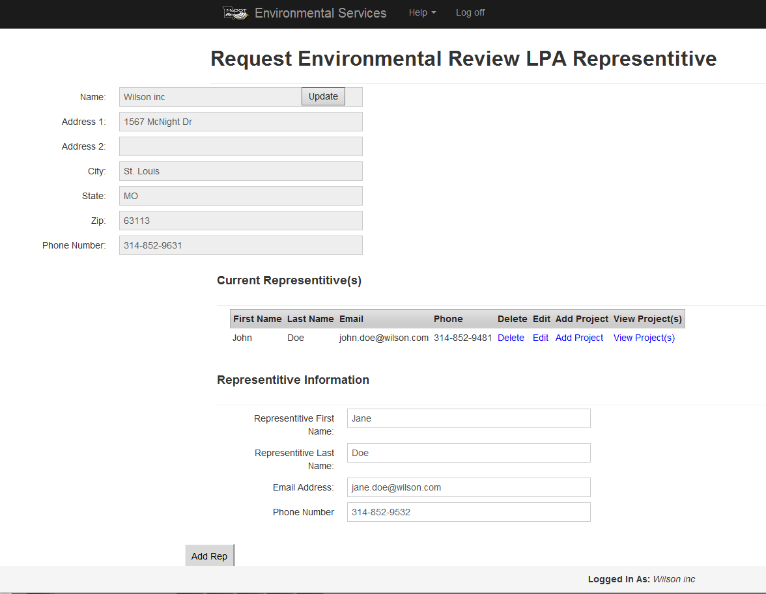

- Once all the Representatives are added to “Current Representatives” the administrator can log off to exit the system.
- Each Representative will use their email address and must use “Password1” the 1st time they long on. Then select “Rep” in the drop down box to login. Once “Login” is clicked they will be prompted to change their password.

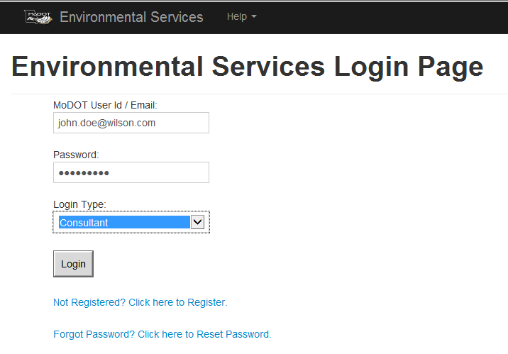

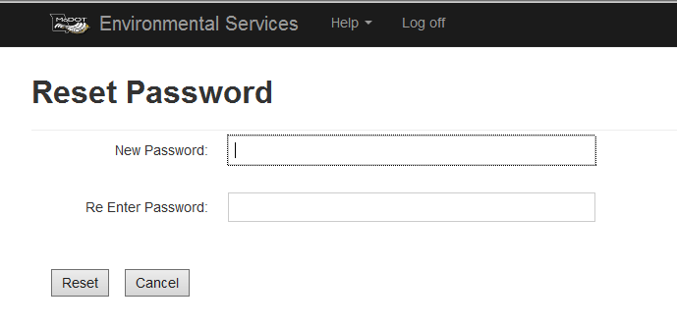

- Once you have successfully changed your password, the Representative will be able to “Create New RES” or only see the projects that have been assigned to that Representative. Any project not assigned to a Representative will not be able to review or edit the RES form
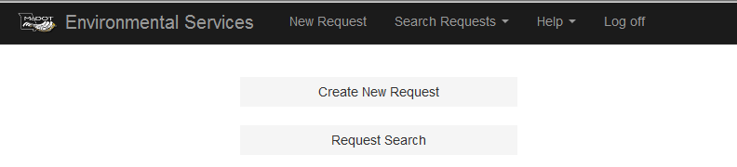

Creating New RES Request
- Enter the Job Number provided to you to make it 6 characters (example 4S3135). The project number should pop up after the 5th number is entered and can be selected to auto populate some information for you.
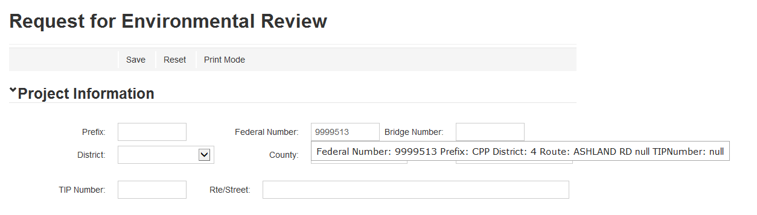

- When the Job Number is selected:
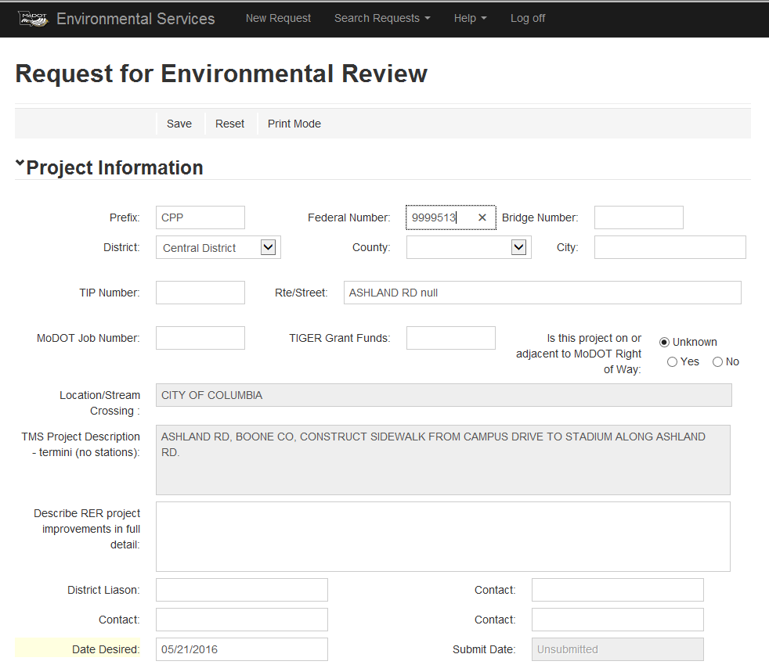

- Please fill in all information correctly.
- County – if there is more than one County associated with the Federal Number, you will need to select “Various” for multiple counties. You can add the counties to the description box as information to the project.
- There are 2 project description boxes – 1st is the pulled information already in system and the 2nd description is for you to enter more detailed information.
- There are multiple required fields that need to be completed before the document will save. The required fields are: County, District Liaison, Acres (Additional R/W, Temp Easement, Permanent Easement), Acres of Tree Clearing, both Bicycle / Pedestrian consideration, and Project is in a FEMA-defined “floodway”.
- At the bottom of the form, there is a Browse button that allows you to select plans, maps, pictures, or any other electronic document. After attaching the documents click the “Save” button to upload the documents. If a form has been submitted an “upload attachment” will need to be clicked in order to upload the documents

- After you have completed the form and saved, it will bring you to the top of the form where you will click “Submit Request to Environmental Services.” This generates an email to the appropriate MoDOT Environmental Specialists assigned to your District identifying the project and containing a link to the log on screen. The Project Manager (PM) for MoDOT should be auto-populated when the job number is entered, but you may enter any MoDOT employee as a “contact” and the PM and all contacts will receive the email link as well.
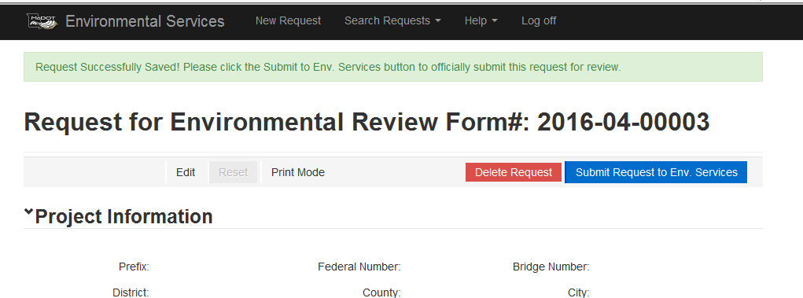

- After RES submittal
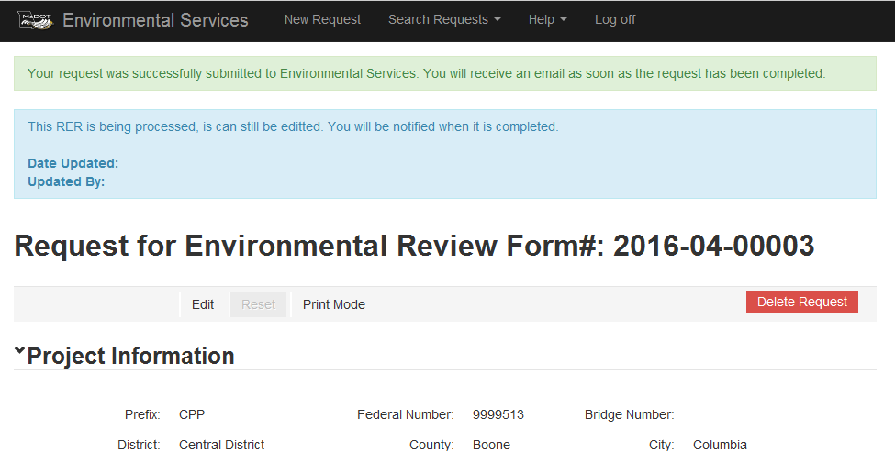

- After the Environmental Specialists have reviewed the RES, the Specialist will click a “Submit to District” button that will send an email automatically back to the “Submitted by” and the District Contacts with a link specifying which RES project was reviewed. (This link will take you to the login screen). Login to the RES system and the form will open.

- There are 3 colors for the review process:
- Yellow – means it has not been looked at
- Blue – means there are issues that need to be completed
- Green – means it is cleared
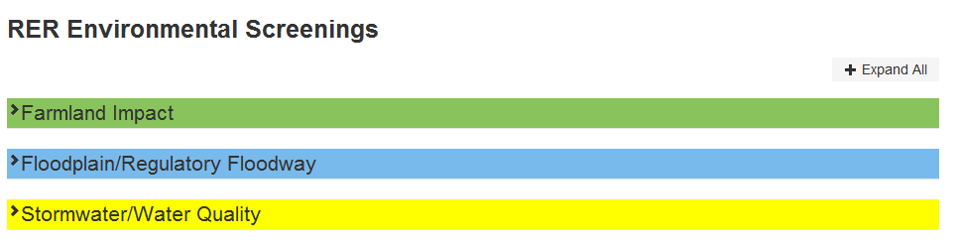
Request Search
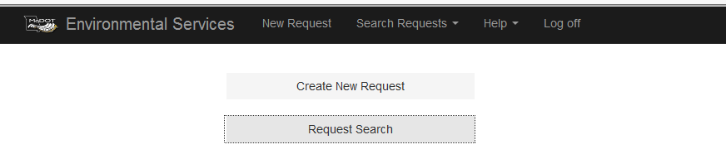
- There are many ways to search for the project you need.
- Request # - is the number that is created when you save a new RES request
- Job Number – is the 6 digit number that was provided to you (example: 4S3515)
- District – is the 7 MoDOT District Offices
- County
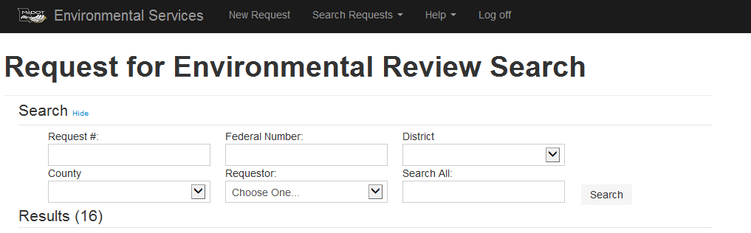
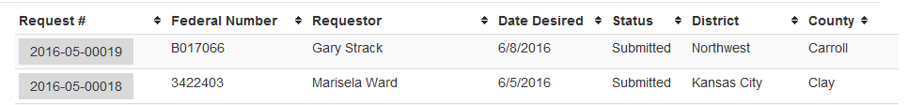

- IF there is ROW, the NEPA Classification Section is where you will find the dates needed for A-Dates (NEPA and SHPO/4(f)). For the A-Date form use the same date for SHPO and 4(f).
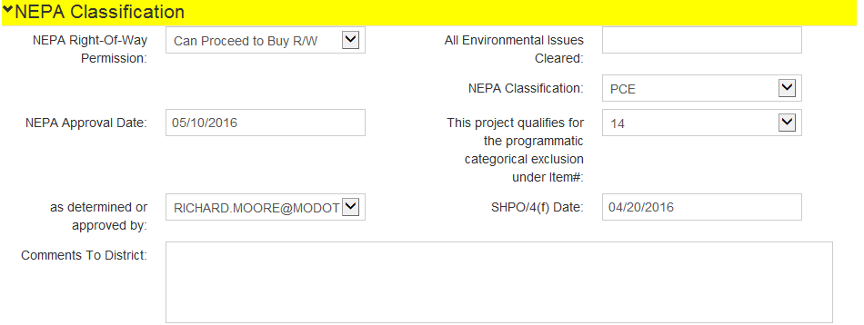
- You will be able to make edits after you have submitted the RES form and before the RES form has been finalized by the MoDOT Specialists assigned to your County. You will need to click the “Edit” button, make the necessary changes, click “Save” and then an edit email will be sent to MoDOT contacts.
- You may contact Richard Moore at (573) 526-2909 or Charlotte Drinkard at (573) 526-4778 if you need further assistance with the new form.

