Quick Reference Guide – to CAPTURE A Signature Image

Version 02/10/2011

These instructions are based on Adobe Acrobat Pro 7.0.5 and may not be applicable to other versions.

0) This guide will typically only be used once by a particular person. Subsequent digital signatures may be applied according to the instructions in the “Quick Reference Guide for ROUTINE Adobe Digital Signatures.

1) This process assumes that a person is authorized to sign documents based on the person’s title, or the person has been delegated to sign documents for the authorized person.

2) Scan an image of the authorized person’s signature into any software capable of capturing an image or picture. This is most easily done by having the authorized person sign a blank sheet of paper, then scanning the page and sending the scanned image to yourself via email, or whatever method your scanner supports. You may want to have the person sign the page several times and select the best version.


3) Paper signed

4) Scan and send the image to yourself (steps 4 and 5 depend on the equipment and software you have available.

5) Image arrives as email attachment or by other means.

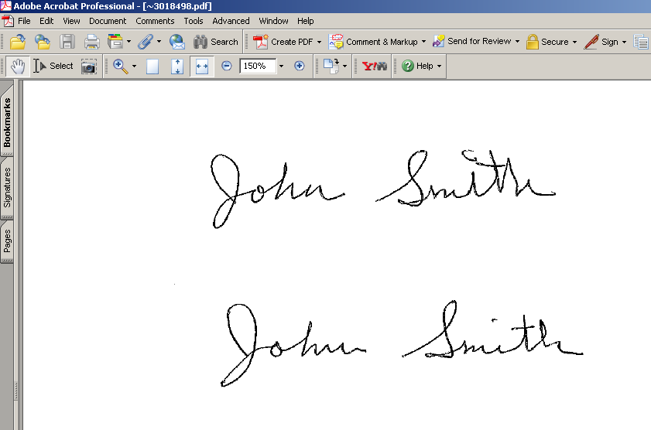
6) Open the image.

7) Use PrintScreen to initiate the PrintKey software, then select the Rectangle tool and capture just the signature from the page. You will be returned to the PrintKey software. (Alternate software may be used to capture an image of a signature. See the instructions for that software, for help. Your goal is to create a bitmap file (.BMP) that is an image of your inked signature and ONLY the white space immediately surrounding it.

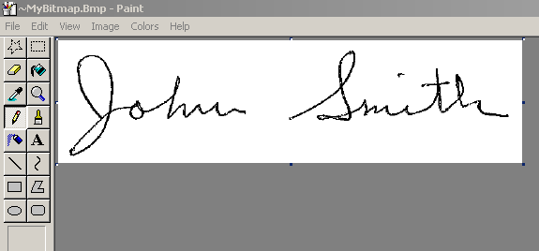
8) Select the Edit tool. The area you captured in step 7 will be displayed in a bitmap editor “Paint”.

9) Click – File – Save As – and enter a name for the file like “Signature”, or “<person’s name>Signature Image” and select a location that you can find again easily, like Desktop or My Documents. You can close the bitmap editor “Paint” and the “PrintKey” application. You are done with them for now.

10) Open Adobe Acrobat Professional.

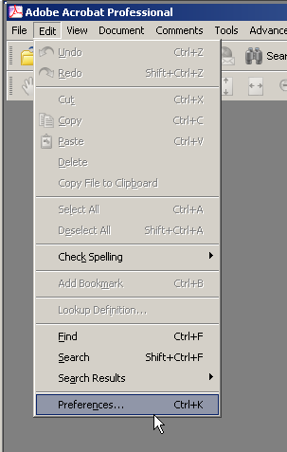
11) Select Edit Preferences.

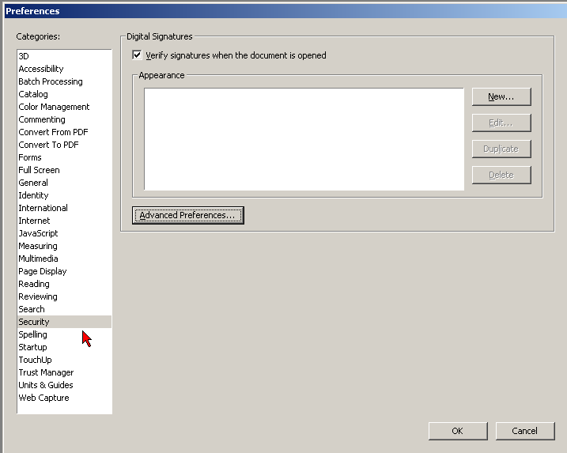
12) Select Security from the first column, then New. 

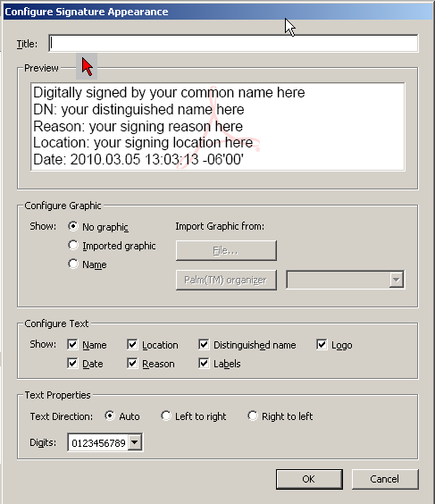
13) Enter a Title for the signature image. Recommended is to use the person’s name plus the word signature, with no spaces. For example “JohnSmithSignature”

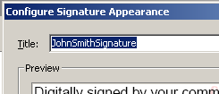
14) Example.

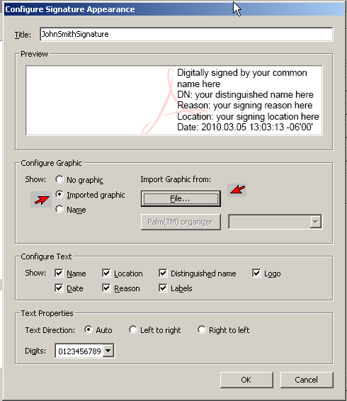
15) Click “Imported graphic”, then the “File” button.

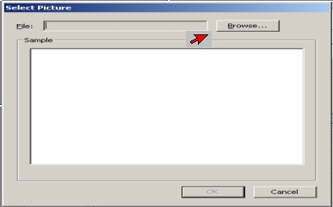
16) Click Browse and navigate to the location where you placed the “signature” file when you saved it in Paint, step 9 above. Because you saved the image as a .BMP, you will need to change the File Type to .BMP in the Browse window. (If you used a different means of capturing the signature you may need to select an alternate File Type.)

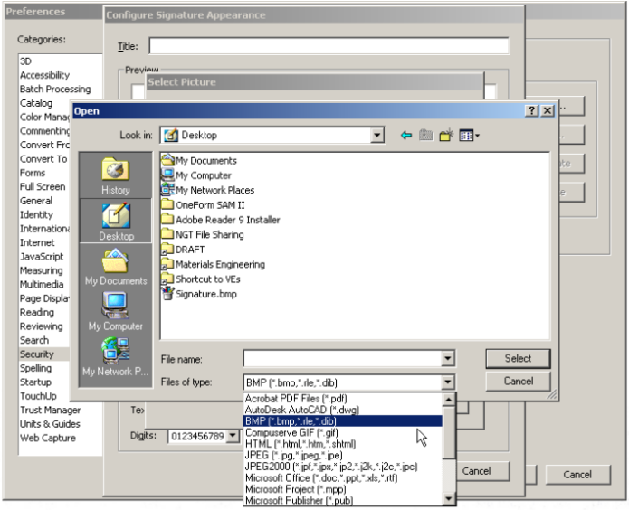
17) Select the file type and then Select the signature file (based on whatever you named it.)

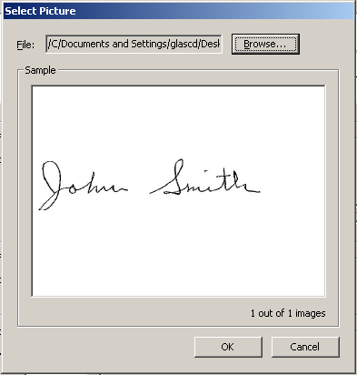
18) The window will display the signature image you created. If it is what you expect, Click OK. If you selected the wrong file, you can browse again.

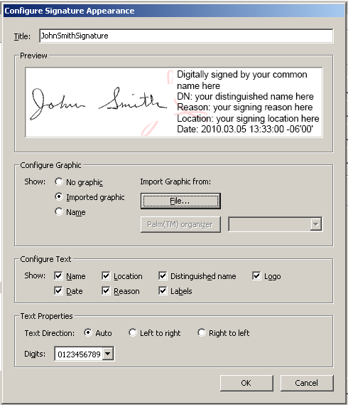

19) UN-Check the Reason box. Click OK.
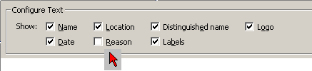
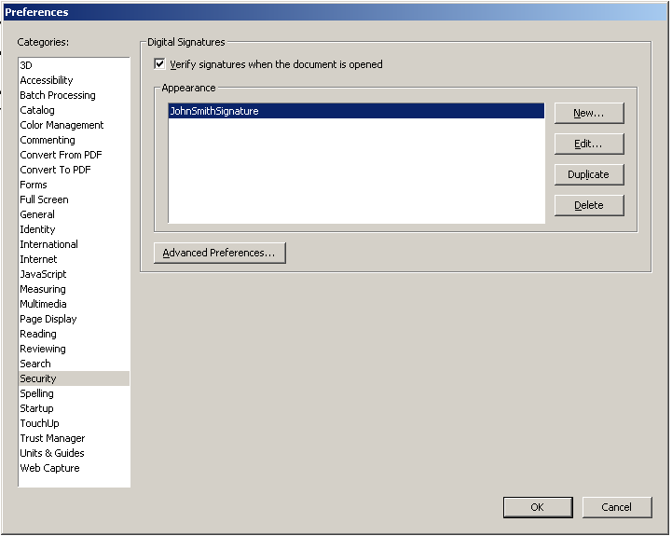
20) There will be a new row in the Appearance box. Click OK.

Now you have an image of the person’s signature that will be incorporated into the digital signature that will be used to sign documents.

This was step one of the process. This is typically done only once.

Step two is to read the Quick Reference Guide “to set up Digital Signature”

