Quick Reference Guide – Concrete Mix Design Creation
Version: 11/18/2010

Concrete Mix Designs will be maintained by the district. The contractor will submit mixes on the standard submittal form for Materials to approve. Upon approval, the mix design will be assigned a mix number and entered in SiteManager. It must be entered before a sample record can be generated using the mix number.
To enter a Concrete Mix Design navigate to Materials Management.Mix Design
Select Portland Cement Concrete Mix Design from the Mix Design options.
Description Tab
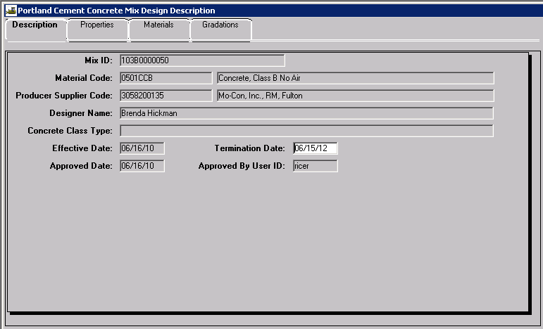
Assign a Mix ID. Each mix design gets a unique identification number. This following format is recommended however, the district may select some alternate identification as long as it is uniformly applied within the district: YYDMIXT####OPTNL. YY = year, D = District (0 for District 10), MIXT = mix type, #### = 4 digits counting up from 0001 (you may start with other numbers), and OPTNL = optional characters at the discretion of the District. Only 15 characters are allowed.
Example: 103B0000050 - 11 characters are required - This format was established by District Materials representatives to provide some uniformity for contractors.

10 For year 2010 (Required - Note that the mix need only be re-entered when the characteristics change)
2 For District 1 (Required)
B000 Code for Class B No Air *see below - required
0050 - mix number 50 for 2010
Codes for concrete mixes Material Code
CSPB Cement Stabilized Permeable Base 0302PBCS
C13G Concrete, 1-3 Grout 0501CC13G
C15G Concrete, 1-5 Grout 0501CC15G
A10A Concrete, Class A-1 w/Air 0501CCA1.A
A1HP Concrete, High Performance A-1 w/Air 0501CCA1HPA
B000 Concrete, Class B No Air 0501CCB
B00A Concrete, Class B w/Air 0501CCB..A
B100 Concrete, Class B-1 No Air 0501CCB1
B10A Concrete, Class B-1 w/Air 0501CCB1.A
B20A Concrete, Class B-2 w/Air 0501CCB2.A
B2HP Concrete, High Performance B-2 w/Air 0501CCB2HPA
B2MD Concrete, Modified B-2 w/Air 0501CCB2MDA
COMO Concrete, Commercial 0501CCCOM
FB00 Concrete, Flowable Backfill 0501CCFB
LATX Concrete, Latex 0505CCLATX
LOSL Concrete, Low Slump 0505CCLOSL
PA0A Concrete, Pavement w/Air 0501CCPA.A
PHEA Concrete, Pavement HES w/Air 0501CCPAEA
PHFA Concrete, Pavement HF w/Air 0501CCPAFA
PAQC Concrete, Pavement w/Air accepted by QC\QA 0501CCPAQCQA
PAVR Concrete, Pavement & Deck Repair w/Air 0501CCPARA
PAOP Concrete, Pavement Optimized 0501CCPA.OPT
SEAL Concrete, Seal 0501CCSEAL
CCSF Concrete, Silica Fume 0505CCSF
SPEC Concrete, Special, misc, or unusual use 0501CCSPEC

Note: Once you have saved a Mix ID, the Mix ID cannot be altered. BE CAREFUL.

- Material Code: Select the appropriate mix type. Usually, the code will start with 0501 then use the search lense. This lessens the number of codes you must look thru. To use the search lense (move the mouse over the field and wait for the cursor to change to the appearance of a magnifying glass) then right click and select search or filter search.
- Producer Supplier Code: The Ready Mix plant or the contractor submitting the mix.
- Designer Name: This field is optional. If you want a record of who designed the mix, fill it in. It could be helpful if questions for the designer arise.
- Concrete Class Type: Left BLANK because it is already set in the Material Code.
- Effective Date: The day the mix is approved and considered valid for use.
- Termination Date: The date you want the mix to expire. It should not be left blank. Typically aggregate characteristics are updated every three years. The mix design should be reviewed at that time. If the mix is still valid, the Termination Date can be reset without reentering the mix.
Properties Tab
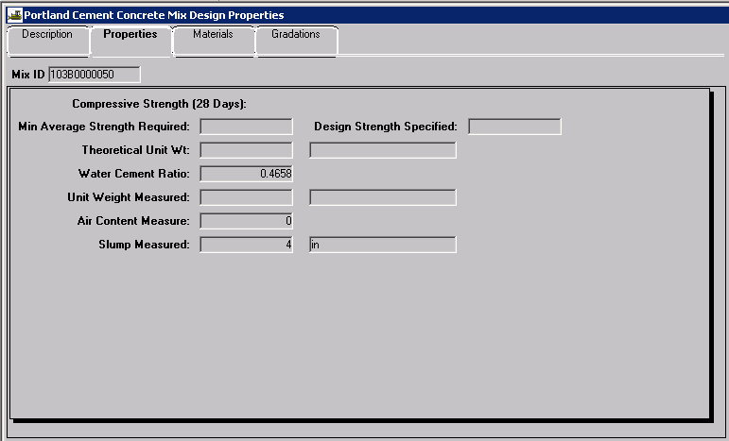
Leave fields blank with the exception of the following:
- Water Cement Ratio: Fill this in. Use the value from the contractor's submittal.
- Air Content Measure: Fill this in. Use the value from the contractor's submittal.
- Slump Measured: Fill this in. Use the value from the contractor's submittal.

Materials Tab

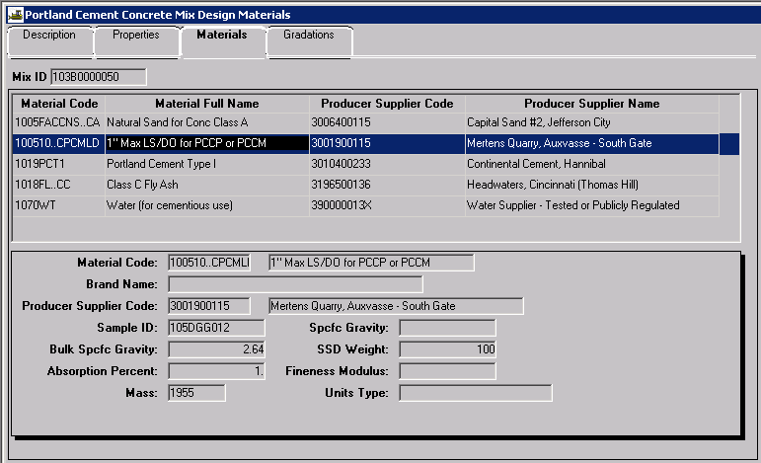
On the Materials Tab, add each of the components designed into the mix (Rock, Sand, Cement, Fly Ash, Water, etc). You may include admixtures in the mix, if you want to. You will need to include exotics (like GGBFS) in the mix design, when they apply. Each material component is added by filling in the blank data fields in the bottom panel. (Examples below):

- Material Code: Right click in the data field, select search, then scroll to and select the desired component. You may type the first 4 digits of the code, then search.
- Brand Name: Leave blank unless you have a branded item such as an admixture that makes the Mix special. For routine admixtures such as air agent, do not include a brand. This will allow a difference air agent to be used without having to update the Mix.
- Producer Supplier Code: Right click in the data field, select search, and scroll to and select the supplier of the component above. For water you can select 390000013X, "Water supplier, publicly regulated", unless you find something in the list that is more specific to your situation.
- Sample ID: Enter the approval ID here for the following materials:
Admixtures: The Sample ID used for admixtures should come from the initial evaluation of the particular admixture, typically established by the New Products Engineer. This sample ID can be found using the department query tool: Link to folder: Public Folders > SiteManager Reporting > Headquarters > Materials – Concrete and Cement > Run this report: Central Lab Admixture Approvals

Cement and Flyash: The Sample ID used for cement and flyash should be the latest Central Laboratory Approval sample. This sample ID can be found using the department query tool: Public Folders > SiteManager Reporting > Headquarters > Materials – Concrete and Cement > Run the appropriate report: Central Lab Cement Approvals or Central Lab FlyAsh Approvals

Aggregates: The Sample ID used to for the aggregate components of PCC mixes shall be the Source sample ID. The Source Sample ID should be compared with the data submitted by the contractor.

- Spcfc Gravity: Leave blank.
- Bulk Spcfc Gravity: For aggregates only, fill in the bulk specific gravity from the submitted mix design. Confirm that the value submitted by the contractor is reasonably close to the three year average established by the Central Lab. If not, contact the Field Office for assistance. No entry is required for the other components; cement, fly ash, water, etc.
- SSD Weight: Leave blank.
- Absorption Percent: Fill this in. Use the value from the contractor's submittal.
- Fineness Modulus: Leave blank
- Mass: Fill this in. This is the dry batch weight per cubic yard. The mass of Water in shown pounds also, don't ask how you can get a dry weight of water - that is a philosophical question beyond the scope of a QRG; just multiply the gallons of water by 8.33 to get the pounds of wet water.
- Units Type: This refers to the unit of measure for the dry weight and should always be pounds.
You must include the Material Code & Producer Supplier Code.

After each component has been entered, click on the save icon .
To enter another component, click on the new icon and start over again.

When you are satisfied the mix data is correct, go to Services - Approve, and Approve the mix (This is just like Authorizing a Sample Record). The task of entering the mix is now completed, and the mix is ready to use.

Gradations Tab

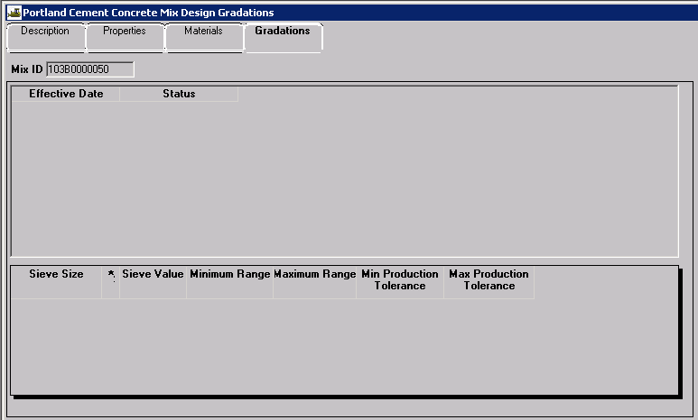
Skip the Gradations Tab unless the mix is optimized. For optimized mixes, enter the gradation submitted by the contractor.

For questions on this subject, contact Lori Greer.

