Quick Reference Guide – Entering Key Dates
Key Dates should be entered in the system at various times during the final stages of a contract. This QRG focuses on the Key Date for the Materials Summary. It will be entered when the last change order is approved or when it is determined that the current contract quantities are final.
Navigate to Contract Administration - Contract Records - Key Dates.
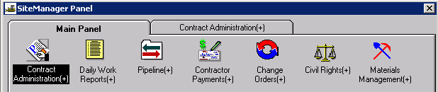
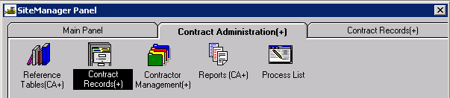
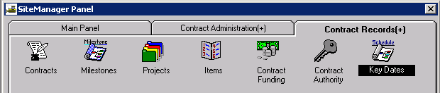
Open the appropriate contract and click the “New” icon.
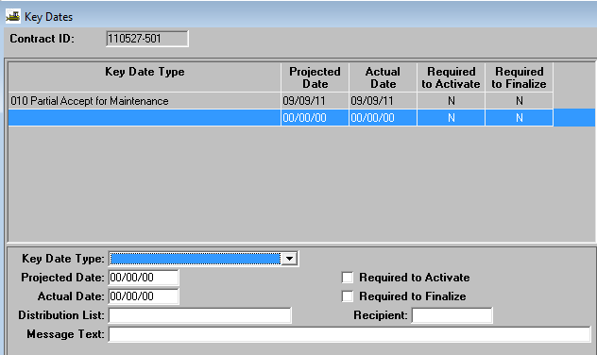
Key Date Type: Select “Project Data ready for Materials Summary” from the drop down list.
Projected Date and Actual Date: Enter the current date in both fields.
Required to Activate: Leave the checkbox unselected.
Required to Finalize: Select the checkbox.
Distribution List: Right click and search to select the appropriate DDMAContacts (DD being the district designation, e.g., CD, KC, SE, etc).
Note: When entering key dates at the project office/District level, a Distribution List must be selected in order save the key date. Select "ReDev" for the distribution list of any key date except Materials Summary.
When complete, the window should look similar to the following:
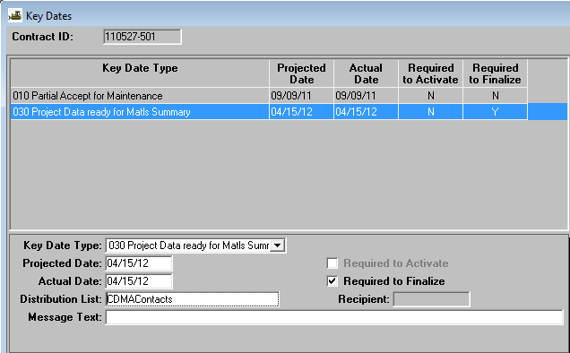

Save and close.
Send a Lotus Note to DDMAContacts (DD being your district designation) advising district Materials personnel that the key date for Materials Summary for the contract has been entered in SM.

