MoDOT Traffic Safety & Operations Report Template
June 2020
The Missouri Department of Transportation (MoDOT) will request that a Traffic Safety & Operations (TS&O) Report be drafted when the future performance of a roadway has come into question. The purpose of a TS&O study is to analyze the current performance of a roadway, the future performance of the roadway without improvements, and the future performance of the roadway after improvements have been made. If there are several design alternatives being considered, the TS&O study will analyze the performance of each alternative under future conditions and use the results of this analysis to recommend the most attractive design alternative. As one example, a TS&O may be requested when access to a freeway is proposed to be added, modified, or removed. If this access is on an interstate and an Access Justification Report (AJR) is required for FHWA, the sections of the TS&O can be repurposed for use in the AJR.
This template is meant to aid consultants and other parties submitting work to MoDOT in their production of TS&O reports. Written below are several guidelines which should be considered when using this template:
- Do not delete any sections in the template. Instead, if a section does not apply to a given project, write “N/A” and give a brief explanation for why that section does not apply.
- If additional information is needed, attached as an Appendix
- Blue text represents information which should be replaced with project specific information.
- Red text represents information which has been included in the template to better explain what each section of the report should include. This text should be deleted before submitting the report to MoDOT.
- Green / Italicized text represents content, usually in the form of a table, which has been included to serve as an example of a way to communicate information. This content should either be modified or removed before submitting the report to MoDOT.
- Because each report will have a unique number of tables and figures, the List of Figures and List of Tables below the Table of Contents has been left for the writer of the report to format.
- Do not alter the format of the template before submitting to MoDOT.

Title of Traffic Study

Draft/Final/Revised Traffic Safety & Operations Report

Date of Completion

Prepared for:
Missouri Department of Transportation
105 W. Capitol Avenue
Jefferson City, MO 65102

Prepared by:

Name of Firm

PLACE LOGO HERE
Street Address
City, State Zip Code

TABLE OF CONTENTS
1 Introduction 2
1.1 Project Background 2
1.2 Study Area 2
1.3 Problem Definition 3
1.4 Design Alternatives 3
2 Existing and Future Year No-Build Traffic Operations and Safety Analysis 4
2.1 Background (Future No-Build) Forecasting 4
2.2 Traffic Operations 5
2.3 Safety 6
3 Design Alternatives Traffic Operations and Safety Analysis 7
3.1 Future Build Forecasting 7
3.2 Traffic Operations 8
3.3 Safety 9
4 Preferred Design Alternative 10
4.1 Design Exceptions 10
4.2 Coordination with Future Development 10
4.3 Coordination with NEPA Process 10
4.4 Conclusion 10

LIST OF TABLES

LIST OF FIGURES

A list of appendices may be included as necessary.

Introduction
The purpose of this chapter and the following sections is to introduce the reader to the study by discussing the project background, study area, definition of the problem at hand, and design alternatives being considered. Use of supporting figures, especially maps of the study area, is expected.

Suggested figures: N/A

Project Background
This section should be used to describe the project background and should include a discussion of the origins (i.e. construction year and original purpose) and relative importance of the roadway segment being studied. This section may also be used to describe the general condition of the roadway (i.e. physical deterioration, traffic delays and congestion, etc.), but writers should keep these descriptions brief because more specific problems associated with the roadway will be discussed in Section 1.3.

Suggested figures: N/A

Study Area
This section should be used to define the limits of the study area. As mentioned earlier, use of supporting figures such as maps is expected.

Suggested figures: map of influence area, map of areas of significant impact

Exhibit 1: Example of Study Area Map
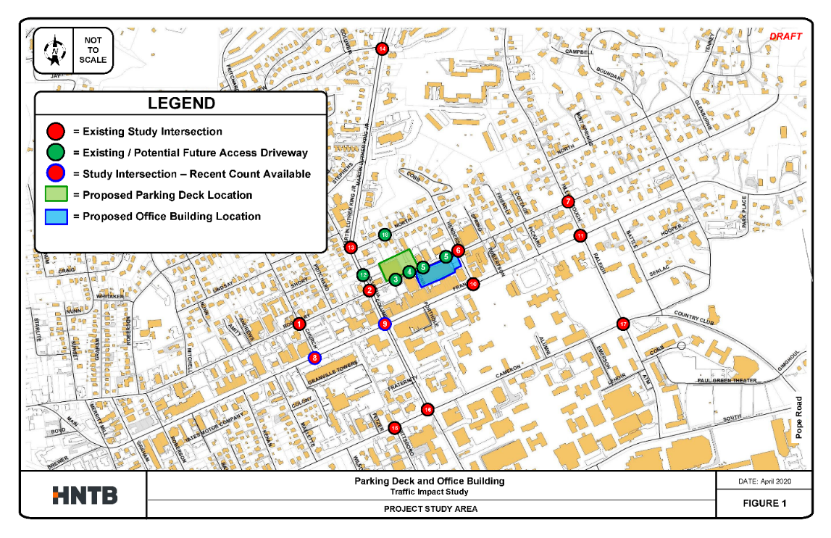

Problem Definition
This section should be used to define the problem(s) motivating the TS&O study. These problems might include, but are not limited to, significant traffic delays and congestion, safety issues, deteriorating condition of bridges and pavements, and limited accessibility.

Suggested figures: N/A

Design Alternatives
This section should be used to briefly describe the design alternatives being considered. This section may also include a description of the thought processes which led to the selection of the design alternatives being considered. If only one design alternative is being considered, writers may choose to use this section to explain why other alternatives are not being studied.

Suggested figures: map of design alternatives

Existing and Future Year No-Build Traffic Operations and Safety Analysis
This chapter and the following section should be used to summarize the state of traffic operations and safety conditions for the existing roadway and for a future year where the roadway has not been improved.

Suggested figures: N/A

Background (Future No-Build) Forecasting
The purpose of this section is to document the development of the traffic volumes that will be on the transportation network in a horizon, or future, year without the construction of the proposed project. In some cases, background forecasting may be requested for multiple horizon years. This section should include a description of how these traffic projections were generated and cite any traffic forecasts used as references.

Suggested figures: tables and/or figures communicating forecasted traffic volumes

Table 1: FYNB Forecast Volume Projections
Roadway | Reference Growth Rate |  |  | Travel Demand Model Daily Traffic Volumes & Growth Rate |  |  | Applied  Growth  Rate | 2019 BYNB Selected AADT | 2040 FYNB  Selected AADT
 | 10-Year Historic AADT Trend Line | 20-Year Historic AADT Trend Line | Previous Forecast | 2018 BYNB | 2040 FYNB | Model CAGR
I-99 – West of Exit 31 | 1.52% | 1.53% | - | 54,029 | 83,197 | 1.98% | 2.0% | 54,400 | 82,100
I-99 – Exit 31 to Exit 33 | 1.13% | 1.14% | 1.4% | 55,209 | 81,733 | 1.80% | 1.8% | 53,000 | 77,100
I-99 – East of Exit 33 | -0.04% | 0.44% | - | 23,290 | 36,198 | 2.02% | 2.0% | 23,600 | 35,900

Traffic Operations
This section should be used to compare existing traffic operations to traffic conditions at a horizon year assuming the roadway has not been improved. The structure of this section will depend heavily on the measures of effectiveness (MOEs) being used to carry out the analysis. For instance, if several MOEs are being considered, a table like the one shown below may be helpful in making a direct comparison between existing conditions and the no-build horizon year. If a single MOE is being considered, writers should consider including figures which are more specific to the MOE being considered. For instance, if travel speed is being analyzed, speed profiles at peak periods for both existing conditions and the no-build scenario may be used to compare traffic operations.

Suggested figures: tables summarizing MOEs used

Table 2: MOEs Comparison
Network Measures of Effectiveness |  | 20XX Existing | 20XX  No-Build
AM Peak | Vehicle Miles Traveled | 442,888 | 545,564
 | Vehicle Hours Traveled | 10,651 | 15,820
 | Vehicle Hours of Delay | 1,788 | 4,581
 | Average Speed | 41.58 | 34.49
PM Peak | Vehicle Miles Traveled | 482,804 | 615,996
 | Vehicle Hours Traveled | 12,113 | 17,930
 | Vehicle Hours of Delay | 2,188 | 5,118
 | Average Speed | 39.86 | 34.36

Writers may also use this section to discuss how the projected traffic conditions may exacerbate the problems discussed in Section 1.3. For instance, decreased travel speeds in the horizon year suggest the extent to which current congestion may worsen over time.

Safety
This section should be used to compare existing safety conditions to safety conditions at a horizon year assuming the roadway has not been improved. A table like the one shown below may useful in communicating this comparison.

Suggested figures: tables comparing safety MOEs used

Table 3: Safety MOEs Comparison
Direction | Segment |  | 20XX Existing |  | 20XX No-Build |  | Increase
 | From | To | AADT | Annual Crashes | AADT | Annual Crashes
EB | Pine | Cedar | 72,000 | 8 | 91,117 | 10 | 2
 | Cedar | Oak | 67,719 | 30 | 92,226 | 40 | 11
 | Oak | Cyprus | 67,367 | 46 | 86,689 | 60 | 13
WB | Pine | Cedar | 72,000 | 32 | 91,117 | 41 | 9
 | Cedar | Oak | 67,719 | 9 | 92,226 | 12 | 3
 | Oak | Cyprus | 67,367 | 17 | 86,689 | 22 | 5
Total |  |  |  | 142 |  | 185 | 43

Similar to Section 2.1, writers may also use this section to discuss how changes in safety conditions over time may influence the problems defined in Section 1.3. For instance, an increase in annual crashes suggests safety conditions will worsen over time.

Design Alternatives Traffic Operations and Safety Analysis
This chapter and the following sections should be used to compare the traffic operations and safety conditions for the existing year, future year no-build scenario, and one or more future year build alternatives.

Suggested figures: N/A

Future Build Forecasting
The purpose of this section is to document the forecast of how much traffic will be on the transportation network in a future horizon year assuming the proposed project has been constructed. This section should include a description of how these traffic projections were generated and cite any traffic forecasts used as references.

Suggested figures: tables and/or figures communicating forecasted traffic volumes

Exhibit 2: Example of Future Build Forecast Comparison Map
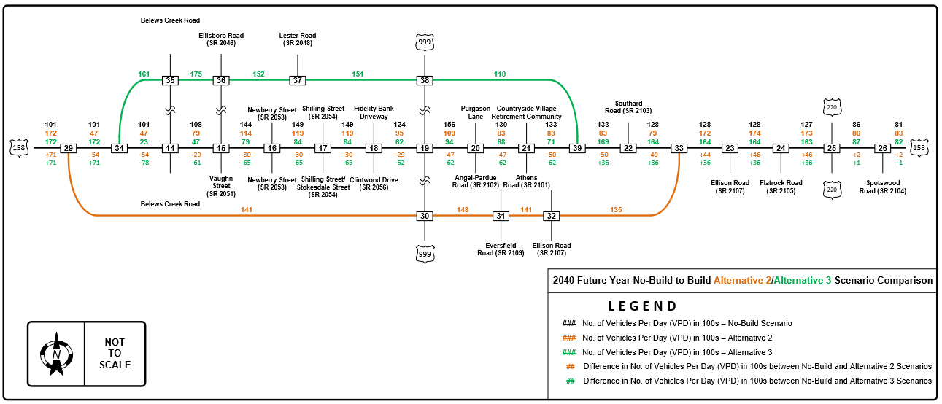

Traffic Operations
This section should be used to summarize traffic operations for the existing year, future year no-build scenario, and one or more future year build alternatives. Similar to section 2.1, the structure of this section will depend heavily on the MOEs being used to analyze traffic conditions. If several MOEs are being considered, a table like the one below may be helpful in communicating the MOEs for each scenario. If a single MOE is being considered, figures specific to that MOE may be more useful in comparing traffic conditions for each scenario.

Suggested figures: tables comparing MOEs for different scenarios

Table 4: Comparison of MOEs by Scenario
Network Measures of Effectiveness |  | 20XX Existing | 20XX  No-Build | 20XX  Alternative A | 20XX Alternative B | 20XX Alternative C
AM Peak | Vehicle Miles Traveled | 442,888 | 545,564 | 500,000 | 475,000 | 525,000
 | Vehicle Hours Traveled | 10,651 | 15,820 | 13,500 | 12,000 | 15,000
 | Vehicle Hours of Delay | 1,788 | 4,581 | 3,000 | 2,500 | 4,250
 | Average Speed | 41.58 | 34.49 | 38.00 | 39.00 | 36.50
PM Peak | Vehicle Miles Traveled | 482,804 | 615,996 | 525,000 | 500,000 | 575,000
 | Vehicle Hours Traveled | 12,113 | 17,930 | 15,000 | 13,750 | 16,500
 | Vehicle Hours of Delay | 2,188 | 5,118 | 4,500 | 3,500 | 5,000
 | Average Speed | 39.86 | 34.36 | 37.50 | 38.00 | 36.00

This section should also be used to compare the performance of the design alternatives being considered in a narrative form.

Safety
This section should be used to summarize traffic safety for the existing year, future year no-build scenario, and one or more future year build alternatives. A table like the one shown below may useful in communicating this comparison.

Suggested figures: tables comparing safety MOEs for different scenarios

Table 5: Comparison of Safety MOEs by Scenario
Direction | Segment |  | 20XX Existing |  | 20XX No-Build |  | 20XX  Alternative A
 | From | To | AADT | Annual Crashes | AADT | Annual Crashes | AADT | Annual Crashes
EB | Pine | Cedar | 72,000 | 8 | 91,117 | 10 | 91,117 | 7
 | Cedar | Oak | 67,719 | 30 | 92,226 | 40 | 92,226 | 25
 | Oak | Cyprus | 67,367 | 46 | 86,689 | 60 | 86,689 | 40
WB | Pine | Cedar | 72,000 | 32 | 91,117 | 41 | 91,117 | 30
 | Cedar | Oak | 67,719 | 9 | 92,226 | 12 | 92,226 | 8
 | Oak | Cyprus | 67,367 | 17 | 86,689 | 22 | 86,689 | 15
Total |  |  |  | 142 |  | 185 |  | 125

This section should also be used to compare the safety performance of the design alternatives in narrative form.

Preferred Design Alternative
This chapter and the following sections should be used to recommend a preferred design alternative and discuss how that design alternative may be implemented. This chapter should reference the results presented in Chapter 3 to justify the selection of the preferred design alternative.
This chapter may also include information on potential construction phasing and/or other considerations that coincide with the preferred design alternative, such as noise effects, ITS and signing requirements, etc.

Suggested figures: N/A

Design Exceptions
This section should be used to identify any known or likely design exceptions associated with the Preferred Alternative. Consider appending any completed design exception documentation.

Suggested figures: Appended documentation of design exception information

Coordination with Future Development
This section should be used to describe how construction of the preferred design alternative may align or conflict with state and regional plans for future development. This may include considering a statewide transportation improvement program or a council of governments transportation improvement program.

Suggested figures: Map, table, or report documentation of state/regionally planned projects

Coordination with NEPA Process
This section should be used to describe the environmental studies the Federal Highway Administration (FHWA) requires under the National Environmental Policy Act (NEPA) in order for the preferred design alternative to be constructed, including an Access Justification Report (AJR) if applicable. This section should discuss the processes by which these studies will be carried out and FHWA approval will be secured.

Suggested figures: Summary of environmental studies required (including key dates)

Conclusion
This section should be used to restate the purpose of the TS&O study and to summarize how the proposed design alternative will address the problems defined in Section 1.3. This section may also include a description of where the project stands in the NEPA process and when a record of decision may be anticipated.

Suggested figures: N/A

