Quick Reference Guide – Moving Contract Files from MoDOT’s External SharePoint to V:\Contract Information Archive
Per Job Special Provision, “…the contractor shall establish a Document Control Procedure for producing and uploading the required Quality Management documents to a web-based electronic storage site provided by MoDOT (Microsoft SharePoint), or to an alternate storage site provided by the contractor and approved by the engineer. This process will allow efficient sharing of documents among authorized users. Any proposed alternate site must provide equal or better efficiency in document sharing as the MoDOT provided site. If an alternate site is utilized, upon completion of the project the contractor shall provide all files to the engineer on an approved electronic media.”
At the end of all Quality Management jobs, project office personnel will be required to move all Quality Management files from MoDOT’s External SharePoint site (or the alternate storage site provided by the contractor) to V:\Contract Information Archive.
This QRG will guide the user on how to move Quality Management files from the external MoDOT SharePoint site to the appropriate folder on V:\Contract Information Archive.
Log on to MoDOT’s External SharePoint site and click on the Construction Contracts function.
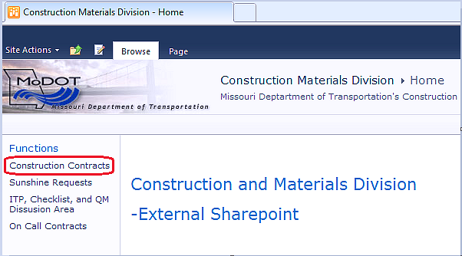

Select the appropriate RE Office quick link on the left side of the page.
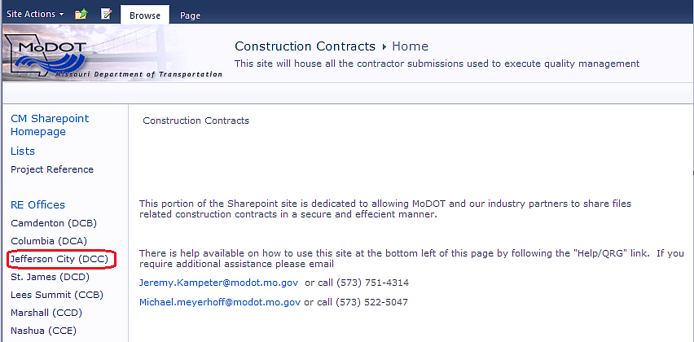
The contract folders will open in the Browse view.
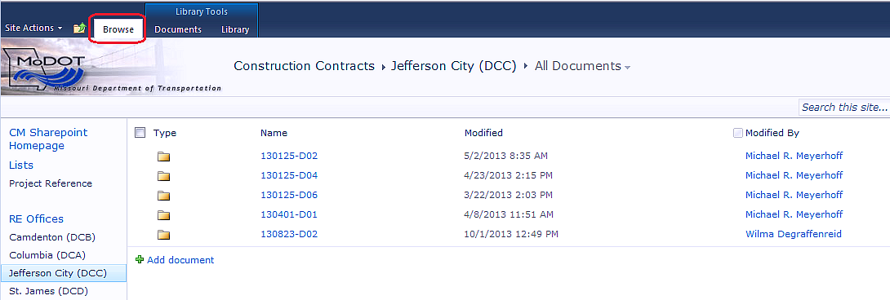

Click on the Library tab, and then select Open with Explorer.
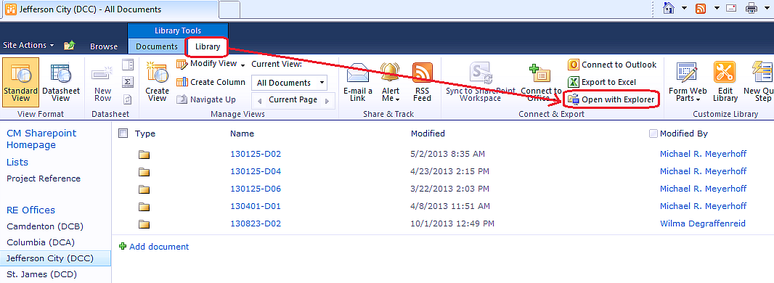

The view will look similar to the screen below.
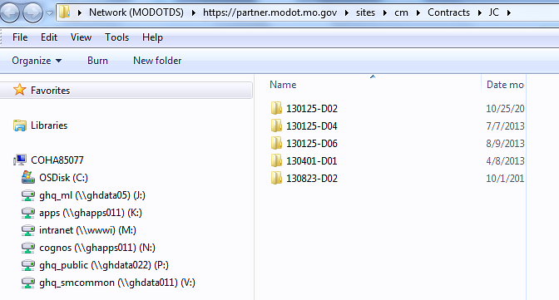
Expand V:\Contract Information Archive\District\Project Office\Contract ID. Locate the “Contractor Quality Management” folder.
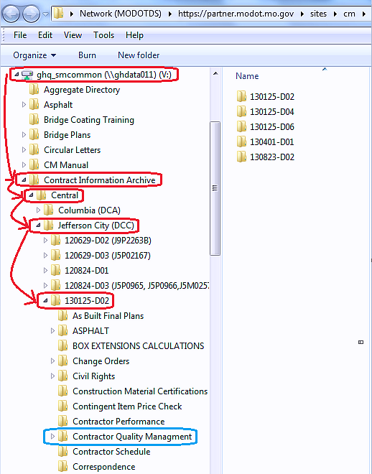

Move the appropriate contract folder into the Contractor Quality Management folder, either by the “Cut and Paste” method or “Drag and Drop” (right click to move) method.
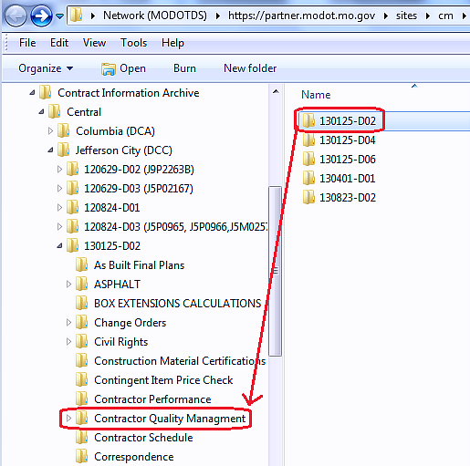

Note: If using “Drag and Drop,” be aware that it is very easy to inadvertently drop the files into the wrong folder. If this occurs, use the Start button and Search for the missing folder/files.
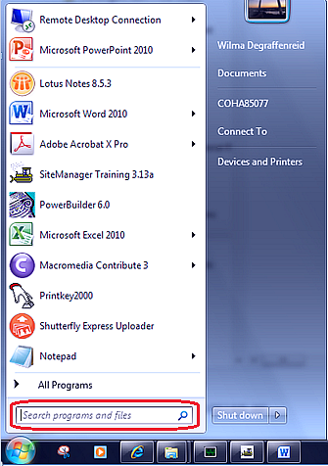

Note: It could take ten minutes or longer to move large contracts.
Once the contract folder is moved, close Explorer and sign out of External SharePoint.

