How to Use Cognos Reports
MoDOT has a new way to Open Cognos reports from the main SharePoint Page:
- From the SharePoint site (http://sharepoint/Pages/Default.aspx) select the Cognos Reporting button
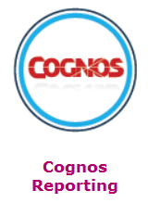
- You will be directed to a page to enter your Cognos User ID and password. If you don’t have a Cognos User ID, your supervisor needs to email your District IS group (ex., SLIS) for a S.T.A.R.T.S. requesting the needed subject areas.
After you have logged in, select My Home link (if shown, otherwise, you default to the available connections for your user ID)
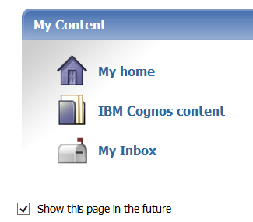
Navigate to the report you want to run using the folder structure similar to image below…
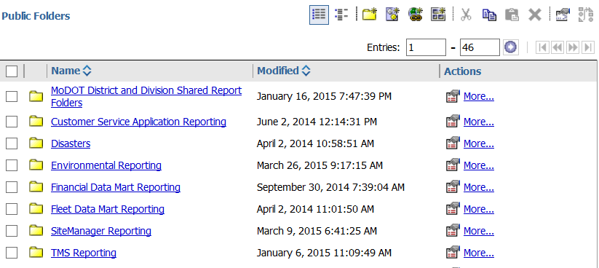
….or find a report using the search field to the right of your user ID (be sure to drop the field down to the right of the search and select the Name or Description field
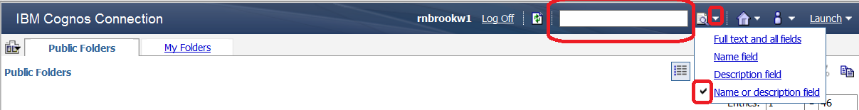

For example a search for “change order” will return the list below. If you need the path to the report, select the first icon under the Actions column. This is the Set Properties and it will list the location.
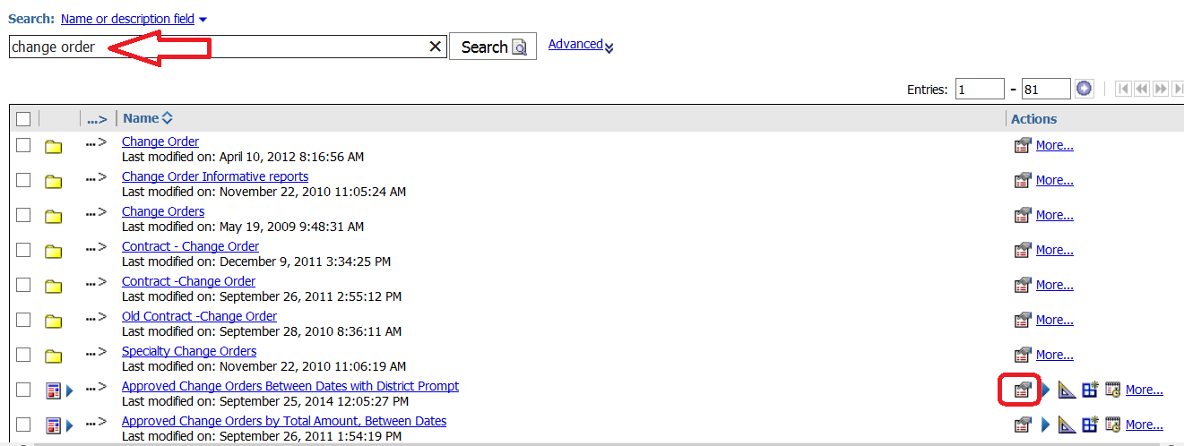

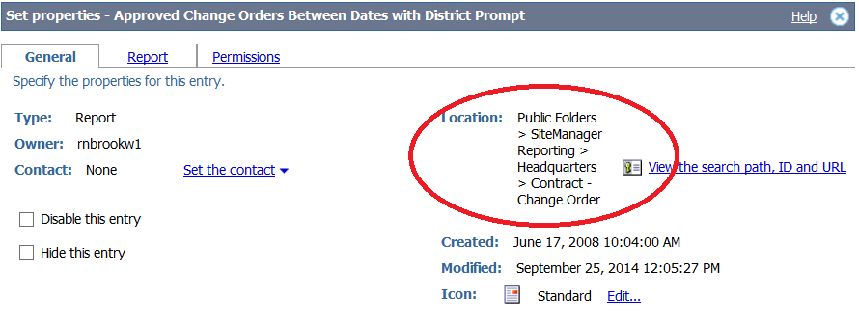

Cognos Action Icons
Set Properties – Lists the owner, location, created/modified dates, package
View report output versions – If the output was kept from the last execution, you can select to see the output.
Run with Options – In the drop down menu select HTML, PDF, or Excel. The link for Advanced Options will let you run a very long running report in the background (freeing the Cognos screen for other work).
Create a Report View - You can create a report view, which uses the same report specification as the source report, but has different properties such as prompt values, schedules, delivery methods, run options, languages, and output formats.
Schedule – Enter the frequency. Select Override the default values to set the format and email recipients.
List all the above actions. It also has links for move, copy, Create a shortcut, Add to bookmarks, delete

Helpful Hints
- Preferences: By default there are 15 entries per page. Each person can alter this for their setting only. Select the icon 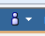 drop down and choose My Preferences. You may change any information. If you want all folders and reports on the same page, set Number of entries in list view to 999.

- Skip Welcome screen and open directly to reporting list: Navigate to the content list. Select the icon. From the drop down menu select Set View as Home 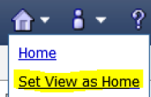

- My Folders: create shortcuts to reports you use frequently and organize on this tab. If it is a shortcut, any changes made to the original report will be used. Navigate to and select the report 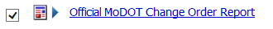 then “More” option to the right . Under Available Actions, select . Specify the name and location (should default to “My Folders”).
- If you run the same report over and over, but just change the ‘prompt’ information (for instance, Contract ID and Estimate Number) – you can ‘Reprompt’ without having to close the report. Just select the “Run Report” icon and the prompt page will come back, allowing you to change your information:
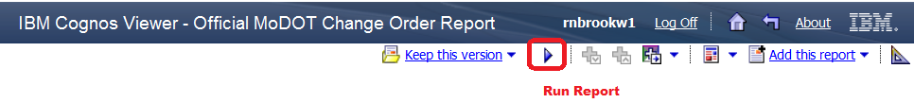

Helpful Construction and Materials Reports
The Cognos reports are organized to mirror the functions of SiteManager. Reports related to those functions in SiteManager are stored in the appropriate folder location in Cognos. They are grouped by Headquarters and Districts. All authorized Cognos users can run any report from any location, as long as you are authorized to query the Cognos collection (i.e., SiteManager).
The Headquarters folder contains reports that apply to the entire state, and most often can be narrowed down using prompts of the report to specific Districts or Offices. Only Headquarters Cognos Authors can save to the Headquarters folders.
The District Folders normally contain customized reports for the District, or more detailed reports than what the Headquarters reports contain. Only District Cognos Authors can save reports to their District folders.
Cognos authors are currently working on adding specific information to each report to describe the intended use and available prompts for each report. Users can see the details by changing the view in their window to show Details:
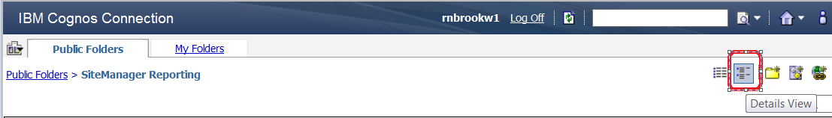
This will then list the report details, if any, below the report name
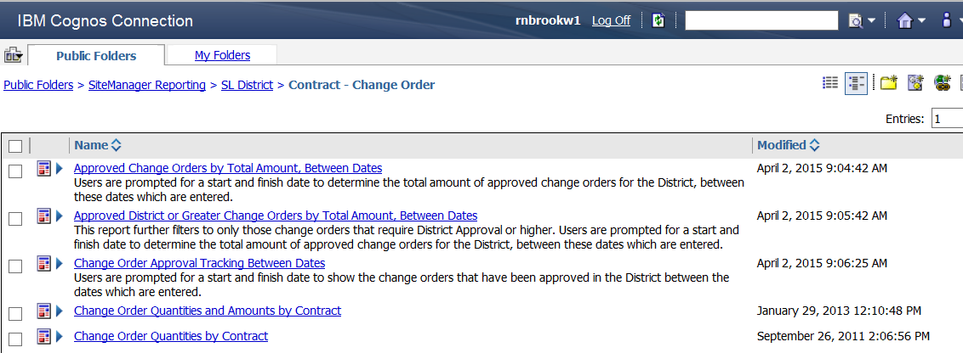

The Top 20 Headquarters are listed below:
Headquarters Top 20 February 1, 2015 to April 1, 2015:
Report Name
QA Feed QC Superpave Lots
QLIS Source
Cross Reference - Contract, Job, Office, Contractor, Route
Estimate Summary for Contract, by Est Nbr with DWR Template Details
Summary of Materials for Contract
Official MoDOT Change Order Report
PAL Shipments Within Date Range
List of Reported Quantities
Source Approval Form for Aggregate
DWR Remarks for Contract ID
QLIS Initial
MODOT Contractors - Detail
Estimate Summary for Contract, by Est Nbr with DWR Template Details, no Remarks
Line Item Adjustments for Contract With Remarks
List of Line Items for Contract
Item Code Price by District
Line Item Adjustments for Contract
Summary of Contract Concrete Mix Designs
Contractors on Site for Contract
CSTR400surf

