QRG – Line Item Adjustments
Line Item Adjustments are adjustments made to the pay estimate that can be associated to a particular line item on the contract. Line Item Adjustments may be system generated or entered by the user. This article is intended to guide the user in the creation of a Line Item Adjustment.
Navigate to Contractor Payments – Contract Adjustments – Line Item Adjustments.
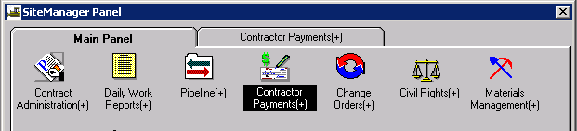
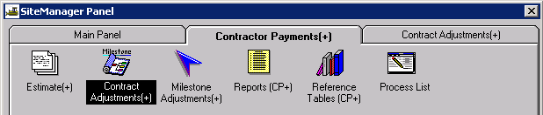
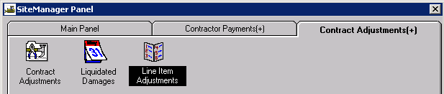

Select the appropriate contract ID and estimate from the lists in the Select Contract and Estimate window.
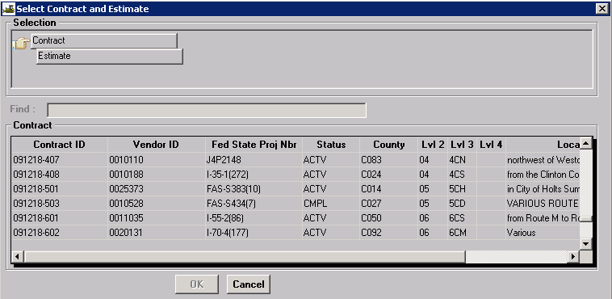

The Line Item Adjustment window allows the user to add, modify or view line item adjustments for an estimate. The top portion of the window displays all line item adjustment for the selected estimate. The bottom portion of the window displays detailed adjustment information for the selected adjustment.
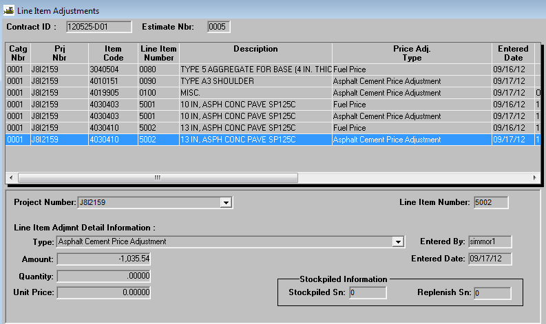
Line item adjustments are created during the estimate generation process and may be system generated or they can be created by the user. Only First Level Approvers (project manager for Progress estimates) can create these adjustments. System generated line item adjustments can only be viewed.

Creating a User Entered Line Item Adjustment
- There must be an existing estimate in “Pending” or “Reject” status in order to create a contract adjustment.
- Navigate to the Line Item Adjustments window and select the appropriate contract and estimate number.
- Select the New icon .
- Select the appropriate project from the Project Number drop down.
- Left click on the Line Item Number field to search for the line item (or enter line item number) for which the adjustment is to be made.
- Select the appropriate adjustment type from the Type drop down.
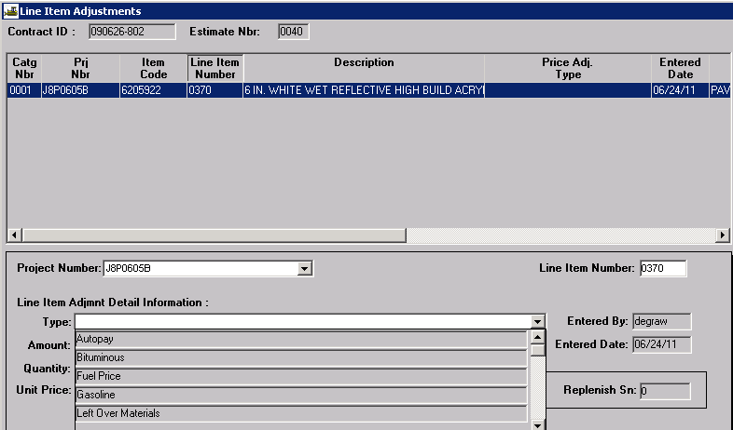
- Enter the appropriate dollar amount in the Amount field. Do not enter any Quantity or Unit Price.
- Select the Remarks icon and enter the reason and/or documentation for the adjustment. Click out of the Remarks icon to close.
- Select the Save icon. All saved adjustments will be updated on the Estimate Summary.
Note: SM cannot automatically calculate the Fuel Price Adjustment for most miscellaneous contract items with a “99” item code, so they must be manually entered. When manually entering fuel adjustments, it is the intent that all work placed on an estimate should use the same factor, even if there is a DWR for the 1st of the month. The majority of the work on an estimate is performed between the 16th and the last day of the month rather than the first day of the month. Therefore, the index that should be used is that of the previous month.

Adjustment Spreadsheet Security Messages
The fuel adjustment, seal coat, and asphalt cement adjustment spreadsheets contain links to the actual monthly adjustment documents. These links must be updated when the spreadsheets are opened in order to work correctly.
Depending on the Trust Center settings the user has enabled in Excel, certain messages may appear when opening a spreadsheet containing links/macros. If the user receives the following message when opening the spreadsheet, click the “Enable Content” button.

If the following message appears, click the “Update” button.
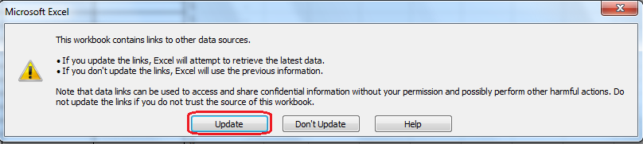

Types of Line Item Adjustments used by MoDOT
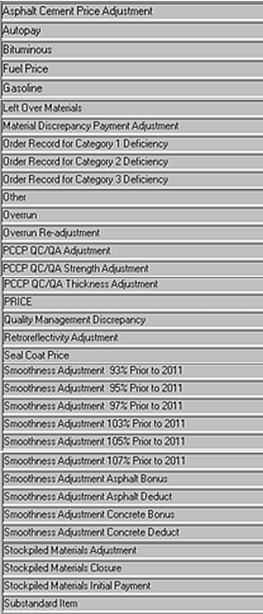
The “Other” adjustment type is used only for special circumstances. DO NOT select “Other” unless directed to do so by the System Administrator or by SM policy.

