Quick Reference Guide – Equipment Verification Samples
This article is intended to guide you in submitting Equipment Verification Samples to the Central Lab for testing and in the creation of an Equipment Verification Sample test record within SiteManager. Initially you should be familiar with the General Information on how to create a Sample Record. See the Quick Reference Guide - Sample Record General Information.

Samples Submitted to the Central Laboratory:

Samples submitted to the Central Lab for testing shall have the following information printed directly on the sample, sample container, or sample tag: Sample ID Number, Material Source (where the sample is obtained), EVS, and any Special Instructions. Asphalt loose mix submitted for specific gravity testing should also have the Mix ID and batch weight written on the box. If multiple tests are to be performed on the same material, a note shall be added to the SiteManger record in Remarks (i.e. if aggregate is submitted for gradation and consensus properties, it should be noted in Remarks)

Sample sizes shall be as follows:

Aggregate for Gradation and/or Consensus testing: – 1 bag (50 lbs)
Asphalt for T209, T166 – 2 boxes (60 lbs)
Concrete for Strength – set of cylinders
Pavement thickness – concrete core marked with orientation to be tested

SiteManager Sample Record:

Log on to SiteManager and navigate to Materials Management Sampling and Testing Maintain Sample Information.
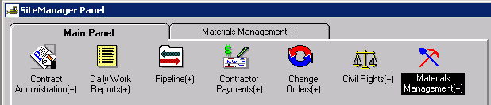

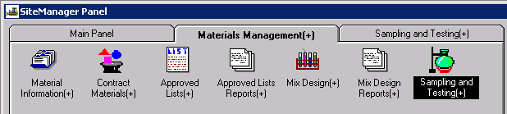

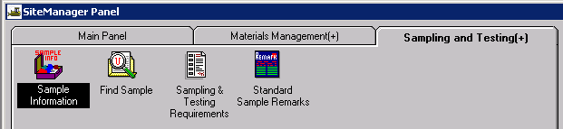

This window has five tabs across the top: Basic Sample Data, Additional Sample Data, Contract, Other, and Tests. When the window opens it should be focused in the first tab, the Basic Sample Data tab: (Tab you are focused in is always in bold letters).

Basic Sample Data tab

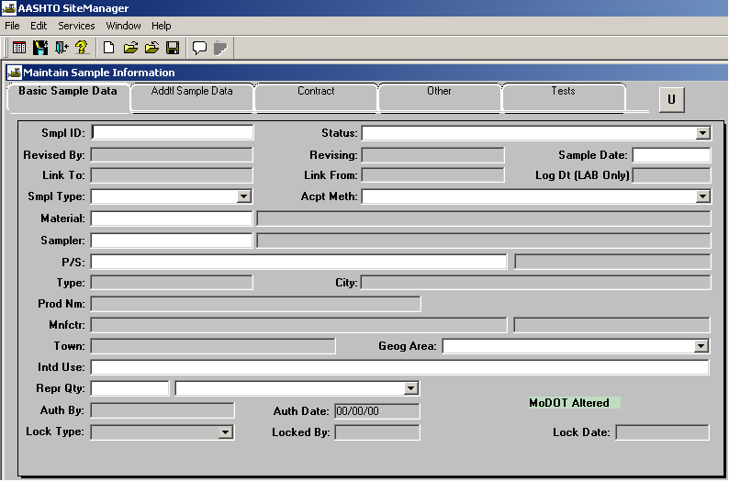

Enter your ID number in the field labeled “Sample ID” (Last two digits of Year, District, User’s assigned initials, 3 digits, with leading zeros ex.”001”). Once the record is saved the Id number cannot be changed.

For the “Status” field, click on the expand arrow to select the appropriate choice. The status should be entered as “Pending” if the sample has been submitted to the Central Laboratory. If the sample has been completed in the District, the appropriate choice would be either “Compares Favorably/Compliant” or “Not Compare Favorably/Not Compliant”.

For the “Sample Date” field enter the date the sample was obtained.

In the “Sample Type” field select “Equipment Verification”.

In the “Acceptance Method” field select “Sample and Test”.

In the “Material” field perform a search and select 0011XX ”Acceptance Testing Facility".

In the “Sampler” field , the person who obtained the sample. Typically, the sampler is the individual entering the sample data.

Select “P/S”. This stands for Producer/Supplier and can only be populated after a material has been selected. Perform a search for the correct Producer/Supplier. Select the company that owns the equipment being verified. This may not always be the specific plant from which the sample was taken. The specific location from which the sample was taken should be noted on the Test Tab in the Lab ID field.

For the “Geographical Area” field select your District.

In the “Intended Use” field, leave blank

In the “Represented Qty” field, leave blank.

Select the “Remarks” icon from the menu bar if any additional information is needed for this record.

Save the record. The Sample ID number becomes protected and cannot be modified.

Addtl Sample Tab:

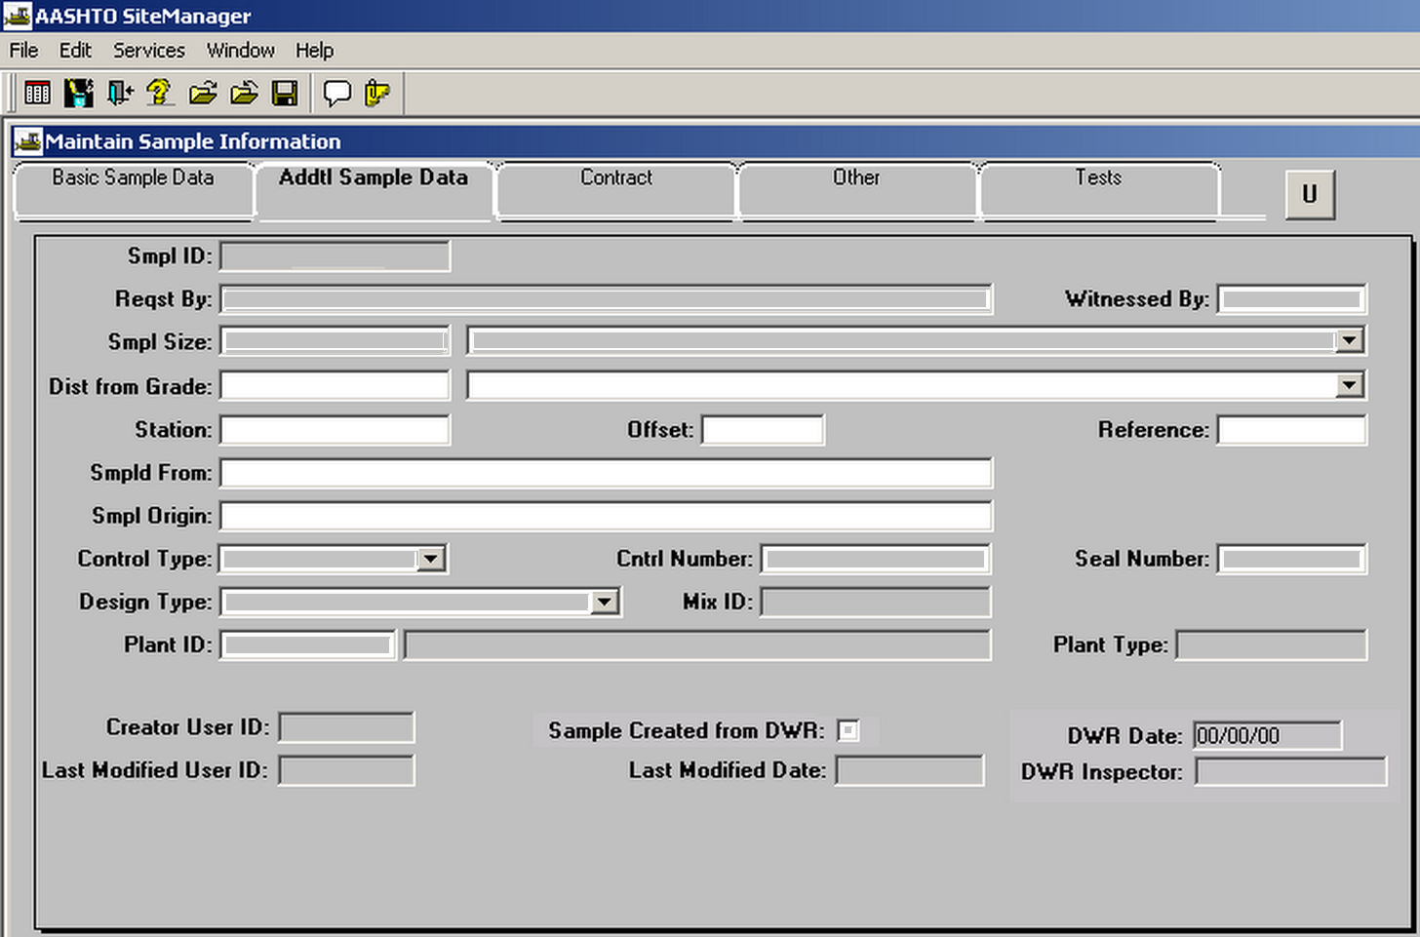

In the "Sampled From" field and enter “Current Location of Lab”.

In the "Sample Origin" field enter “Job site”.

Contract Tab:

Leave blank. This tab is not used for equipment verification samples.

Other Tab:

Leave blank. This tab is not used for equipment verification.

Test Tab:

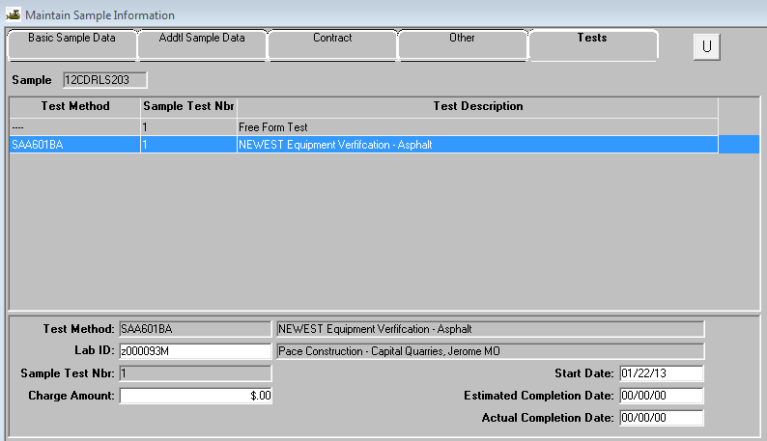

Focus in the bottom panel of the window, in the field “Test Method”. Perform a search and select the correct test (SAA601xx).

In the “Lab ID” field, perform a search and select “Lab where original equipment is located”. If the Lab is not in the list, contact Central Office Construction and Materials to verify that the Lab has been audited. If the Lab has not been audited, the District will need to perform an audit and complete an audit checklist to get the Lab added to the list.
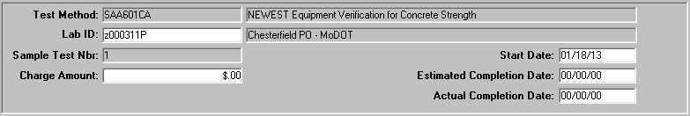

In the “Sample Test Nbr” field and enter the number “1” for the first test result. When adding more than one test result to this record, the sample test number must be increased incrementally for each test.

In the “Start Date” field and enter the date that the test was performed.

Skip the “Estimated Completion Date”.

In the “Actual Completion Date” field and enter the same date that the test was completed, (usually the same date as the “start date”).
Available Sample Templates:
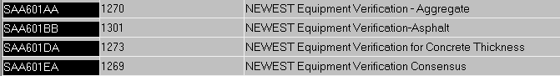

From the Services drop down menu, select Enter/View Test Data. This will open the test template, allowing the Inspector to enter test results. When the Test Template Usage screen appears, enter the test data and other information as required to fill all applicable fields.

NOTE: Comparisons for gradations are applied based on percent passing amount, not size of aggregate.

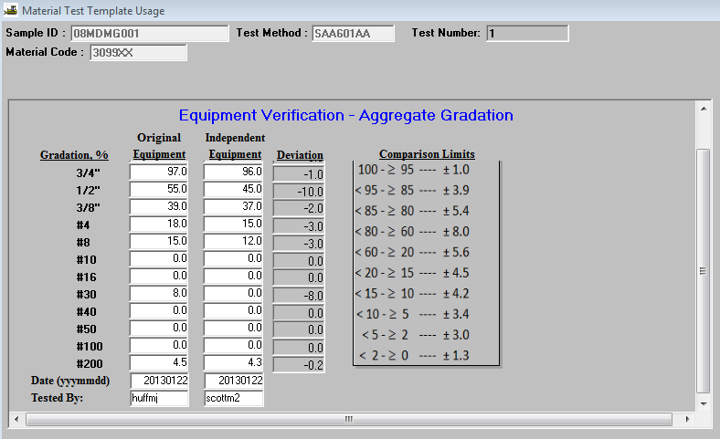

If more room is needed for comments than is provided, use the Remarks option, or add a “Free Form” test.
Save and close. Do not authorize until data is entered from both labs. The record is complete.

