QRG – Job Order Contracts

This article will guide the user in creating and authorizing a Daily Work Report (DWR), printing a job order, and generating a contractor’s pay estimate for Job Order Contracts.

# Creating the Daily Work Report

Log on to SiteManager and navigate to Daily Work Reports – Daily Work Reports.  
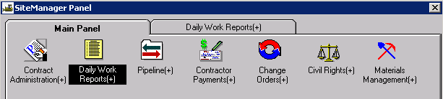

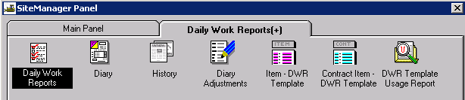

## DWR Info Tab

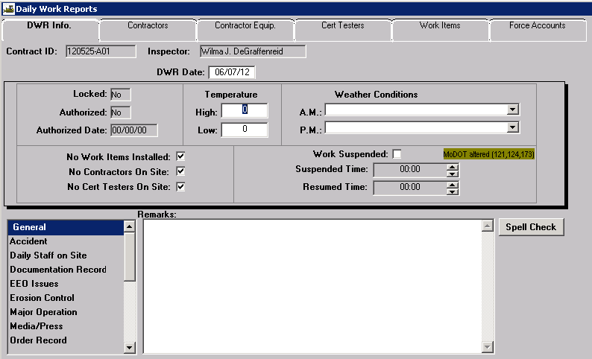

The Daily Work Report (DWR) is the inspector’s record of work performed on a contract.

**Contract ID:** Select Services – Choose Keys to select contract.

**Inspector:** Automatically entered by system.

**DWR Date:** The date defaults to the current date. Double click the date field to select a different date using the pop-up calendar.

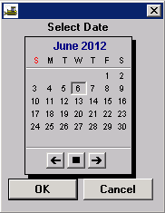

**Locked:** **A**utomatically entered by system.

**Authorized: A**utomatically entered by system.

**Authorized Date: A**utomatically entered by system.

**Temperature:** It is not necessary to enter High or Low temperatures for JOC contracts.

**Weather Conditions:** It is not necessary to enter Weather Conditions for JOC contracts.

**No Work Items Installed**: **A**utomatically entered by system.

**No Contractors On Site**: **A**utomatically entered by system.

**No Cert Testers on Site**: **A**utomatically entered by system.

**Work Suspended**: MoDOT does not use this field.

**Suspended Time**: MoDOT does not use this field.

**Resumed Time**: MoDOT does not use this field.

**Remarks**: Select the appropriate “Remarks Type” from the list to the left of the Remarks field and enter any necessary remarks. Multiple “Remarks Types” may be selected and entered for the day. Click the “Spell Check” button to run the spell check for remarks.

**Note:** Occasionally, Spell Check will go to the background when activated. If the DWR appears to be locked after clicking the Spell Check button, select both the “Alt” and “Tab” keys to move to the spell check.

Save the information. Once saved, the Daily Work Report cannot be deleted.

## Contractors Tab

Navigate to the Contractors tab to add contractors to the DWR.

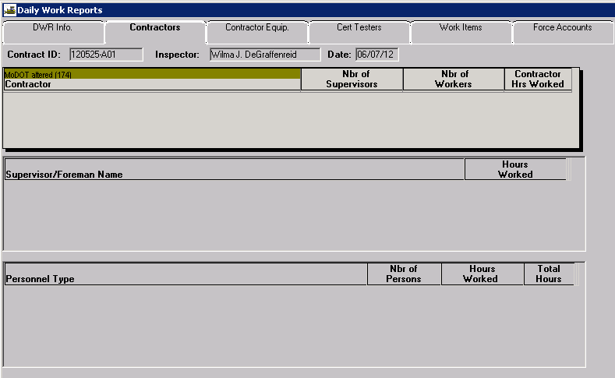

With the focus in the top panel of the window, click the New icon. Select the contractor who was active on the project for the selected date. A contractor must be selected if items are to be entered on the Work Items tab.

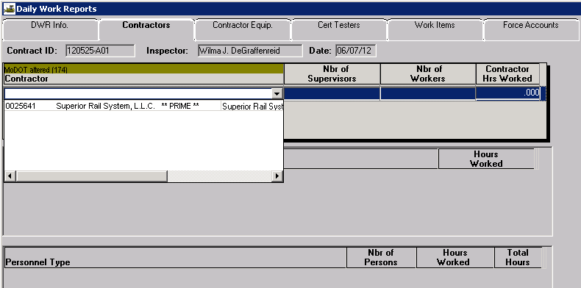

**Nbr of Supervisors, Nbr of Workers,** and **Contractor Hrs Worked**: Do not enter anything in these fields. The system will automatically calculate these fields based on data entered in the Supervisor/Foreman Name and Personnel Type panels.

**Supervisor/Foreman Name:** It is not necessary to enter supervisor/foreman for JOC contracts.

**Personnel Type:** It is not necessary to enter personnel types for JOC contracts.

**Note**: The system will not allow a Save if there is a blank line in any area. Should an extra line be inadvertently added, simply highlight the blank line and click the Delete icon.  
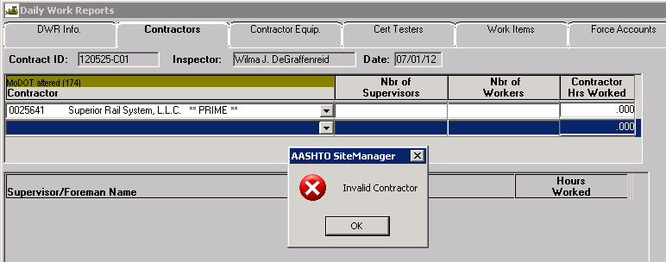

## Contractor Equip Tab

This tab will not be used for JOC contracts.

## Cert Testers Tab

This tab will not be used for JOC contracts.

## Work Items Tab

Click the Work Items tab to access the list of adjustment factors for the contract.

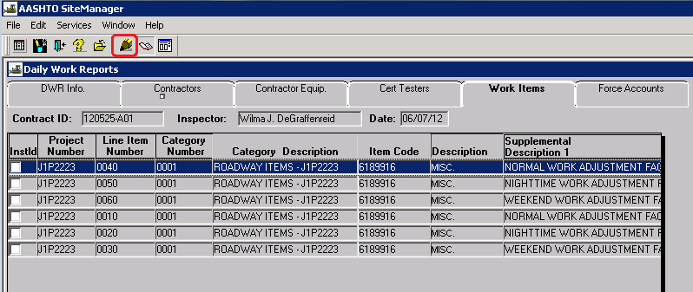

Highlight the adjustment factor for the type of work to be done and click the “Record Work Item” icon  or simply double click the item.

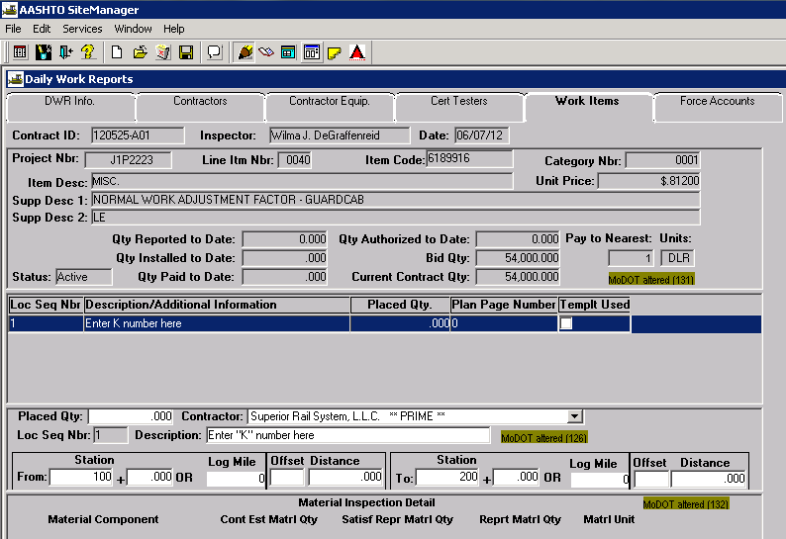

When the Record Work Item window opens, click the New icon, enter data for the following fields only:   
**a) Contractor**  
**b) Description** – Enter the property damage claim number (“K” number)  
**c) Stationing or Log Miles** – Enter 0 (zero) for stations

**Note:** Do not enter data in the Placed Qty field. Once data has been entered in the JOC templates and saved, this field will be automatically populated.

Select the Save icon.

Select the DWR Template icon.



The DWR Template panel will open to display a list of available templates for the selected pay factor. One JOC Header must be created for each property damage claim number (“K” number).

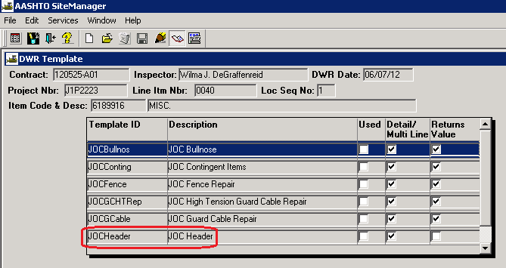

Double click the JOC Header template or highlight the template and select the Record Template Data icon . When the template opens, enter the appropriate data in the fields.

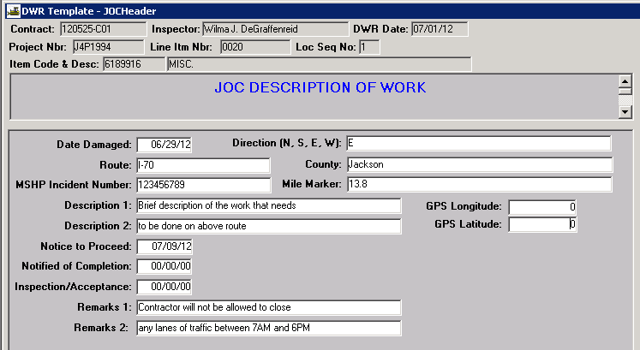

When all data has been entered in the JOC Header Template, click the Save icon , then click the Select Template icon  and select the appropriate template to enter estimated quantities for the job order.

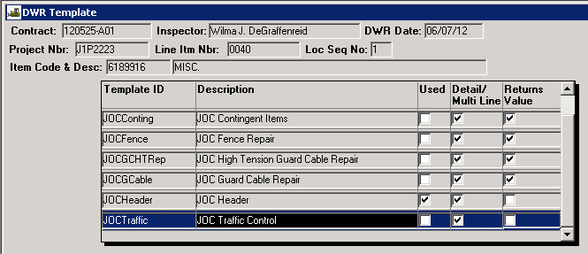

The JOC Guard Cable Repair template is shown as an example. Enter the “MoDOT Estimated Qty” for the appropriate items.

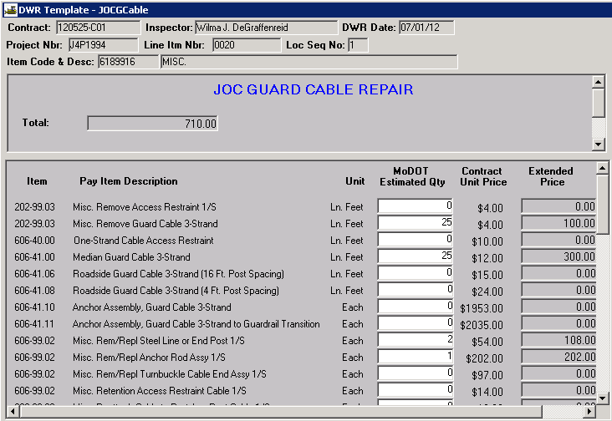

Once estimated quantities have been entered, click the Save icon [or File-Save from the menu bar]. Click the Closebutton [or File-Close from the menu bar] to return to the Record Work Item window. The Placed Qty field is now populated with the value from the JOC Template and the Templt Used box is checked.

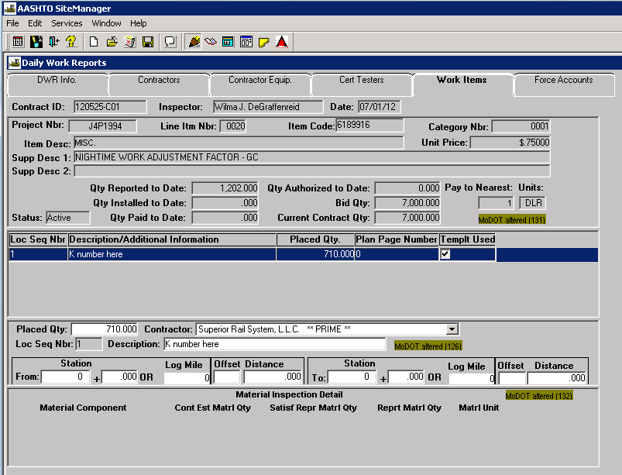

If additional items need to be entered for the work order –   
1) Click the New icon  to enter a new Loc Seq Nbr  
2) Enter data for the **Contractor, Description,** and **Stationing/Log Miles** fields only  
3) Select the Save icon  
4) Select the DWR Template icon  
5) Select the appropriate template and enter the necessary data  
6) Save and close the template

Repeat the above steps as necessary for each pay item for the work order.

Different property damage claims/work orders (K numbers) can be entered on the same DWR. However, remember that a separate header is required for each separate property damage claim/work order.

# Printing the Job Order

Once all estimated quantities for the claim have been entered in SiteManager, log on to Cognos 8 and print the **“Job Order Contracting”** report located in the Headquarters > Contract – Administration folder. This report will serve at the official job order to be given to the contractor for the work to be done.

# Verify Final Quantities for Each Work Order

When work for a job order has been completed, the user should open the previously entered DWR for this work order. On the Work Items tab, select the appropriate adjustment factor, click the DWR Template icon , and open the JOC Header template. Enter the Notified of Completion and Inspection/Acceptance dates. 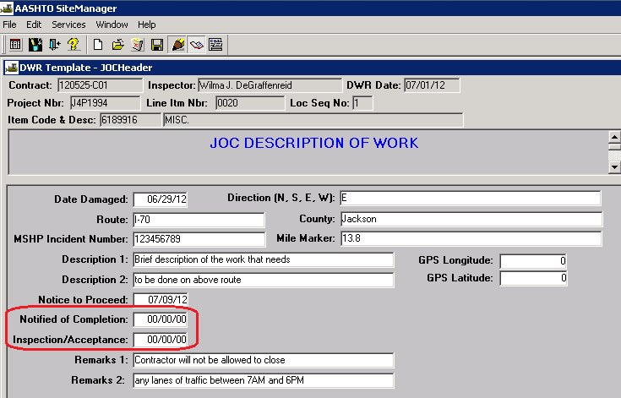

Save, then click the Select Template icon . Select the template with previously entered estimated quantities, and make any necessary changes for final quantities. Repeat for any other headers and templates for this job order.

# Authorizing the DWR

Once all final quantities for a job order have been entered, the DWR must be authorized prior to payment. Navigate to Daily Work Reports – Diary.  
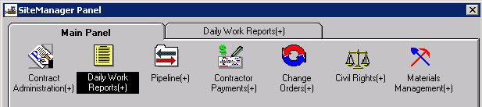

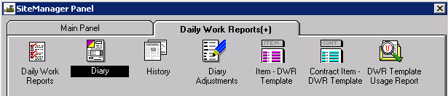

**Contract ID:** Select Services – Choose Keys to select the contract.

**Diary Date:** Double click the date field to select a date using the pop-up calendar.

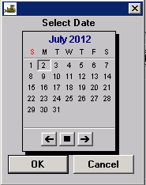

**Last Modified User ID:** Automatically entered by system.

**Creator User ID:** Automatically entered by system.

**Inspector:** The inspector who created the DWR for the Diary Date will be listed. A selected DWR may be reviewed and/or printed by selecting the Preview DWR icon in the toolbar.

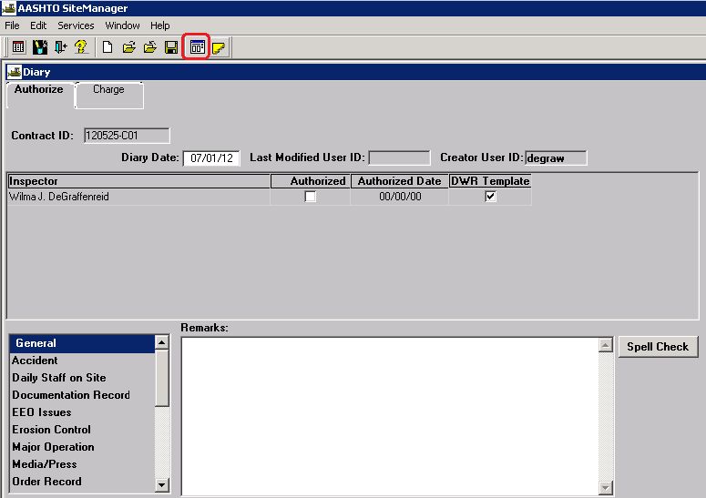

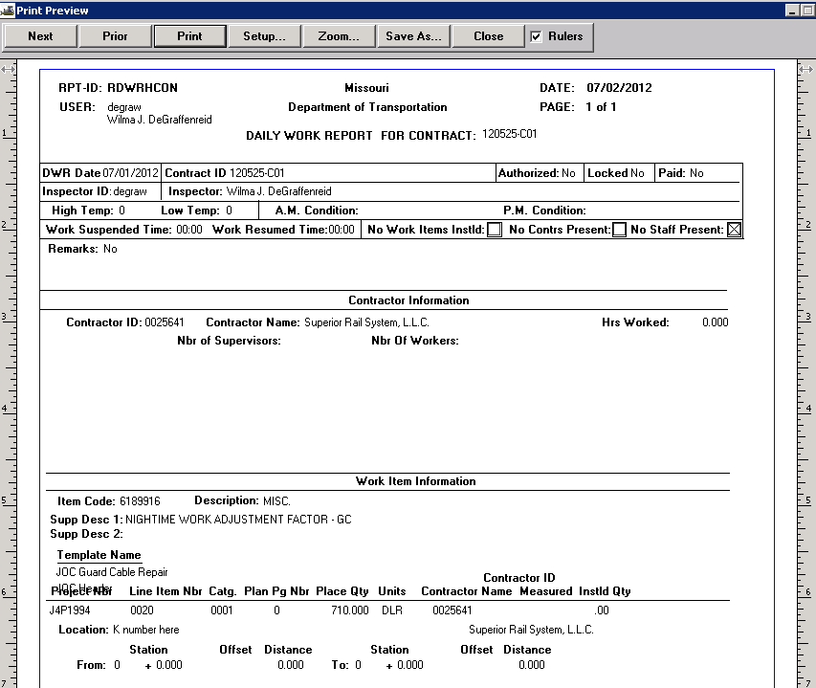

**Authorized:** If satisfied with the DWR, select the Authorize checkbox

**Authorized Date:** Automatically entered by system when the Authorized check box is selected.

**Remarks**: Select the appropriate “Remarks Type” from the list to the left of the Remarks field. Type any necessary remarks. The diary remarks need not repeat the inspector's remarks from the DWR.

**Note:** Once a DWR has been authorized, no changes can be made to it. However, a DWR may be unauthorized for correction or addition unless it has been included on a pay estimate.

Save the information.

**Charge Tab:** The Charge Tab will not be used for JOC Contracts.

# Generating a Pay Estimate

The Contractor Pay Estimate is generated to provide payment to the contractor for all work performed during the estimate period. The user must be logged on as a Construction Project Manager to generate Progress estimates. The official pay estimates are generated with period ending dates of either the 1st or the 15th (See [EPG 109.7.1](http://epg.modot.org/index.php?title=Category:109_Measurement_and_Payment#109.7.1_Payment_Estimates)). Estimates may be generated at any time prior to the estimate ending date in order to check quantities.

**NOTE:** Estimates can be re-generated without having to delete the previously generated estimate. Should the user need to re-generate an estimate, the system will indicate that an estimate already exists for the period and will prompt, “Would you like to delete?” (meaning to overwrite the existing estimate). Select "Yes," which will reset the tables and the estimate will be generated with any new data that has been added.  
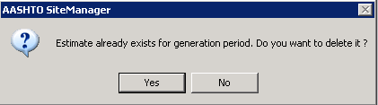

Prior to generating the estimate, verify all DWRs have been authorized in the diary for the estimate period. All pay quantities contained in DWRs for the estimate period that have been authorized on a Diary will be included for payment. Any DWRs that have not been authorized will not be included for payment until such time they are authorized on a Diary.

Navigate to Contractor Payments – Estimate – Generate Estimate.  
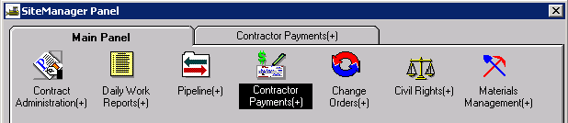

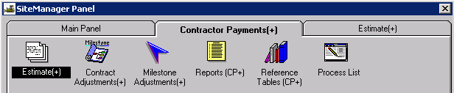

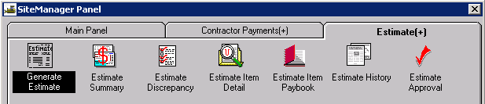

Select the appropriate contract ID from the Contracts Selection window.  
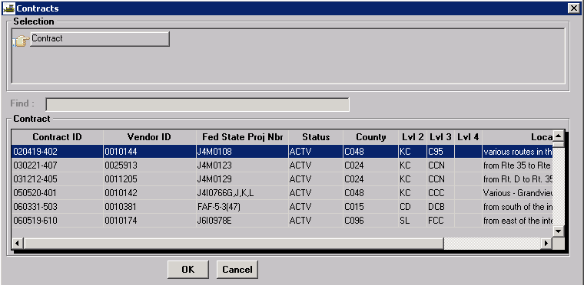

A pop-up box will appear asking for certain information. Read the directions carefully for Critical Dates and populate the date field if the event has occurred. Select the update button. If there are no fields that need to be updated, close the window by selecting the “X” in the upper right hand corner of the window.

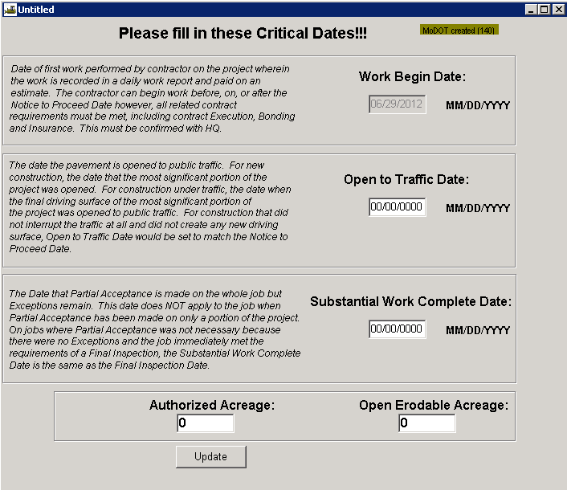

When the Generate Estimate window opens, verify the ending date is correct. If generating an early estimate, select the current date.

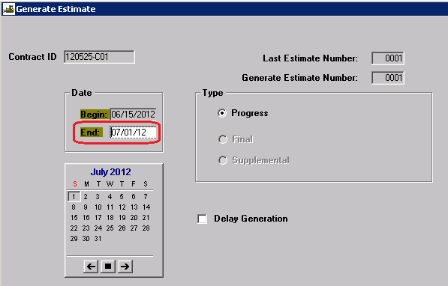

Select the Generate Estimate icon (last icon on the tool bar).  
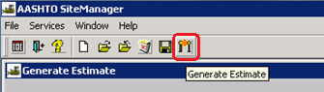

Click OK on the process submission message.  
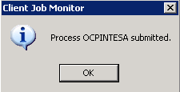

Click OK on the process completion message.  
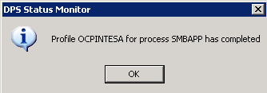

**Note:** If running in Terminal Services, user will not receive process completion messages. Check process status by selecting “Process Status” from the Services drop down menu.

Once the estimate is generated, navigate to Contractor Payments – Estimate –Estimate Summary.  




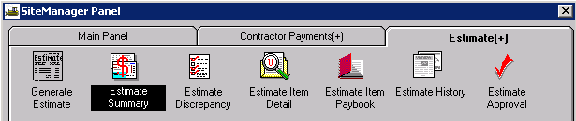

Select estimate just generated.  
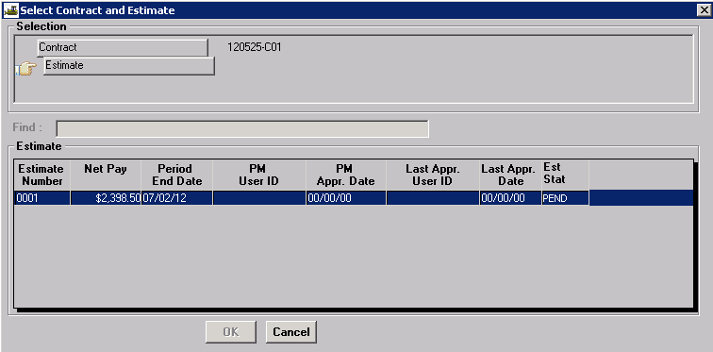

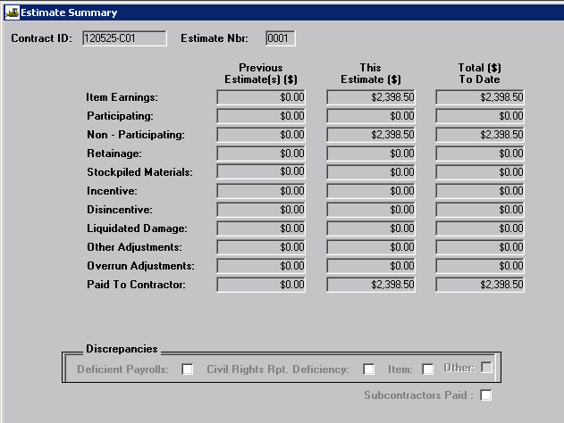

View the Estimate Summary. Once contract amounts are determined to be correct, approve the estimate. A message will be sent to the next reviewer (the Resident Engineer) for approval. The Resident Engineer should review the estimate and approve accordingly. If errors are found at the Resident Engineer level of approval, rejection should be made and the first level approver should correct the estimate and generate/review/approve accordingly.

The last level of approval, Controller's Office, is set in place to ensure generation of all estimates for all active projects statewide, rejection of negative estimates, and creation of the electronic information sent to the Office of Administration in order for the Contractor to receive payment.

Once it is verified that the estimate has been approved at the Resident Engineer level, log on to Cognos 8 and generate the “Estimate Summary for Contract, By Est Nbr with DWR Template Details” report located in the Headquarters > Contract – Estimate folder. This report should be sent to the contractor according to [EPG Category 109.7.1.6](http://epg.modot.org/index.php?title=Category:109_Measurement_and_Payment#109.7.1_Payment_Estimates) and saved as a PDF file in accordance with [EPG Category 137](http://epg.modot.org/index.php?title=Category:137_Construction_Inspection_Guidance_for_Records_to_be_Maintained).