QRG – Terminal Services/Remote Desktop Connection
Using Terminal Services to access SM can often speed up your work. This article is intended to guide the user on how to log on to Terminal Services through the Remote Desktop Connection:
Step 1: You must first establish a network connection (either through a hard wire or wireless connection). Log on to Terminal Services through the Remote Desktop Connection icon:
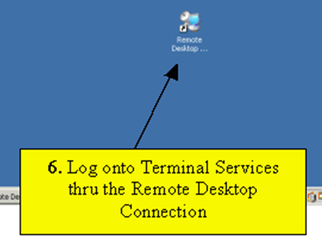

Step 2: Connect to the proper server. Currently, that server is "GHTSSMWP01". Select the Connect Button:
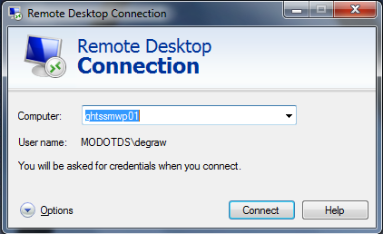

…or

Select the Start button – Remote Desktop Connection – ghtssmwp01 (as shown below):
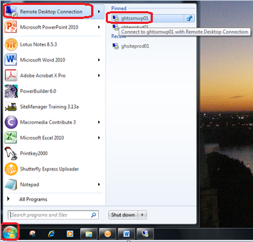

Step 3: Enter your network password and click OK.
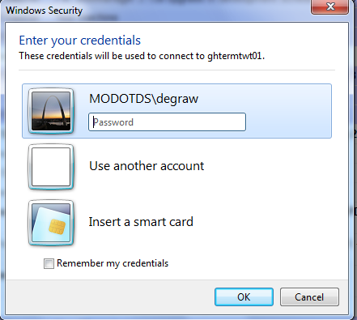

Step 4: Log on to SiteManager as normal.
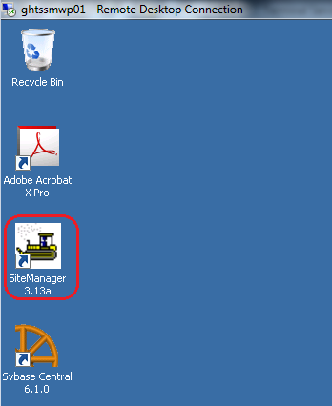

Note: When logging on to SiteManager in Terminal Services, unless you are the first user to log on, you will receive the following DPS Status Monitor message:
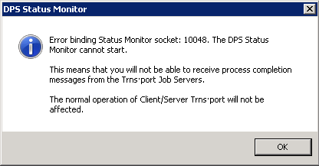
This is NOT an error; it is simply an informational message stating you will not receive process completion messages. Click the OK button and continue.

Step 5: To log off of Terminal Services, select the “Start” button, then select “Log Off.”
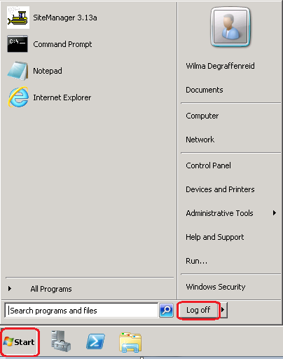

NOTE: Selecting the “X” in the upper right corner of the Remote Desktop does not close SiteManager.
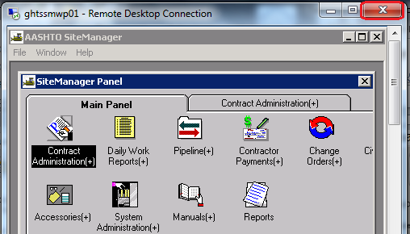

It simply disconnects your Remote Desktop session, and if you have not logged off of SiteManager, it will continue to run.
