Quick Reference Guide: Change Orders - Zero Dollar
This article is intended to guide the user in the creation of a Zero Dollar change order. The example given is to add Job Special Provisions. The same would apply for Specification changes, reducing the contract DBE goal, etc.
Navigate to Change Orders – Change Order Maintenance – Header.
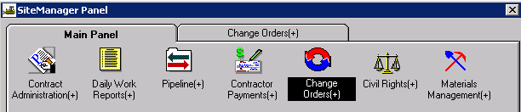
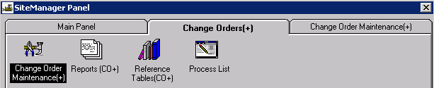
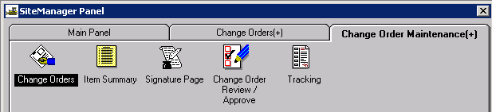
Create the Change Order Header
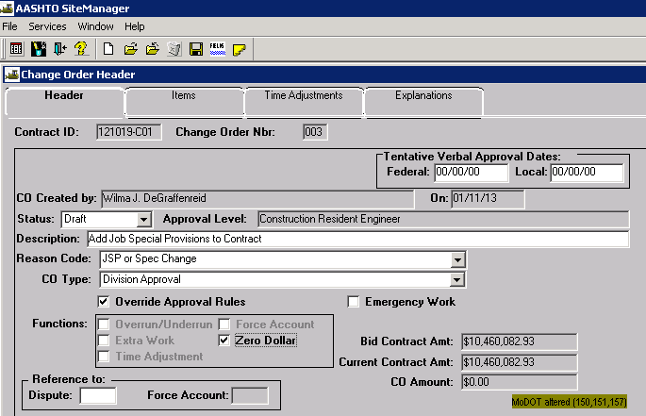
Contract ID: Select Services – Choose Keys to select contract.
CO Number: The system will automatically number the change order.
Tentative Verbal Approval Dates: May be used if it applies.
CO Created By: Automatically entered by system.
On: Date automatically entered by system.
Status: Leave Status as “Draft” until time adjustment and explanation has been entered.
Approval Level: Automatically entered by system based on change order rules.
Description: Enter a description of the change order.
Reason Code: Select “JSP or Spec Change” from the drop down list, if appropriate. Otherwise, select “Combination.”
CO Type: JSP and Specification change orders are always Level 3 Approval. Select “Division Approval” from the drop down list.
Override Approval: User may have to select Override Approval Rules to force the change order to the appropriate approval level.
Emergency Work: Does not need to be checked.
Functions: Select “Zero Dollar.”
Reference To: Dispute and Force Account: These fields are not used.

The user will not be able to add any change order items.

Adding the Change Order Explanation
Select the Explanations tab, and select "General Change Order Explanations" from the drop down list. Click the New icon and enter the explanation, including any affected line number(s) in the reason, if necessary.
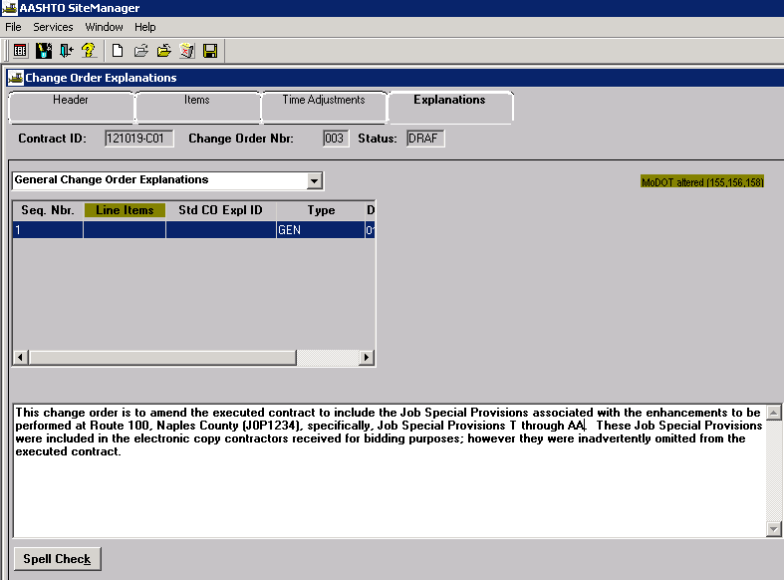

Changing the Status of a Change Order
Once the explanation has been added to the change order, return to the Header tab. User may choose to “Calculate Change Order” from the Services drop down menu. Make sure the user-selected CO Type matches the system calculated Approval Level. Remember, ALL change orders for Specification changes must be approved at Division level.
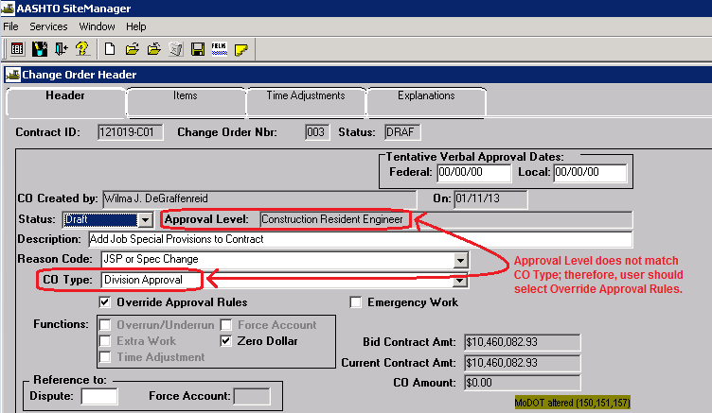
Override Approval Rules, if necessary. Change the status from “Draft” to “Pending” and save.
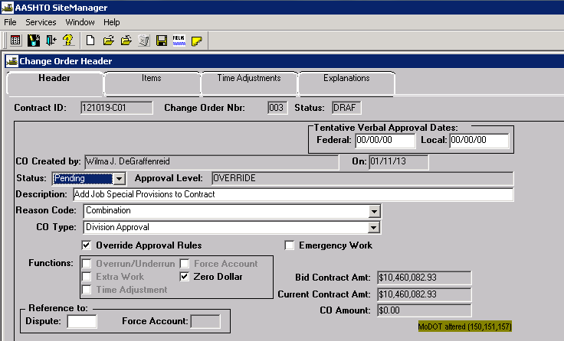
Make the appropriate selections for each approval level, and click OK.
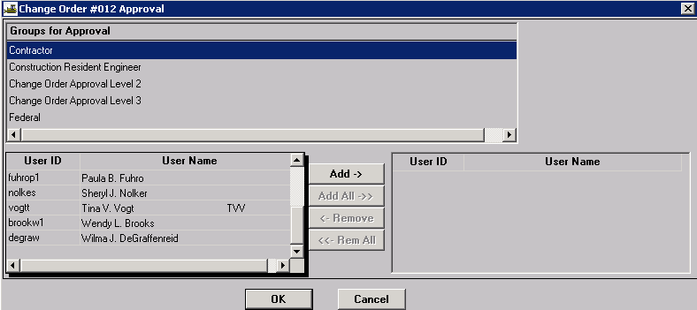
If the approval levels have been overridden, the user will be required to make the appropriate selections for both “Groups for Approval” and users as noted below. Once the selections have been made, click OK.
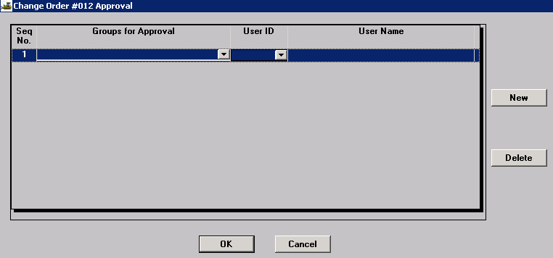

Printing the Change Order
Print the appropriate ReportNet report – either “Official MoDOT TIME EXTENSION Change Order Report” or “Official MoDOT MILESTONE ADJUSTMENT Change Order Report.” See Change Order Reports for guidance.

Saving the Change Order
All change orders must be saved in .PDF format to the V: drive in the following path for your district and org code: V:\Contract Information Archive\District # \ ORG # \ Contract ID \Change Orders\Pending. (See Note below.) File name should include the change order number placed within the file name so the change orders will sort properly when listed in the folder. See example below:
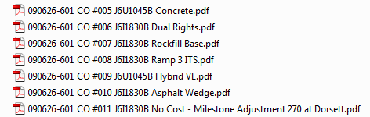

Once the change order has been approved at all levels, it shall be saved with all attachments in a single file to V:\Contract Information Archive\District # \ ORG # \ Contract ID \Change Orders\Completed.
Note: When distributing a change order electronically for signature, it should be stored with all attachments in a single file in the “Completed” change order folder and linked from there. Once the last digital signature is applied, the process is complete. No further action is necessary on the part of the project office, that is, there is no movement of the document from one folder to another.

