QRG – Contractor Pay Estimates
The Contractor Pay Estimate is generated to provide payment to the contractor for all work performed during the estimate period. The user must be logged on as a Construction Project Manager to generate Progress estimates. The official pay estimates are generated with period ending dates of either the 1st or the 15th (See EPG 109.7.1). Estimates may be generated at any time prior to the estimate ending date in order to resolve discrepancies or check quantities.
NOTE: Estimates can be re-generated without having to delete the previously generated estimate. Should the user need to re-generate an estimate, the system will indicate that an estimate already exists for the period and will prompt, “Would you like to delete?” (meaning to overwrite the existing estimate). Select "Yes," which will reset the tables and the estimate will be generated with any new data that has been added.
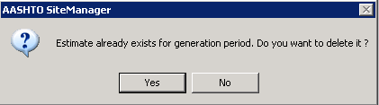
Prior to generating the estimate, the user should verify all DWR's have been compiled and approved in the diaries through the estimate period. This may be done in the Daily Work Reports - History section. All pay quantities contained in DWR's for the estimate period that have been authorized on a Diary will be included for payment. Any DWR's that have not been authorized will not be included for payment until such a time they are authorized on a Diary.
Navigate to Contractor Payments – Estimate – Generate Estimate.
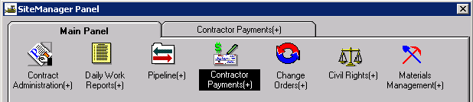
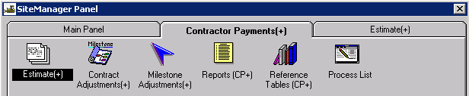
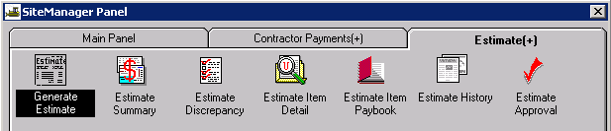

Select the appropriate contract ID from the Contracts Selection window.
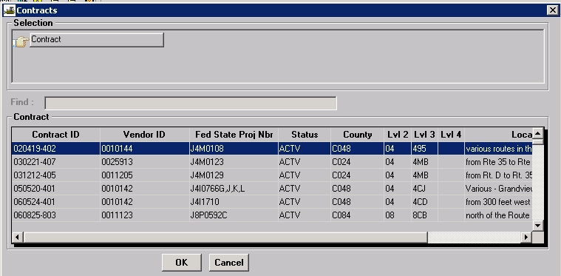

A pop-up box will appear. Read the directions carefully for Critical Dates and Primary Receiving Waters. Populate the date fields if the event has occurred. If there is Authorized/Open Erodible Acreage on the project, enter the data in the appropriate fields. Enter Primary Receiving Waters with Job Number for projects with more than one acre of land disturbance. Select the update button. If no fields are updated, close the window by selecting the “X” in the upper right hand corner of the window.
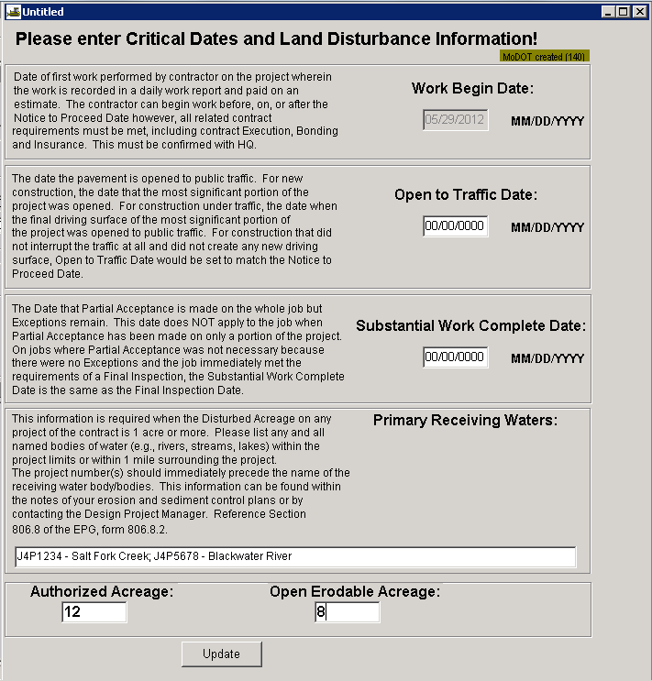
When the Generate Estimate window opens, verify the ending date is correct. If generating an early estimate, select the current date.
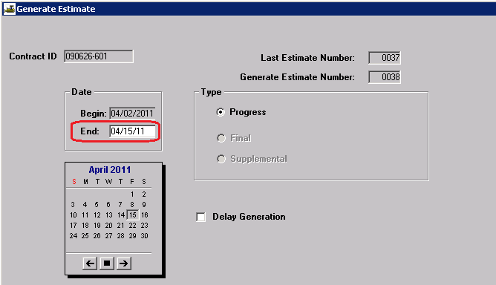
Select the Generate Estimate icon (last icon on the tool bar).
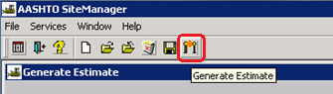
Click OK on the process submission message.
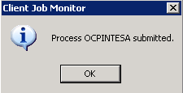
Click OK on the process completion message.
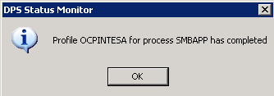
Note: If running in Terminal Services, user will not receive process completion messages. Check process status by selecting “Process Status” from the Services drop down menu.

Resolve Discrepancies
Navigate to Contractor Payments – Estimate –Estimate Discrepancy
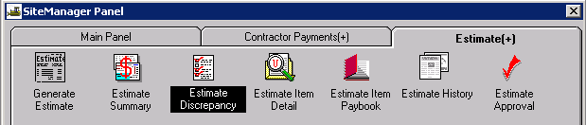
This will open the Estimate Discrepancies window.
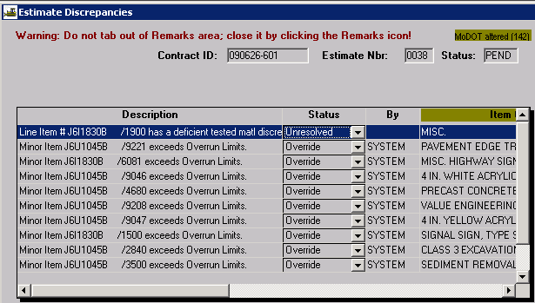
TIP: Selecting “Recalculate Discrepancies” from the Services drop down menu immediately upon opening this window may resolve some discrepancies listed without having to manually resolve them.
Select Navigation from the Services drop down menu or the Navigation icon to help resolve these discrepancies. Once resolved, recalculate the discrepancies.
It may be appropriate to Override certain discrepancies. In this instance, appropriate and detailed remarks must be included in the Remarks window.
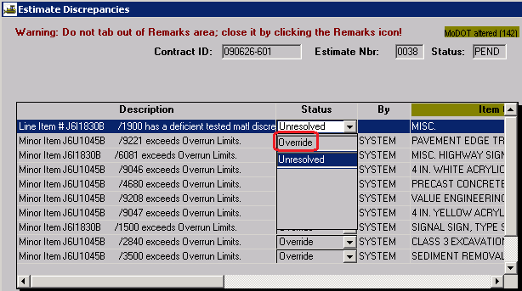
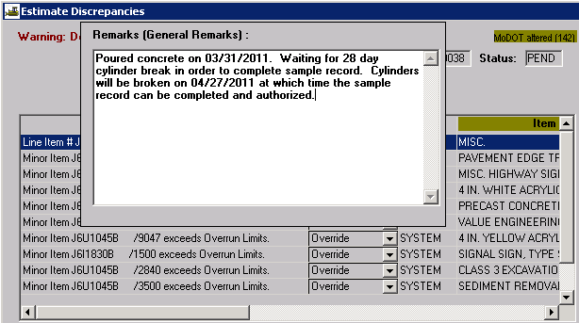

NOTE: If generating an early estimate in order to check quantities and/or resolve discrepancies, do not override discrepancies until the official estimate is generated. This will save time, as discrepancies must be overridden each time an estimate is generated. It is advisable to resolve the discrepancies.
Review the Estimate Item Detail to verify the quantity for payment for each line item is correct. Incorrect quantities must be corrected by creating a DWR/Diary and regenerating the estimate. Do NOT make corrections to the Estimate Item Detail.
Items that have intentionally overrun do not need to be corrected on a DWR. The system will automatically override overrun discrepancies and create line item adjustments to deduct payment for the contract items that have exceeded the current contract item quantity. Once a change order is approved for the contract overruns, the system will make overrun re-adjustments on the next generated estimate.

Review Estimate Summary
Navigate to Contractor Payments – Estimate –Estimate Summary.
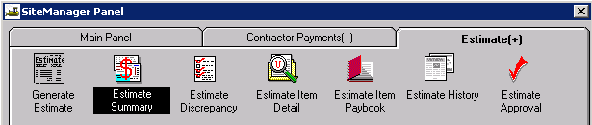
Select estimate just generated.
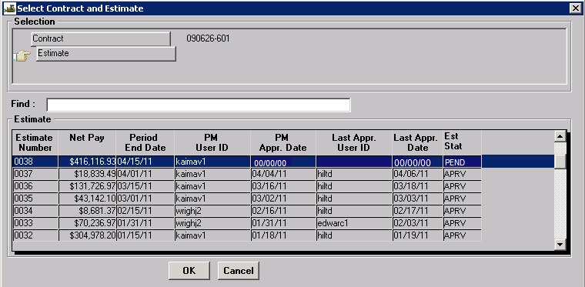
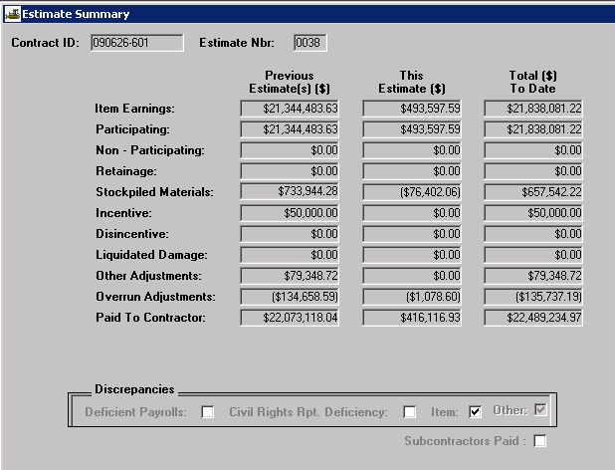
View the Estimate Summary and verify Stockpiled Materials payments (if applicable) are accurate. Verify Fuel Adjustments are accurate (if applicable, they will be grouped with Other Adjustments).
Refer to the Contract Adjustments QRG, Line Item Adjustments QRG, and/or Milestones QRG if any of these types of adjustments need to be made to the estimate.
Once all adjustments have been made and contract amounts are determined to be correct, approve the estimate. A message will be sent to the next reviewer (the Resident Engineer) for approval. The Resident Engineer should review the estimate and approve accordingly. If errors are found at the Resident Engineer level of approval, rejection should be made and the first level approver should correct the estimate and generate/review/approve accordingly.
The last level of approval Controller's Office is set in place to ensure generation of all estimates for all active projects statewide, rejection of negative estimates, and creation of the electronic information sent to the Office of Administration in order for the Contractor to receive payment.

Generate Cognos Estimate Report
Once it is verified that the estimate has been approved at the Resident Engineer level, the Cognos report “Estimate Summary for Contract, By Est Nbr with DWR Template Details” should be generated and saved as a PDF file on the V: drive in the appropriate Contract Information Archive folder. The report should be emailed to the prime contractor.
The Resident Engineer is responsible for ensuring this report has been sent to the contractor according to EPG Category 109.7.1.6 and saved as a PDF file in accordance with EPG Category 137.

