QRG – Digital Signatures Adobe DC Reader / Pro
  - These instructions are written for Adobe Acrobat Reader DC and Acrobat Pro DC and may not apply to other versions.

Section 1: CAPTURE a Signature Image
This section will typically be completed only once by a particular person.
This process assumes that a user is authorized to sign documents based on the user’s title, or the user has been delegated to sign documents on behalf of the authorized user.
There are many options that can be used to capture your signature image. If you have your own method to capture your signature as a .PDF please do so, the rest of this section just explains one method that can be used. Due to some changes in the Adobe DC packages you are now required to have your signature as a .PDF file. The image and file to be the most efficient size will need to be about 1inch tall by about 2 inches long.
Scan an image of the authorized user’s signature into to a .PDF file. This is most easily done by having the authorized user sign a blank sheet of paper, then scanning the page and sending the scanned image to your email. It may be advisable to sign the page several times and select the best version.
Paper signed…
Scan and send the image to yourself. The image will arrive as an email attachment, similar to this
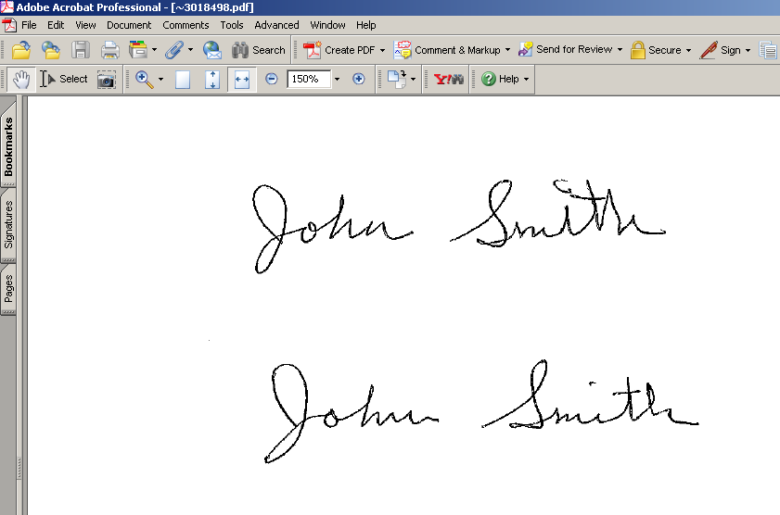
Open the .PDF file in Adobe
If you made multiple signatures decide which one you want.
Click on the Edit pull down menu and you will see “Take a Snapshot” option.
Click on “Take a Snapshot” a “+” cursor will appear. Draw a rectangle around you signature. This will automatically be copied to the clipboard.
Now open Microsoft Word.
In Word open a new blank page. Set the margins to 0.0 for top, right, left, and bottom. (If you get an error saying the margin is too small, just hit the ignore button)
Set the page size to custom and 1inch height and 2 inches width.
Paste the signature from the clipboard.
Under the file menu choose “save as” and select the file type .PDF.
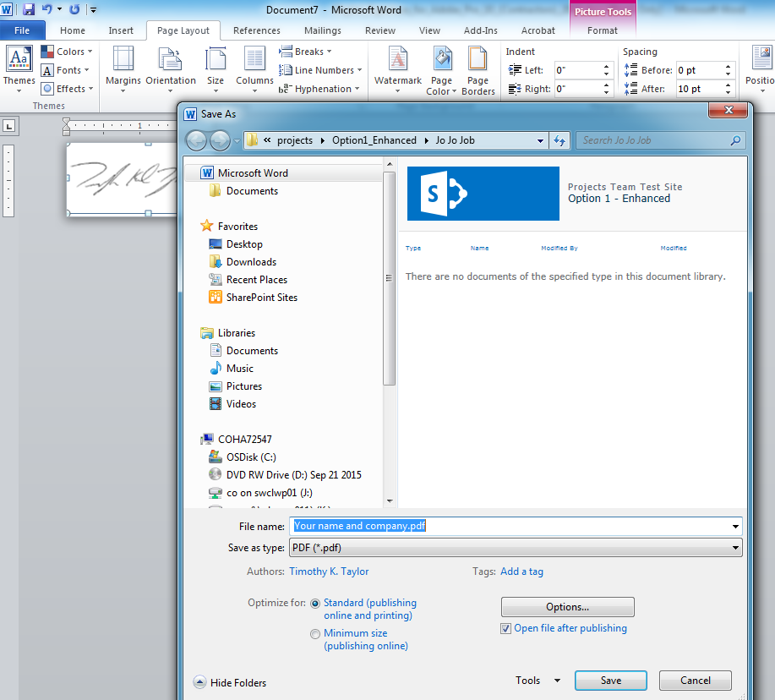
Save the signature file where you can get to it in a few minutes. We will be using this to finish the Digital Signature.
Close Word, and if Adobe opened the signature file close it too.

Section 2: SET UP an Adobe Digital Signature ID
Open Adobe DC or Adobe Reader DC
Navigate to Preferences. Edit-> preferences 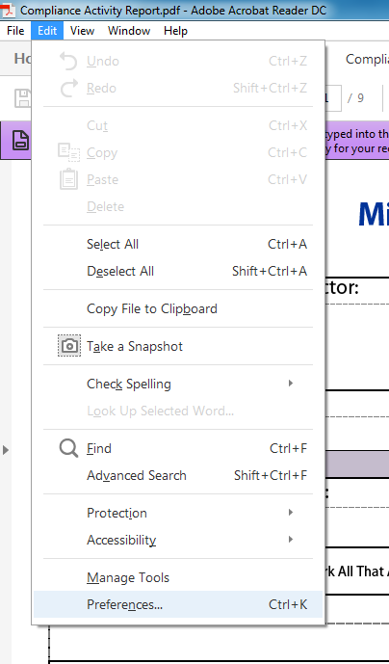
Now find and click on Signatures on the left Side, this will change the screen to the Digital Signatures options. In the “Identities and Trusted Certificates” section click on the “more button” 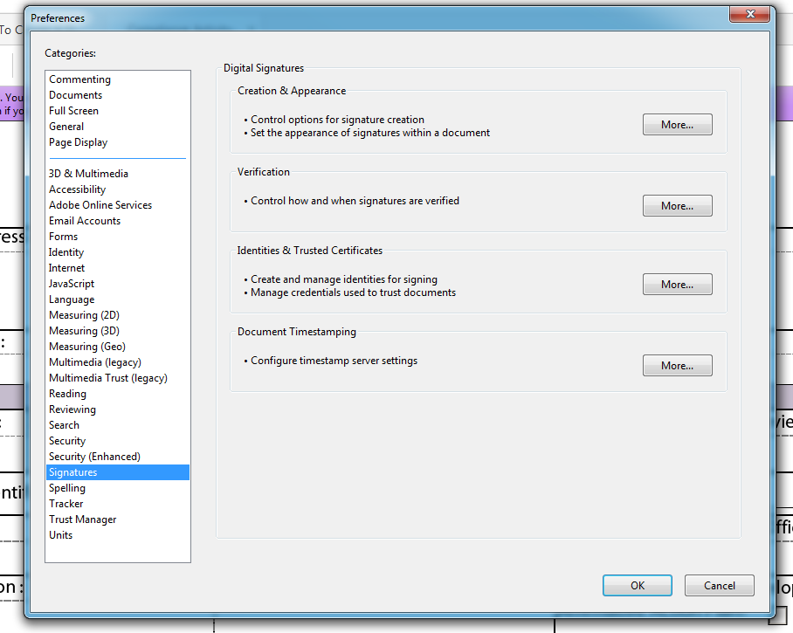
1
2
Click on the Add ID button. 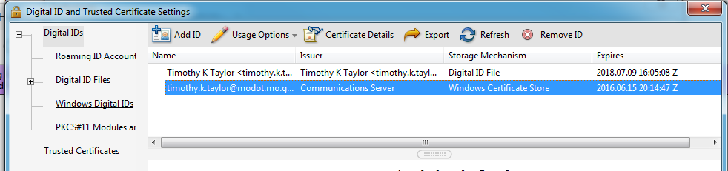
Click on the radio button next to “A new digital ID I want to create now” Then click the “next” button. 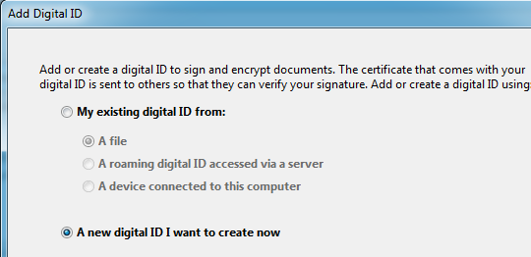
Make sure the “New PKCS#12 digital ID file” is selected. And click “Next” 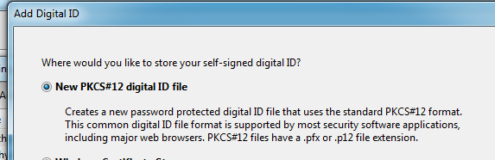

Fill out the top 4 lines and make sure the bottom 3 lines match the picture below. 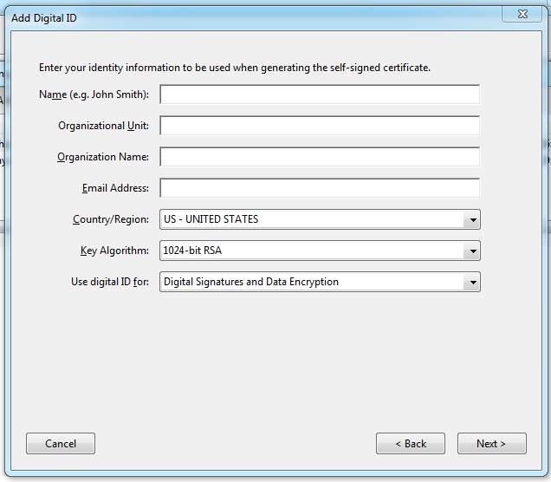
Create a password and then click on “Finish” 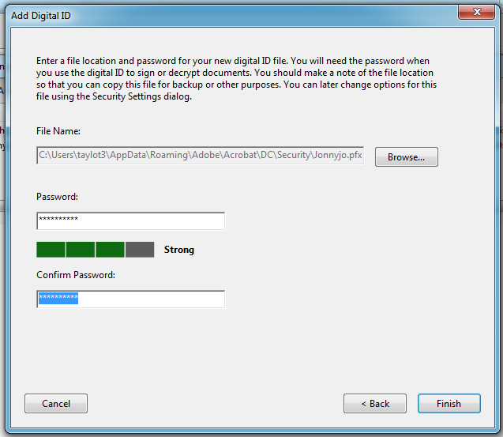
You are done with the Digital ID. Now we will apply the Signature to the Digital ID.

To attach the signature to the Digital Id you will have to open a .PDF document (this can be a document that you need to sign.)
You will have two options when you sign a document.
- The document will have an adobe signature block that will open the signature window
- You will have to draw your own signature block.
I will explain the second one since the first is self-evident.
Open a .PDF document. (One that does not have an Adobe Signature Block.)
Click on Tools and then on Certificates.
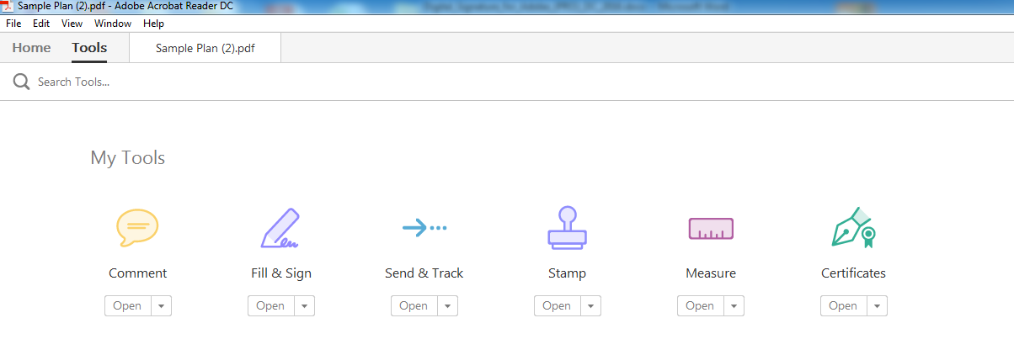
This will open the certificate window look for the “Digitally Sign” (see below) and click on it.
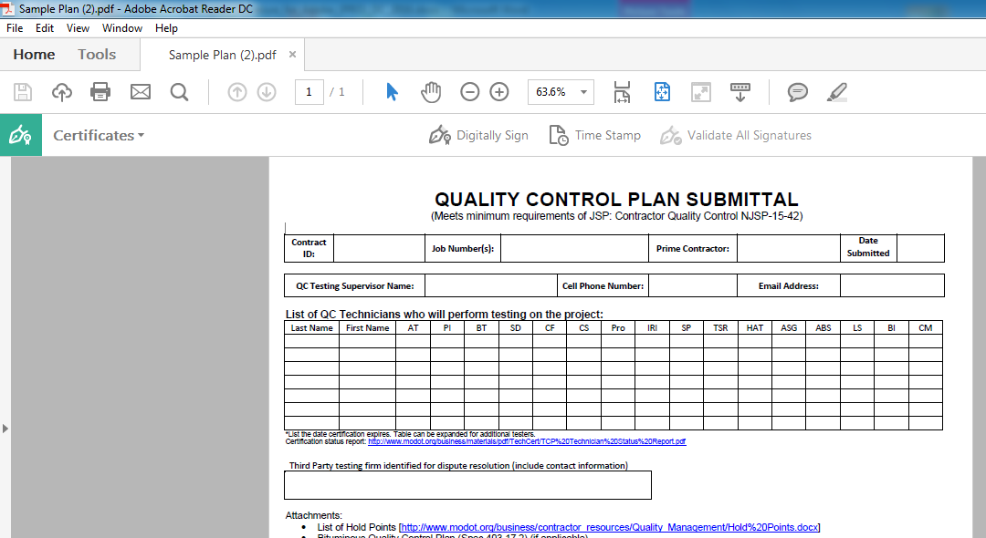
You will get a pop-up box that tells you to place the signature block, follow the instruction, if you place it in the wrong spot just cancel and try again.
Once the box is placed you will get the “Sign Document” Window. Usually you will only have to enter your password to be done, but this first time you will have to add your signature so there are a few extra steps.
Now click on the Appearance Down menu, select “Create New Appearance” This will open a new window
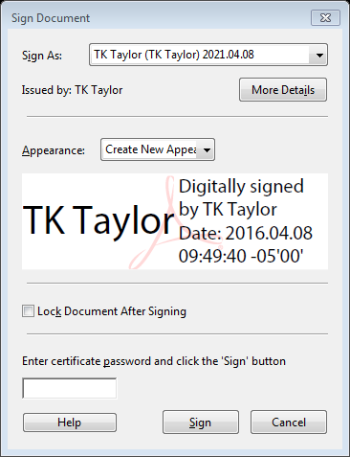
Put your name in the Title Line
In the Configure Graphic area, select “Imported graphic” and click the “File” button.
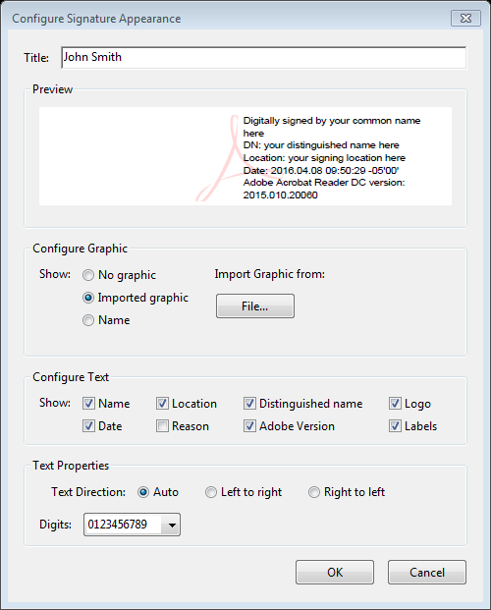

Click the Browse button and navigate to the location where the signature file was saved.
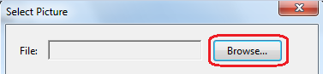
Because Adobe only accepts, .PDF files for the Signature, It will be your only choice.
Select the signature file name and click the Open button.
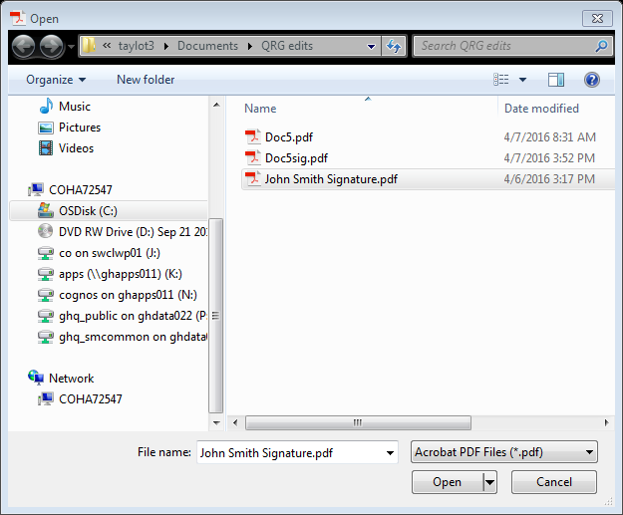
The window will display the signature image. If it is correct, click OK. If the wrong file was selected, browse again.
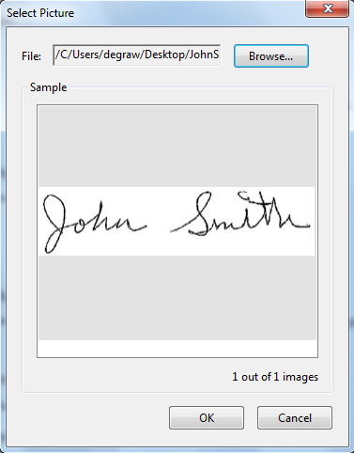
Select all the boxes circled below except for the “Reason” box and click OK.
Click the OK button.
You are now ready to Sign the Document
Enter the Password you chose earlier and click the “Sign” button…you will now be asked to save the document. This will allow you to overwrite the current file or make a new signed copy.
Make your choice and click the “Save” button
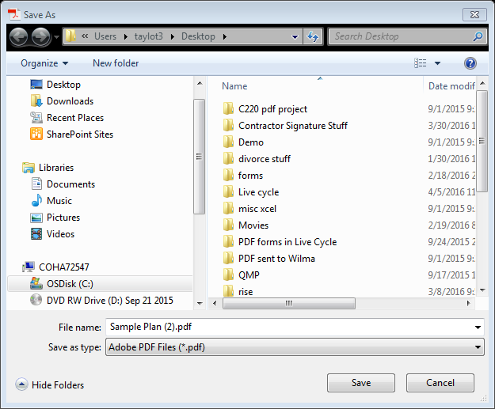

You are now done signing a document. It will be much easier the next time. There are just a couple of steps now that we have your Digital Signature Created.

Please continue there is one final step for verification and security of signatures.

See next page

Section 3: SUBMIT a Digital Signature Certificate (Public Key) and List of Signers
Each user will create his/her own digital signature using Adobe Acrobat Pro DC or Adobe Acrobat Reader DC. This will be done concurrent with the first “signing” of a document. The user will then e-mail a copy of the digital signature public certificate file to MoDOT Construction and Materials, where it will be stored in: V:\Digital Signatures\Contractor FDF files. This public certificate is not your digital ID (Private Key), but it is a Public Key that allows MoDOT to verify your digital signature on documents.
To submit a digital ID, open Adobe Acrobat Reader /Pro DC. Edit – Preferences – Click the “Identities & Trusted Certificates” More” Button. (NOTE: These instructions are for Adobe Acrobat Reader/Pro DC; other versions may be different, but this function will be available.)

Select Your Digital Signature name (the blue row in the image below), then select “Export.”
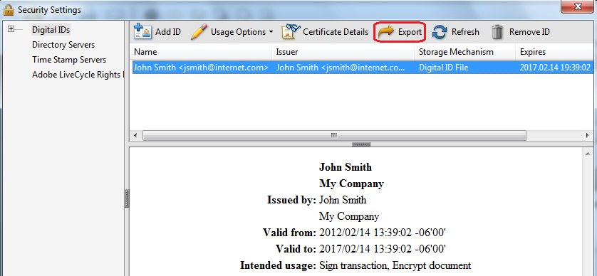

Select “Email the data to someone” and click the Next button.
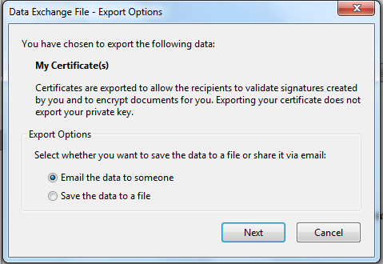
Click the Email button. It is NOT necessary to fill in the “To:” field. The system will transfer the user to the company email which can then be sent to ReDev@modot.mo.gov
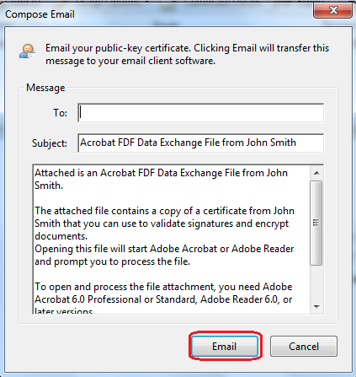
The contractor’s submission of the FDF file (Public Key) is to be accompanied by a letter (see next page) stating that the contractor accepts the prescribed digital signature process in use by MoDOT at the time of the submission.

PFX Files
The PFX file holds your digital ID (Private Key) and is stored on the user’s computer. It is advisable to also store this file in a back-up location in case it is lost. Do not send this file to MoDOT. The file is password protected and cannot be used by any other user.
To locate the PFX file to copy and store a back-up, the simplest process is to Search the C:\ drive for *.PFX.

Example Letter for Authorized Digital Signers

<Contractor LETTERHEAD>

<date>

Mr. David Ahlvers
State Construction and Materials Engineer
Missouri Department of Transportation
P.O. Box 270
Jefferson City, MO 65102

Mr. Ahlvers:

The individual(s) listed below hereby agree to communicate official <type of documents > via electronic means including sending and receiving the <type of documents> documents, and signing the documents with a digital signature applied using Adobe Acrobat Pro. We acknowledge that MoDOT will act as the approver of the digital signature and that MoDOT will retain the attached digital signatures on file for comparison if that becomes necessary.

The individual(s) are:
<first and last name – add as many rows as needed> <inked signature>

MoDOT will be notified of any changes to the list as soon as practical.

Sincerely,

<signature>
<name and title>

Section 4: ROUTINE Adobe Digital Signatures
This process assumes that a person is authorized to sign documents based on the person’s title, or the person has been delegated to sign documents for the authorized person. This section may be used as many times as necessary once the user has completed the steps documented in Sections 1-3.
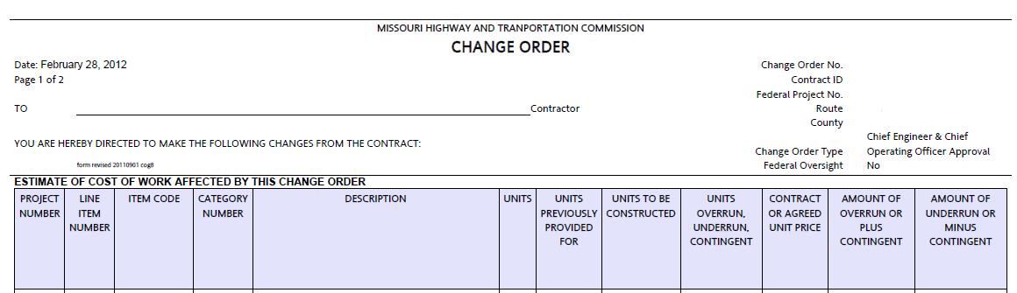
Detach the PDF document from the email by saving from the email system to a hard drive on the computer. Open the document in Adobe Reader/Pro DC. (Part of an example PDF document is shown above. This example is a change order, but digital signatures may be applied to any PDF file.)

Select Tools – Certificates – Sign Document.

This pop-up may be displayed to remind the user to designate a location on the page for the digital signature. Once familiar with the process, this notification may be suppressed by checking “Do not show this message again.” Click “OK” to continue.

Select the area where the digital signature should appear. On a change order PDF, define the full area of the change order signature line that applies to the signature you are attaching. The selection area will appear as a light blue rectangle. Make the rectangle about the same size as shown below.
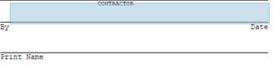
This pop-up may appear. If satisfied that the selected area is adequate, click “Sign;” otherwise, click “Start Over” to reselect the signature area.
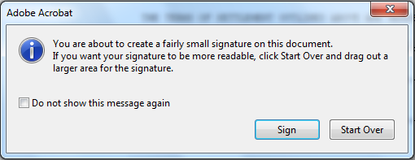

When the mouse button is released, the Sign Document dialog box will appear. Select the appropriate digital ID in the “Sign As” drop down field.
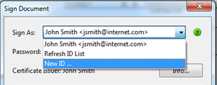
.

Note: MoDOT will NOT accept the “Standard Text” digital ID. If Appearance defaults to “Standard Text,” make sure to select the digital signature file created when the signature image was captured, as shown below (“JohnSmithSignature” in this example).

Do NOT select “Lock Document After Signing.” Selecting this option locks all fields, including any remaining signature fields.
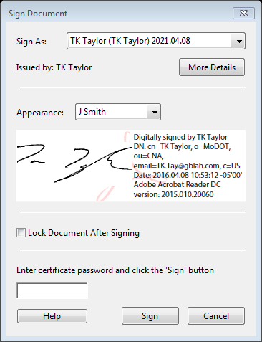

Once the signature file is selected, enter the password established when the digital ID was created

Click the Sign button.

Save the signed document. The document will look something like this where it was digitally signed.

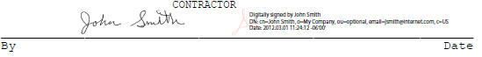

Attach the digitally signed change order (or other document) to an email, and return it to the Resident Engineer.

