Quick Reference Guide – Emergency Contacts
With the elimination of the Lotus Notes Construction Directory, a Cognos report has been created to address emergency contacts for all active contracts statewide. The report is sorted by Route to facilitate Customer Relations bucket calls. This Quick Reference Guide will guide the user on how to enter direct contact and after-hour emergency phone numbers for both the contractor and project office personnel for all contracts.
From the Main Panel, navigate to Contract Administration -- Contract Records -- Contacts.
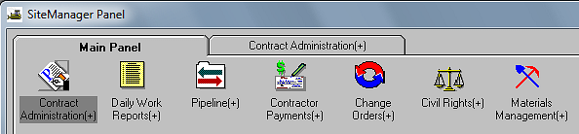
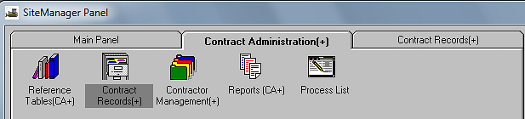
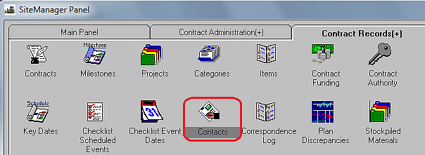
Select the appropriate contract from the Select Contract window.
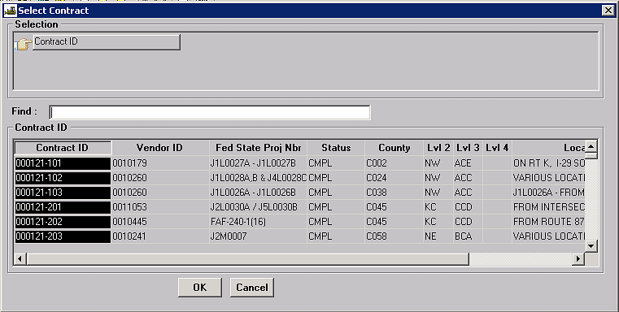
The Contacts window will open; click the “New” icon to enter emergency contact data.
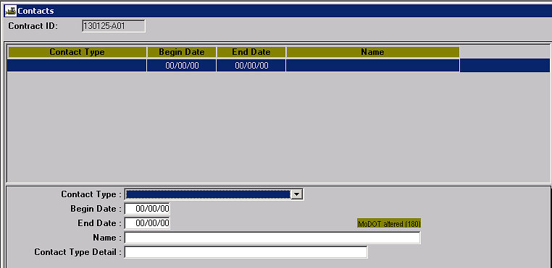
Contact Type: Select “Emergency Contact” from the drop down list.
Begin Date: Enter the date the contractor begins work and assumes maintenance on the project.
End Date: Leave this field blank. This field will automatically populate once the Final Inspection key date has been entered in the Key Dates area of the system. An End Date will remove the contact from the Emergency Contact report.
Note: If a contact needs to be removed for another reason, e.g., lead inspector transferred to a different project, the user may enter an end date.
Name: Enter contact’s name. If the name is personnel for a subcontractor, e.g., signing subcontractor, enter the company name also. The report will automatically pick up the prime contractor’s name.
Contact Type Detail: Enter the appropriate telephone number. It is acceptable to enter multiple numbers for the same contact name; however, the type of number, i.e., office or mobile, must be entered in parentheses following the number. (See examples on page 3.)
Save the contact entry.
To enter additional contacts, select the New icon , and repeat the above steps. Multiple contacts for the same contractor may be entered if desired.

Note: At a minimum, it is expected that an office and mobile number will be entered for the prime contractor, and mobile numbers for the Resident Engineer and lead inspector will be entered. The Emergency Contacts report will automatically pick up the project office number for Resident Engineer and lead inspector from the system reference tables.
(See examples below.)
Example of prime contractor information:
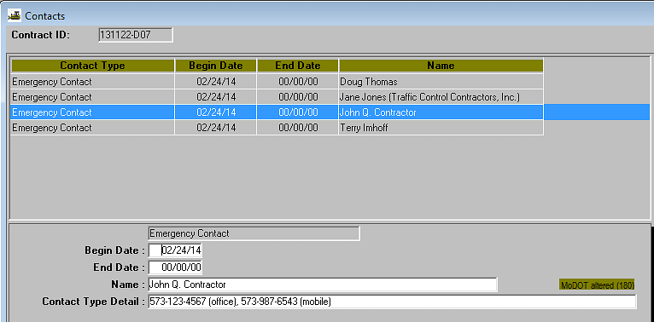
Example of signing contractor information:
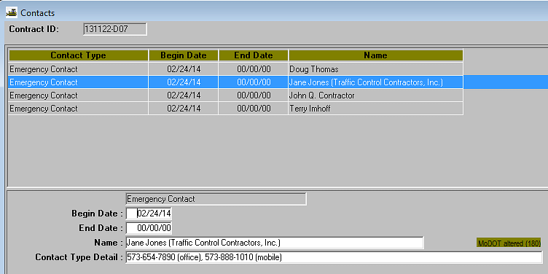
Example of Resident Engineer/lead inspector information:
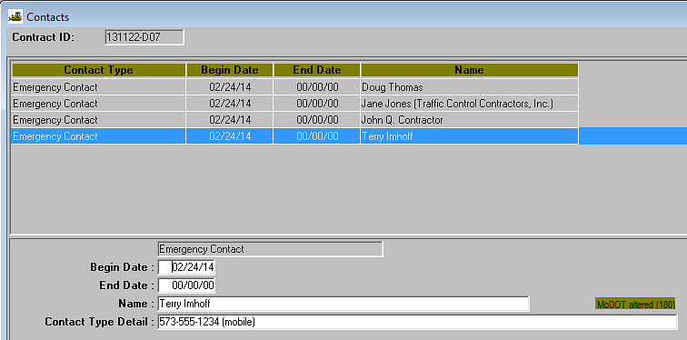

The report may be accessed from the Emergency Contacts link on the Construction & Materials – Contract Administration page in SharePoint.
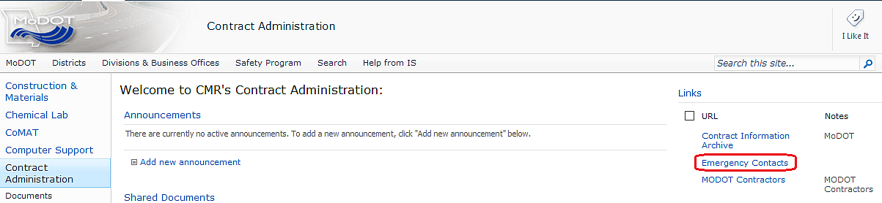
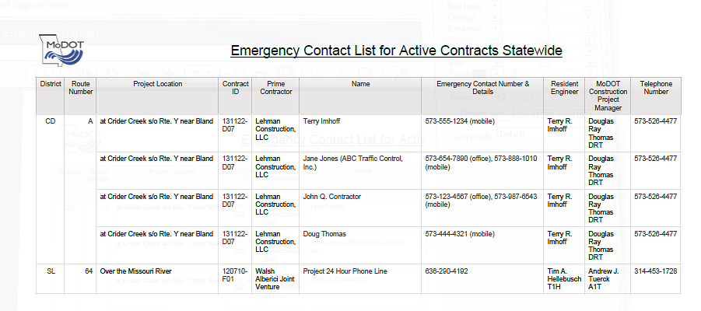
The Emergency Contacts report is sorted by district and route. The report is also available in Cognos in the following path:
Public Folders > SiteManager Reporting > Headquarters > Contract-Administration

