Quick Reference Guide – Cognos Access for SM
Cognos 10 is the official reporting tool for Construction and Materials. There are two authoring tools in Cognos 10. Author access may be limited by an allotted number of licenses.
Query Studio is an easy to use basic authoring tool for simple queries. Report Studio is a more complex authoring tool for creating and customizing professional reports. To gain access to Query Studio/ Report Studio, users must complete the required Learning Management System (LMS) courses.

How to navigate and run reports in Cognos 10:
Cognos Connection is the web portal for accessing Cognos 10 reports and is located on the MoDOT intranet site. Follow these steps to access the Cognos Connection from the intranet:
- Under Quick Links on the left side of the page, click the “Official MoDOT Reporting” link.
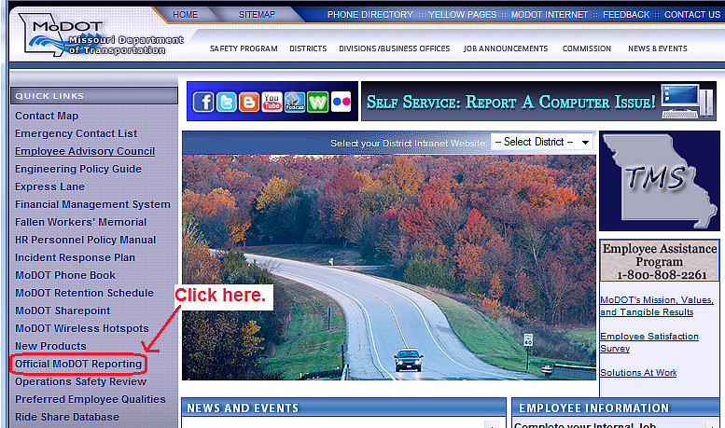

- Click the Cognos Connection (Cognos 10) link.
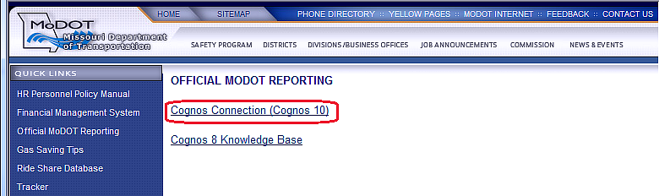
- Log in to Cognos 10.
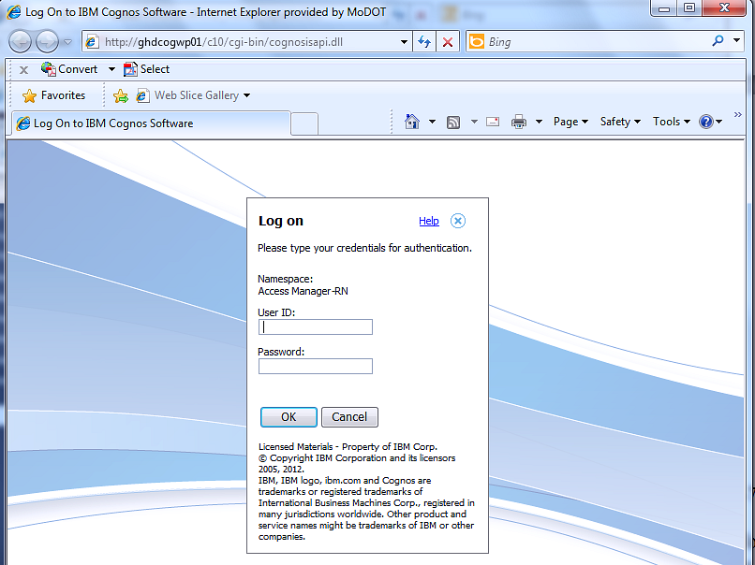
Note: Passwords for Cognos 10 can only be changed by contacting the IS Helpdesk at 573-751-5000.
- For easier access to Cognos 10 in the future, a shortcut to the desktop can be created before logging on by right clicking the mouse on the web page. Select “Create Shortcut” in the pop up box.
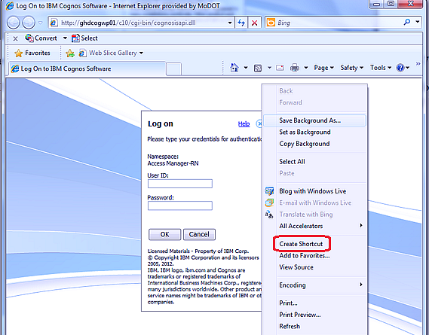

- Click “Yes” on the pop-up message box, and a shortcut to Cognos 10 will be placed on your desktop.
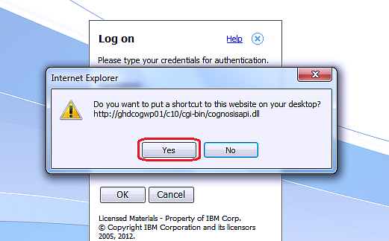
- Right click the new icon (“Log on”), select “Rename,” and name the icon “Cognos 10.”
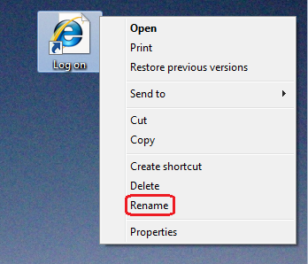
- After logging on, the Cognos 10 Welcome page will appear. From the Welcome Page, select “IBM Cognos content.”
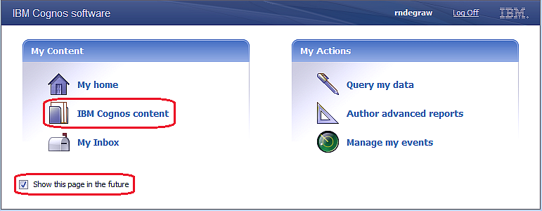
Note: Uncheck “Show this page in the future” if you do not want to see this page each time you log on to Cognos 10. The Welcome Page can always be accessed by selecting the drop down Help arrow at the far right end of the Cognos Connection tool bar.
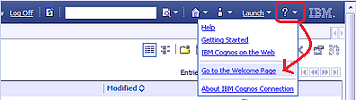

- From the Public Folders tab, select the “SiteManager Reporting” folder.
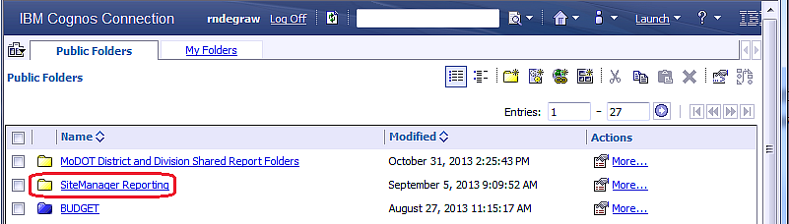
- At this point, users may set their preferred view as Home Page, set personal preferences, and launch reporting tools as noted below.
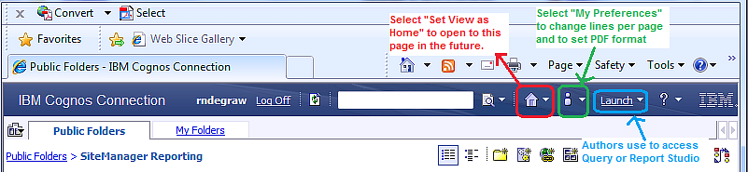
- The Cognos 10 folder structure provides folders for FHWA, each district, and Headquarters. Select the appropriate subfolder.
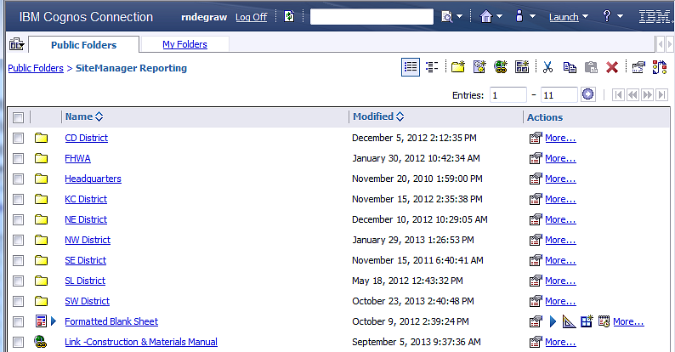

When navigating through the folder hierarchy, the path is displayed below the Public Folders/My Folders tabs. To move back up the hierarchy, select the folder from this path. Using the Internet Explorer BACK button 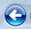 may work, but does not always function as expected and should be avoided. It is best to navigate using the links found within the Cognos Connection.
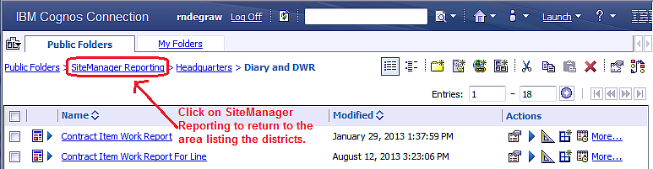

Click on the report title to run a report. If the report requires data entry to run correctly, a prompt page will display. Some prompts are mandatory while others are optional. On-screen instructions may provide direction, including information about which prompts are mandatory.
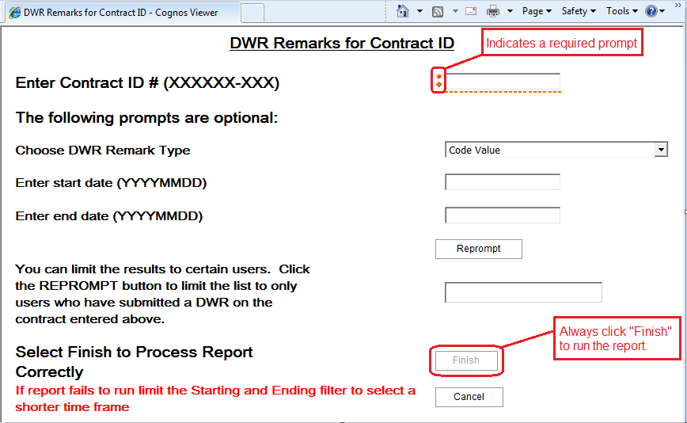

To re-run the same report with different prompts, click the “Run” icon . After the report runs, click the “Return” icon to return to the previous page.
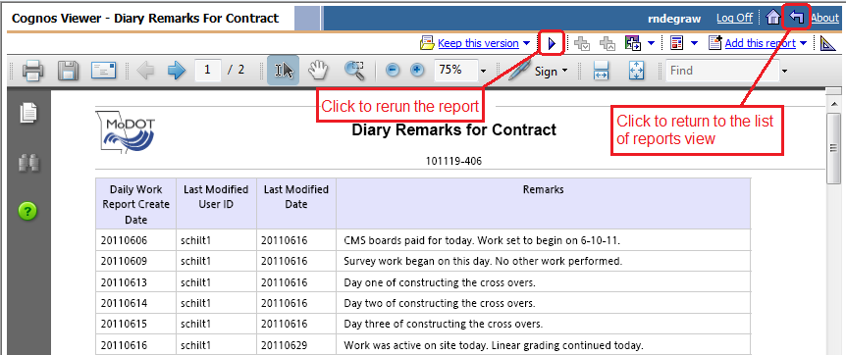
Click “Log Off” to exit Cognos 10.
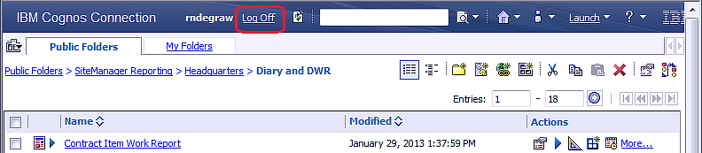

For more details on navigating and personalizing the Cognos Connection, take the Cognos Connection Quick Tour by selecting “IBM Cognos Connection Quick Tour” button on the Official MoDOT Reporting intranet page.
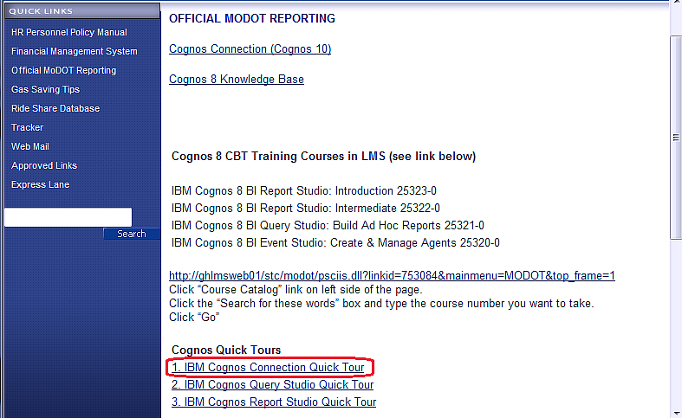

Views:
A useful feature of Cognos 10 is the ability to create a “View” of a standard report. This allows the user to build links to commonly used reports in the “My Folders” area. This can save time with reports that are run frequently.
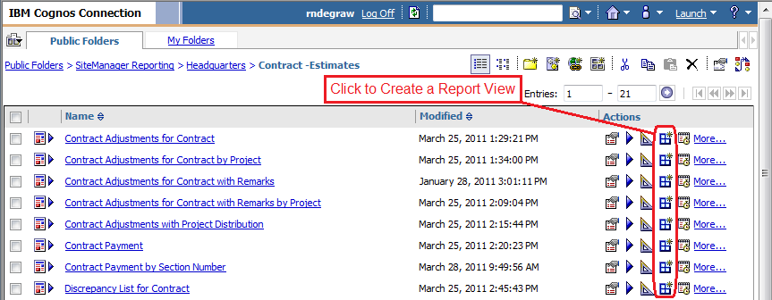

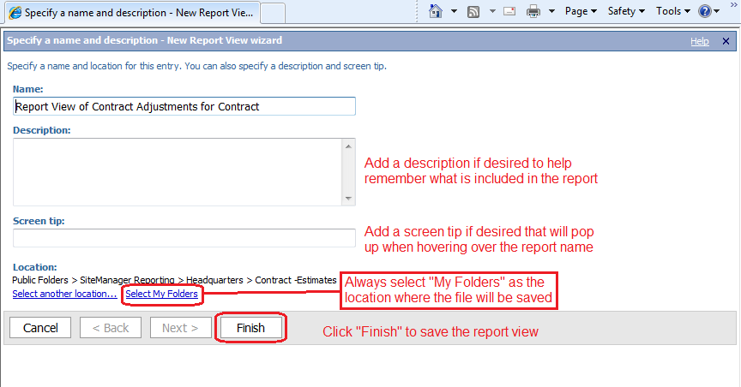
Note: A Report View will continue to run if the original report is updated, whereas a copied report will not.

Printing:
Cognos 10 has the ability to output reports in multiple formats. However, the PDF format was chosen as the best overall output format for Construction and Materials reports. One nuance of PDF output is that the user must use the print button on the PDF tool bar for the report to print correctly.
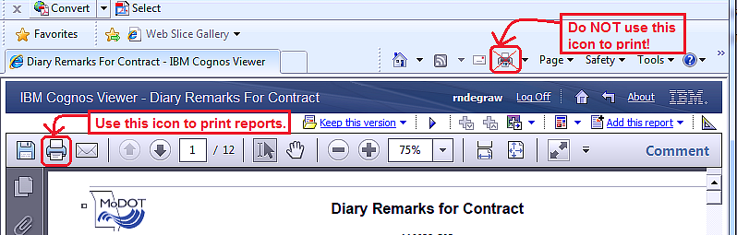

Change the Output Format of the Report:
SiteManager reports should default to a PDF format for output report. However, there are other formats the user could select if desired, such as an Excel format. To run a report in a different format, select the “Run with Options” button.
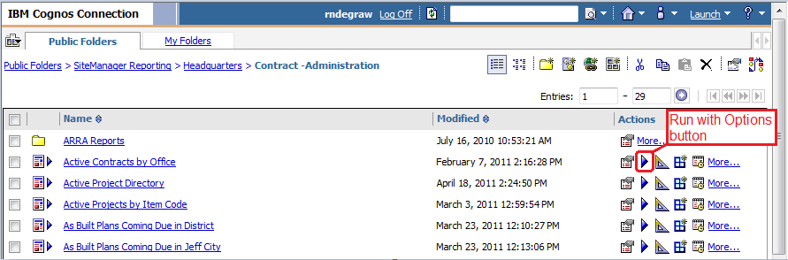
The user can then select a different output format from the drop-down list.

