Fig. 806.8.15

Imhoff Cone & Turbidity Tube Testing Procedures

(Note: The current MoDOT state operating permit for land disturbance does not require sampling of either settleable solids or turbidity.)

Imhoff Cone Testing Procedure for Settleable Solids
(Developed by the Nebraska WEA, http://www.ne-wea.org/LabManual/settleable_solids.htm)
Procedure
- Fill an Imhoff cone to the one-liter mark with a well mixed sample.
- Allow sample to settle in the Imhoff cone for 45 minutes.
- Gently stir the sample with a glass rod to release the suspended matter clinging to the sides of the Imhoff cone.
- Let sample settle for an additional 15 minutes.
- At this point, one hour has passed. Record the volume of settleable solids (in milliliters/Liter/hour) in the Imhoff cone.
Note: Do not include any floating solids or any voids in the settled solids as settleable matter.

Turbidity Tube Testing Procedure for Turbidity
(Developed from the SOP for Turbidity Measurements Using Turbidity Tube, Rev. 1, Utah DEQ, DWQ, 2011, as well as Myre, E., & Shaw, R. (2006): The Turbidity Tube: Simple and Accurate Measurement of Turbidity in the Field, Michigan Technology University, Michigan )

Procedure:
- Collect a water sample in a large, clean container (bucket/jug/jar). Be careful not to include sediment from the bottom of the body of water.
- Rinse the tube with the water that is going to be tested and pour it out.
- Stir or swirl the water sample in the container vigorously until it is homogenous, introducing as little air as possible.
- Place your head 10 to 20 centimeters directly over the tube so that you can see the viewing disk while the sample is being poured into the tube.
- Slowly pour water into the tube. Try not to form bubbles as you pour. If bubbles do form: Stop pouring and allow any bubbles to rise and the surface of the water to become still.
- Keep slowly adding water until the pattern on the disc becomes hard to see.
- Watch the viewing disk closely and add water even more slowly. Stop pouring as soon as the pattern on the disk can no longer be seen. If you can still see the viewing disk pattern when the tube is full: Record the turbidity value as less than the final measuring mark. (Example: If your tube is full and your highest mark is 5 NTU, write down that the turbidity is “<5 NTU”.)
- Read the turbidity from the scale on the side of the tube. Remember: If your turbidity tube does not have turbidity values marked on the tube side, simply measure the water level with a ruler or tape measure and find the corresponding turbidity value in the table on the following page. Clean the tube and disk.

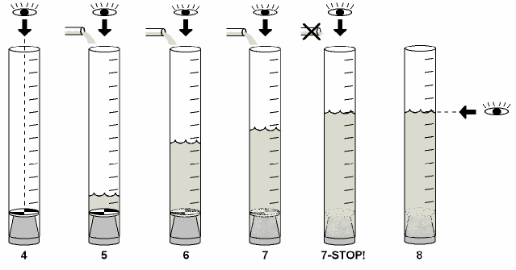
Schematic of turbidity measurement using a Turbidity tube (Myre and Shaw, 2006)
Length-to-Turbidity Conversion Chart
The following table provides the turbidity values (in NTU) that correspond to different lengths measured above the viewing disk. These values can be used to mark the turbidity tube directly or to convert measured values to turbidity units.

