AASHTOWare Project
Certified Testers
Quick Reference Guide

Contents
AASHTOWare Certified Testers Walkthrough 2
Navigate to the Contract 3
Certified Testers Agency View 4
Adding New Testers 4

Overview & Purpose

Certified Testers is a view that is used at the Contract level to record certified testing personnel to a contract in AASHTOWARE Project (AWP). This information is used by MoDOT Independent Assurance Auditors to determine audits of certified materials testers.

This Quick Reference Guide (QRG) will describe the policies and procedures for adding certified testers for the contractor, consultant, and project office personnel in AASHTOware Project Construction & Materials (AWP). This can be performed by CM Project Office Assistant, CM Inspector, CM Project Manager, CM Materials Inspection and CM Resident Engineer roles.

NOTE: Entry for each person performing tests on a contract MUST be made at least one time. Should the contract extend into another calendar year, then each person would need to be added again if performing tests on the same contract.

AASHTOWare Certified Testers Walkthrough

For clarity, input field pictures displayed in this Quick Reference Guide (QRG) will follow:
- All REQUIRED fields will be highlighted yellow
- All required fields only IF APPLICABLE will be highlighted green
- All OPTIONAL fields will be highlighted blue
- All DO NOT USE fields will be highlighted red

NOTE: All field names within AWP give a field description when your mouse cursor hovers over it.

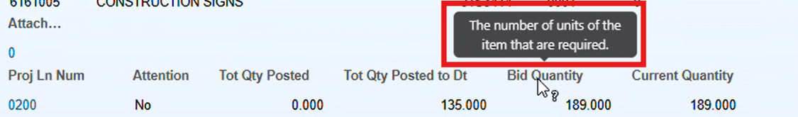

Select Appropriate Role  On the AASHTOWare Project (AWP) homepage, select the dropdown arrow at the top-left of the screen next to the Home button and select one of the roles listed below:  - CM Construction Project Manager  - CM Project Office Assistant  - CM Materials Inspection  - CM Resident Engineer roles  - CM Inspector | 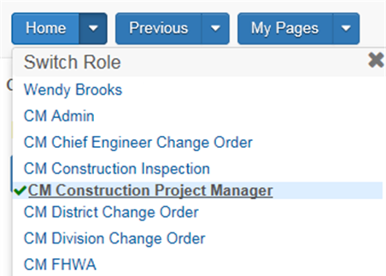

Navigate to the Contract

From the AWP Homepage, select Contract Progress from the Construction section.

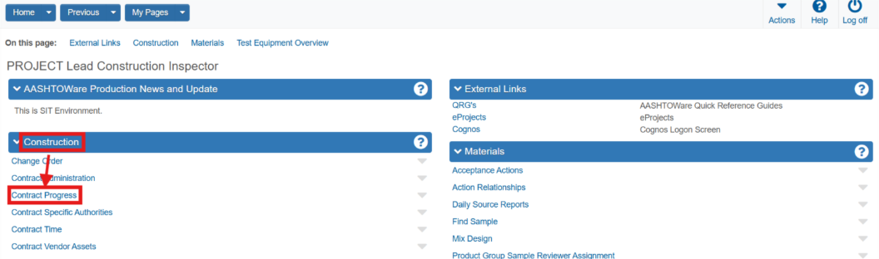

Search for and select the desired contract.

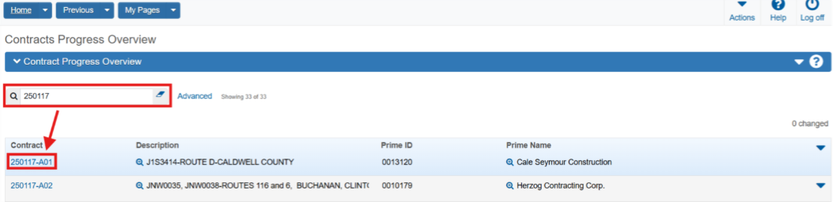

Certified Testers Agency View

On the top-right of the Contract Progress Summary page, click the drop-down arrow next to the Save button and select Certified Testers for Contract.

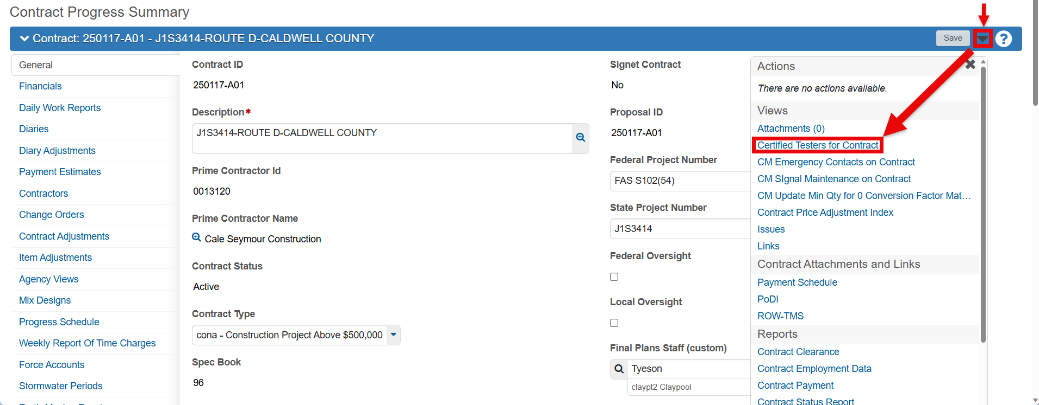

Adding New Testers
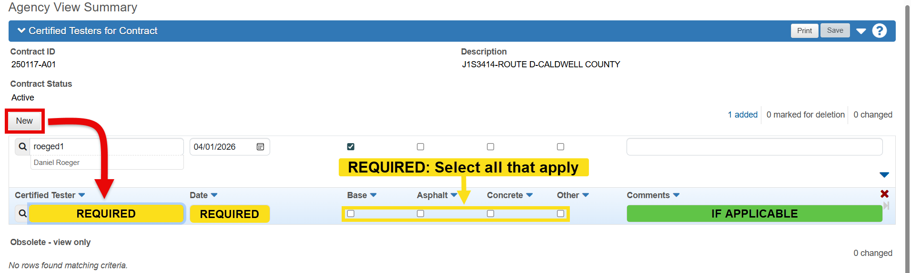
On the Agency View Summary page, all currently entered Certified Testers will be listed. To enter new testers, click the New button. With the new entry field available, search for the user.
- If the user does not appear, contact the Technician Certification Program Coordinator (techcert@modot.mo.gov)

Next, enter the Date, check each check box under the material that the user is certified to test.
- If the Other box is checked, use the Comments field to specify which certification.

When done, click the Save button at the top right of the page.
- If multiple testers need to be added, use the New button as many times as needed.

End of Quick Reference Guide

