AASHTOWare Project Change Order
Adding New Items or Overrun/Underrun of Existing Items
Quick Reference Guide
This Quick Reference Guide (QRG) will explain how to add new items to a contract or how to overrun/underrun existing contract items. The QRG picks up from where the AASHTOWare Project Change Order Overview (1Change Order Overview QRG) ended.
Increase/Decrease Items:
Below you will find the details regarding the entry fields, policy and procedure for “Increase/Decrease Items” window:
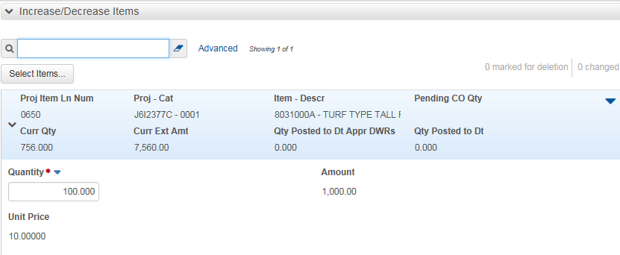
Select Items: Used to pick the line item from the contract to add to the change order.
Quantity: Enter the quantity change for the item. This can be a positive or negative number.
Amount: You can view the current total dollar value of the item.
Unit Price: You can view the unit price of the item.
Expand the Change Order Explanations section of the row. You add information in these fields for one or more explanations:
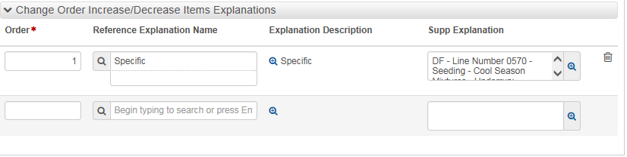
Order: A number that represents the relative position of the change order reference and supplemental explanations on components and the change order report. The number one (1) will be entered in this field. Note: if your Supp Explanation exceeds 4,000 characters, you will enter the number two (2) in the subsequent line Order field.
Reference Explanation Name: A type classification for a reference change order explanation. For Overrun/Underrun it is “Specific Item”. When you enter a value in this field, the system displays the explanation type below the name, and it displays the description in the Explanation Description field.
Supp Explanation: Field to enter the explanation (aka Reason) for the change in quantity of the contract item.
Note: The Supp Explanation field only allows for 4000 characters per row (Order). Should you need more room, you would need to add another Order (row). We recommend you are brief with the explanation and, in instances where you are adding JSP or Specifications, then you should attach them to the change order, not copy into the Supp Explanation to avoid exceeding the 4000 characters.
Balance Completed Items:
MoDOT will not implement this function at this time.
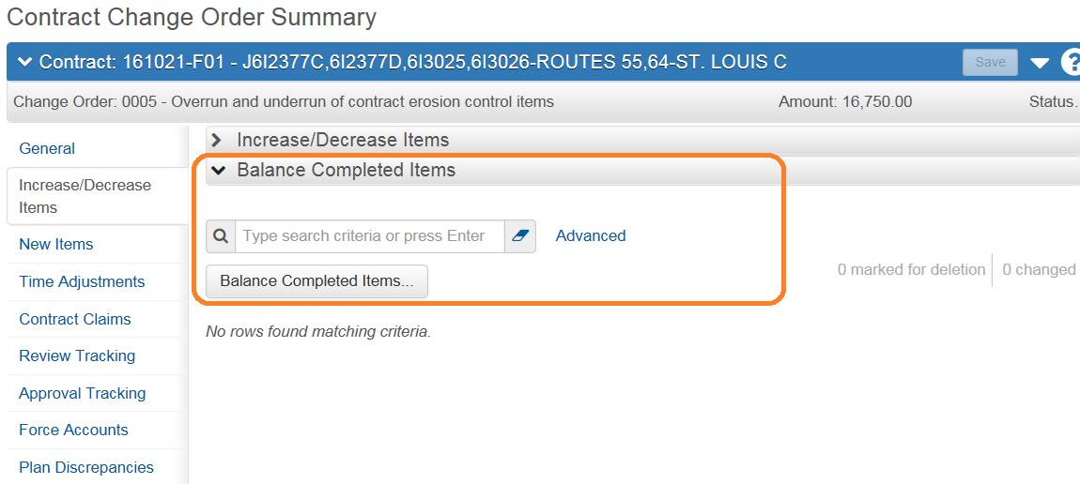
The following steps describe how to increase or decrease contract items by change order:
- From the left menu select Increase/Decrease Items and then Select Items button:
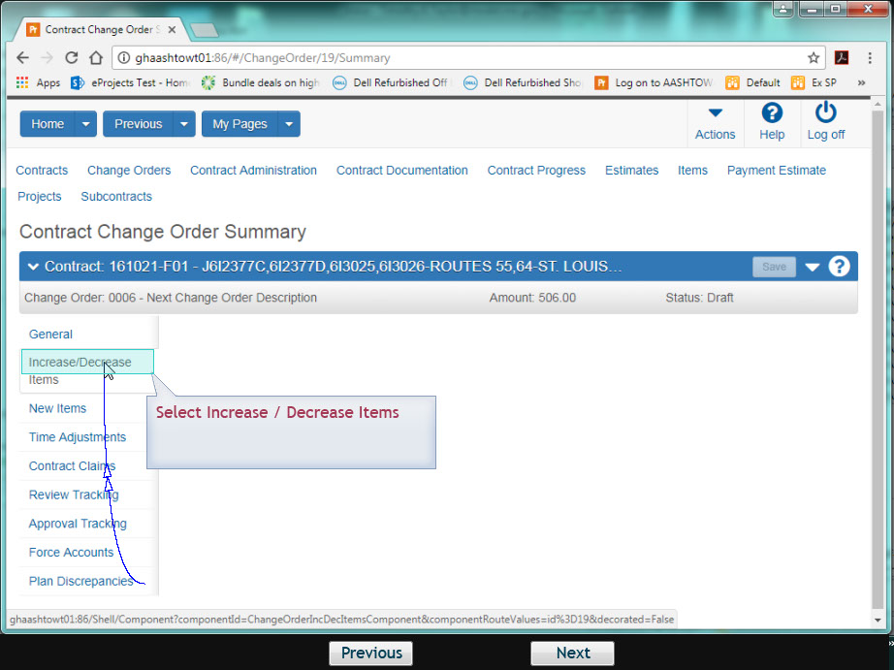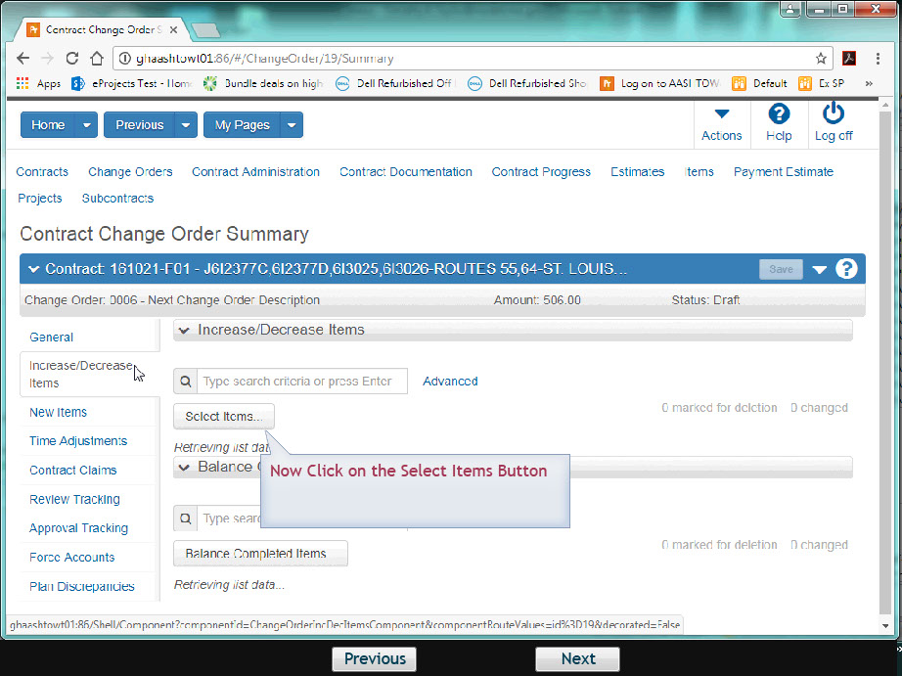
- Focus in the Search box and type in the Line Item number:
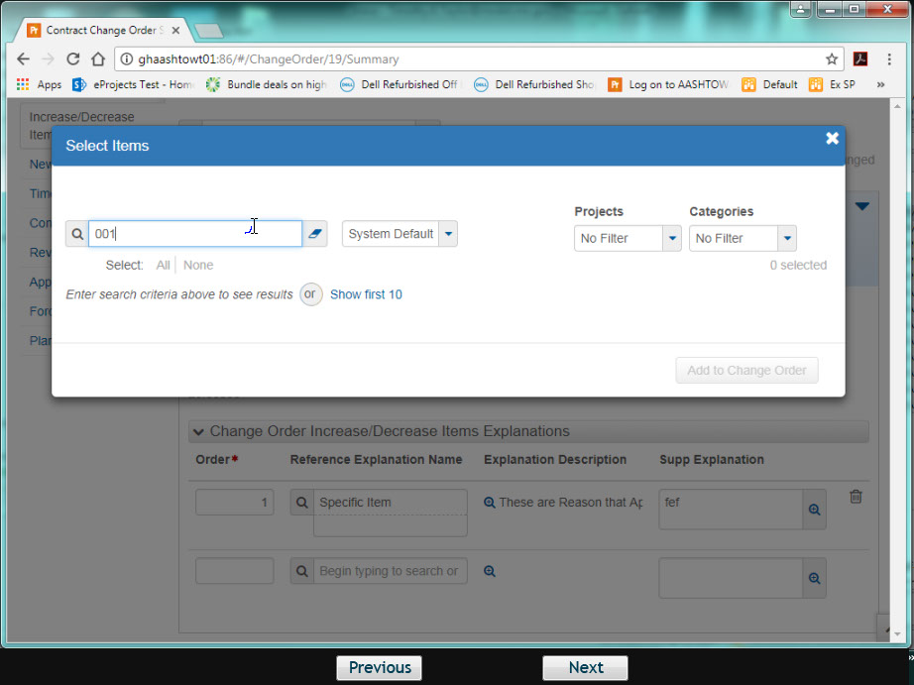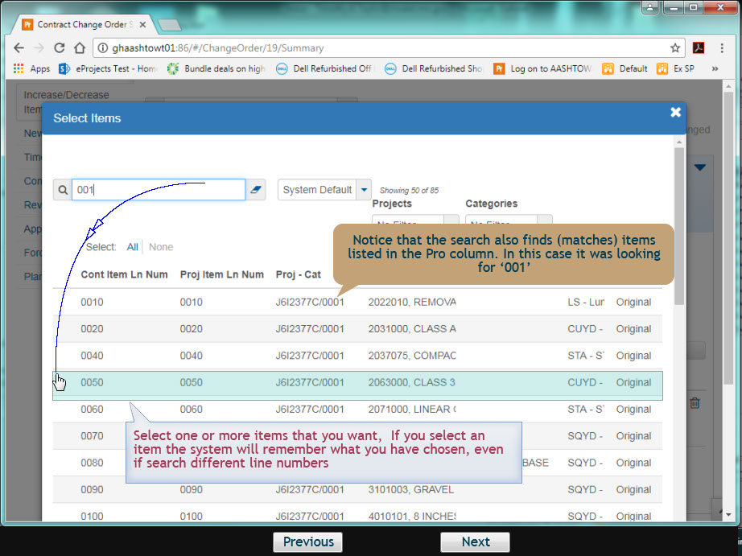
- Select one or more items. Every selected item will show a green checkmark. Once you have the items selected, scroll to the bottom of the window and select the “Add to Change Order” button. Note – if you select more than one item, you will need to perform steps 4 through 5 below before you can Save.
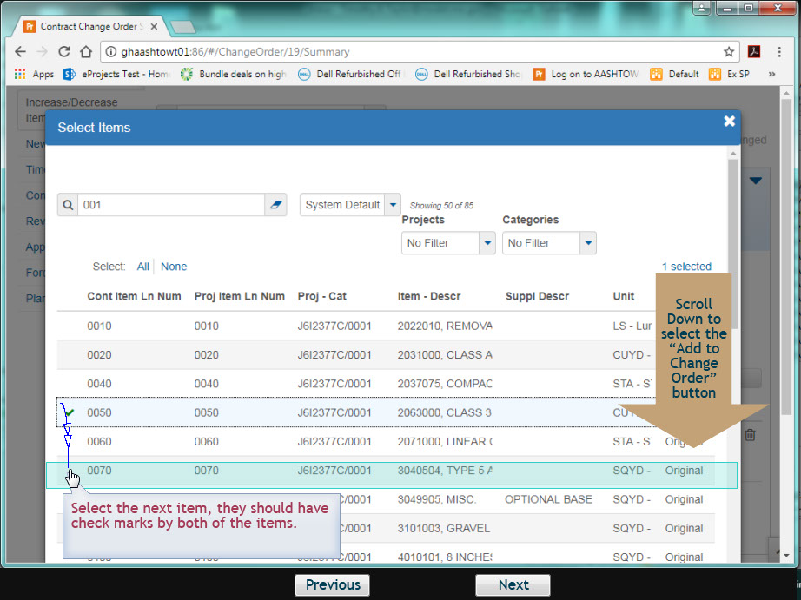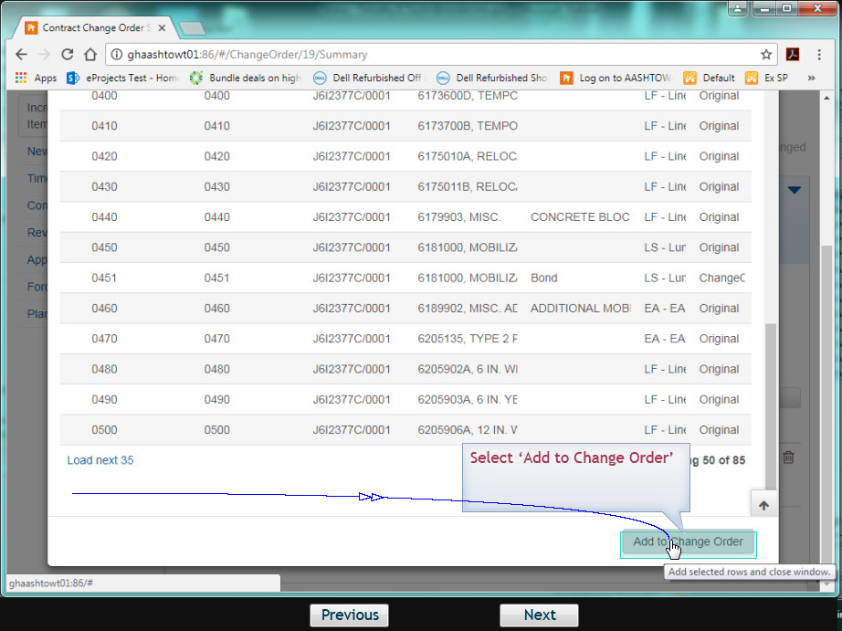
- Expand the row (see figure below) and enter the quantity for the change order:
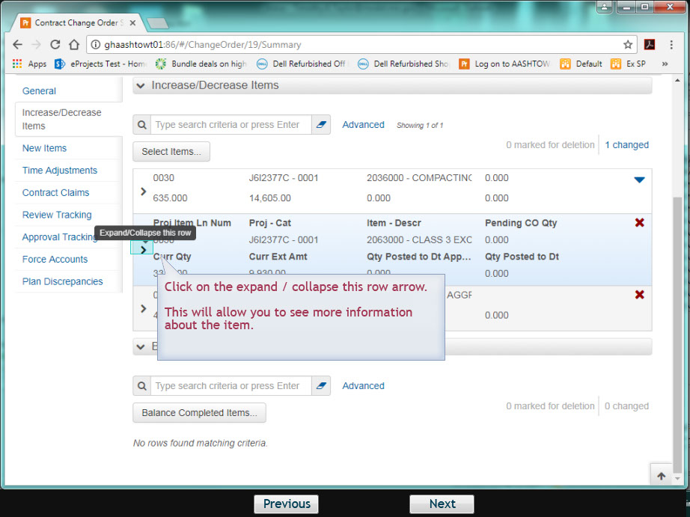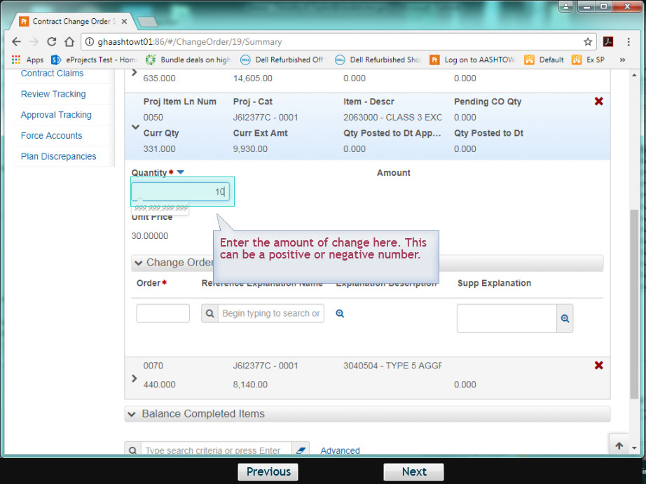

- Fill out the Order, Reference Explanation and Supp Explanation fields (if using a Standard Explanation, see section below for more information):
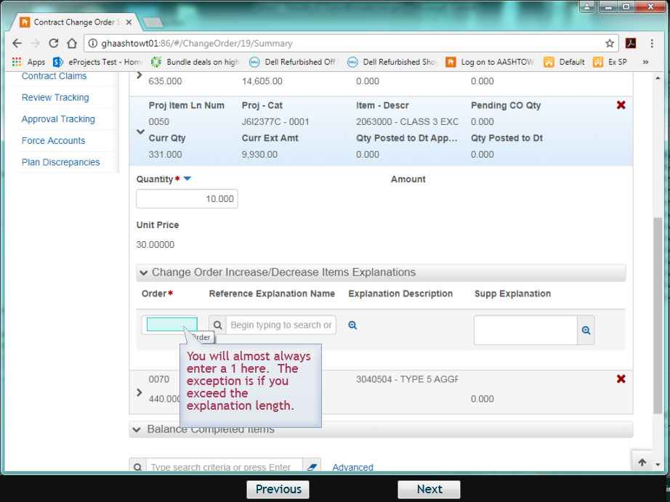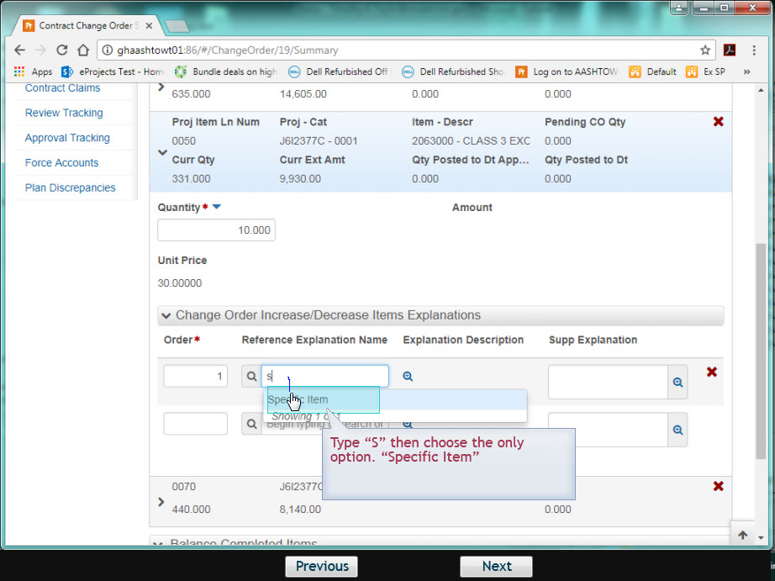
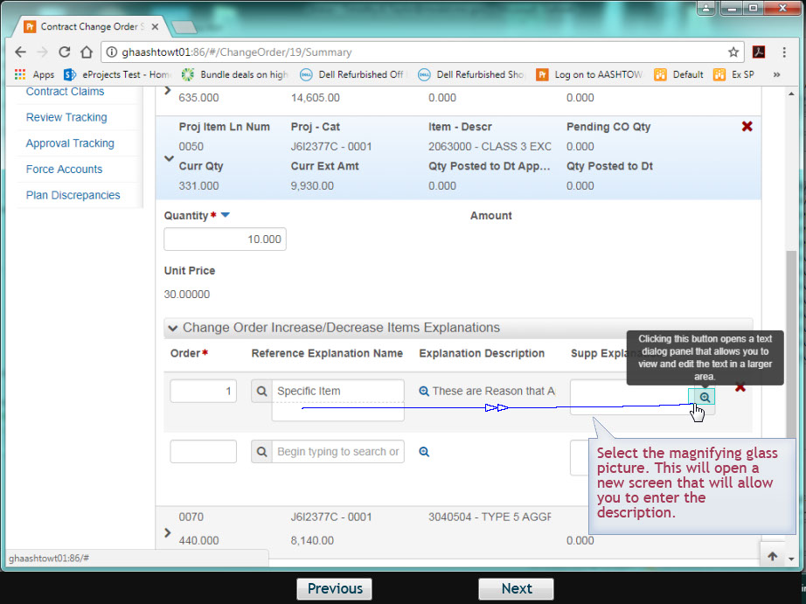
Explanations for changes to existing contract items must begin with the following: Reason Code - Line Number - Description - Overrun or Underrun: Reason. For example: RA - Line No. 0010 - Removal of Improvements - Overrun: Begin typing the reason....
Definitions and examples for the codes may be found in the Change Order Codes QRG.
NOTE: If you copy and paste from another application (ie., Word, NotePad, etc.) the amount you paste in is limited (3999 characters) AND may not paste in full if reaching that limit. Be sure to copy in smaller ‘chunks’ to avoid any issues (normally, it just won’t paste anything and not throw an error).
When a change order reason affects multiple line items, a detailed description of the change must be entered for the first line item. All subsequent line items must then be entered. However, the same level of detail is not required and can reference back to the first line item reason. For example:
VE - Line No. 0020 - Class A Excavation - Overrun: The contractor submitted a Value Engineering Proposal henceforth known as VE No. 2. The proposal is to eliminate the Aggregate Base, Stabilized Permeable Base and Edge Drains and substitute 12 inches of Rock Fill Base. This proposal was reviewed by MoDOT's Pavement Engineering experts and met their approval. The Value Engineering proposal was approved August 3, 2007. In order to install 12 inches of rock fill, additional Class A Excavation will be generated.
VE - Line No. 0040 - Compacting in Cut - Underrun: Same as Line No. 0020.
VE - Line No. 0060 - Stabilized Permeable Base (4 In. Thick) - Underrun: Same as Line No. 0020.
VE - Line No. 0070 - Type 5 Aggregate for Base (4 In. Thick) - Underrun: Same as Line No. 0020.
To delete an item quantity change from a Draft change order, select Delete from the Actions menu on the quantity change row. The system shades the row gray to indicate it is marked for deletion. To reverse the delete action, click the Undo button.
- When you are finished making changes, click the Save button.
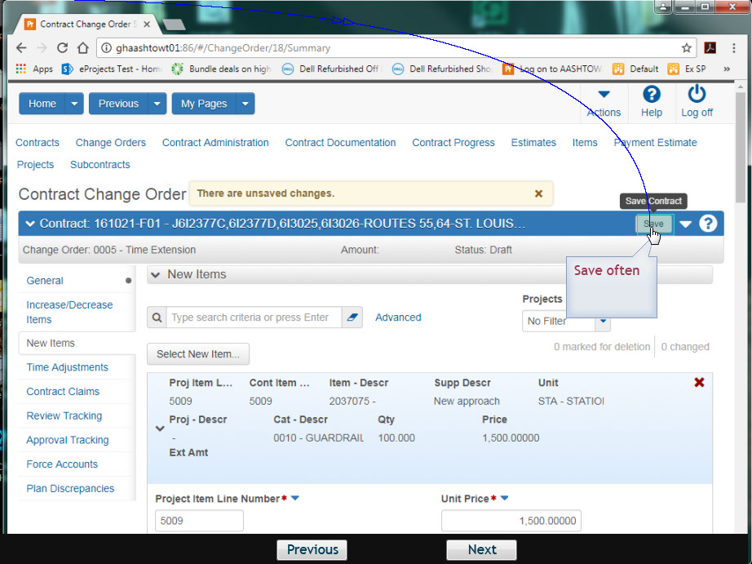

Using Standard Explanations:
- Start the Order with 1.
- Select the Reference Explanation Name. For Increase or Decrease in Contract Items, this will begin with IDI.
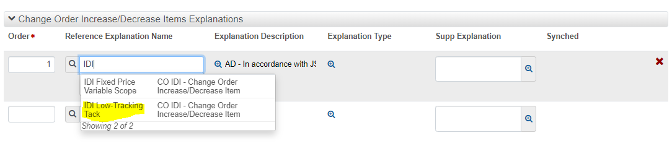
- Use the magnifying glass to open the Explanation Description. Copy the text.
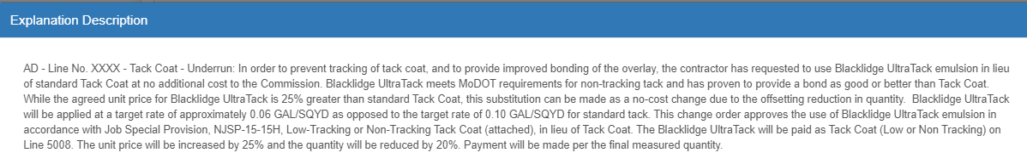
- Open the Supp Explanation window and paste the explanation. Modify for the contract as needed by replacing the XXXX with this contract specific information.
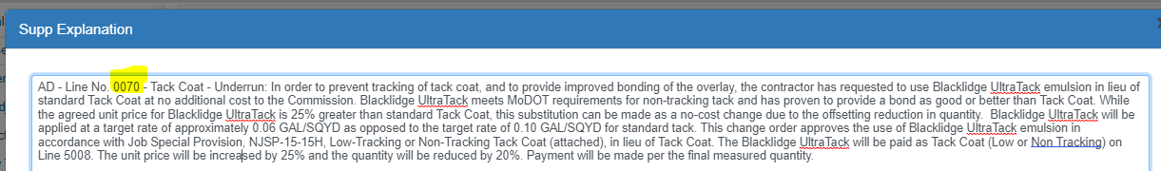
- Save when completed.

Adding New Items (Contingent Items) to the Change Order:
Below you will find the details regarding the entry fields, policy and procedure for the “New Items” window:
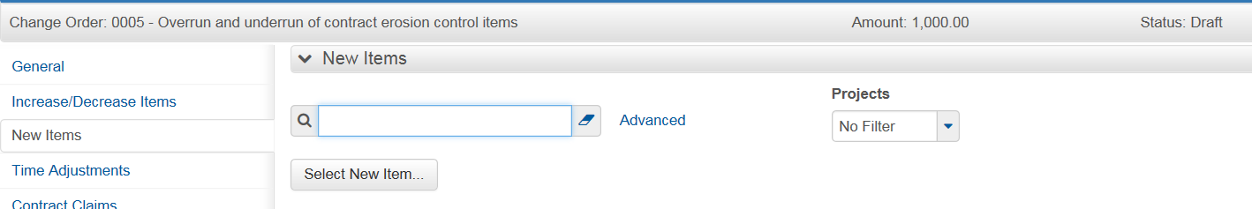
Select New Item: Used to select the Reference Item (Item Code) and
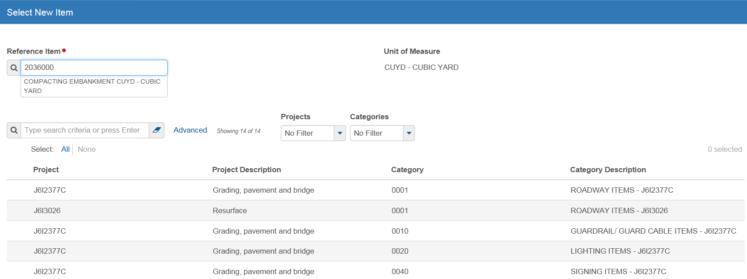
Reference Item: Item Code for the new item. Item codes follow the Standard Specifications. For example, all item codes for earthwork will begin with 200. Find the specification number closest to the item code available from the spec book. Search the Items window by Unit to find all of the Units available for that item. Choose the item code that matches the unit and is as close to the description as possible. There is usually a “Misc.” description that will match. If you cannot find a match, send an email to ReDEV.
Projects & Categories: Applies the new item to a project and assigns the Category for the item. Although this is a multi-select field, MoDOT will only apply a new item to one Project/Category.
Select Add to Contract.
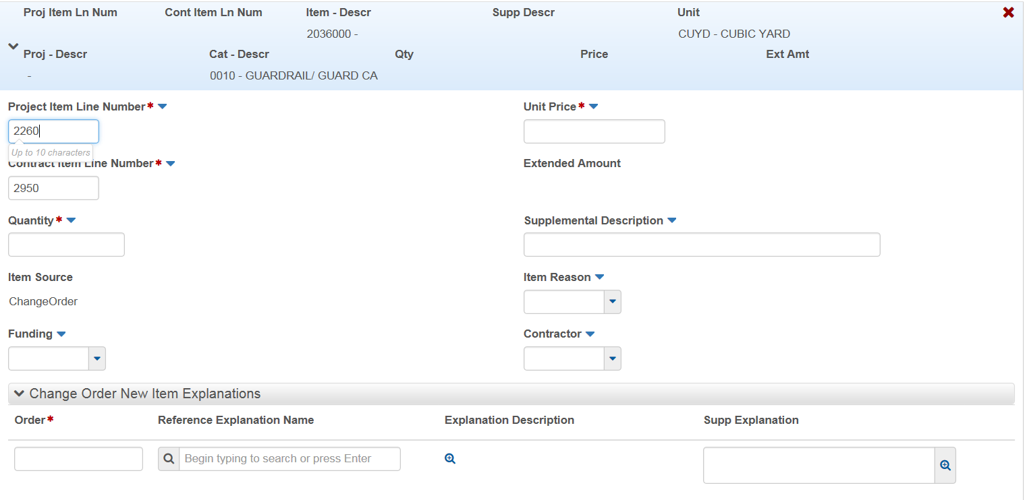

Project Item Line Number: Used to identify the item added to the project. The system will automatically assign a number. Change to correspond with MoDOT’s policy regarding Contingent items which is: the first instance of a new Project Item Line number for the New Contract Item will begin with 5001 for the first project in the contract. If multiple projects are associated to the contract, the line numbering will begin with 5101 for the second project, 5201 for the third project, 5301 for the fourth project and so on. New contract Line Item Numbers shall be sequential per project, regardless of the category.
Note: It is possible for line items to be numbered beyond 5000 on large contracts. In this instance, begin numbering with the next available option, e.g., 6001, 7001, etc.
Contingent Items added to a contract which are due to JSP/Specification changes, shall be added as one number greater than the original contract line item number. For example, if there was a JSP or Specification change to contract line item 0050, the new contingent line item number would be 0051.
Contract Item Line Number: Used to identify the item added to the contract. The system will automatically assign a number. Change to match the Project Item Line Number.
Quantity: The number of units required for the new item. This must be a positive number.
Item Source: Default field “Change Order” displayed by the system.
Funding: Used to determine participation of the item. Listed in order of contract funding. Select the correct funding for the Category of work on the contract.
Unit Price: Agreed upon price of each unit of additional work. This can be either a positive or negative number.
Extended Amount: Product of the Quantity and Unit Price.
Supplemental Description: Required for MISC items added to the contract to further describe the specific item.
Item Reason: MoDOT is currently not using this field.
Contractor: Drop down list to select the contractor performing the additional work. NOTE: If you select a SUBCONTRACTOR – you will need to add the New Item to the SUBCONTRACT AFTER the change order is fully approved.
Order: A number that represents the relative position of the change order reference and supplemental explanations on components and the change order report. The number one (1) will be entered in this field. Note: if your Supp Explanation exceeds 32,000 characters, you will enter the number two (2).
Reference Explanation Name: A type classification for a reference change order explanation. For Overrun/Underrun it is “Specific Item”. When you enter a value in this field, the system displays the explanation type below the name, and it displays the description in the Explanation Description field.
Supp Explanation: Field to enter the explanation (aka Reason) for the change in quantity of the contract item.
Select Contract Items:
MoDOT will not implement this function at this time.
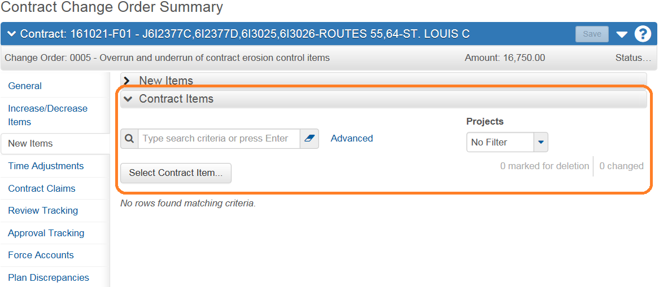

The following steps describe how to add new items to the change order:
- From the left menu select New Items:
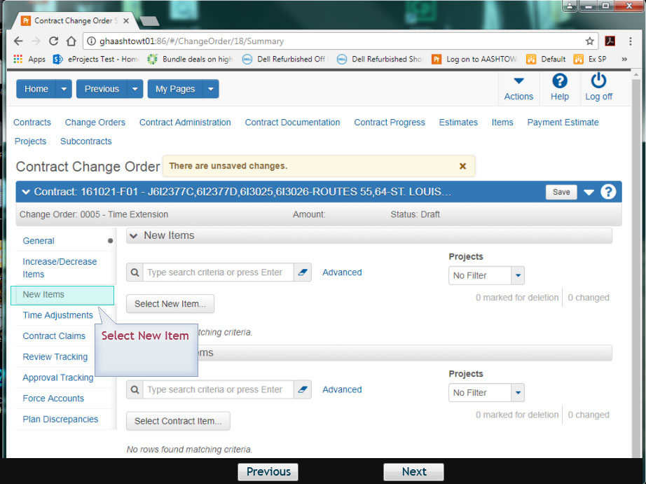
- Select the New Items button – then begin a search in the Reference Item for the Item Code needed for the change order. Search can be performed on the Name or Item code number:
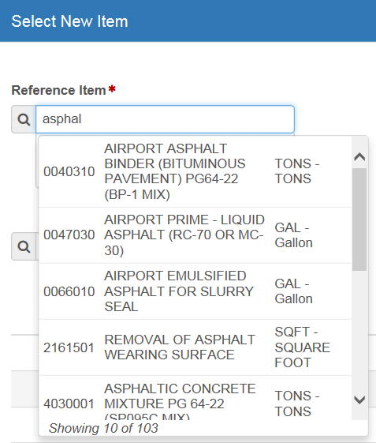
- Select the Project/Category for the new item of work and then “Add to Change Order”:
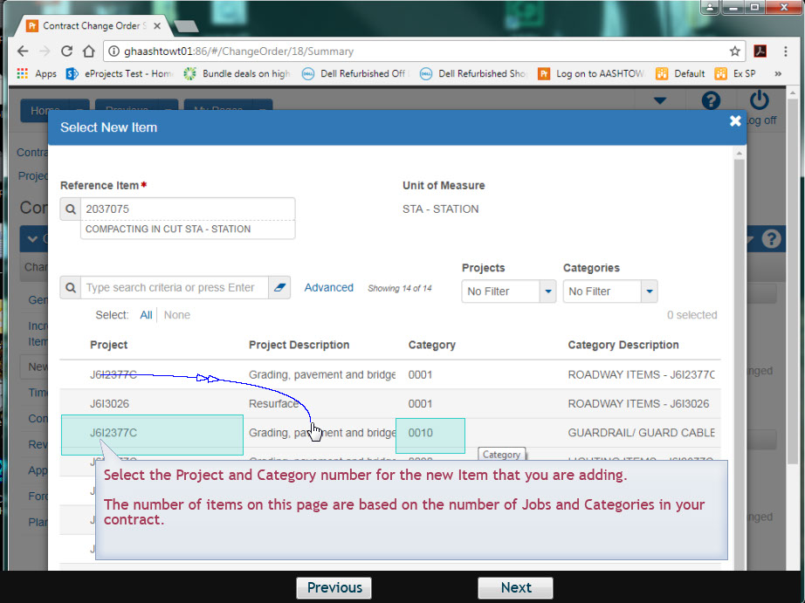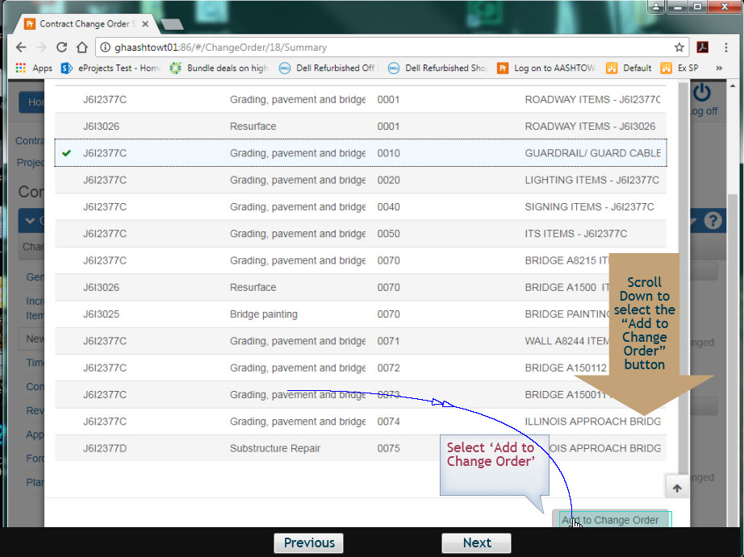
- Enter the line numbers for the Project and Contract Item Line Numbers following the Contingent Items rules for numbering.
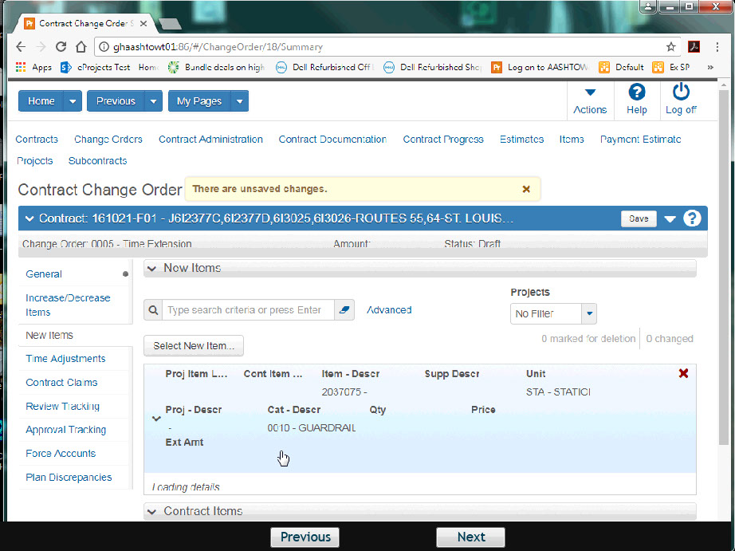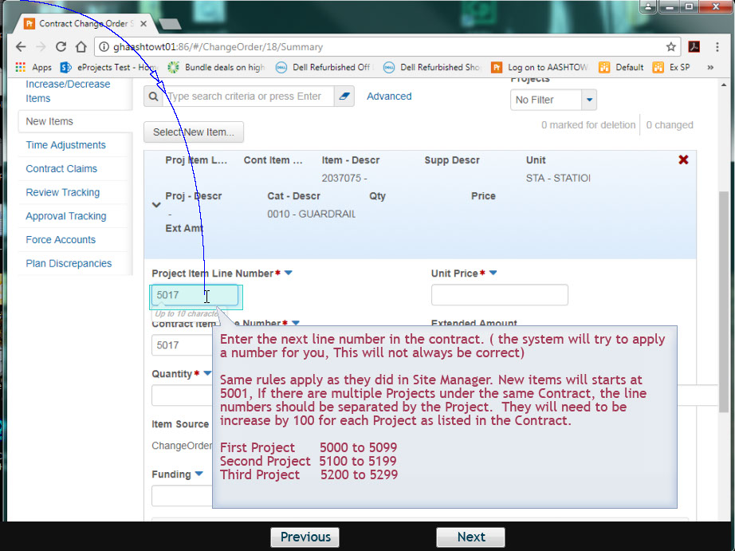
- Enter the Quantity and select the funding:
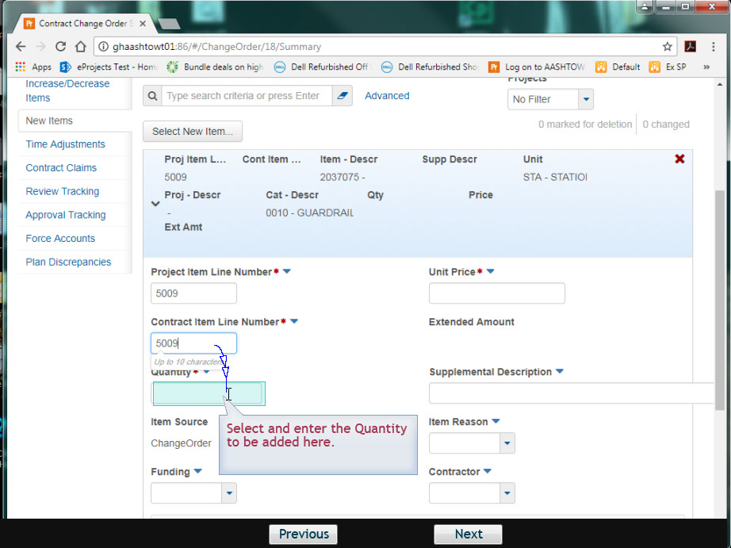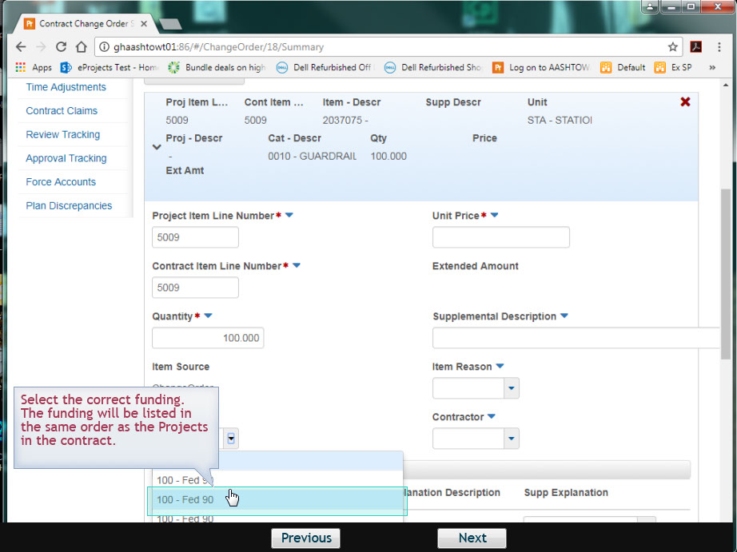
- Enter the Unit Price and add a Supplemental Description if a Miscellaneous (99) item code was selected.
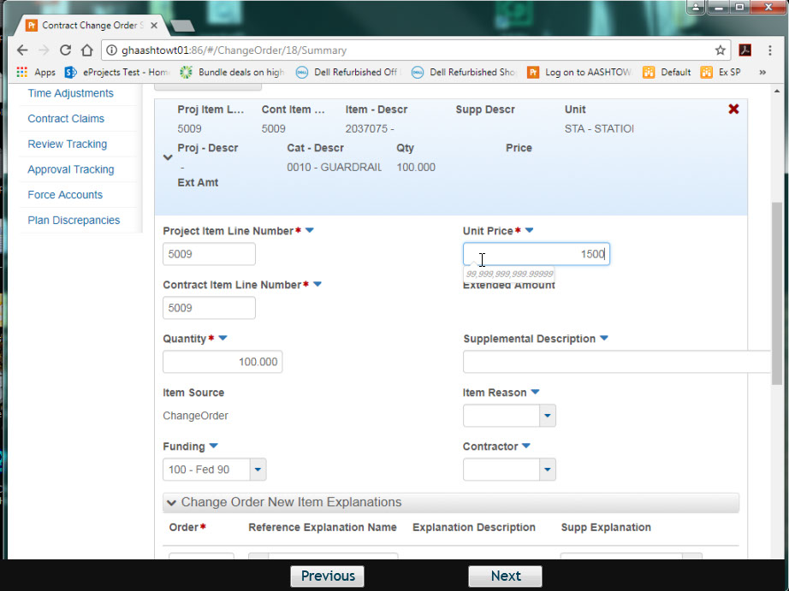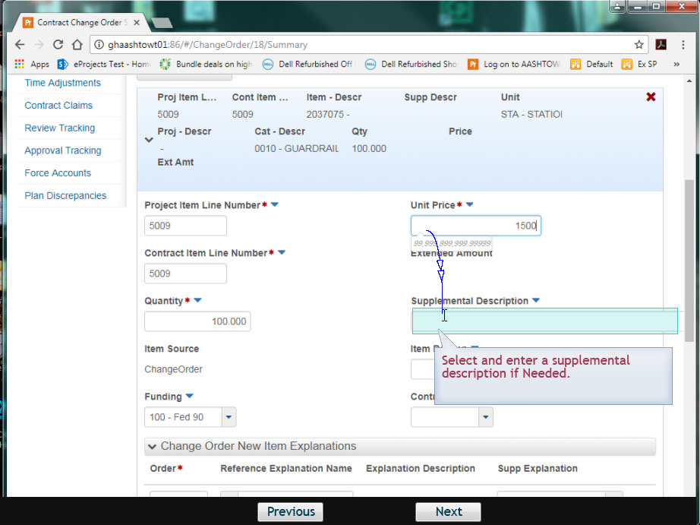
- Item Reason is not being used at this time. Select the contractor performing the work from the drop down list.
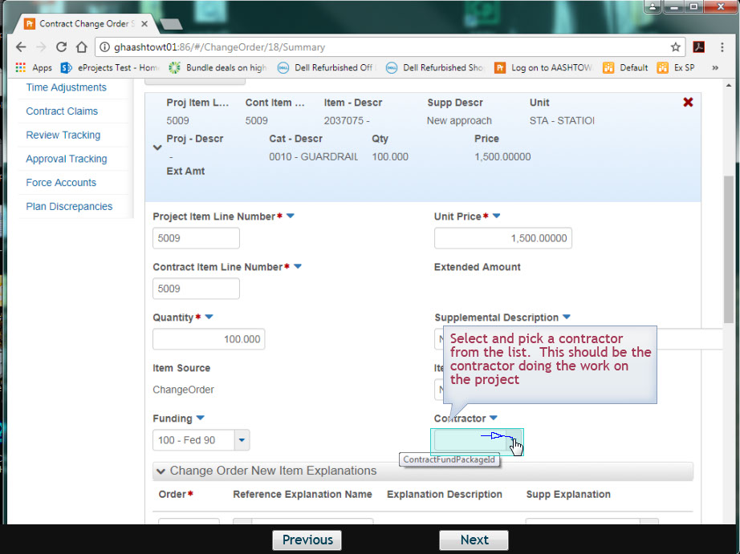
- Scroll down to apply the Explanation to the item:
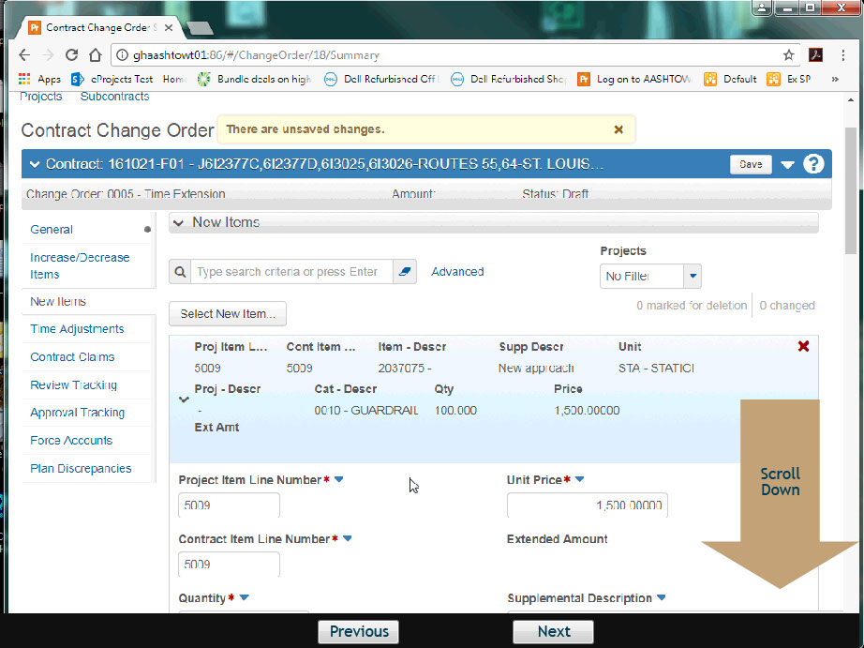

- Fill out the Order, Reference Explanation and Supp Explanation fields (if using a Standard Explanation, see section below for more information):
Explanations for new contract items must include the "Settlement of Costs" statement at the beginning of the reason, immediately following the item description. For example: AD - Line No. 5002- Flashing Arrow Panel - Extra Work: Settlement of Costs based on the agreed price of $52.50 per each. Begin typing the reason.
Reason Codes are required for new contract items. Definitions and examples for the codes may be found in the Change Order Codes QRG.
Note: Once the reason code is selected for a contingent item, the user shall use the same reason code for any and all subsequent changes to the contingent item of work, including routine adjustments.
To delete an item quantity change from a Draft change order, select Delete from the Actions menu on the quantity change row. The system shades the row gray to indicate it is marked for deletion. To reverse the delete action, click the Undo button.
- When you are finished making changes, click the Save button.

Using Standard Explanations:
- Start the Order with 1.
- Select the Reference Explanation Name. For New Items, this will begin with NI.
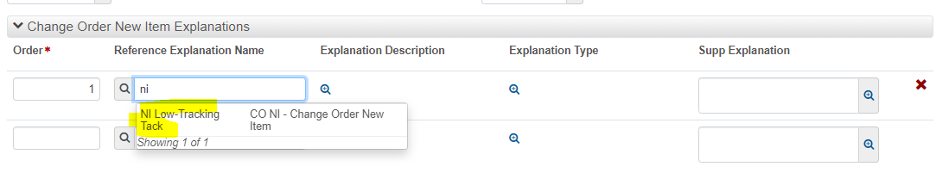
- Use the magnifying glass to open the Explanation Description. Copy the text.
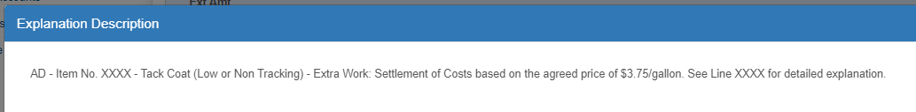
- Open the Supp Explanation window and paste the explanation. Modify for the contract as needed by replacing the XXXX with this contract specific information.
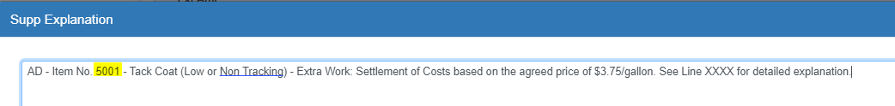
- Save when completed.

Note: To find your New Items previously added to a Change Order – Navigate to the New Items tab and focus in the Search Window (above the Select New Items) and hit Enter. The previously added items will appear beneath the Select New Items button.
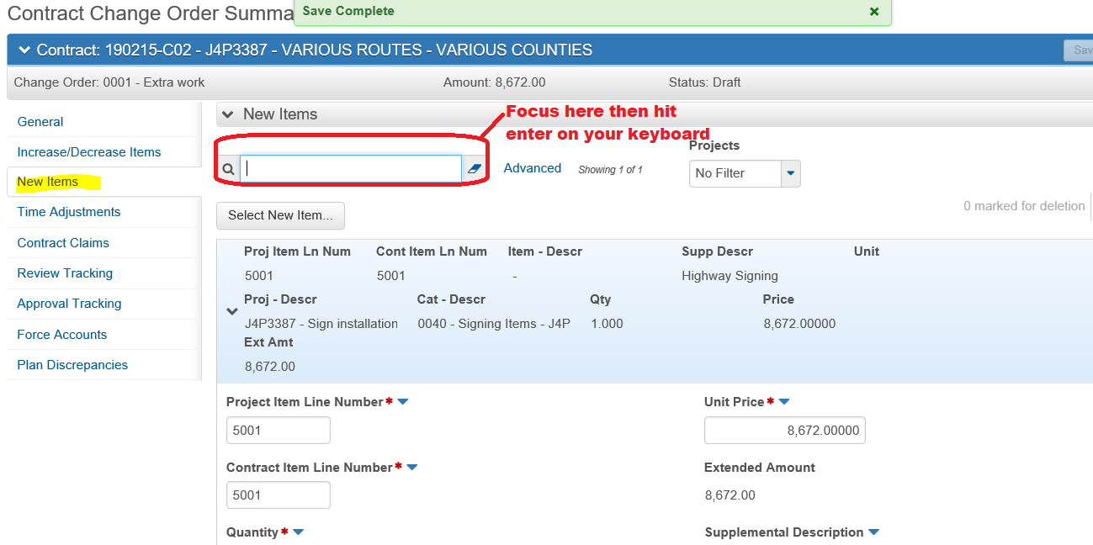

End of Quick Reference Guide. Continue on to 7ChangeOrderApproval QRG, if needed.

