AASHTOWare Project
Change Order Approval
Quick Reference Guide

This Quick Reference Guide (QRG) will explain how to submit a change order for approval as well as how to approve a change order. This is done the same way for every type of change order.

Submit for Approval:
Submit for Approval is a Task function accessed from the Actions menu of any of the change order component windows.
When the change order is ready for approval, perform the following steps:
- From the Actions drop down menu, select the Submit for Approval task:
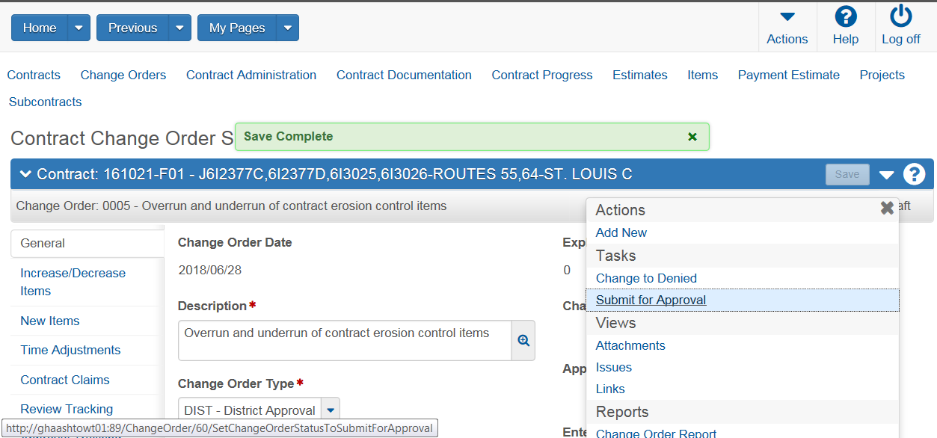
- There will be a processing message and may be some informational messages that return. The change order is submitted for approval successfully when the status has changed to “Pending Approval”. Note – the system will send an Outlook email to first sequence of approval for the Change Order.
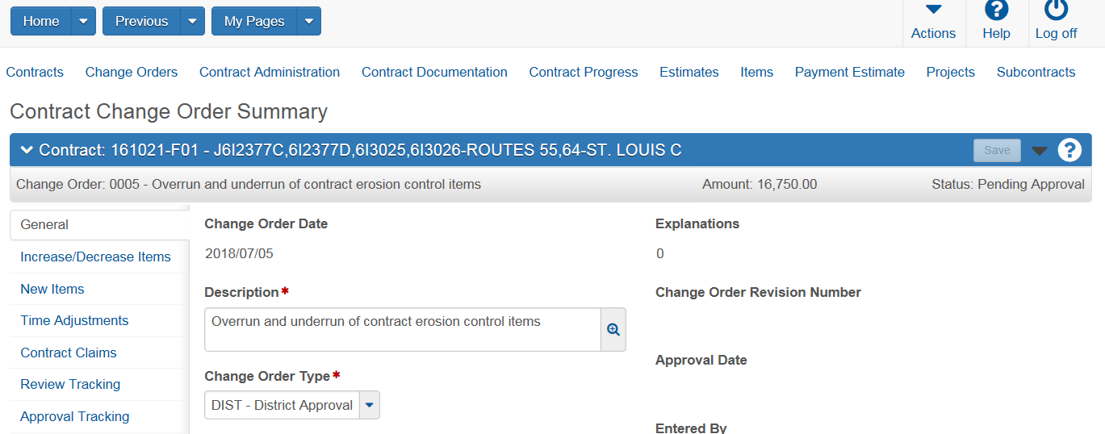:
- Should any corrections need to be made to any change order, the status of the change order must be in Draft. Users can access the Actions menu drop down to change the status of the change order at any time up until final approval:
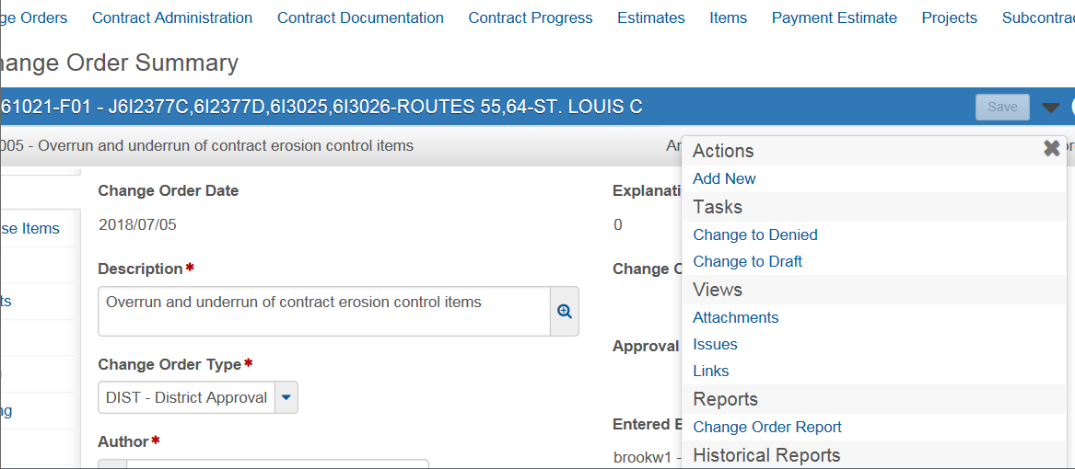

Note: See end of QRG for what to do if errors occur during this process.
Override Approval Sequences
Overrides (changing approval sequences) are performed prior to submitting for approval. Groups can be added or removed depending on the circumstance. Note: if the removal of an approval group must be done AFTER it was submitted for approval, see instructions at the end of this section.
- Select the Approval Tracking item on the left side, then the Add Approval Group button to Add another approver OR drop down the actions of the specific approval group to delete the approval group:
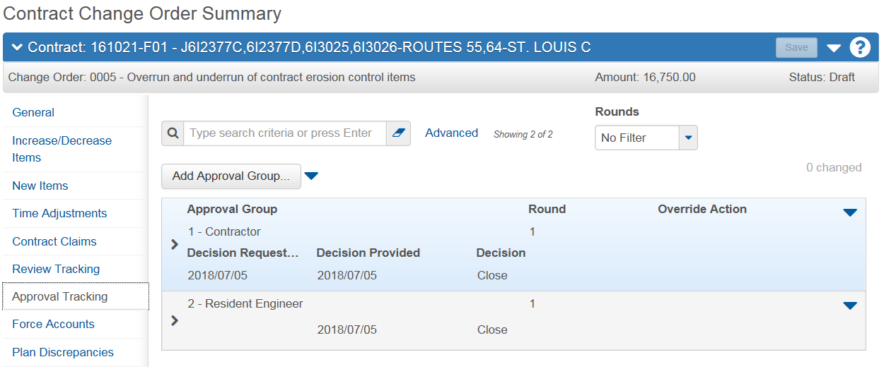

- Override comments are required. More than one group may be added – click next to the group(s) to select and then select Save:
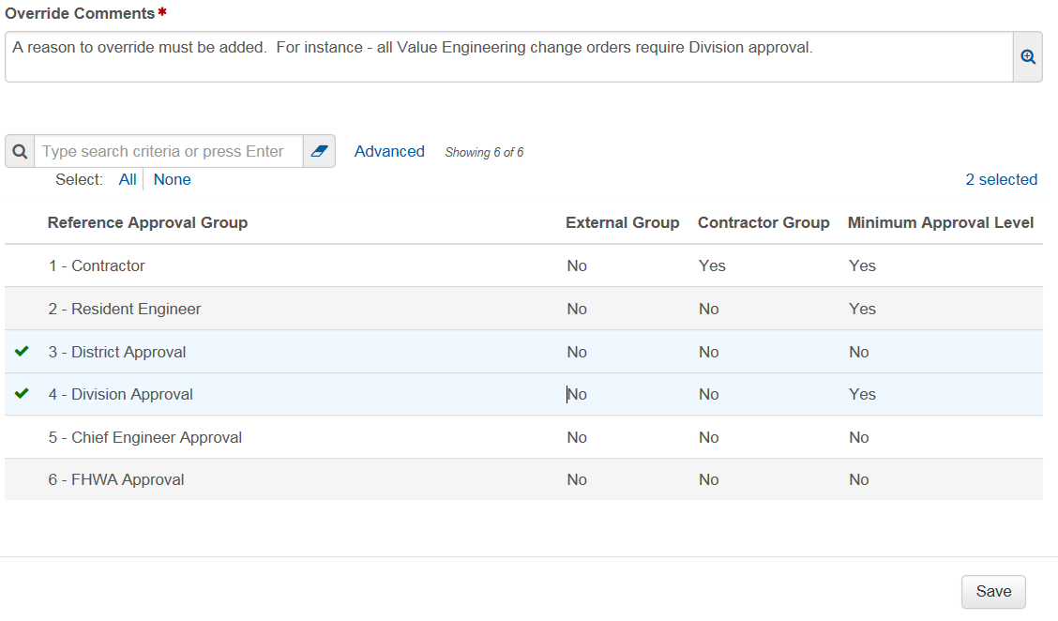
- To remove a group – drop down the Actions menu for the approval group and select “Remove Approval Group” to delete them. Once removed select the Save button:
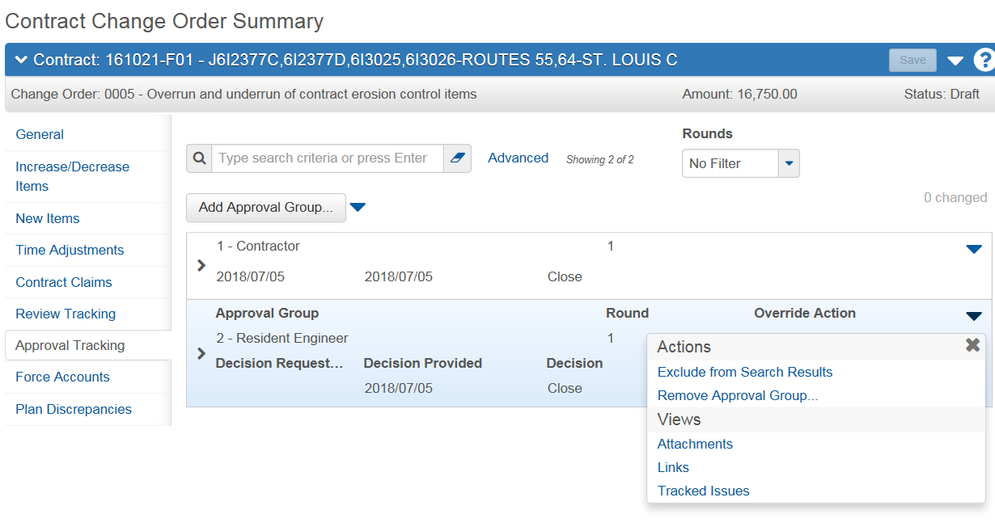
Note: To remove a group AFTER it was submitted for approval:
Change the status back to Draft. You will notice in the Approval Tracking, there will be a Decision of “Close”.
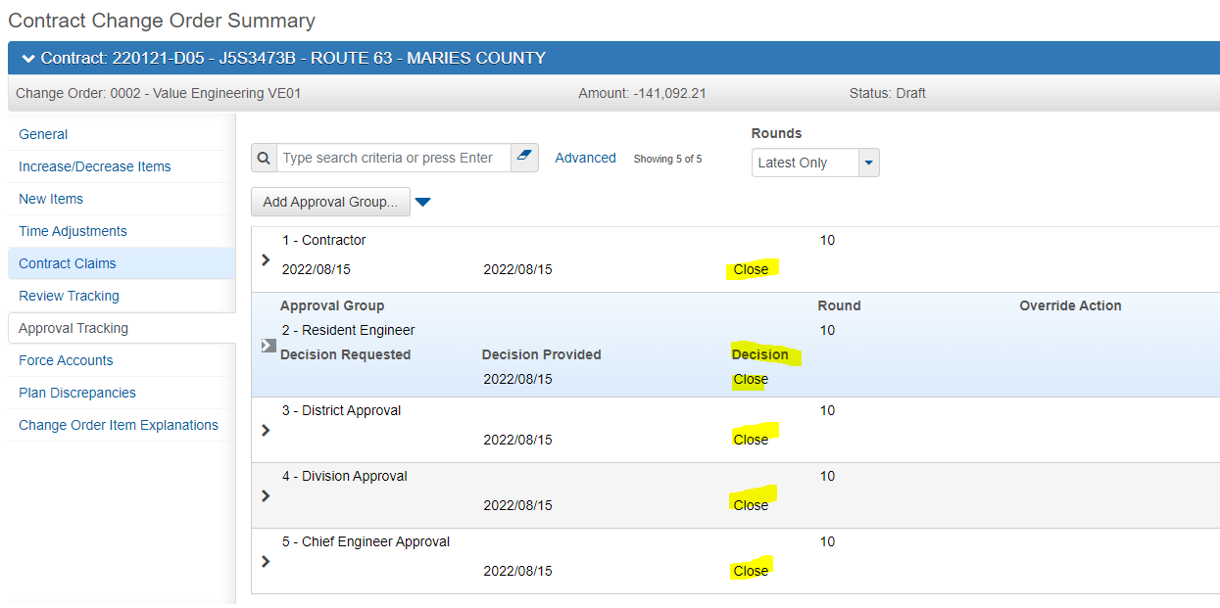
From the Approval Tracking tab – drop down the button next to Add Approval Group, and select “Assign Default Approval Groups”:

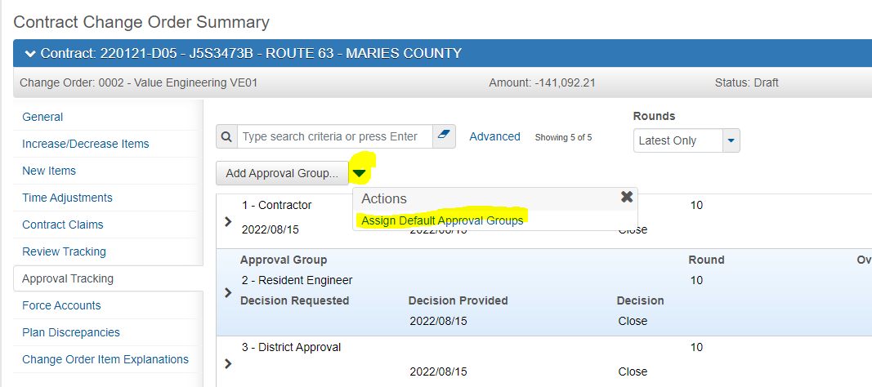
This removes the Decision from all approval levels. Now, you can use the drop down for the decision level that needs to be removed, in this instance, Chief Engineer Approval:
Add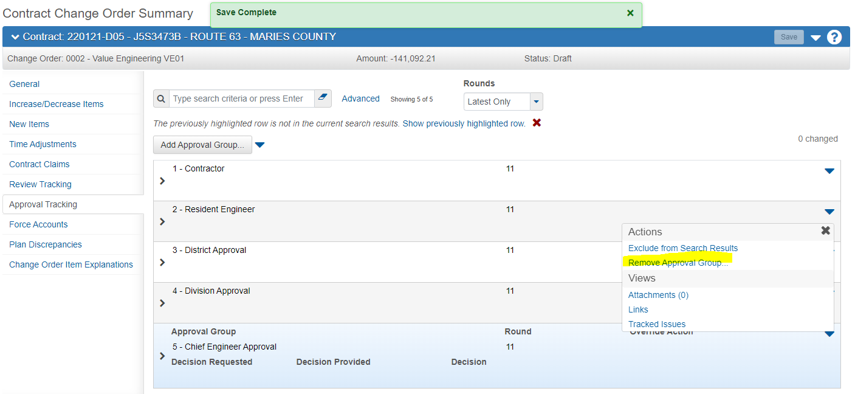
Add the comment and save:

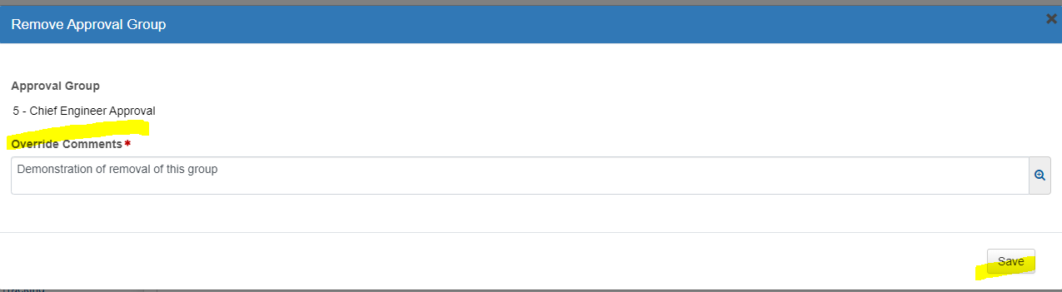
Be sure to change the Type of Change Order on the General Tab to reflect the change
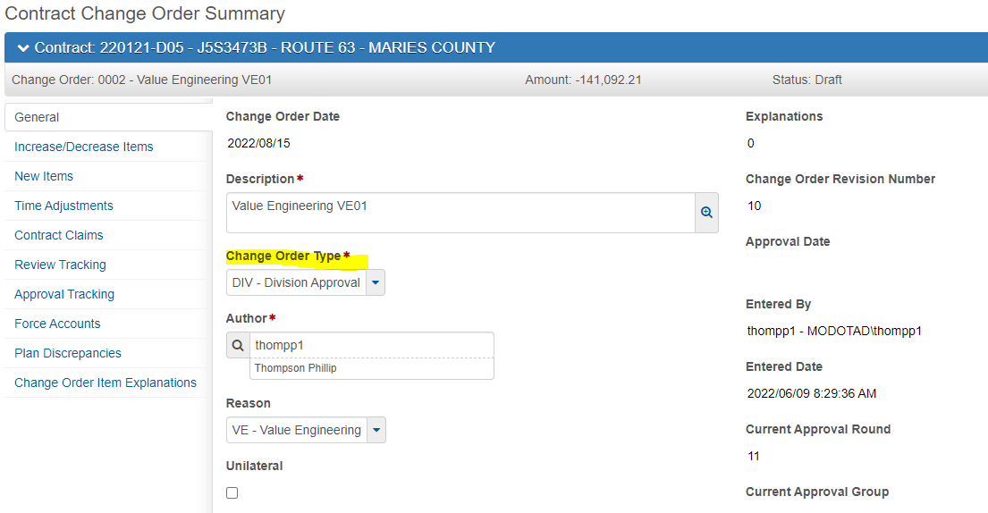

Approving the Change Order:
Below you will find the details regarding the entry fields, policy and procedure for approving the change order:
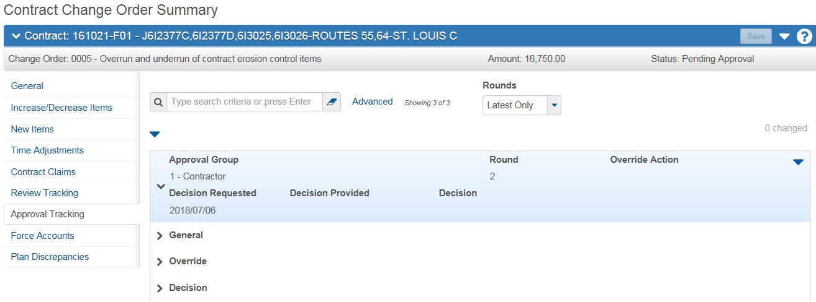

Approval Group: Number and Description of the sequence of approval for the change order.
Round: An integer assigned by the system representing the relative position of this approval round in the change order’s approval process that increases by one for each approval cycle. This includes changing the status of the change order.
Override Action: Lists if any approval group was added or removed during the approval process.
Decision Requested: The date after which a decision may be made. Assigned automatically to the first sequence of approval.
Decision Provided: Date on which the Decision took place.
Decision: The Decision for the sequence of approval – user may select Approve or Reject. The system can set the decision of Closed.
General: Summary for the approval group of certain dates and actions.
Override: Summary for the approval group of any override actions performed.
Decision: Summary for the approval group of the Decisions provided, including dates.
Approval Group Added Date: Automatically populated when changing the status to Pending Approval.
Note: In the Actions Menu during Change Order Approval – there is a Task options to Reject the Change Order. The approver may Reject the change order or change the status to Draft. Corrections to change orders wil need to be completed by changing the status of the Change Order to Draft. Once corrected, change the status to Pending and resubmit for approval.
Generating a Change Order Report
Generate the Cognos Change Order report at this point. To generate the Change Order Report and instructions on distribution, refer to the Change Order Reports Quick Reference Guide.

Easy Approval Reference Steps:
The following steps describe how to approve the change order:
- Confirm Group Authority corresponds to the sequence of approval:
  - CM Project Office Clerk = Sequence 1 – Contractor
  - CM Resident Engineer = Sequence 2 – Resident Engineer
  - CM District Change Order = Sequence 3 – District Approval
  - CM Division Change Order = Sequence 4 – Division Approval
  - CM Chief Engineer Change Order = Sequence 5 Chief Engineer Approval
  - CM FHWA = Sequence 6 – FHWA Approval
- From the left menu select Approval Tracking:
- Select the Component Actions menu and the Task of Approve:
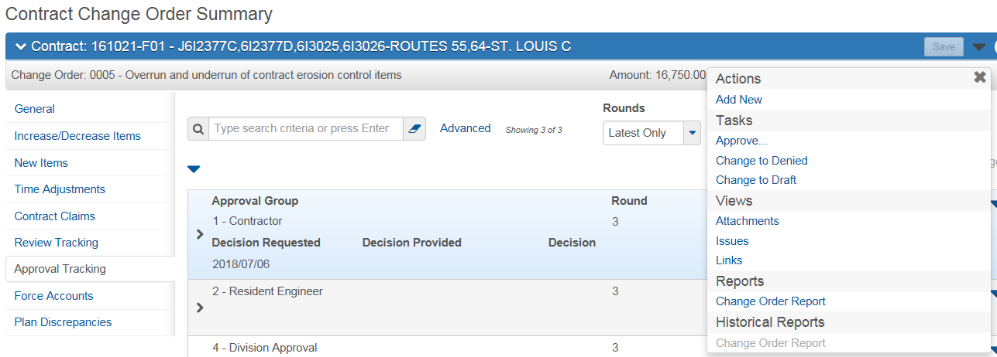
- Add the approval Decision Comments and select Save. Note: the Project Office Clerk shall add the date of when the contractor signed the Cognos Change Order:
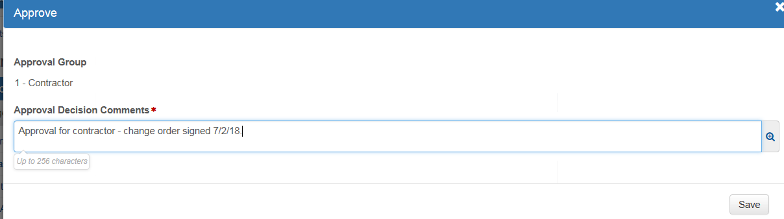
- A message will be sent through Outlook to the next sequence of approval.
- Once all sequences have approved the change order – the status will update to Approved.

Errors with Approval

If any of the following errors occur (or any others not listed) during the approval process, contact ReDEV to help resolve.

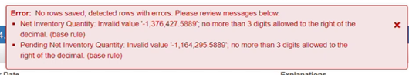
This error is produced when a Sample Record has reported quantity to greater than 3 decimal places. ReDEV can help find the Sample Record to get the precision of the quantity changed.

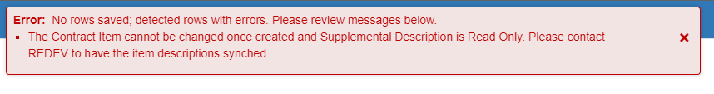
This error REQUIRES ReDEV – IS rep to synchronize descriptions – contact ReDEV to resolve.

End of Quick Reference Guide

