AASHTOWare Project Construction Stockpiles
Quick Reference Guide

This Quick Reference Guide (QRG) will describe the policies and procedures for Construction Stockpiles in AASHTOware Project Construction & Materials (AWP).
A Construction Stockpile is a payment advanced to the contractor to store or purchase material in bulk quantity. The percentage paid for each type of stockpile and the storage location is outlined in the Standard Specifications. MoDOT Specification 109.7.2 allows for payment to the contractor for Construction Stockpiles, also called “Material Allowance”. Refer to the specification and EPG for minimum requirements which must be met prior to payment. After a Construction Stockpile is created, the entire initial payment will be paid to the contractor on the next estimate as a system generated line item adjustment. This stockpile balance is then recovered on each estimate when the contract item is installed and paid for as a negative system generated line item adjustment. Before the end of the contract, the item is to be paid in full and the stockpile balance should be zero.
- AWP uses dollar-based percentages for payment and recovery of the Construction Stockpiles. This is a very easy way to manage the initial payments and ensure the amount paid is recovered in full without risking over-payment to the contractor.
For example: The contractor submits an invoice to purchase 100,000 each Shear Connectors and the Bid Quantity of the Shear Connectors is 225,000. The material cost for the Shear Connectors is 0.50 cents each and the invoice value is $50,000.00. The bid cost for the Shear Connectors installed is $2.50 each. The percentage of the quantity of the item is 44.4% ([100,000/225,000] * 100). The stockpile will be set up to initially pay the contractor $50,000 for the material. As the contractor installs the shear connectors, the system will proportionally deduct the material cost as a Stockpile Adjustment until 44.4% of the item quantity is paid out.
Replenishment of the stockpiles is needed when the same material is invoiced for the same line item on subsequent invoices. When replenishments are received, the Previous Invoiced Quantity is added to the new invoiced quantity to determine the new percentage of recovery.
For example: The contractor submits another invoice to purchase another 100,000 each Shear Connectors. Again, the material cost on the invoice is $0.50 cents each and the invoice value is $50,000. The percentage of the total invoiced quantity is 88.9% ([200,000/225,000] * 100). The system will use the new Recovery Percentage to deduct the material cost as a Stockpile Adjustment until 88.9% of the item quantity is paid out.
Note: If the invoice units are the same as the Line Item units in the contract, the quantity represented on the invoice will be used for the Construction Stockpile. If the units on the invoice are not the same (usually when the material is a component of the pay item), the quantity from the invoice will need to be converted to match the pay quantity units first.

Contents
Add Construction Stockpiles 2
Deleting a Stockpile 4
Stockpile Transactions 5
Construction Stockpiles and Recovery 7
Replenish an Existing Stockpile 7
Estimates with Construction Stockpile Payments & Adjustments 9
Review Construction Stockpiles 12
Manual Close Out of Construction Stockpiles 15

Add Construction Stockpiles
Instructions contain Read only and User Entry fields
- Log on to AASHTOWare Project (AWP) in the CM Project Manager or CM Resident Engineer role and navigate to the Contract Progress for your contract.
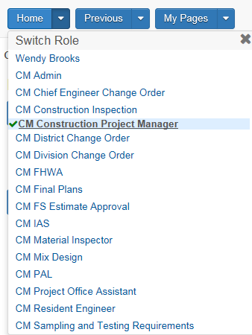
- Navigate to the Contract Progress tab and then select your Contract from the Search box.
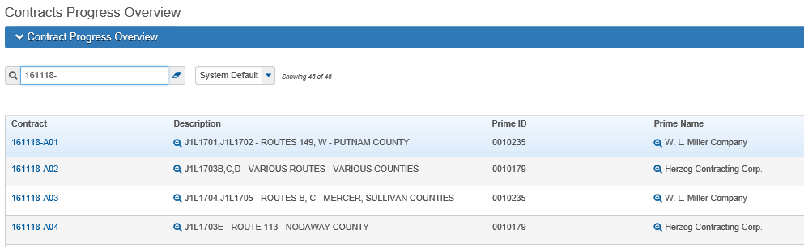
- Select the Construction Stockpile from the upper link in your Contract Progress Summary window.
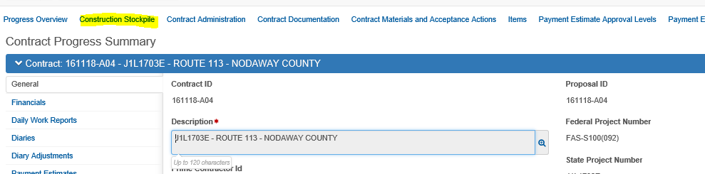
- The Construction Stockpile Overview window opens. Any previously added Stockpiles to this contract are displayed here.
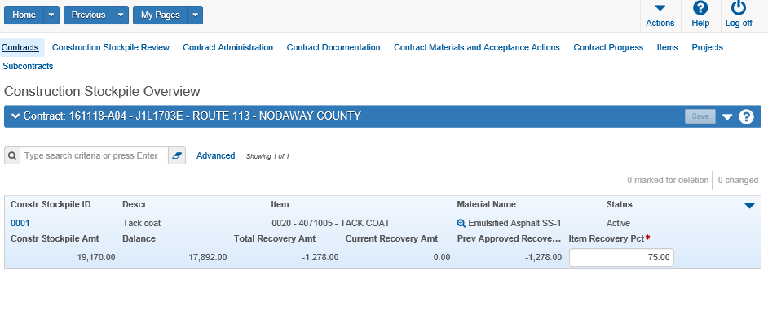
- To add a new stockpile to the contract, select Add from the Actions menu.
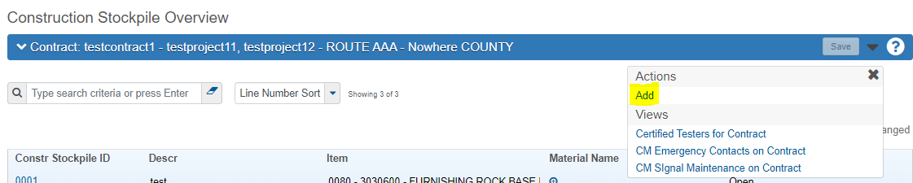
- Enter the following information:
  - Description – This is the description of the Stockpile Material
  - Item Recovery Percentage – This field determines how fast the system recovers the stockpile initial payment as items are installed. When the entered percentage matches the percentage of the item installed, the stockpile balance will be 0. It is recommended to not set this percentage at 100 as an item underrun would mean that the contractor owes money at the end of the contract.
PLEASE NOTE: Since the Stockpile Calculations in AWP are based on Remaining Quantity of the bid item AND based on the date the Stockpile is created – any payment made to the line item prior to entering the Stockpile will not be adjusted. This includes any DWR’s within the pay estimate period for which you are creating the Stockpile. Be sure to look at your POSTED quantity of the line item to reduce your ‘bid quantity’ take-off, as needed.
  - Item Code
  - Recovery Date - This date is when the system starts to recover the stockpile balance when DWR Postings are created. Enter today’s date.
  - Save when complete
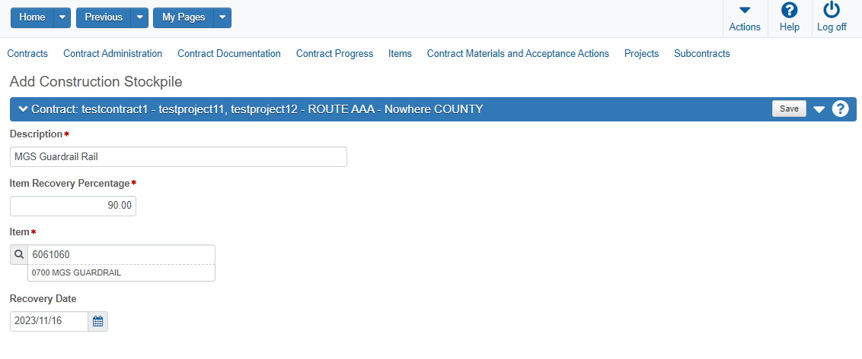

Deleting a Stockpile
If a Stockpile has not been included in a Payment Estimate, It can be deleted by:
- Navigate to the Construction Stockpile Overview for the contract.
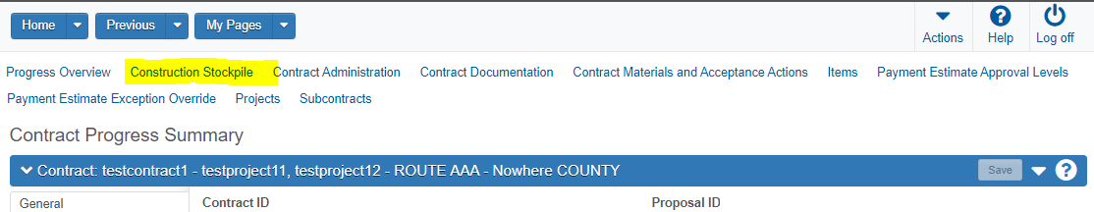
- Clicking the Row Action Menu and select Delete.
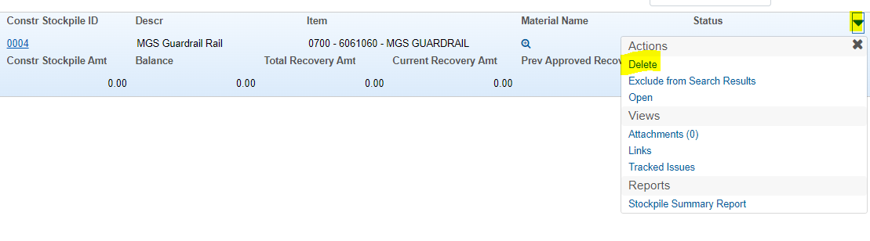
- Click Save.

Stockpile Transactions
Adding a Transaction
- In the upper portion of the window, enter information in the following fields:
  - Material: Select the Material code for the Stockpile. In this example it is: 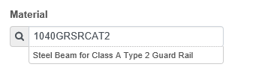
  - Source: Select the Source for the Material. In this exampe it is: 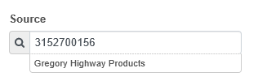
Note: The remaining fields will populate from previous windows or will update when saved.
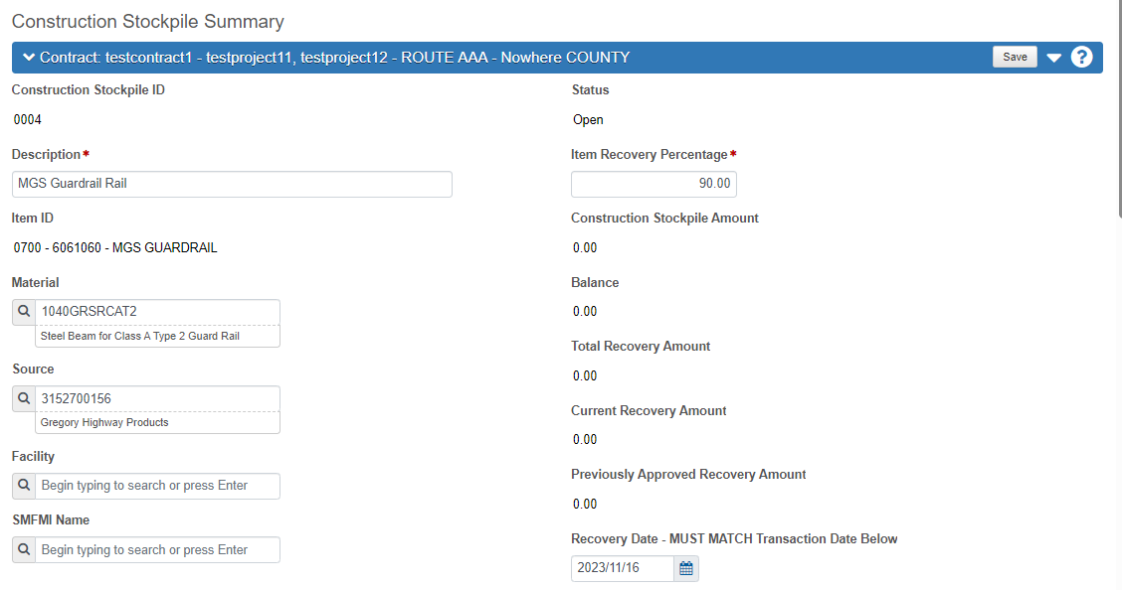
- In the New Construction Stockpile Section, enter information in the following fields.
  - Transaction Amount: The dollar amount of the construction stockpile transaction. This is populated from the Project Item Distribution section, Constr. Stockpile Amount
  - Comments: Comments are required. Enter details regarding the stockpile payment. This will be useful during the estimate process and reports sent to the contractor for the Line Item adjustments. Specifics regarding the $ paid on the stockpile and percentage recovery set up are suggested comments to add.
  - Invoice Number: Enter the invoice number for the stockpile.
  - Invoice Date: Enter the date from the invoice.
  - Transaction Date: Enter the date the stockpile was entered into AWP.
  - Transaction Type: Select STMI – Stockpile Material Initial Payment as the type.
  - Invoice Quantity: Enter the total quantity of the item as represented on the invoice OR the converted quantity if the invoice units are different from the pay item units.
  - Invoice Description: Enter the date the PAID invoice is to be received from the contractor (42 days from the payment estimate date for which the stockpile payment will be made). In addition, enter any information regarding where the stockpile is stored and if any Right of Entry was needed. If so, detail the location of the document in eProjects.
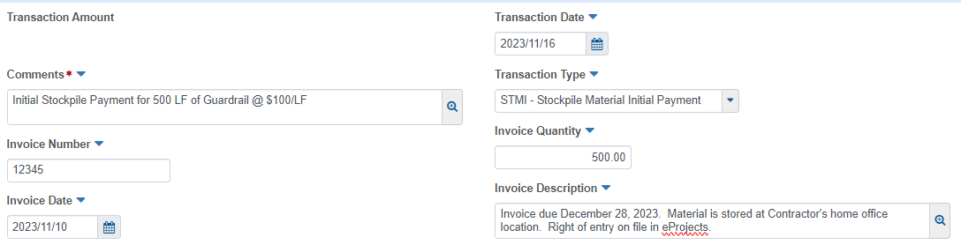
- The “Project Item Distribution” details the stockpile payment to the contractor. Enter information in the following fields
  - Item: Select the line item from the drop down list.
  - Constr Stockpile Amt: Enter the invoice amount for the stockpile.
  - Fund Package ID: Set after the record is saved, based on Contract funding set up in AWP.
  - Fund Package Description: Set after the record is saved, based on Contract funding set up in AWP.
  - When complete, select the Save button. Below is an example of the saved stockpile transaction:
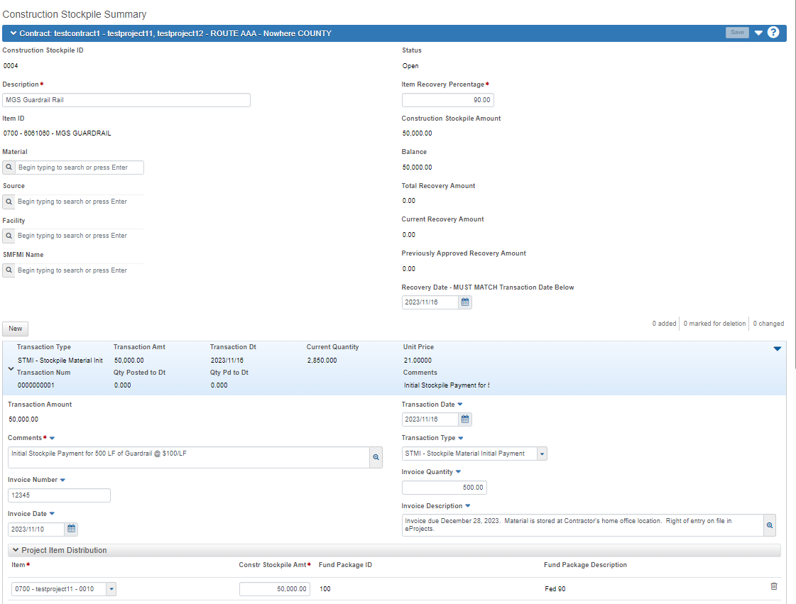

Construction Stockpiles and Recovery
Once the stockpile is created, the initial stockpile payment will be issued to the contractor on the next estimate as a system generated line item adjustment.
After the Recovery Date, when associated stockpiled items are installed, there will be a negative system generated line item adjustment on the Payment Estimate.

Replenish an Existing Stockpile
If additional quantities of the same stockpiled material need to be entered, DO NOT create an additional stockpile. The original stockpile must be replenished.
- Navigate to the Contract Progress tab and then select your Contract from the Search box. Open the original stockpile.
- Select Construction Stockpile from the upper link in your Contract Progress Summary window.
- The Construction Stockpile Overview window opens. Any previously added Stockpiles to this contract are displayed here. Select and Open the Stockpile which needs the replenishment.
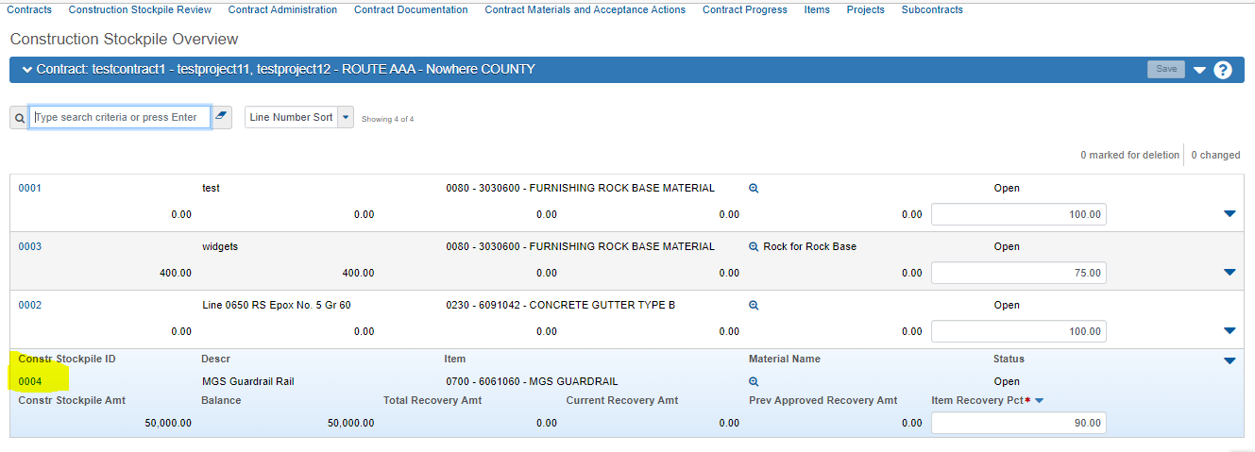
- Scroll to the middle of the screen and on the left-side, select the New button.
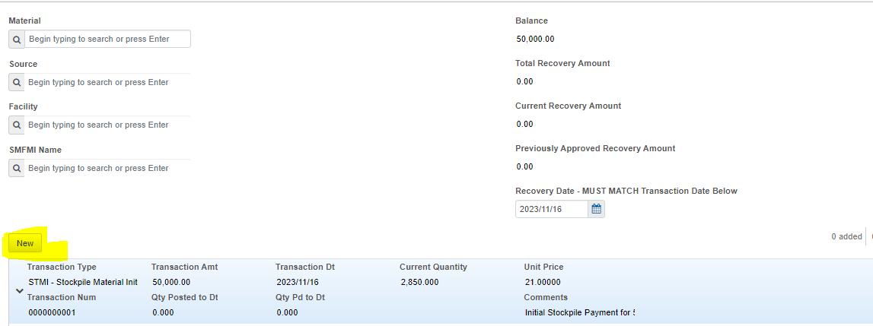
- Fill in the required information as previously entered.
- Set the transaction type to STMA (Stockpile Adjustment)
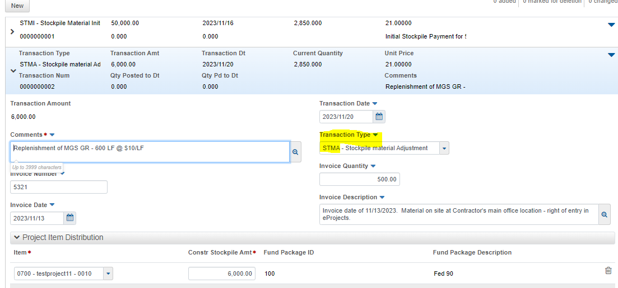
- Click Save.
NOTE: If you need to change the recovery percentage, you should do it at this point now. Otherwise, leave as is. In this instance, when the Line Item is paid out at 90%, all Intial and Adjustment Stockpile transactions amounts will be recovered.
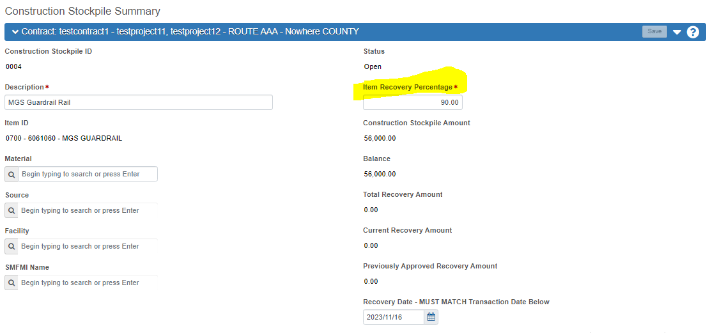

Estimates with Construction Stockpile Payments & Adjustments

Construction Stockpiles are System-Generated Item Base Adjustments on the Contact Payment Estimate. You can review these adjustments when the Payment Estimate generation is completed. Compare the results from AWP with your Stockpile Spreadsheet.
- Navigate to the Contract Progress Summary Window and Select the Payment Estimate number to review the Stockpile Payments. Click on the Estimate Number to open the summary:
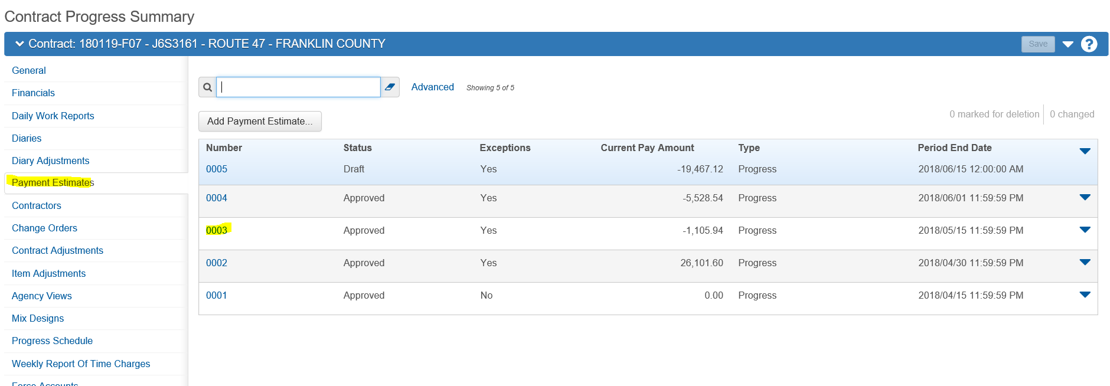
- From the General Tab, scroll down to review the Contract Payment Estimate Summary. The total of all of the Construction Stockpile payments are listed.
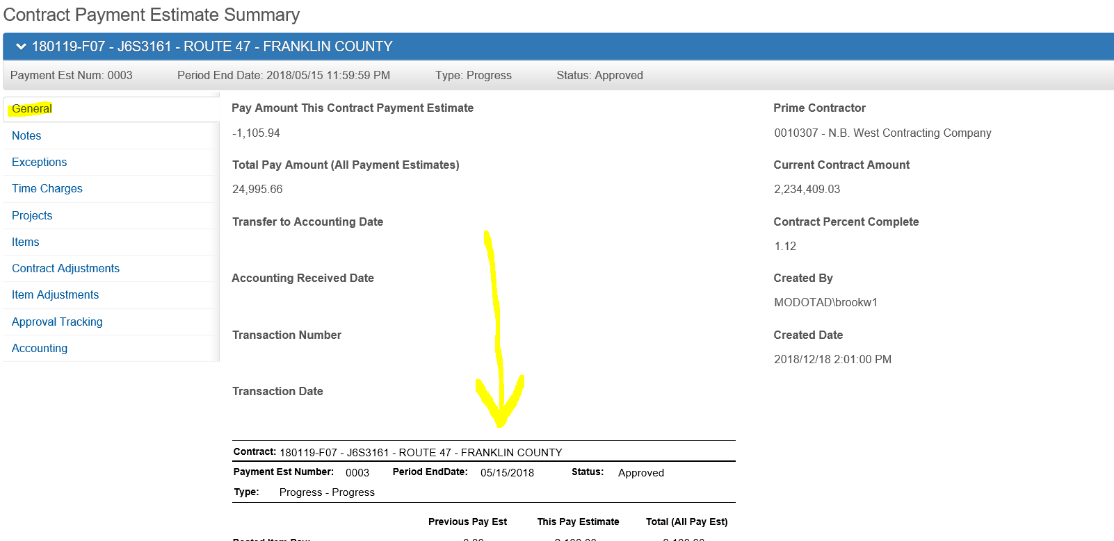
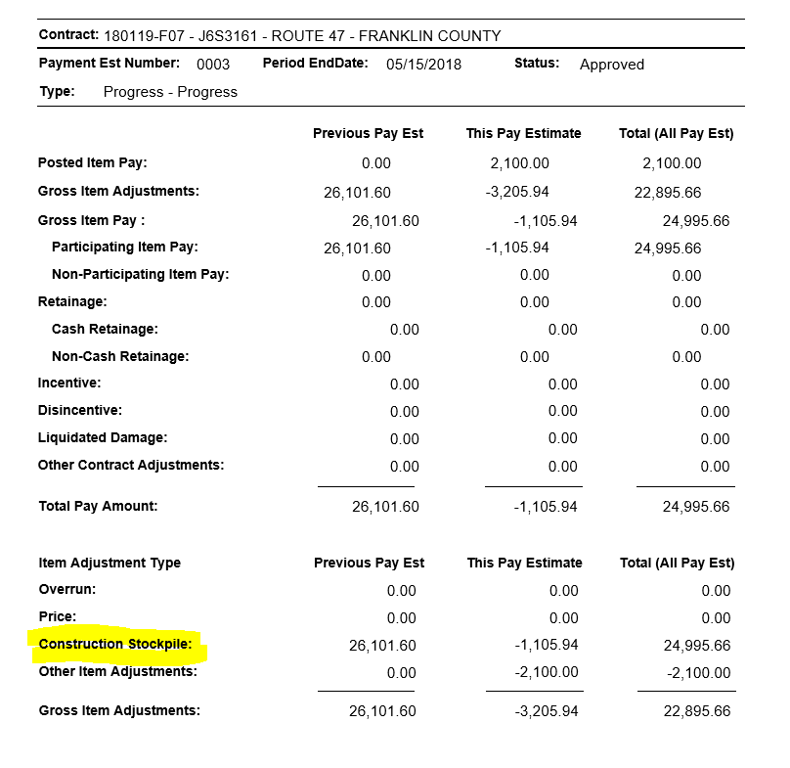

- Select the Item Adjustments tab and scroll down to the System Generated Item Adjustments section of the window.
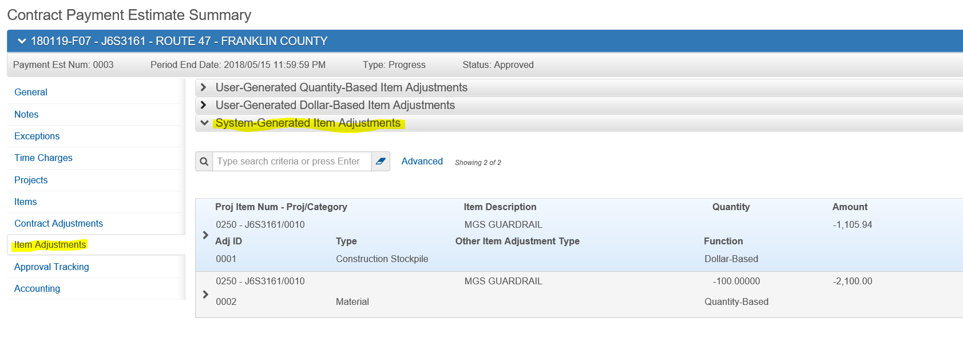

- Each particular Construction Stockpile transaction for this esitmate is listed. Expand the rows for further details.
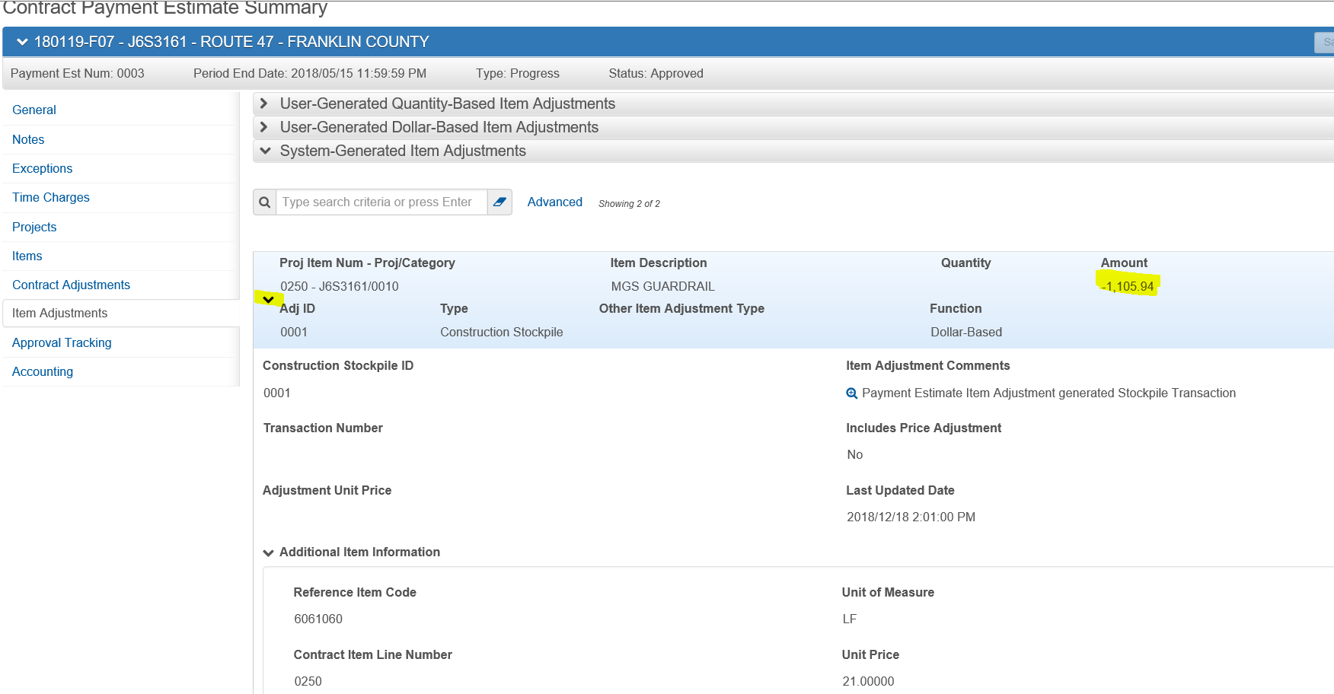

NOTE: If at any time you discover discrepancies with your Stockpile adjustments, or have any questions, contact ReDEV BEFORE approving any estimates.

Review Construction Stockpiles
The Construction Stockpile Review link allows you to view a list of all stockpile adjustments for the contract, including those created through line-item adjustments and payment estimates.
- From the Construction Stockpile Overview window, Select the Construction Stockpile Review link in the upper portion of the window.
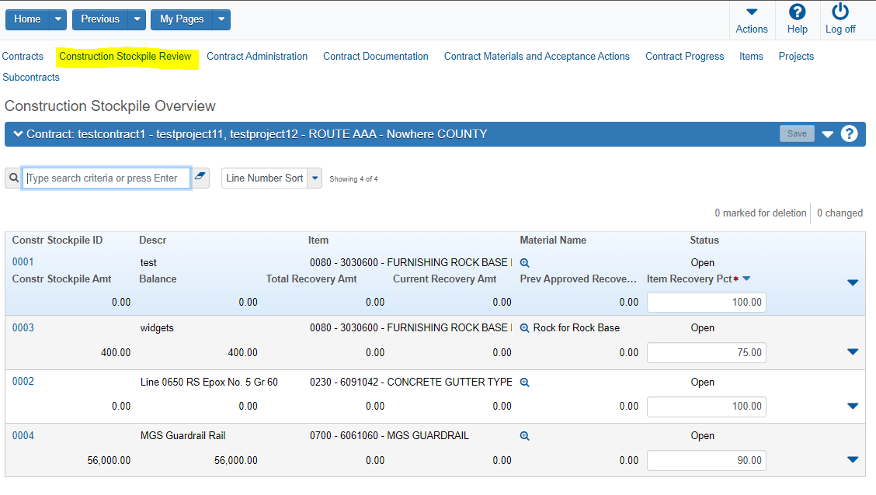
- The window opens with all Construction Stockpile records. The window contains the following Read Only fields for review:
Constr Stockpile ID: Unique number assigned by AWP for each stockpile record.
Descr: Description of the Stockpile Item
Contract Item Ln Num: Line number and brief description of the item
Project Item Ln Num: Line number, project and category displays here
Constr Stockpile Amt: Amount of the initial payment for the stockpile
Number – Estimate number the transaction number took place.
Transaction Type – Description of the type of transaction – with stockpiles it will be STMI – Stockpile Materials Initial payment or STMA – Stockpile Material Adjustment.
Item Adj Amt – The dollar amount of the adjustment for the transaction.
Balance – The remaining balance for the construction stockpile.
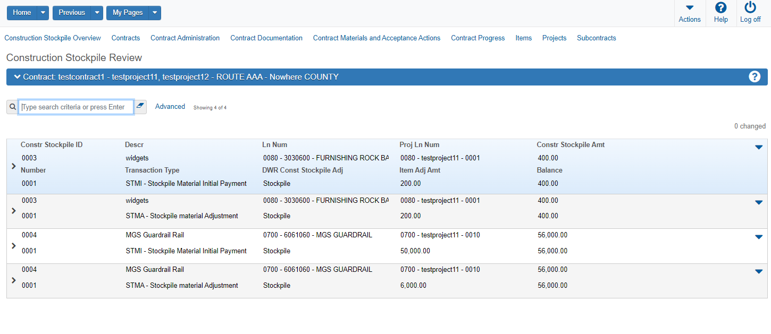
Drop down the list for the record to reveal further information regarding the record.

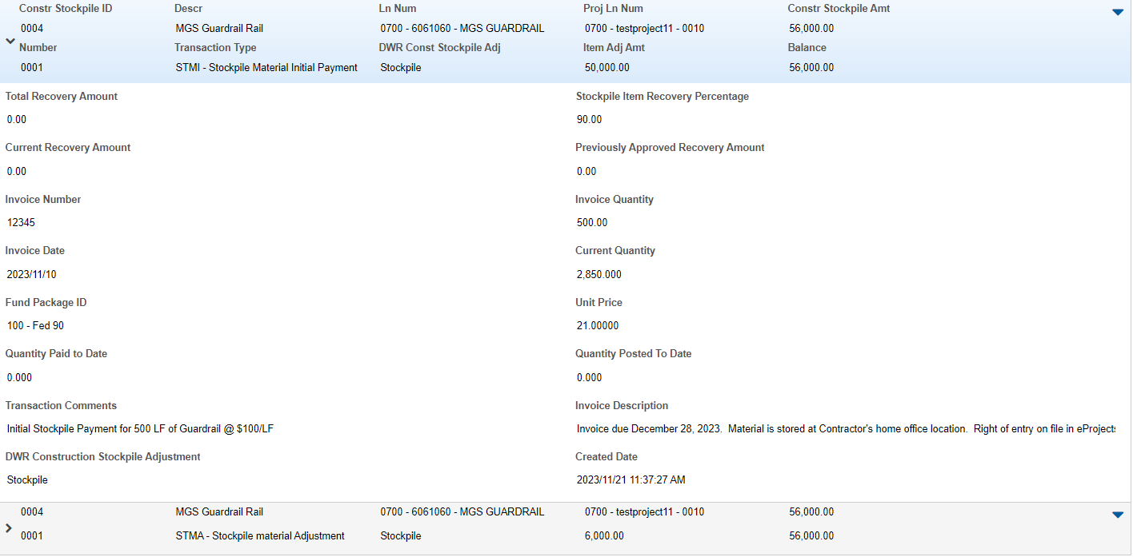
Total Recovery Amount – Total gross recovered amount for this item and construction stockpile on all payment estimates.
Current Recovery Amount – The pending dollar stockpile recovery adjustment dollar amount for this item and construction stockpile on the current payment estimate.
Invoice Number – Specific invoice number used for this stockpile transaction.
Invoice Date - The date of the invoice associated with this stockpile transaction. You cannot enter a future date.
Fund Package ID - Based on Contract funding set up in AWP.
Quantity Paid to Date - The number of units of this work item for which payment has been made to the contractor to date.
Item Adjustment or Transaction Comments - Additional information about the associated record. Entered by the user during the original creation of the stockpile and/or adjustment.
DWR Construction Stockpile Adjustment - A value that describes the type of construction stockpile transaction.
Stockpile Item Recovery Percentage - The historical value of the item recovery percentage when the transaction occurred. The item recovery percentage is the contract item percent complete for which the construction stockpile amount will have been fully recovered.
Previously Approved Recovery Amount - The total gross stockpile recovery adjustment dollar amount for this item and construction stockpile on all previous estimates.
Invoice Quantity - The quantity included on the invoice for the stockpile transaction.
Current Quantity - The quantity of the contract item at the present time, calculated as the Bid Quantity plus the Net Change Order Quantity.
Unit Price – The unit price of the contract item.
Quantity Posted to Date - The total of all Quantity Posted entries for an item on one or more DWRs, regardless of whether the quantities are authorized or included on a contract payment.
Invoice Description - Brief text describing the invoice associated with the construction stockpile transaction.
Created Date - The date and time this record was added to the system. This field is automatically populated by the system.
Note - As soon as the estimate generation is completed, the Construction Stockpile Review updates with the information regarding the transactions on the estimate.

Manual Close Out of Construction Stockpiles
AWP Construction Stockpiles will achieve the status of Closed at the time of the Final Estimate Generation. Because of the dollar percentage recovery, all Construction Stockpiles will have been recovered, however, they remain with the status of Active until this time.
There are 3 instances where the Project Offices would need to manually close out a Constrction Stockpile.
- If a paid invoice for the stockpiled material is not received from the contractor within 42 days of the date of the estimate on which payment for the material was made. At that point, the stockpiled material is to be manually closed and any payments which had been made will be deducted from the next estimate.
- If the Line Item for the Stockpile is underrun AFTER the stockpile was created and has been included on a pay estimate.
- If a Stockpile was created for a Line Item that was removed via Change Order.
  - If removed and replaced by a Contingent Item – the original Stockpile Record(s) would need to be Closed and a corresponding Stockpile would need to be created for the Contingent Item.
  - It is preferable to perform this on the same estimate period, which would result in a zero dollar adjustment overall, assuming no postings were made to the original or Contingent item(s).
To manually close out a Stockpile Material, adjust the Percent of Recovery to 0.00% for the stockpile which needs to be closed.
- Navigate to the Construction Stockpile Overview. Enter 0.00 in the Item Recovery Pct field for the Stockpile transaction you need to close out.
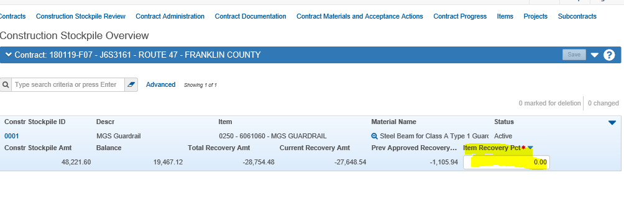

End of Quick Reference Guide

