QRG – Documentation Records
Documentation Record is a term that is often used to reference an important record or calculation that is stored either in AASHTOWARE Project (AWP) or eProjects. The focus of this QRG is to provide users a sense of the type of information that should be documented, as well as how to enter it into AWP.
Documentation Records cover a variety of activities related to any given contract. It is the Resident Engineer's responsibility to see that documentation records are diligently recorded in the appropriate location of AWP or eProjects. Some documentation entered into AWP also needs to be displayed on the Estimate so that the contractor can correlate payment with their records, while other information is simply recorded in AWP for general record keeping and not displayed on the estimate.
One important purpose for creating a documentation record is to record information on work performed that cannot be easily seen or measured after the work is complete. Some common examples of this are installation of erosion control devices, temporary traffic control devices and cold milling. Once a project is complete, you cannot go back and verify which items were used, where they were placed or the quantity of each. Documentation records are needed in other situations as well, such as providing information on contractor payments where calculations are necessary to make a payment determination or a contract adjustment.
There are two primary reasons for the information traditionally called Documentation Record.
1) A detailed record of the work, as historical proof that the work was performed
2) Information the contractor may review in a timely fashion and use to confirm or dispute quantities, locations of work, calculations, logic behind calculations, or other routine activities where a controversy may result later in the job's life.
The documentation record process described in this QRG does not change the fact that other information may need to be communicated to the contractor verbally, by e-mail, by letter, by Order Record, or by other applicable means.
The following list includes some examples of issues and activities that need to be well documented. The list should not be considered complete, but rather just a process guide. Any issue or activity that meets the criteria listed above should be documented in AWP or eProjects. If the contractor needs the information, it should also be stated in the Estimate report by including the information in the appropriate area of AWP.

EXAMPLES OF ISSUES AND ACTIVITIES THAT NEED DOCUMENTATION:

1) Estimate Data Type: Contract Adjustment
- Asphalt Cement Price Adjustments (Spreadsheets are available to calculate these adjustments.)
- Asphalt Pavement Pay Factor Adjustments (QC/QA results affecting pay - Include detailed calculations and information related to adjustment)
- Fuel Price Adjustments (These are auto calculated and paid by AWP. Spreadsheets are available to manually calculate adjustments on qualifying non-standard items.)
- Pavement Smoothness Price Adjustments (Include detailed calculations and information related to adjustment.)

Contract Adjustment entries should provide enough detail, so the typical reader has no questions regarding the adjustment.
ABIR | Smoothness Adjustment Asphalt Bonus IRI
ADIR | Smoothness Adjustment Asphalt Deduct IRI
ARET | Cash Retainage Withheld
ATLD | Application of Trainee Liquidated Damage
ATRN | Application of Training Adjustment
BRDC | Blast Residue Disposal Costs
CBIR | Smoothness Adjustment Concrete Bonus IRI
CDIR | Smoothness Adjustment Con. Deduct IRI
CLMS | Settlement of Claim
CSP | Core Sample Payment
DBQL | DBE Liquidated Damages
FTH | Footing Test Holes
NHIN | New Hire Incentive
OTHR | Other
PLNT | Adjustment for Planting of Trees
RFAD | Railroad Flagging Adjustment
SIGN | Sign Inspection Transportation Costs
SPAD | SuperPave Adjustment
TSR | TSR Adjustment
WFDV | Work Force Diversity Adjustment
APTA | Asphalt Performance Testing Adjustment (Requires JSP)
AIDA | Asphalt Increased Density Adjustment (Requires JSP)

2) Estimate Data Type: Item Adjustment
- Concrete Pavement Price Adjustments (QC/QA results affecting pay - Include detailed calculations and information related to adjustment)
- Manual Fuel Adjustments (Indexing - especially instances where quantities are adjusted later, precipitating a need to adjust indexing)

Item Adjustments should provide enough detail, so the typical reader has no questions regarding the adjustment.

ACAD | Asphalt Cement Price Adjustment
FUEL | Fuel Price
MATL | Left Over Materials
MDPA | Material Discrepancy Payment Adjustment
MEMB | UBAWS Adjustment (Membrane Only)
OADJ | Overrun Re-adjustment
OTHR | Other
OVRN | Overrun
PCCP | PCCP QC/QA Adjustment
PCCS | PCCP QC/QA Strength Adjustment
PCCT | PCCP QC/QA Thickness Adjustment
REFL | Retroreflectivity Adjustment
SEAL | Seal Coat Adjustment
STMA | Stockpiled Materials Adjustment
STMC | Stockpiled Materials Closure
STMI | Stockpiled Materials Initial Payment
SUBI | Substandard Item
UBAW | UBAWS Adjustment (Membrane and AC)
UNDR | Undersealing
PPPS | Partial Payment for Pending Sample
INTC | Intelligent Compaction

3) Estimate Data Type: Item Payment
- Any Pay Item (Include location, amount and date of installation. If special details are required include them in the remarks for that Location Sequence Number
- Compacting In Cut (one area of work may be done before another area. Each completed area should be documented as completion is achieved.)
- Modified Cold Milling (one area of work may be done before another area. Each completed area should be documented as completion is achieved.)
- Undergrading (one area of work may be done before another area. Each completed area should be documented as completion is achieved.)

Item Payment entries should provide enough detail, so the typical reader has no questions regarding the payment or location of the work.

4) Estimate Data Type: DWR Documentation Remark
- Slope Stake Marking Explanation
- Retroreflectometer readings taken by the Project Office
- Seedings/plantings details

A DWR Documentation Record Remark can be used to document anything that does not logically fit in one of the categories above.

THE MECHANISM TO ACHIEVE PROPER DOCUMENTATION:

1A) Estimate Data Type: Contract Adjustment
See other references to "Contract Adjustment" in the EPG and QRGs for additional details on Contract Adjustments.

Enter the Contract Adjustment in the Contract Adjustments tab form the Contract Payment Estimate Summary. In the Comments area, be certain to include calculations and details related to the issues such that the typical reader would have no questions regarding the work done, the reason for the payment, or the calculations performed to arrive at the payment or deduction.

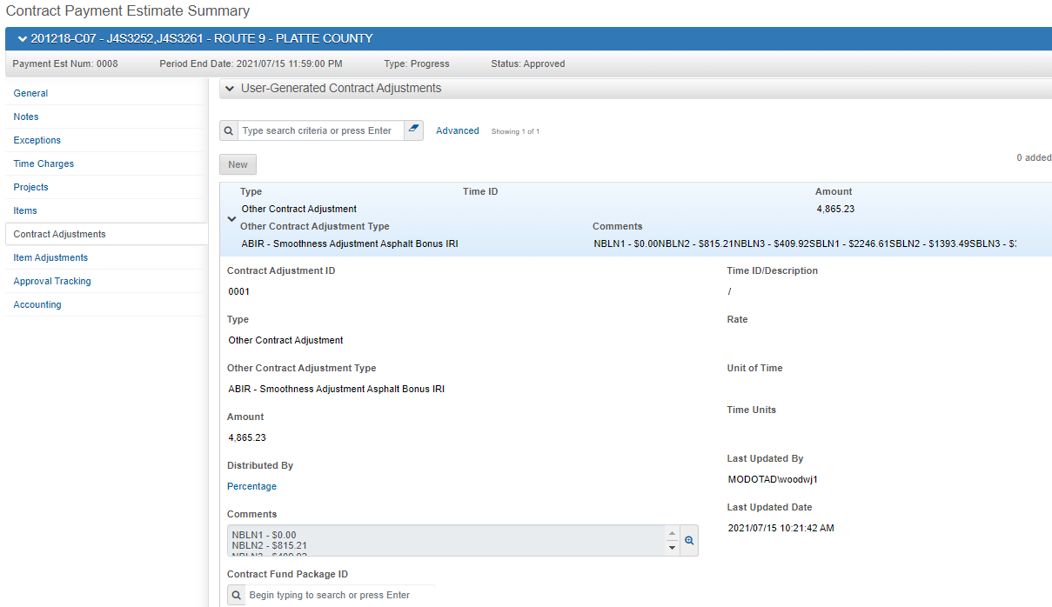

The Estimate will reflect the entry above and this is considered adequate documentation of this payment.

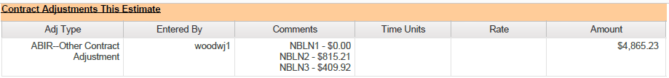

2A) Estimate Data Type: Item Adjustment

See other references to "Item Adjustment" in the EPG and QRGs for additional details on Item Adjustments.

Enter the Item Adjustment in the Item Adjustments tab of the Contract Payment Estimate Summary. In the Comments area be certain to include calculations and details related to the issues such that the typical reader would have no questions regarding the work done, the reason for the payment, or the calculations performed to arrive at the payment or deduction.

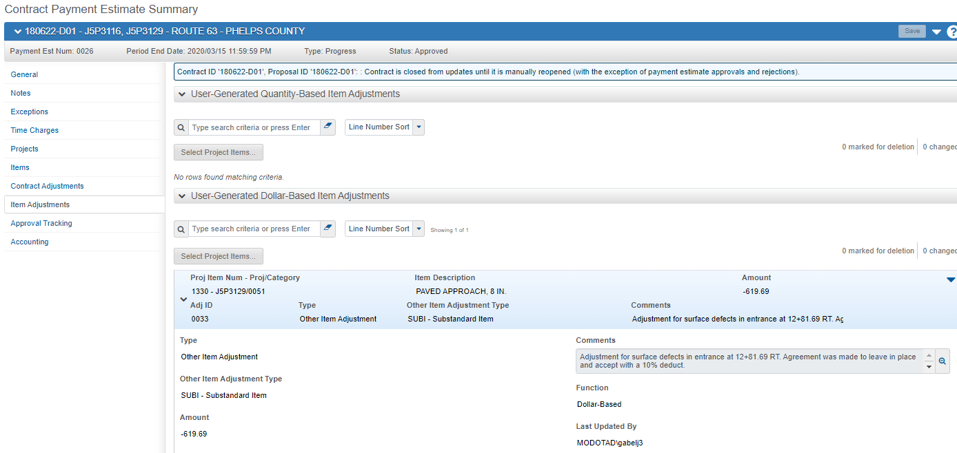

The Estimate will reflect the entry above and this is considered adequate documentation of this payment.

3A) Estimate Data Type: Item Payment

See other references to "Daily Work Reports - Postings" in the EPG and QRGs for additional details on Daily Work Reports - Postings entries.

Enter the Work Items in the Daily Work Reports window, on the Postings tab.

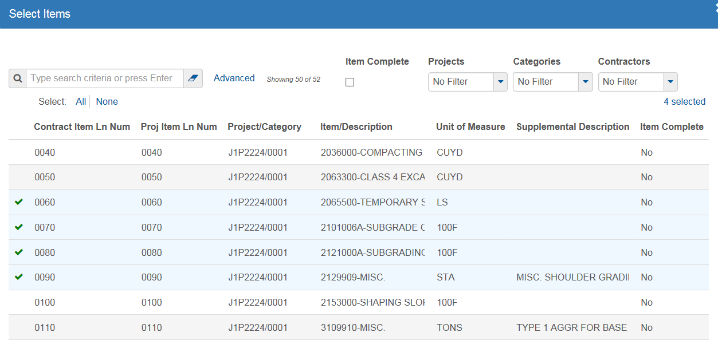

For each Work Item, provide an entry (Item Posting Num) to document the quantity and location of the work. The system requires either station or log mile. Every feature, payment, or deduction applies to some point, some portion, or the entire job (job limits - generally you can ignore equations for this purpose). This can be indicated via stationing (on a stationing job) or by Log Mile (on a Log Mile job).

When there are variations of width of work, skipped area, or other aspects that make a certain length of the work different from another, a new line should be added for that work (Item Posting Num - click the action menu, then click New Posting). Certain features, such as detour signs, may be outside the project limits. You may use TMS to determine the continuous Log Mile designation of the point, or you may reference the point from a stable landmark such as an intersection or a river.

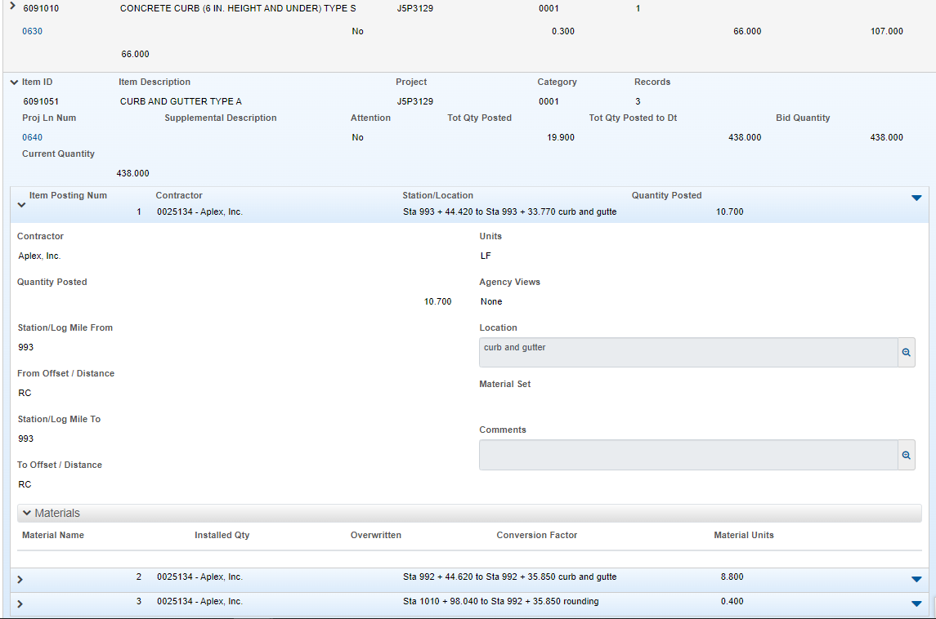

Part of this information is listed in the Estimate, as in the example below. This example covers the information above and below. The balance of the information will be presented elsewhere in the Estimate, review the rest of the QRG, below.

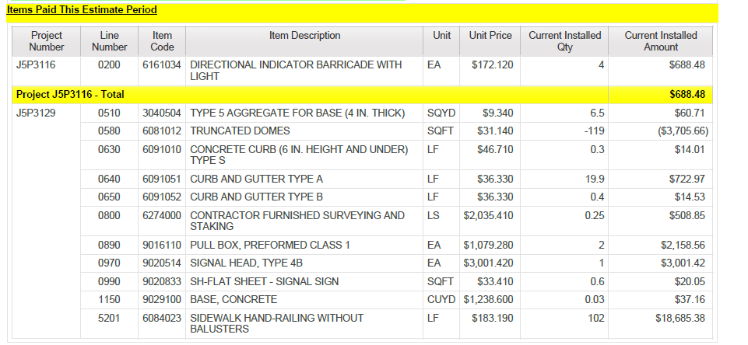

If the description field and the location specific details do not provide enough information, a Comment specific to the Item Posting Number can be added.
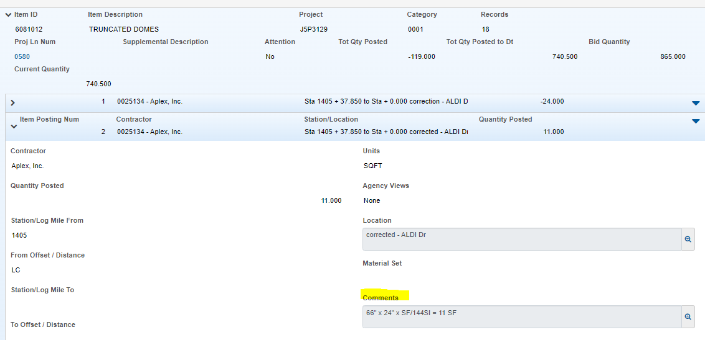

The comment will show up in the estimate subservient to the location information of the work.
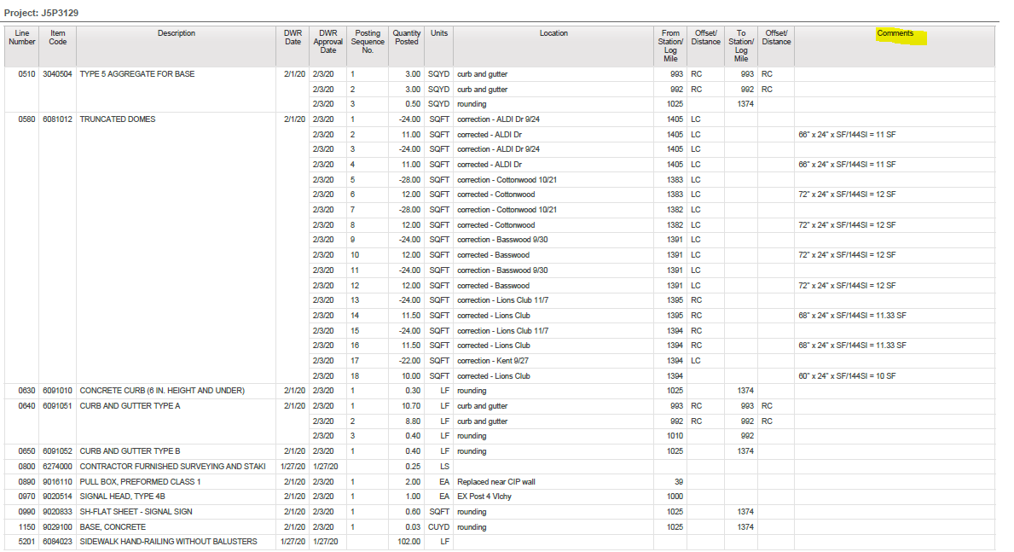

There is one specialized Agency View for Construction Signs and Relocated Signs. When your project has these pay items, use this Agency View to document locations.

To view or enter usage for a posting by using an associated DWR agency view, select the name of the DWR agency view from the Actions menu on the posting row. Data in associated agency views can be entered and modified only when the contract is active and the DWR is in Draft status. In addition, the association between the agency view and the contract item must also be active.

There are currently two specialized Agency Views for DWR postings. Those for Construction Signs (Item Code 6161005) and Relocated Signs (Item Code 6161010) to help in documenting sign detail and location. The other Agency View is for Tack Coat (Item Code 4071005). When your project has these pay items, use of this Agency View is required for the posting.

Note: If you do not see this Agency View for these pay items, contact ReDEV.

Select the line item to post. You must first add the line and save to get the Actions menu item – to add you must select a contractor and station at a minimum. Only add one instance of a posting per DWR. All location information for the signs is recorded in the Agency view. Adding multiple instances on a DWR may cause the total payment to be incorrect.

Once added, select the Actions drop down list to attach the Agency Views from the Views location. Select the Agency View (this example shows CM_DWR_Construction_Signs). Double click to attach.

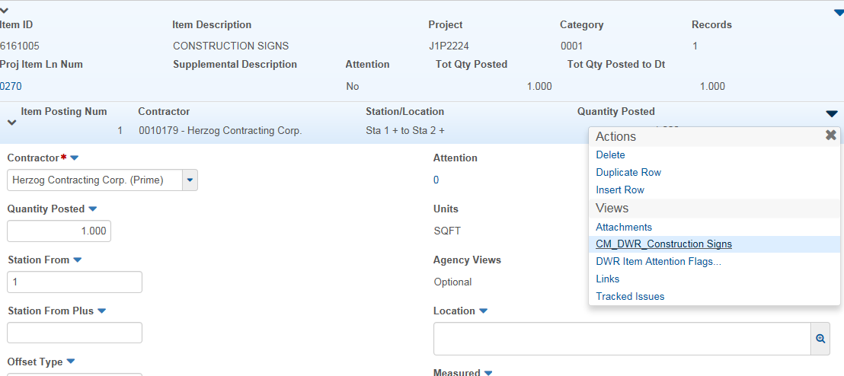

Select the New button in the bottom screen of the template.
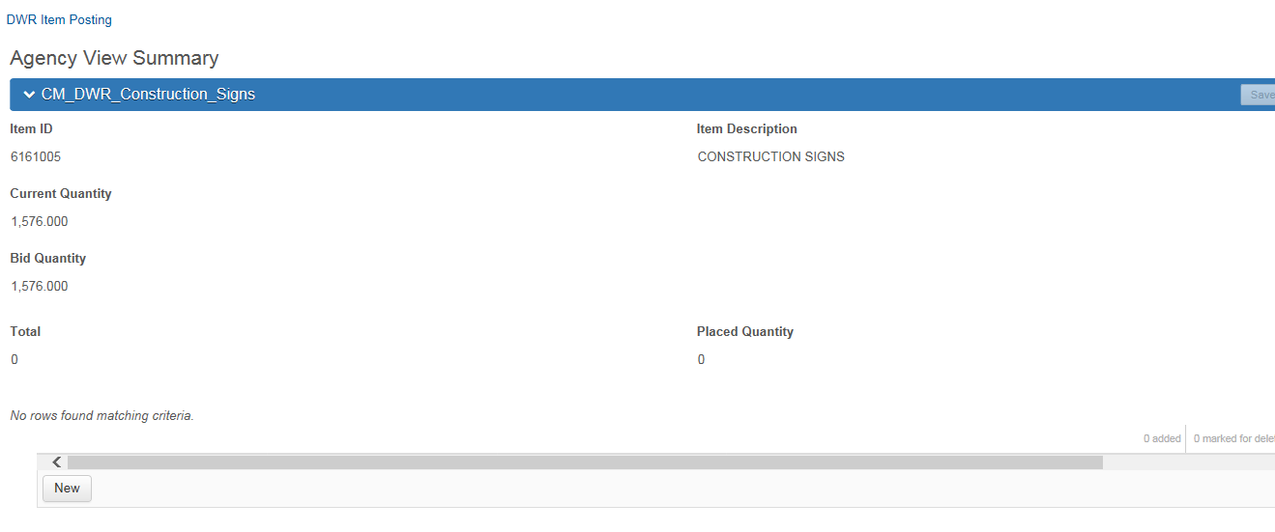
Click in each field of the template to add the sign installation/relocation location. You cannot tab through this template – you must click into each field. Use the scroll bar at the bottom of the row to access more fields. The New button can be used multiple times to add additional construction signs.
See below on field population requirements.
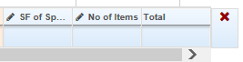
Station: Enter the Station if it is not a Log Mile Project
Log Mile: Enter the Log Mile if it is not a Station Project
Location: Enter the location, including offset for the sign
Sign Number: Select the standard construction sign from the drop down list. Use the scroll bar to access the full list of signs, listed alphabetically by sign number
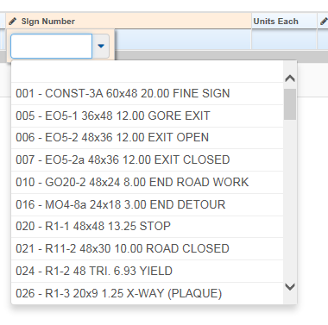
Units Each: Automatically populated based on the Sign Number picked
Special Sign Legend: Use this field to add the dimension and description for any special, non-standard Construction Sign. No special formatting is necessary.
SF of Special Sign: Use this field to add the square footage of one special sign
No of Items: Enter the total number of the Signs (standard or Special) selected at this specific location
Total: Automatically populated with the total SF of the signs (standard or Special)
When you have completed your entries, select the Save Button. The Totals will be added together and rounded to the nearest SF to give you a Total SF paid on the posting:
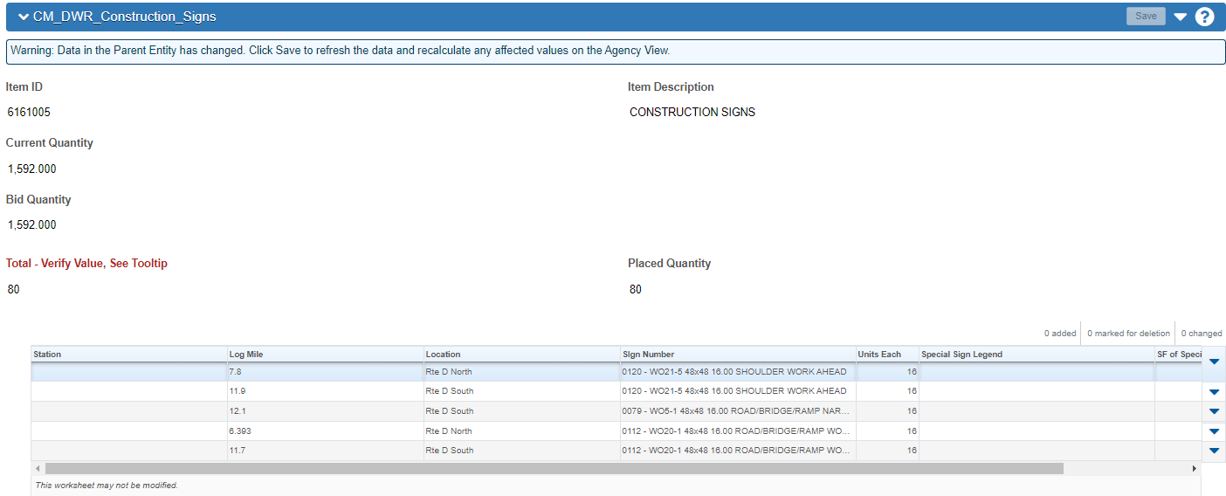
Return to the DWR Item Posting. The Quantity Posted has updated to the Total SF of the Construction Items (rounded to the nearest SF).

Either of the processes described above will result in the detail like the following.

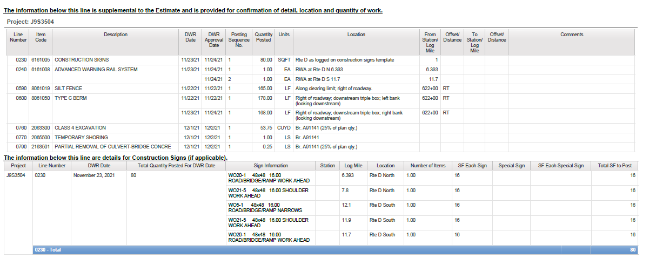

Frequent Questions:

1) Permanent signs: Permanent Signs have multiple pay items each time a sign is installed (up to 6 individual items). A contractor can easily drill and pour many sign footings in a day. This can happen for several consecutive days on large projects. Does each sign assembly need to be entered separately or could they be lumped together for sign payment? Some sign locations have one sign and some have 10 or more. In the past, we would add up the total for each pay item and make one entry. It would also list the sign numbers being paid for but to get the station and offset you would need a set of plans to cross-reference.

AWP is the primary repository of information regarding the construction of a project. While the signs are listed in the plans, AWP needs to know when a particular sign was installed. In order to know when the sign was installed, we need to know which sign the record is addressing. Note that we can come back to the job anytime and see a permanent sign. While each individual sign must be referenced, the work done related to signs; footings, posts, etc. can be indicated as a single entry for each work item for the work you are paying that day. The location would be project limits (or a subset of that if you can determine it easily) and part of the description would be “placed according to the plans”. This assumes that you have DWR remarks that indicate which signs (or sign components) were constructed on a given day. This can be done as simply as possible, in most cases this would be via the unique number assigned to each permanent sign in the plans. So… we need to know when and where the sign was placed, but the where can be a reference to the plans if the sign is placed according to the plans.

2) Channel Post Delineators: Can these be entered for a range?
Yes, “placed according to the plans”, then indicate the station or LM limits. If there were exceptions, for example, the delineators were placed from LM 3.0 to LM 14.0 and LM 15.2 to LM 16.0; this would require two entries on Loc Seq Nbr line on the Work Items tab of the DWR. Alternately, you could show LM 3.0 to LM 16.0 and put a Documentation Record remark type on the DWR Information tab and indicate the exception. This kind of exception comment would make more sense for a few missing delineators, than it would for 1.2 miles of missing delineators.

3) Construction Signs: Many portable mounted signs are mobile as they are moved along with an operation (i.e., Lane Drop package, Flagger package, etc.), how do you define their location? What level of detail is needed to show the location of a series of repeating post-mounted signs, such as No Center Line or Uneven Lanes?
Each time you pay for construction signs you should indicate each sign type installed and its general location. If it is a mobile sign used in a package, indicate the sign package it is used with, such as, “part of mobile Flagger signing package”. This placement record should match standard placement of such signs in accordance with the traffic control plans, MUTCD or other guide as may have been used. This gives you an opportunity to establish that it is, in fact, a standard set of signs or that there are exceptions added or deleted. A repeating series of signs, such as No Center Line or Uneven Lanes, can be indicated as follows: “A total of 10 No Center Line signs, 5 in each direction, were installed on Rte. 22 from Rte. 63 to Rte. 124, and spaced in accordance with Std. Plan 620.10G.” Taking a video of final sign installations throughout the project is a good practice to document initial sign installations in case of an accident, but this is not required in all instances.

4) Ditch Checks: Contractors often install several of these in a day, sometimes 30 to 40 or more. If they are in the same area down a continuous ditch can a range be used or separate entry for each?

Individual checks should be indicated with a specific location. A series of checks in a continuous ditch can be shown with beginning and ending station and the Description “<number> in accordance with plans and SWPP”. Note, in this instance a "continuous ditch" would encompass a series of checks placed in sequence as a group. "Continuous ditch" should not typically be construed as running the full length of the project.

5) Silt Fence: See Ditch Checks

A single run of fence should be indicated with beginning and end. A series of fences placed mostly continuous can be shown with beginning and ending station and the Description “in accordance with plans and SWPP”

6) Type IV Obj Markers: Current project they are not listed by station and offset. These are quite often on roadway that is closed and may not have stationing on the plans. Do we pick a station from plans best as possible?

Location can be defined in the Description field if a location is not designated on the plans, for example, “placement at end of East Outer Road to I-49”.

Bridge Items

7) Piling, Pile Point Reinforcement, Girders, Bearing pads, Slab Drains: Do these Items need to be reported individually or can we continue to report total length of pile for a bent, Pile points for entire Bridge, Bearing pads, girders and Slab Drains when installed?

All of these are designated on the plans, including specific locations and quantity. The location of placement would therefore be the limits of the structure (or the specific location would be acceptable, if easily determined.).

8) Timely notification to the Contractor: There may be instances when the contractor does work, and we should document it and notify the contractor of the work even quicker than at the next estimate. For example, work that is done and will be covered within a few days (paved over, backfilled, etc.). What should we do then?

Make the normal entries in AWP, at least those related to the work in question. Run an estimate and provide it to the contractor, and explicitly indicate that it is a preliminary estimate covering specifically that work that might be of special interest due to the contractor's progress. Advise the contractor that he may wish to review those details and raise any concerns he may have while the area can still be visited and remeasured, retested, or whatever may be required.

9) Retroreflectivity Details to the Contractor: Should the retroreflectivety cover letter and spreadsheet results be provided to the contractor?

Yes, the cover letter and spreadsheet report from the third-party retro-evaluation consultant are examples of documentation records that should be saved to eProjects. They should also be submitted in their native format to the contractor by email attachment and copying the pavement marking subcontractor. If the retro evaluation was instead made using a hand-held unit, or acceptance was made based on visual evaluation, the results should be conveyed to the contractor by email (can use Doc Record form) and documented in AWP.

10) Drop Inlets and other things that are the combination of multiple bid items: Is it necessary to repeat all entries for each component of something like a drop inlet? For example, a drop inlet will include excavation, the inlet (or components to cast-in-place), and grate and bearing plate.

Consider each Drop Inlet as an independent unit to be documented. Provide detail for the most important component (in this instance, the inlet). If you install 5 drop inlets in one day, each of the 5 inlets needs to have its only line on the DWR Work Item tab, indicating its location and designation. Work incidental to the drop inlet, such as excavation will need a single entry, with the work limits encompassing the placement of all 5 inlets, and a reference to the inlets that the excavation affected. Same thing for grates and bearing plates, one entry for the day. This process may be applied to other, similar processes, where the primary components get individual lines, and the incidental items get a single line per item, with a reference to the primary item.

