AASHTOWare Project
Estimate
Quick Reference Guide
Applicable Links
Final Estimate QRG: AWP_CO_Estimate_Final
Item Adjustments QRG: AWP Item Adjustments
Contract Payment Estimate Exception Override QRG: Estimate Exception Override Supplement

References
Engineering Policy Guide: 109.7 Partial Payments (for Sec 109.7)

Contents
AASHTOWare Project (AWP) Estimate Walkthrough 1
Navigating to Payment Estimates 2
Add Contract Payment Estimate: 3
Checking the AddPaymentEstimate.log and/or Error.log 4
Contract Payment Estimate Summary 6
General Tab 7
Notes/Remarks Tab 7
Exceptions Tab 8
Exceptions – Special Considerations 11
Submitting Estimate for Approval 11
End of AWP Estimate Walkthrough 13
Estimate Additional Guidance Information 13
General Tab 14
Time Charges Tab 16
Projects Tab 17
Items Tab 18
Contract Adjustments, Construction Stockpiles, & Item Adjustments Tab 22
Approval Tracking Tab 22
Rejected Estimates 22

Overview & Purpose
The Contract Pay Estimate is used to calculate and process payment to the prime contractor for work completed during the estimate period. Before generating an estimate, verify that all Daily Work Reports (DWRs) for the period have been compiled and approved. Only authorized pay quantities will be included for payment.

This Quick Reference Guide provides instructions for generating and approving estimates in AASHTOWare Project Construction & Materials (AWP). It also includes guidance on handling rejected estimates and contractor notifications. Users must be logged in as a Construction Project Manager to generate progress estimates.

IMPORTANT NOTE: Refer to the end of this QRG regarding “Rejected Estimates” and what is required of the Project Office for contractor notification.

AASHTOWare Project (AWP) Estimate Walkthrough
For clarity, input field pictures displayed in this Quick Reference Guide (QRG) will follow:
- All REQUIRED fields will be highlighted yellow
- All required fields only IF APPLICABLE will be highlighted green
- All OPTIONAL fields will be highlighted blue
- All DO NOT USE fields will be highlighted red

NOTE: All field names within AWP give a field description when your mouse cursor hovers over it.

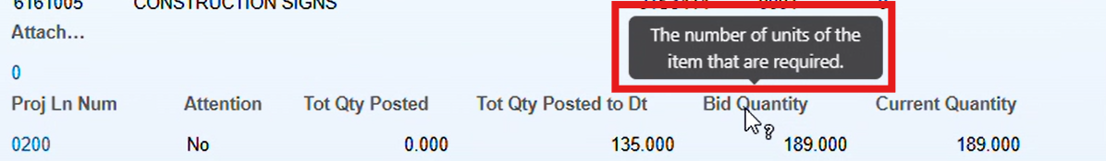

Select Project Manager Role  On the AASHTOWare Project (AWP) homepage, select the dropdown arrow at the top-left of the screen next to the Home button.  Select CM Construction Project Manager | 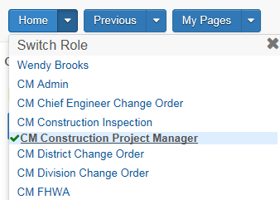

Navigating to Payment Estimates

From the AWP Homepage, select Contract Progress from the Construction section.
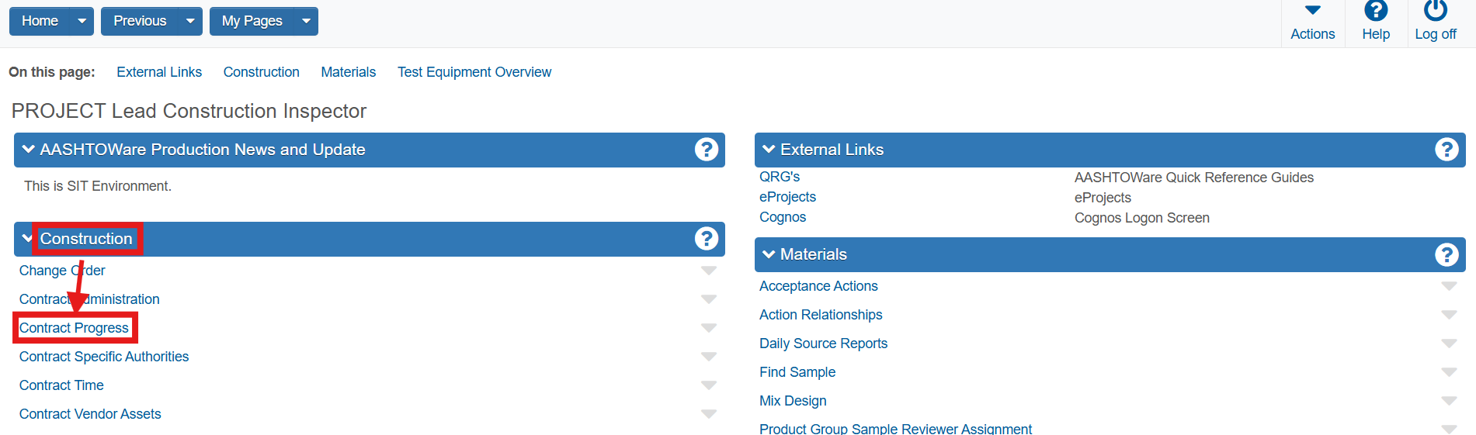

Search for and select the desired contract.
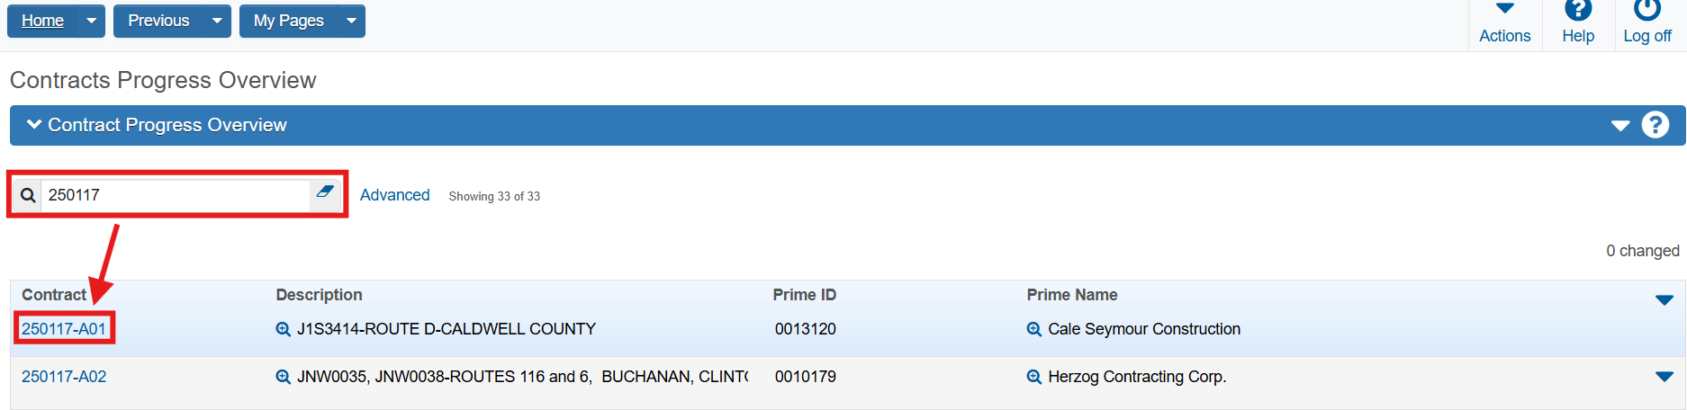

Navigate to the Payment Estimates tab and then select the Add Payment Estimate button

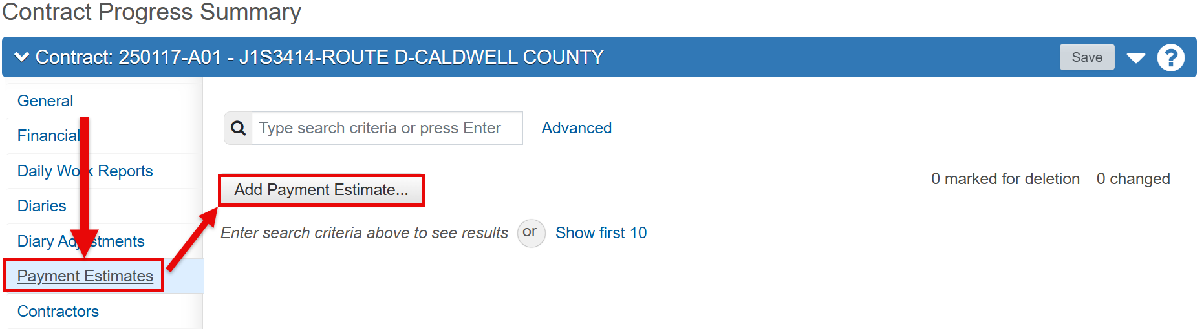

Add Contract Payment Estimate:
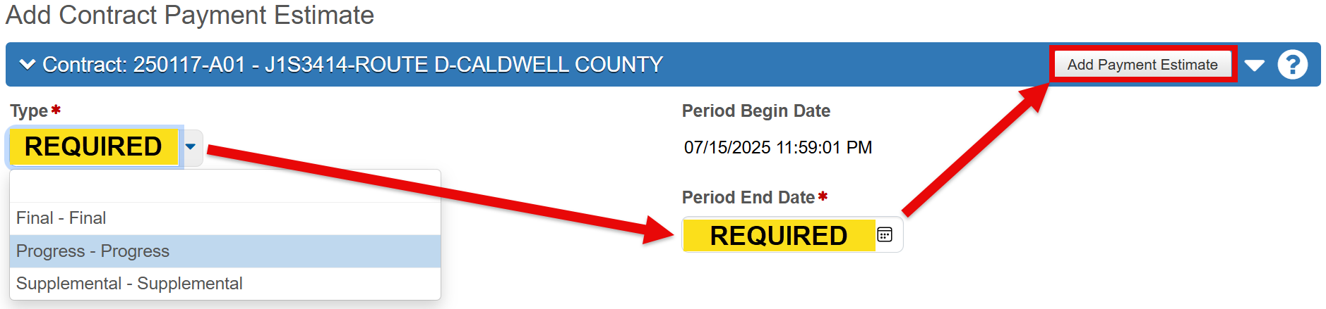

Type: Select one of the three types of estimates from the drop-down list.
- Progress: Generated with period end dates of either the 1st or the 15th (See EPG 109.7.1). Mock estimates may be generated at any time prior to the estimate ending date to resolve exceptions or check quantities but must be deleted.
  - Final: Generated at the end of the project once verified that all DWR’s are correct and have been authorized.
  - Note: Final Estimates are generated at the CM Resident Engineer (RE) role. Reference the Estimate Final QRG for further details.
- Supplemental: Only used if an error is found after the final approval of the Final Estimate type.

Note: This type will only be selected if directed to do so by a System Administrator.

Period Begin Date: Automatically populated by AWP. For the first estimate, this date equals the contract Notice to Proceed (NTP) Date. For subsequent estimates, it is the day after the previous estimate’s Period End Date—typically the 2nd and 16th of each month.

Period End Date: Verify this date before generating the estimate. AWP defaults to the 1st and 15th.

Once finished, select the Add Payment Estimate button to generate the estimate and then navigate to the Process History Overview link at the top of the page to verify estimate completion.

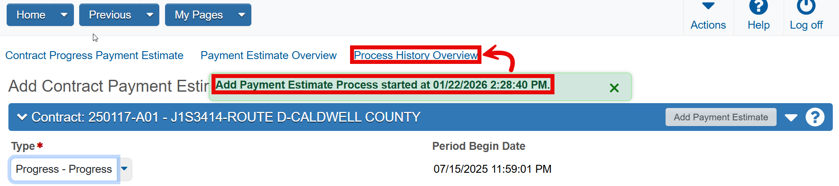

Checking the AddPaymentEstimate.log and/or Error.log
The estimate may take a few minutes to appear. The output file is named AddPaymentEstimate.log.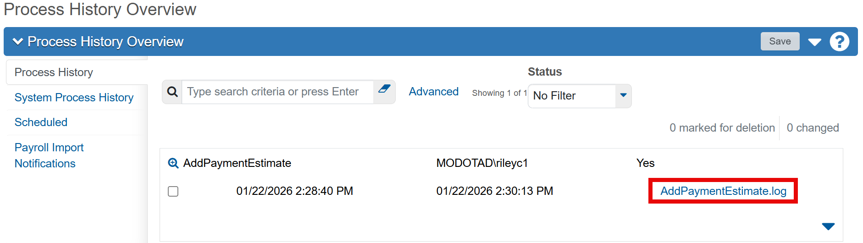
If any errors occur, the output “Error.log” will also appear.
- NOTE: that all errors will be found in the “AddPaymentEstimate.log”, not in the “Error.log”. All errors found will need to be corrected before an estimate can be generated.
- In the example below (picture 2), the change orders need to be fully approved first.
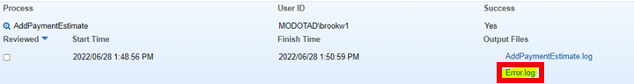

AddPaymentEstimate.log: Open the log to verify successful estimate generation. This is important to review – especially if you do not see the generated estimate in the Contract Progress window.

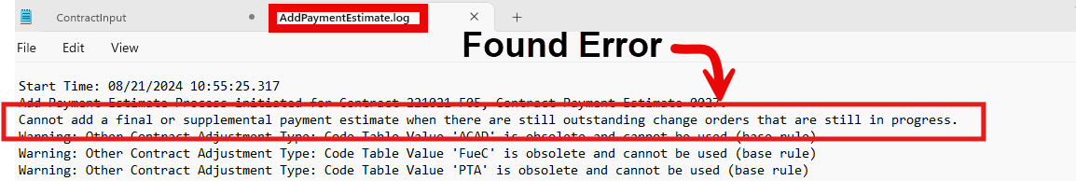

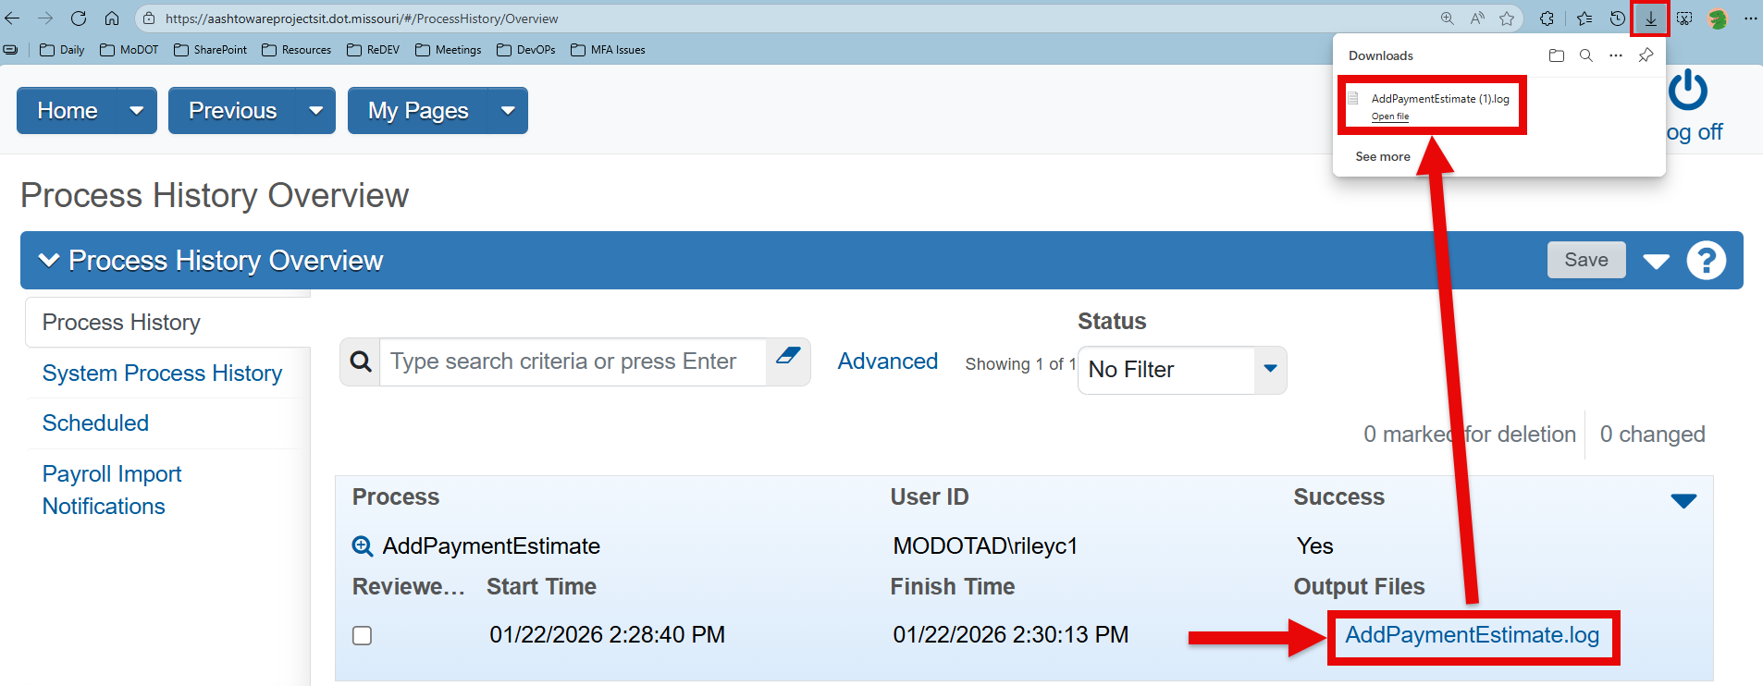

Review the message log  - Any warnings (such as Obsolete Code table values) are normal and does not prevent the estimate from generating.  - Any errors returned will prevent the estimate from generating, and will need to be corrected. | 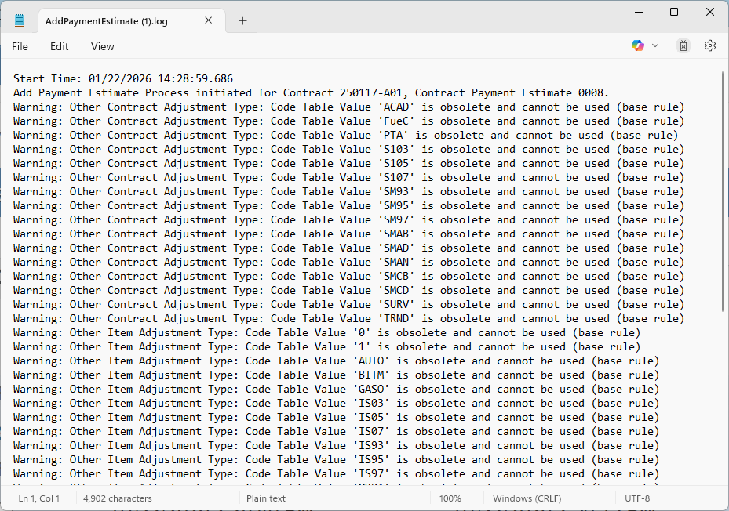
Once finished, use the Previous drop-down menu to return to the Contract Progress Summary.
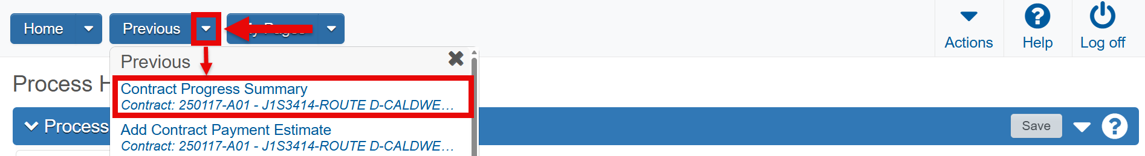

Contract Payment Estimate Summary
From the Contract Progress Summary page, navigate to the Payment Estimates tab. Click the search bar and press the “Enter key” to show the estimate list. Select the estimate you just created.
- This location is used to manage Exceptions, Milestones, Project Distribution, Contract Adjustments, Item Adjustments and Approval, and Tracking of the Estimates.
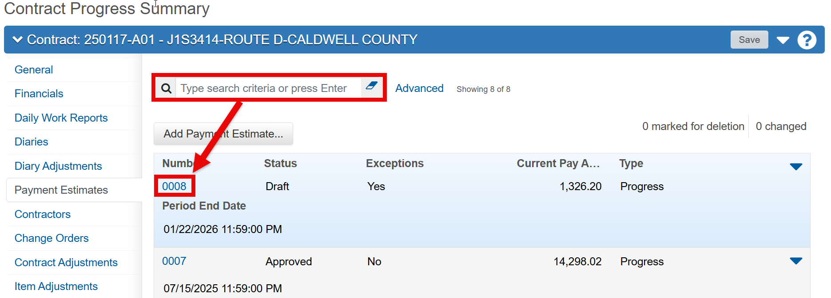

General Tab
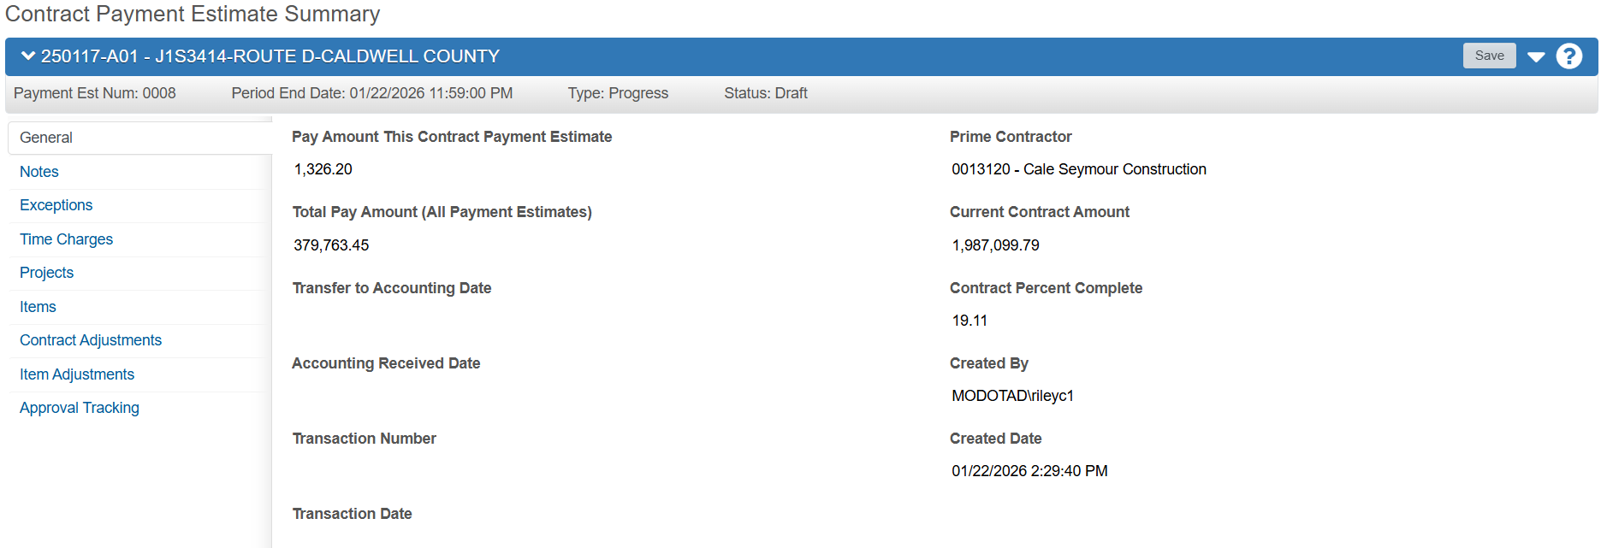
The General Tab contains important information regarding the contract, the current pay amount for this estimate period, and total payment amounts for the contract.

When ready, navigate to the Notes Tab.

Notes/Remarks Tab
This tab contains all notes you’ve made for this estimate. MoDOT does not require notes, but they are encouraged to assist you if needed. If ReDEV makes estimate corrections, those notes will appear here.
- Previous notes may not appear until the search bar is clicked on and the “Enter key” is pressed

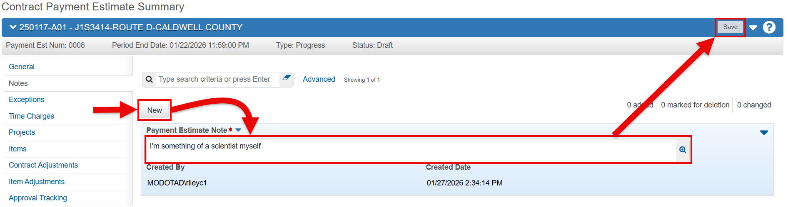

To add a note, click the New button. Leave your note/remark and then hit the Save button. Once saved, the Created By and Created Date fields will auto populate.
- Only the note creator can modify/delete the note in its’ drop-down arrow menu to the right of it.

When finished, navigate to the Exceptions tab.

Exceptions Tab
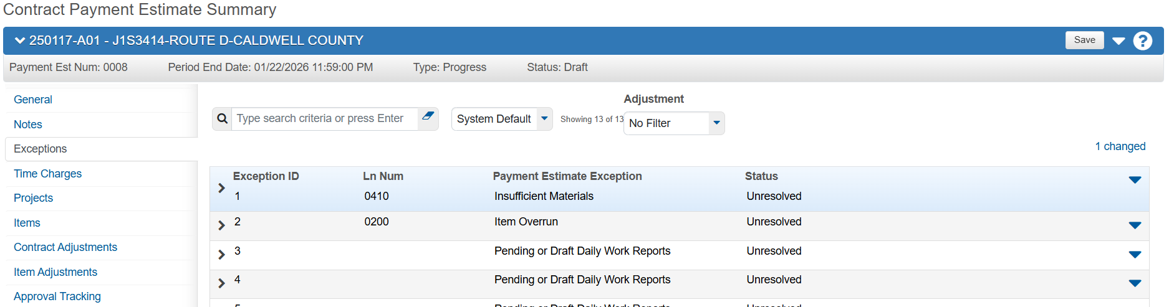

The Exceptions tab lists all generated exceptions and allows you to address and resolve them as needed to allow approval of the payment estimate.
You MUST review and resolve every exception before approval. Do not leave any exceptions as Unresolved.

To inspect an exception, click the drop-down arrow to the left of the exception.
The discrepancy will be found in the Description field. To view the complete description, click on the magnifying glass next to it.
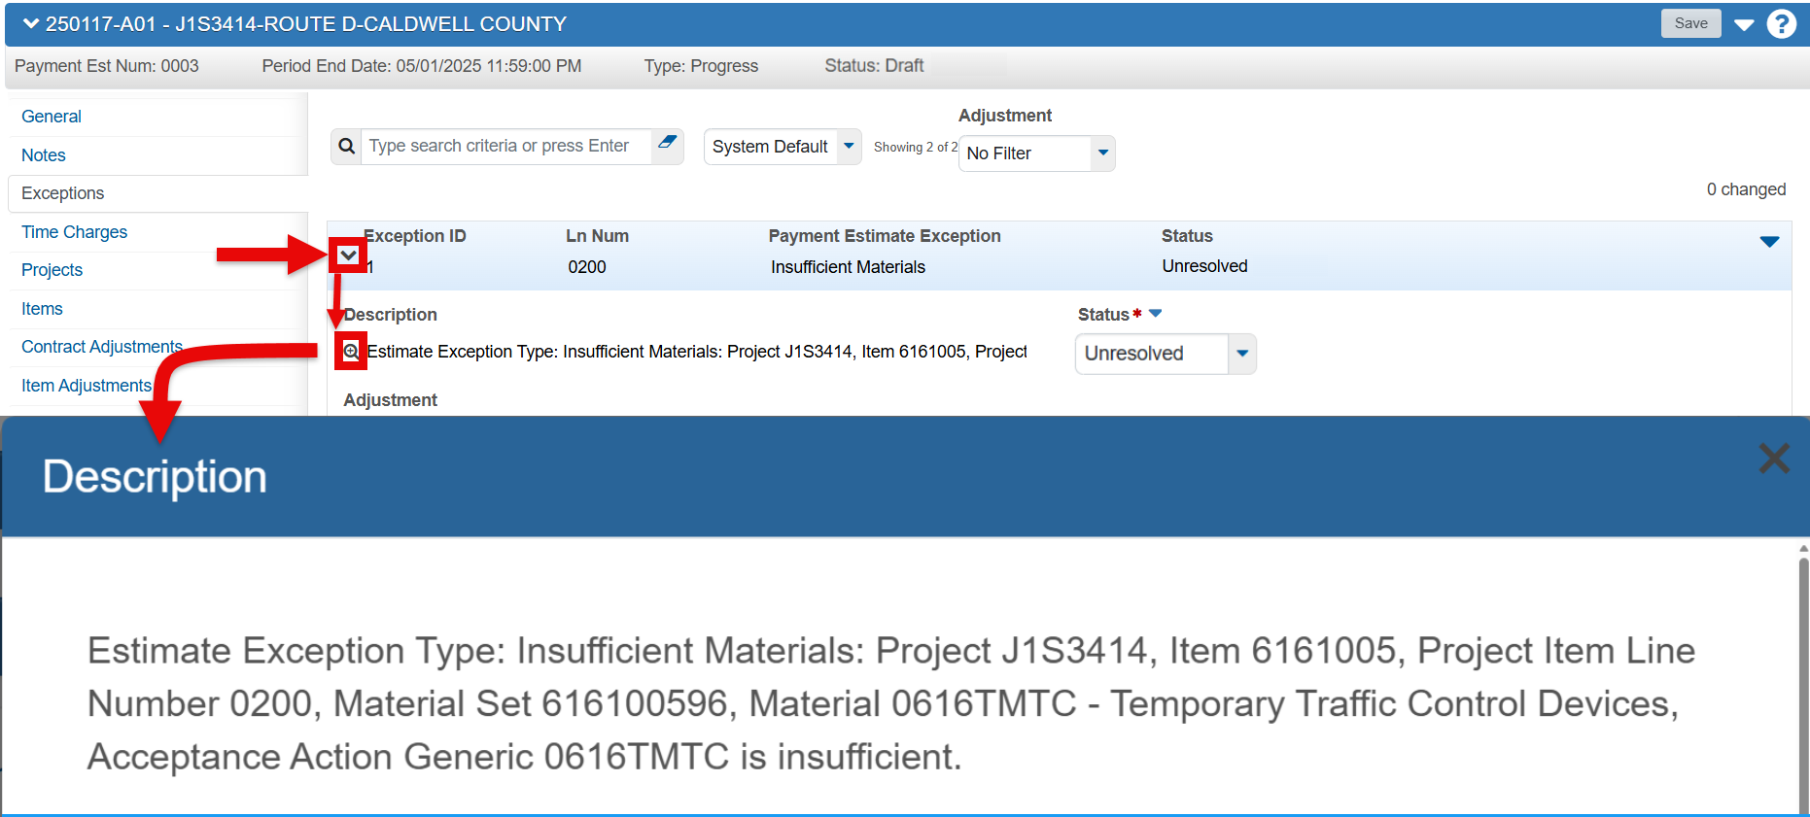

At this point, you will need to determine the best course of action to correct the discrepancy (e.g. completing Sample Records for missing material, completing a change order for dollar amount difference, etc.).

After resolving an exception, click the drop-down action menu and select Recalculate Exceptions.
This will regenerate the estimate and remove any of the resolutions you made for each exception.
- This action MUST be performed BEFORE you Acknowledge any exception. Recalculating will ERASE all acknowledgements and actions.

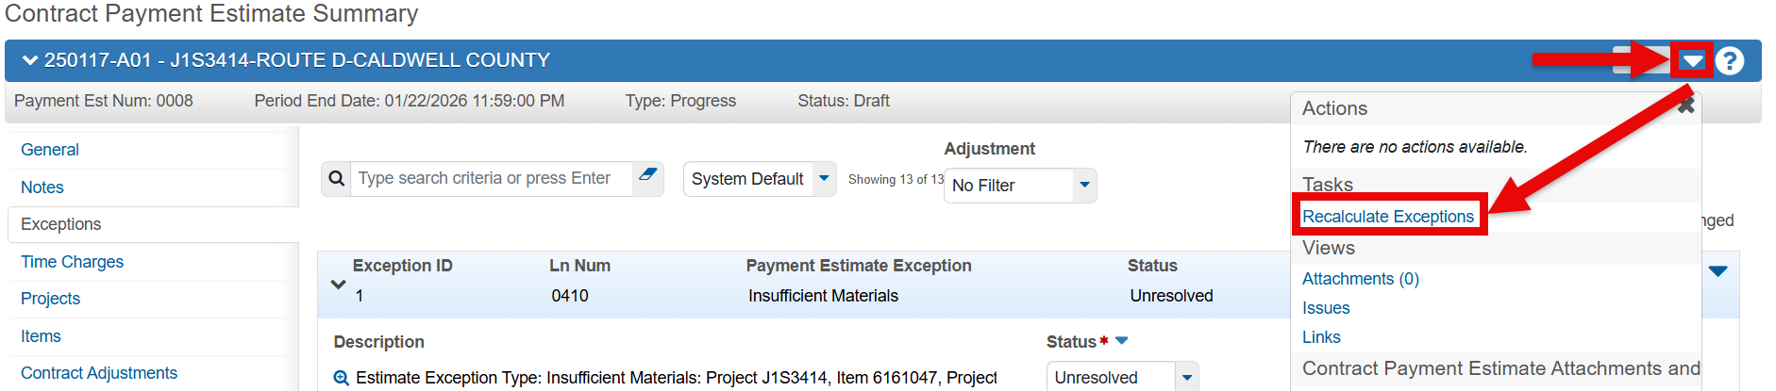

After recalculation, update each exception’s status using the drop-down menu in the Status field. Change every exception to either Acknowledged or Overridden, and both REQUIRE informative Remarks (e.g. “Contractor needs to send their shipping report forms to the materials department.”).
Select the appropriate Remarks Type and enter a clear, factual explanation in the Remark field—avoid personal opinions.

Note: Once an exception is saved with a status of Acknowledged, it cannot be changed.

Unresolved: Exception still needs to be addressed. Exceptions that can only be resolved:
- Missing Start Time

Acknowledged: You agree with the exception; payment will be withheld through an Item Adjustment. Exceptions that can only be Acknowledged:
- Exceeded Available Time, Exceeded Calendar Time, & Exceeded Completion Date
  - If assessing Liquidated Damages, this date will occur after the Original or Current Contract Completion date. Contact ReDEV to have the "Exceed Overall Contract Time" exception rule modified for the contract. Once changed, recalculate exceptions.
- Insufficient Materials
- Item Incomplete
- Item Overrun
  - If standalone and no Insufficient Materials Discrepancy for same line number.
- Pending or Draft Daily Work Reports

Overridden: You choose not to withhold payment. For further guidance, see the Item Adjustments QRG. Exceptions that can only be Overridden:
- Insufficient Materials
  - If your RE deems an Insufficient Materials exception should NOT be included on the estimate, the exception MUST be Overridden.
  - Do NOT use manual line-item adjustments to compensate contractors for completed work. If the exception clears and the adjustment is not offset, there is a risk of overpayment. Additionally, tracking manual adjustments creates unnecessary administrative burden. For further guidance, see the Item Adjustments QRG.
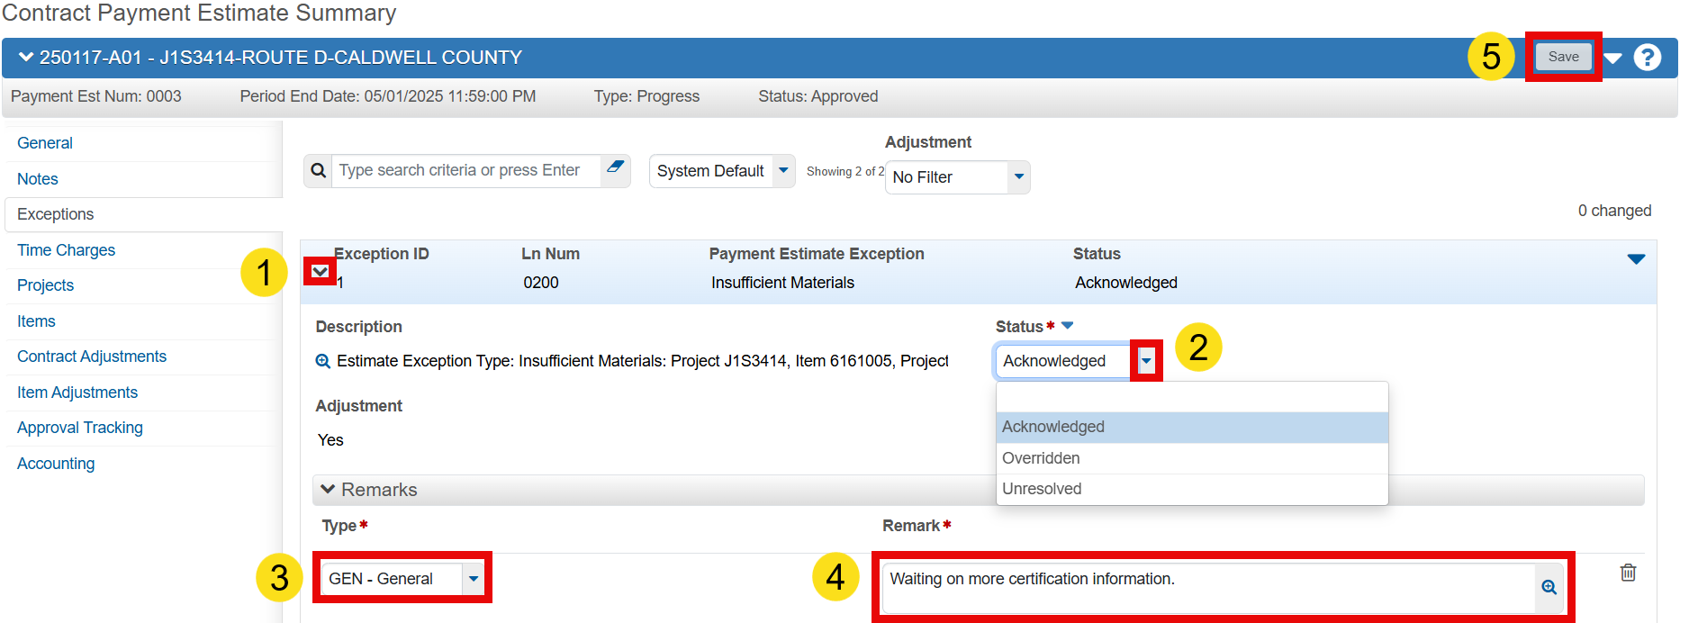

Exceptions – Special Considerations

Exception Deductions: AWP reconciles exception deductions each estimate period. First, any previous deduction is credited back. Then, the system checks if the exception still applies.
If requirements remain unsatisfied (e.g., insufficient materials), the appropriate amount is withheld again. The deduction may change based on completed testing or additional quantities posted during the current period.
- For example, if $10,000 was withheld last period, the current estimate credits $10,000, then deducts again if the issue remains.

Multiple Exceptions: A line item can have more than one exception (e.g., Insufficient Materials and Item Overrun). The preferred resolution is to Acknowledge Item Overrun and Override Insufficient Materials.
NEVER acknowledge both exceptions for the same line-item on the same estimate.

When finished, click the Save button and then navigate back to the General Tab.

Submitting Estimate for Approval

Before estimate approval, return to the General Tab and verify that the field, “Pay Amount This Contract Payment Estimate” number matches the report receipt’s mirrored field “This Pay Estimate (Total Pay Amount)” below it.  - In my example, 4,500.00 should be in both of these fields.  If these amounts DO NOT match, DO NOT approve the estimate.  The estimate MUST be deleted and regenerated because an error has occurred within the system that you have no control over.  - After Regenerating, if these fields still do not match contact ReDEV.  If the above fields DO match, you’re ready to submit your estimate for approval. | 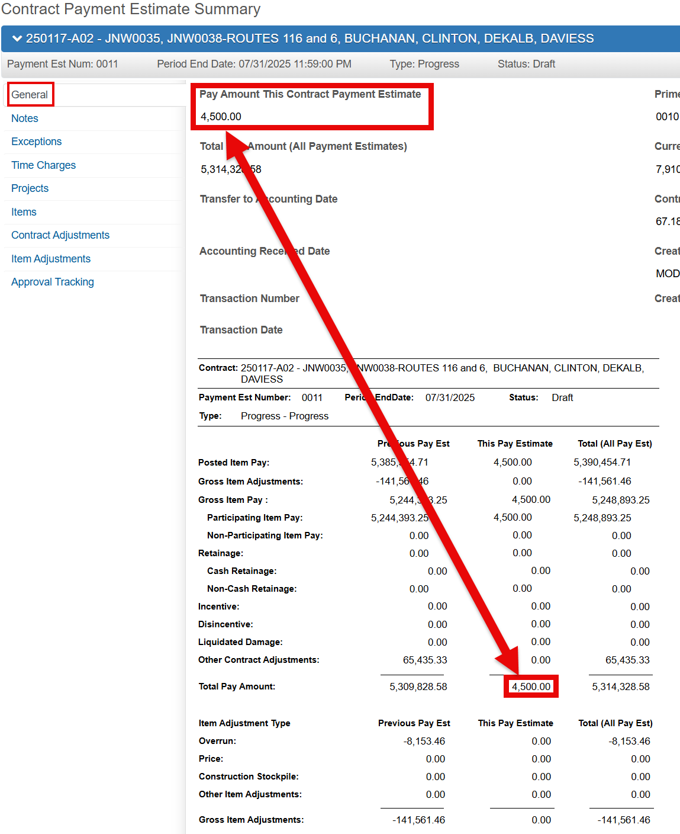

To submit, click the drop-down arrow next to the Save button and select Submit for Approval.

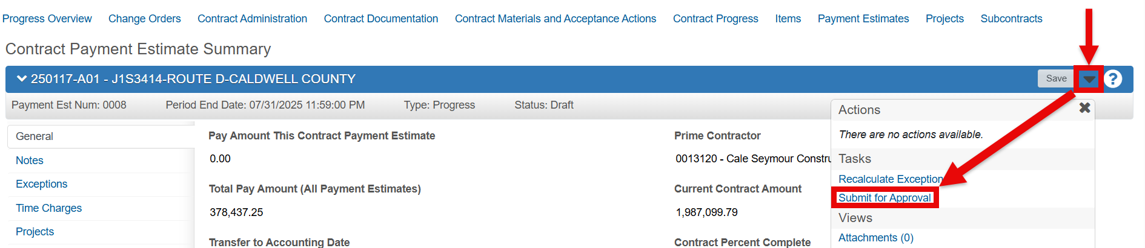

After clicking the Submit for Approval link, click the drop-down action menu again.  You will now be able to see Approve and Reject under the Tasks section. Click on Approve. | 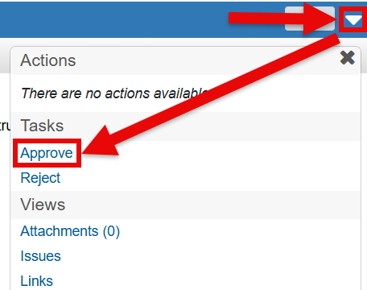

You have now successfully submitted your estimate.

End of AWP Estimate Walkthrough

Estimate Additional Guidance Information

General Tab

The General tab displays the following read-only information regarding the payment estimates:

Pay Amount This Contract Payment Estimate: Total amount paid for the current payment estimate, including item-level adjustments.

Total Pay Amount (previous + current): Total paid for all the payment estimates this contract.

Prime Contractor: The contractor who was awarded the contract.

Current Contract Amount: The awarded contract amount plus/minus any approved change orders.

Contract Percent Complete: Shows the percentage of contract time used based on the current schedule and time charges, or the time elapsed since the start date. Calculation varies by time type.
- Note: This value differs from the Cognos Contractor Payment Estimate report, which calculates percentage by dividing total Pay Item payments by the Current Contract Amount.

Created By: The name of the person who generated the estimate.

Created Date: The date and time the estimate was added to AWP.

Scrolling down the General tab will display the Contract Payment Estimate Summary Report. The report header displays current values in these fields:
Contract: The Contract ID and job number with summary for this contract.  Payment Est Number: The payment estimate number.  Period End Date: The Period End date for this estimate.  Status: The current status of this estimate (Draft, Pending, Rejected, or Approved).  Type: This displays the estimate type (Progress, Supplemental, or Final). | 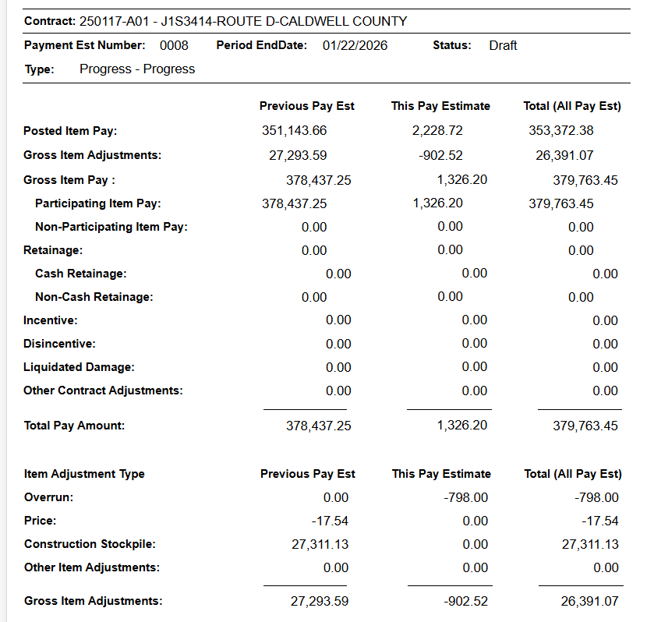
Below the report header, the report lists three columns of data: Previous Pay Est, This Pay Estimate, and Total (All Pay Est).

In each column, information is displayed in these fields:

Posted Item Pay: Amount of payment on the estimate for the items.
- This doesn’t include any line-item level adjustments.

Gross Item Adjustments: Total gross line-item adjustments of all types on the current estimate.

Gross Item Pay: The total gross participating and non-participating item amount paid for the payment estimate, including item-level adjustments.
- MUST MATCH the Pay Amount This Contract Payment Estimate, or you should not approve.

Retainage: The total cash and non-cash (paid via securities and escrow) retainage amount paid on the payment estimate. MoDOT doesn’t automatically withhold retainage on estimates.

Incentive: The total incentive amount paid on the payment estimate requires specific JSP (not bonus contract adjustments).

Disincentive: Total disincentive amount paid on the payment estimate requires specific JSP (not bonus deduct adjustments).

Liquidated Damage: Total liquidated damage (should represent only contract admin costs) amount paid on the payment estimate.

Other Contract Adjustments: Total contract adjustments of this user-defined type for all previous, current, and total estimates (including Road User Cost Damages).

Total Pay Amount: Total amount paid for the payment estimate, including item-level adjustments.

Item Adjustment Type: Identifies the type of line-item adjustment listed below.
- Overrun: The total of overrun adjustment amounts summed for this project on previous, current, and total estimates.
- Price: The total price adjustment amounts summed for the contract on all previous, current, and total estimates.
- Construction Stockpile: The total of construction stockpile adjustment amounts summed for the contract on all previous, current, and total estimates.
- Other Item Adjustments: The total of other user-defined item adjustment amounts summed up by this contract for all previous, current, and total estimates.
- Gross Item Adjustments: The total gross line-item adjustments of all types summed for the contract on all previous, current, and total estimates.

Time Charges Tab
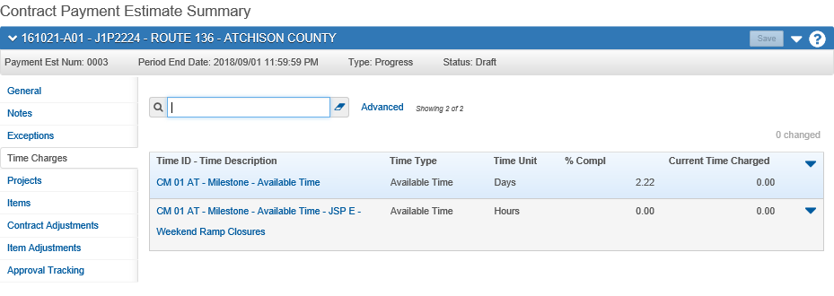

This tab contains the list of contract times associated with the contract. Each Time Charge event listed will contain the following read-only fields of information:

Time ID - Time Description: Unique identifier for the contract time with a contract time description.

Time Type: The type of time information recorded in this contract time record (Available Time, Calendar Time, Completion Date, Informational, or Recurring).

Time Unit: The type of unit being used to measure the proposal time, either Days or Hours.

% Compl: Displays the percentage of contract time completed, based on the current schedule and time charges or the time elapsed since the start date. Calculation varies by time type.

Current Time Charged: Number of time units charged to the contract time for the current estimate.

For more information and guidance, refer to the AWP_Contract_Times and AWP_Milestones QRGs.

Projects Tab
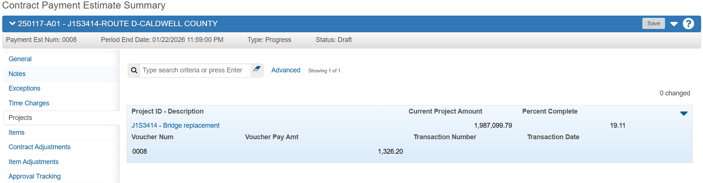
This tab lists information about all the payment estimates recorded for the selected contract project.

Items Tab
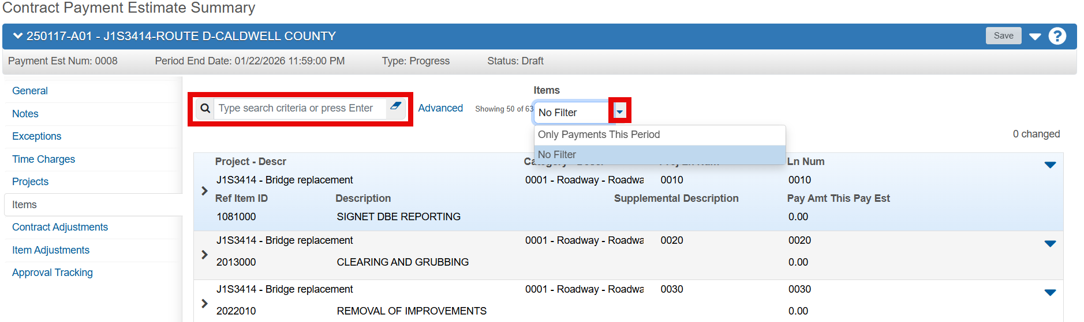
The Items tab displays read-only information about items included in the selected payment estimate.
- Utilize the search bar and Items drop-down filter menu to locate specific items.

Each item row contains the following fields:

Project – Descr: Lists the project number and brief description of the project.

Category – Descr: The category of the line number along with a brief description of the category.

Proj Item & Contract Item Ln Num: The number associated with an item for a contract/project.

Ref Item ID: The spec book’s unique identifier number assigned to this item.

Description & Supplemental Description: Primary and secondary description of the item.

Pay Amt This Pay Est: Dollar amount paid for the item on this current payment estimate.

You can also expand an item’s row using its’ drop-down arrow, which displays the following fields:

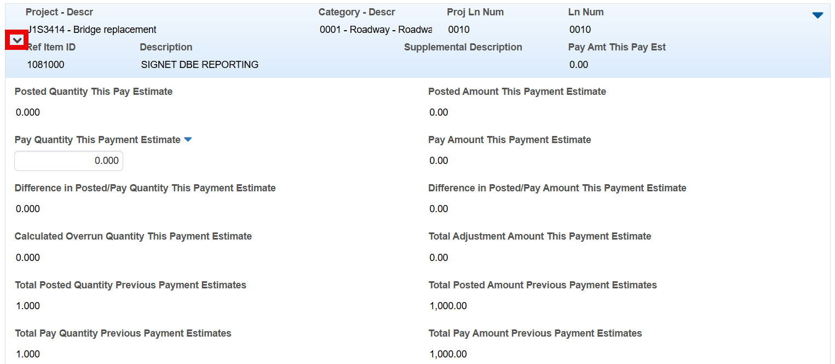

Posted Quantity This Payment Estimate: The quantity of the item that was installed or posted for the current payment estimate.

Pay Quantity This Payment Estimate: Quantity of the item paid on the current payment estimate, including item-level adjustments.

Difference in Posted/Pay Quantity This Pay Estimate: The difference between the installed amount and paid amount for the item on the current payment estimate.

Calculated Overrun Quantity This Payment Estimate: The quantity that exceeds the maximum overrun quantity for the item on the current payment estimate.

Total Posted Quantity Previous Payment Estimates: Total installed quantity for all previous payment estimates for this contract item.

Total Pay Quantity Previous Payment Estimates: Total paid quantity for all previous payment estimates for this contract item.

Posted Amount This Payment Estimate: The dollar amount posted for the item in the current payment estimate. Calculated as the installed quantity multiplied by the unit price for the item.

Pay Amount This Payment Estimate: Dollar amount paid for the current payment estimate, including item-level adjustments.

Difference in Posted/Pay Amount This Pay Estimate: The difference between the installed amount and paid amount for the item on the current payment estimate.

Total Adjustment Amount This Payment Estimate: Total of all adjustment amounts for the item on the current payment estimate.

Total Posted Amount Previous Payment Estimates: Calculated as the Total Posted Quantity from previous payment estimates multiplied by the unit price for the item.

Total Pay Amount Previous Payment Estimates: Calculated as the Total Paid Quantity from previous payment estimates multiplied by the unit price for the item.

Within an item row, you can expand the Contract Project Item section to view the following fields:
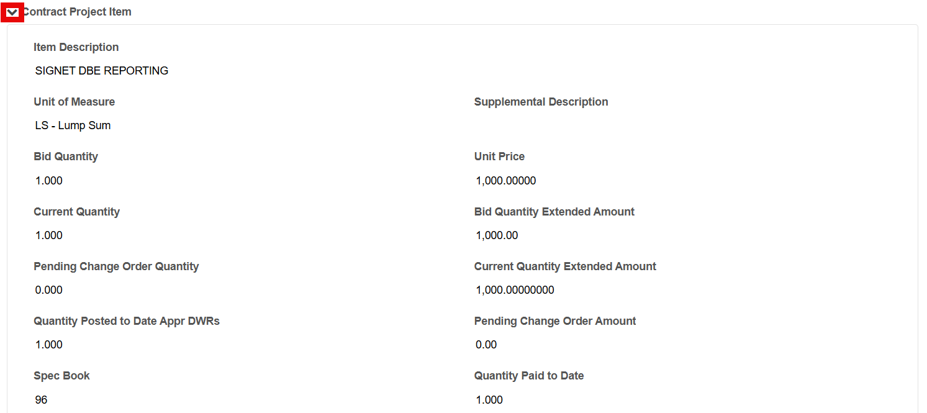

Item Description: Description of the Line Item.

Unit of Measure: Units of measure for the item.

Bid Quantity: The original number of the units of the item.

Current Quantity: The current number of units of the item, adjusted by approved Change Orders.

Pending Change Order Quantity: The change order quantity awaiting approval.

Quantity Posted to Date Appr DWRs: The total of all quantity posted entries for an item on one or more approved DWRs, regardless of whether they are included on an estimate.

Spec Book: The unchanging specification book number used by MoDOT.

Supplemental Description: Used with MISC items, further describes the item.

Unit Price: The unit price for the item at the contract project level.

Bid Quantity Extended Amount: The total original quantity of units bid at the time of award for this project item, calculated as the product of the Bid Quantity multiplied by the Contract Item Unit Price.

Current Quantity Extended Amount: The bid amount or initial change order amount plus or minus all approved amounts via change orders (increased or decreased quantities).

Pending Change Order Amount: The change order amount awaiting approval.

Quantity Paid to Date: The total of all Quantity Posted entries for an item on one or more DWRs, regardless of whether the quantities are authorized and or included in a payment estimate.

Within an item row, you can also expand the Payment Estimate Exceptions section to view rows of exceptions recorded for the item. Each exception row displays information in these fields:
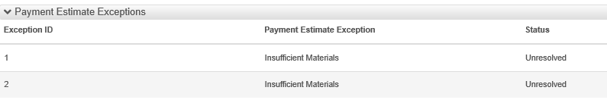

Exception ID: Unique identifier for a payment estimate’s exception.

Payment Estimate Exception: Identifies the type of payment estimate exception that was generated.

Status: Current state of the payment estimate exception (Unresolved, Acknowledged, or Overridden).

Contract Adjustments, Construction Stockpiles, & Item Adjustments Tab
Specific details explaining these tabs are defined in the AWP_Contract_Adjustments, AWP_Construction Stockpiles and the AWP_Item_Adjustments QRGS.
Please refer to them for specific adjustments to your estimate and how to maintain and/or add them.

Approval Tracking Tab
This tab tracks decisions for this estimate. Progress Estimates have three approval levels: CM Construction Project Manager (PM), CM Resident Engineer (RE), and CM FS Estimate Approval (Financial Services).
For general understanding, the AWP Estimate’s standard order of operations path goes as follows:
- The job site inspector (PM) creates the estimate, ensures its’ accuracy, and approves it.
- The RE then verifies the accuracy of the estimate, and if satisfactory, approves it as well.
  - If rejected, the PM is responsible for making corrections before resubmission.
- FS is the final authority to verify the accuracy of the estimate. If approved, the Prime Contractor is notified and payment is issued.
  - Generally, the primary is sent an estimate copy from the PM. Refer to RE for guidance.
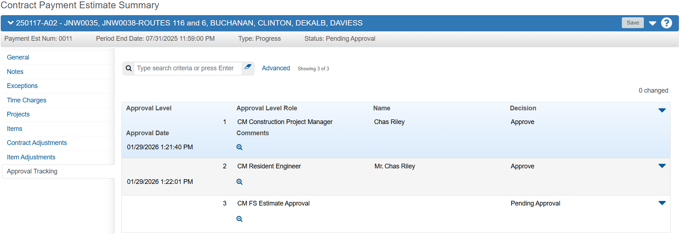

Rejected Estimates
Rejected estimates (negative progress estimates) MUST be sent to the prime contractor by the Project Office because they are not included in Web Estimate generation.

After the Central Office-Financial Services rejects the estimate, generate the payment estimate Cognos Report that was rejected to show any pay items or adjustments for that period.

Email the report to the prime contractor and cc any subcontractor with pay quantity or adjustments to comply with Missouri Prompt Payment law.

After saving the Cognos report to eProjects/MoProjects, the RE MUST change the estimate status to Draft before the estimate can be deleted.

This allows the estimate to be regenerated in the next pay cycle. Items and adjustments from a rejected estimate roll into the next estimate because the period covers all activity since the last approved payment.

This continues until a positive payment occurs or the final estimate is processed.

The CO-FS can approve a negative final estimate and will issue an invoice to the contractor.

End of Quick Reference Guide

