AASHTOWare Project Associating Materials to Sources/Facilities
Quick Reference Guide
This QRG provides basic instruction for associating Materials to Sources and Facilities.

Note: The User must have the correct Source Management Levels assigned before being able to perform this function. If authority has been granted and you do not have access, contact the program administrator to assign proper Source Management Levels. Program administrators can be contacted by sending an email to the group “ReDEV”.

The User must be logged on in the CM Sampling and Testing Role.

Materials must be associated to each Source/Facility before the Source/Facility will be available for selection on a Sample Record. This includes associating quarry ledges to materials and specific plants to materials. This is accomplished by finding the specific source of interest and adding the material code to both the “Source” and the “Facility”. Users are asked to be judicial when adding materials to Sources/Facilities, adding only materials that are appropriate for the supplier.

Definitions:
Source - A producer or manufacturer of material.
Facility - The plant name associated with a producer of material or ledge designation for aggregate.
Material – The Material Code which represents the material tested.

From the Dashboard go to “Source Overview”. Either enter a name or click on “Show first 10”. The search allows for partial entries and will filter/search as you type.
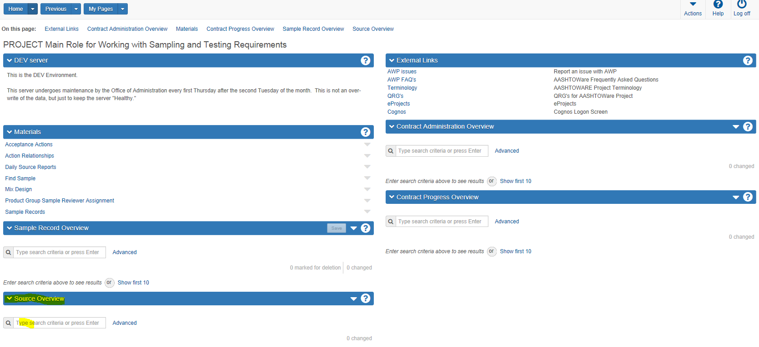
Select the Source by clicking on the “Source ID”
Be cognizant of the “Status” and the “Type” for the Source selected.
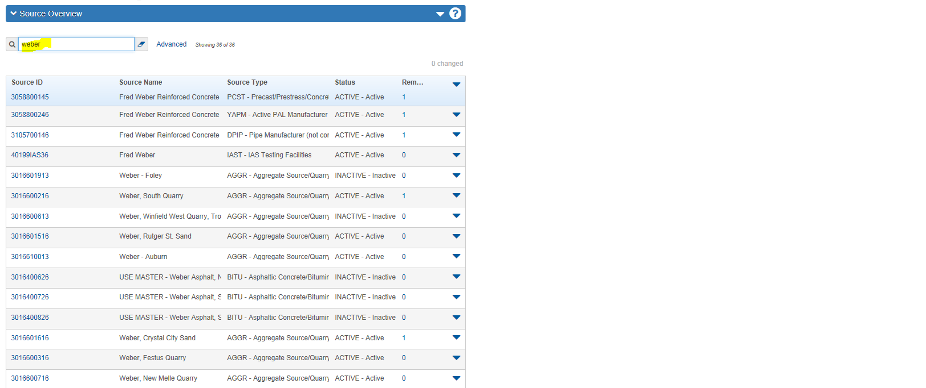

In the “Source Summary” window, only the “Facilities” tab and the “Materials” tab will be edited. Changes on other tabs should not be made unless directed to do so by the system administrator.
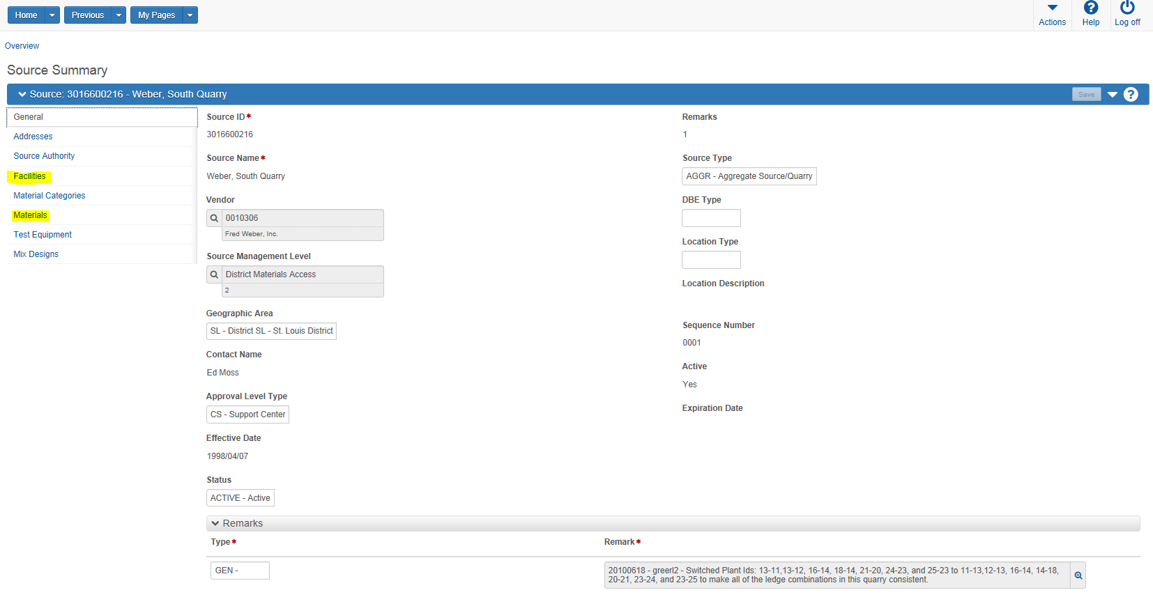

Select the “Materials” tab and click on the “Select Source Material” button:
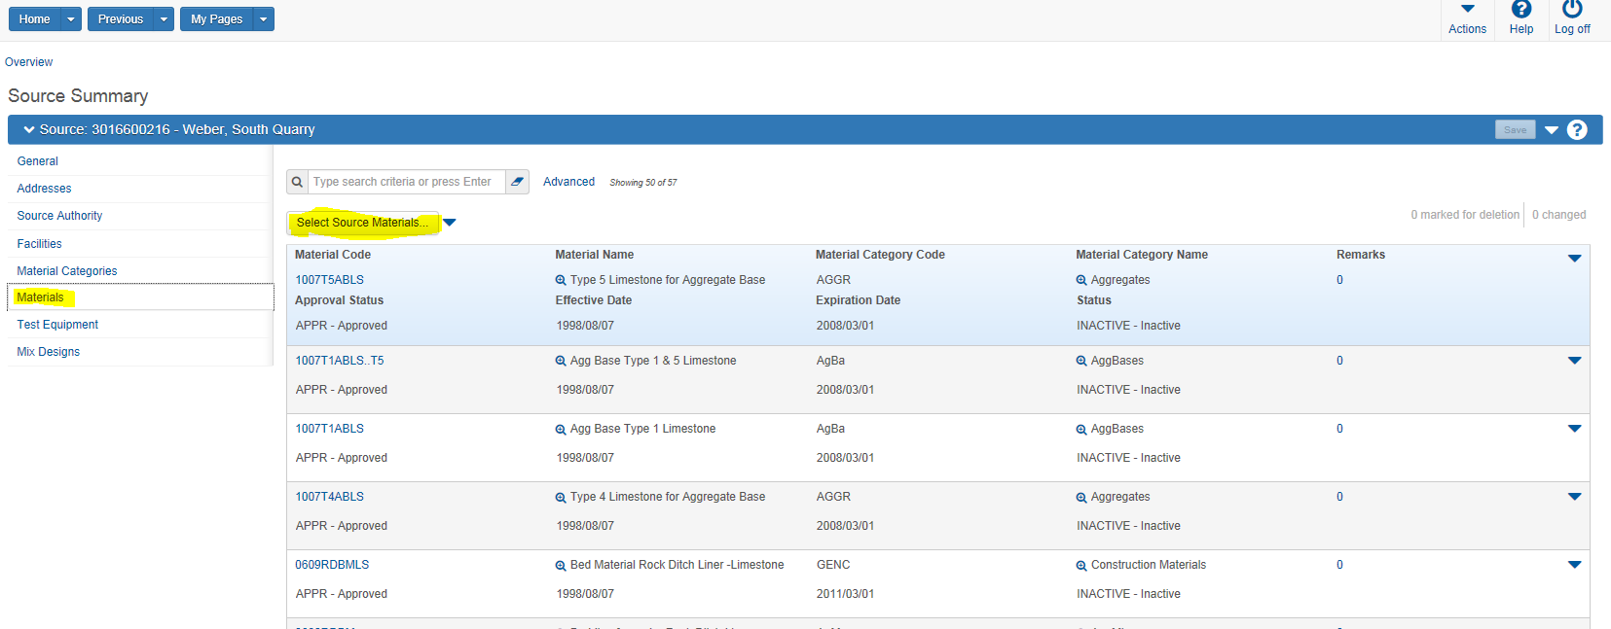

In the Seach Bar, enter the Material Code to be added. The User can enter a partial number and select from the list. Click next to the code desired to “check” the product, then click on the “Add to Source” button on the bottom right of screen.
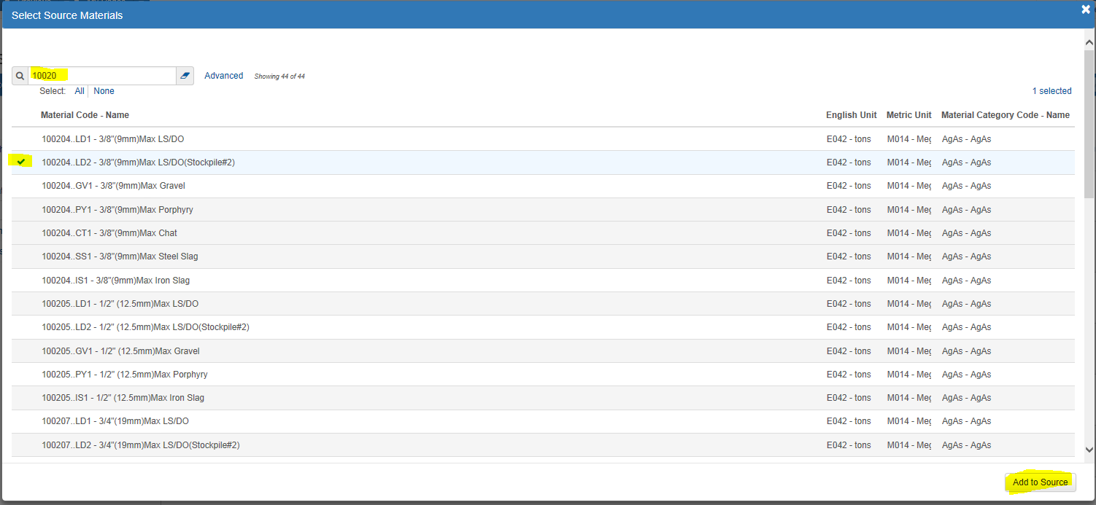

Click on the “Save” button to make the added material available. The added material will be listed at the bottom of the list. Depending on how many materials are listed the user may need to click on “load next ##” to access the added material.

Click on the blue material code link for the added material:
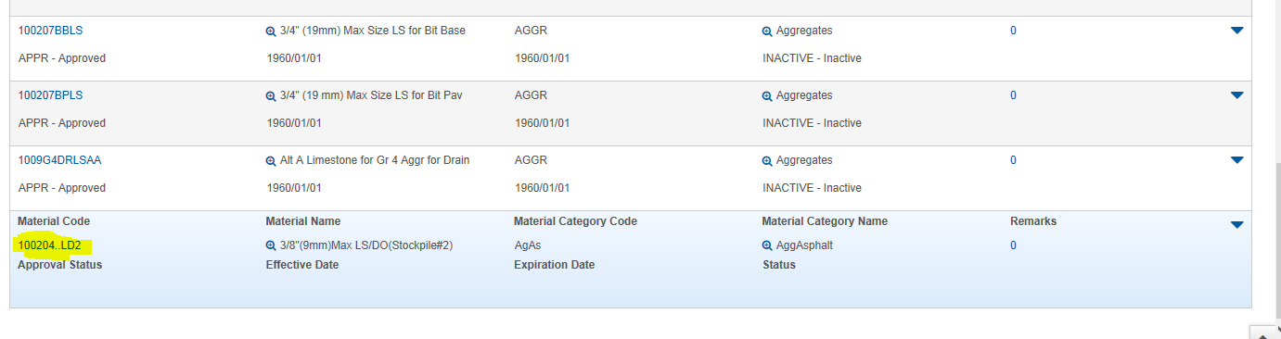

From the “General” tab, enter the “Approval Status”,” Effective Date”, “Expiration Date”, and the “Status”. Be sure to “Save” data entered.
Beaware, the “Effective Date” must be before sample date if adding this material for a sample already obtained. Also, the “Expiration Date” is generally 3 years ahead of the “Effective Date”.
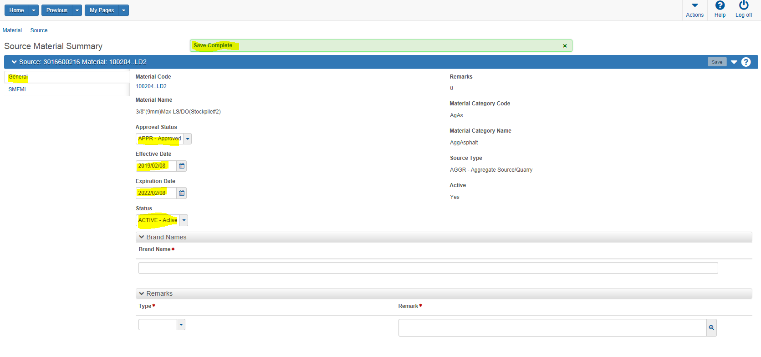
When complete, click on the “Source” link in the upper left menu to return to the “Source Summary” page.
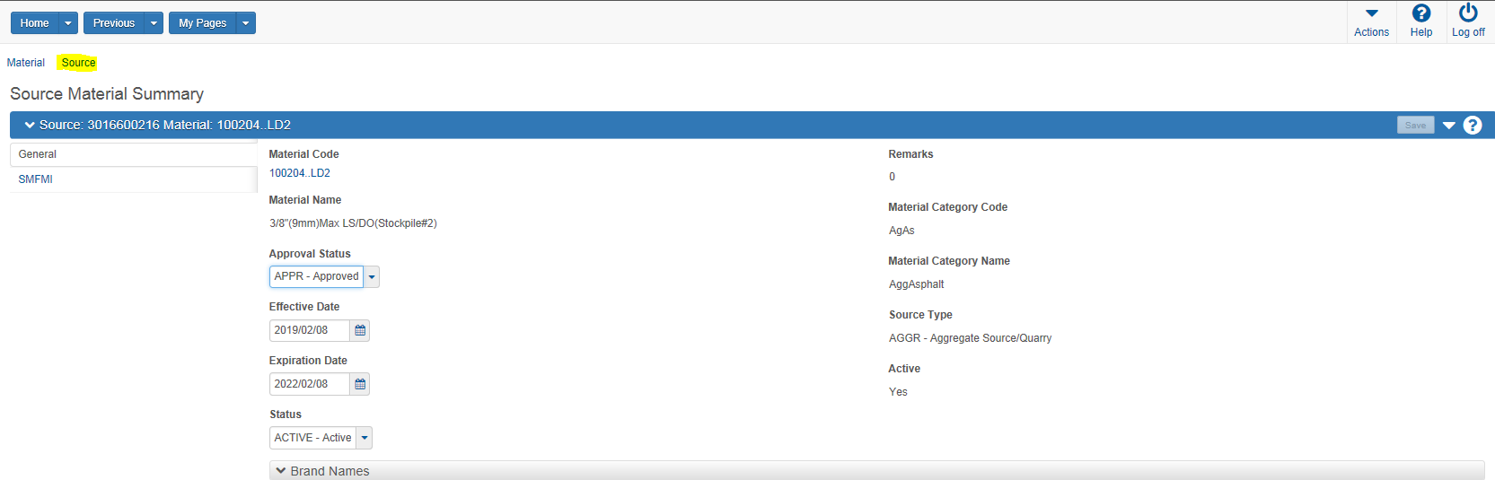

From the “Source Summary” window click on the “Facilities” link. Either enter information in the Search Bar, or click in the Search field and press enter while leaving the field blank to return all options.
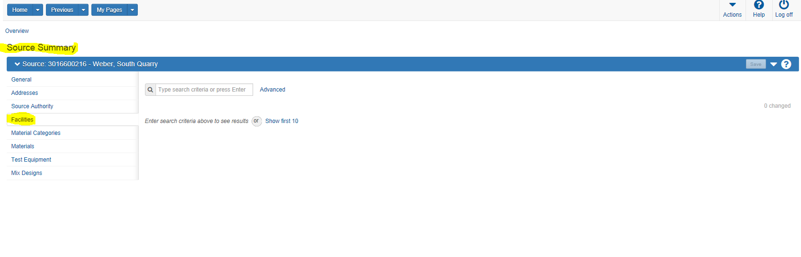
Options presented are filtered based on the selected Source. Select the “facility” by either clicking the blue link under SiteManager Plant ID” or by clicking on the line and going to the actions down arrow for the line and selecting “open”.
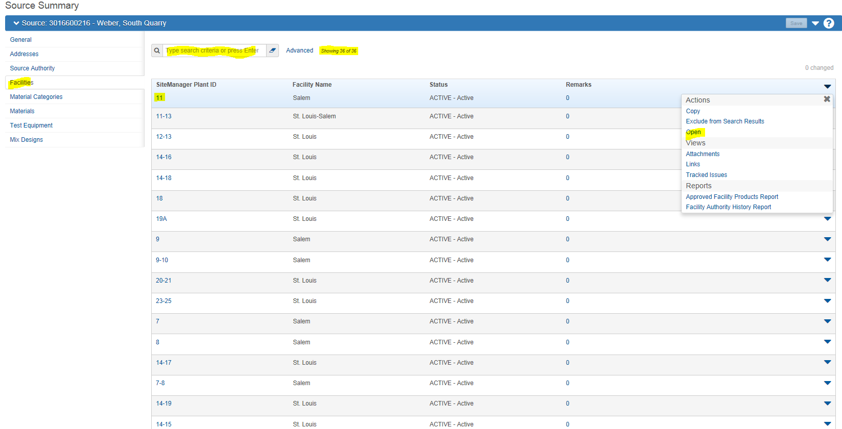

In the “Facility Summary” window, only the “Materials” tab will be edited. Changes on other tabs should not be made unless directed to do so by the system administrator.
Click on the “Materials” tab and click on the “Select Facility Materials” button.

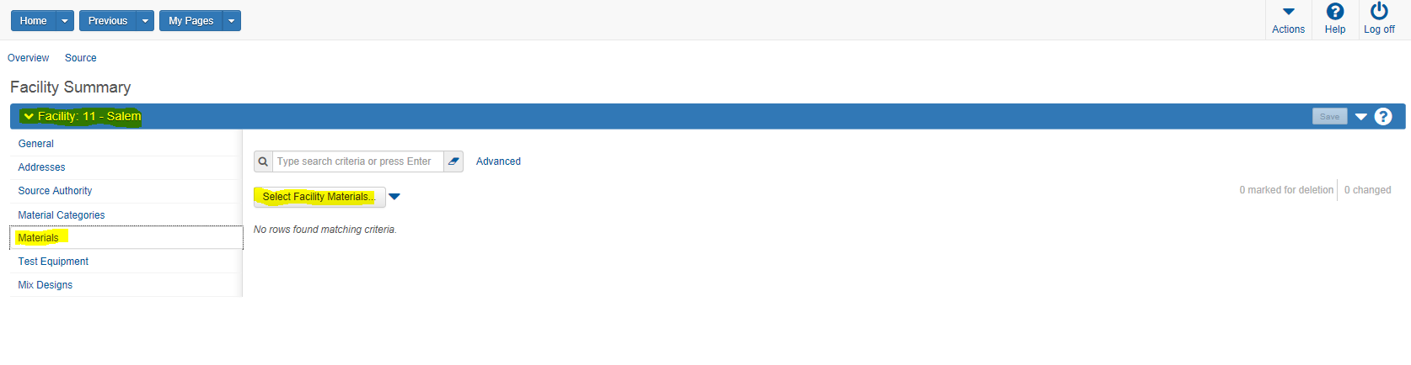
In the Seach Bar, enter the Material Code to be added. Can enter a partial number and select from the list. Click next to the code desired to “check” the product, then click on the “Add to Facility” button on the bottom right of screen.
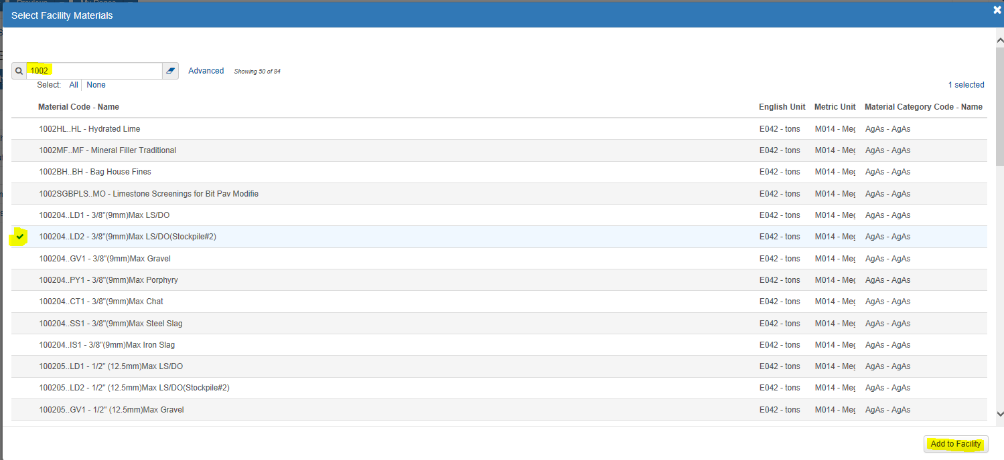

Click on the “Save” button to make the added material available. The added material will be listed at the bottom of the list. Depending on how many materials are listed the user may need to click on “load next ##” to access the added material.

Click on the blue material code link for the added material:
From the “General” tab, enter the “Approval Status”,” Effective Date”, “Expiration Date”, and the “Status”. Be sure to “Save” data entered.
Beaware the “Effective Date” must be before sample date if adding this material for a sample already obtained. Also, the “Expiration Date” is generally 3 years ahead of the “Effective Date”.
The “Source” and “Facility” should now be available for selection on the sample record.

Once a “Facility” is set up accuratly and completely, there is an option to copy those material code associations to any other Source or Facility in the system. Multiple Facilities or Sources can be selected in one Copy action. Again, be judicial with using this action as to not add inaccurate materials to a Source or Facility.
From the” Facility Summary” window, in the “Materials” tab, click on the down actions arrow next to the “Select Facility Materials” button.
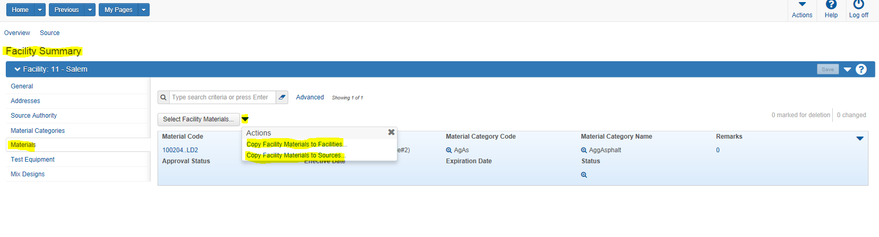
Check the “Facilities” where you want to copy/Add the Material(s) and “Save”:
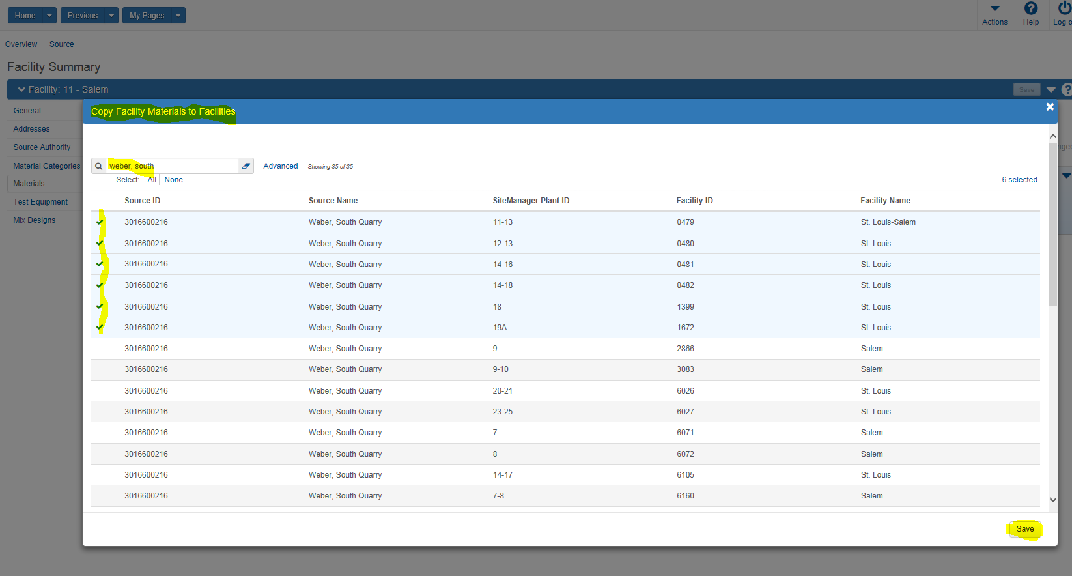
After “Saving” you will be returned to the “Facility Summary” window you were originally working in.

End of QRG

