AASHTOWare Project D.E.C. Sample Record
Quick Reference Guide
This QRG provides basic instruction for the creation of a District Engineers Certification (D.E.C) Sample Record. DEC stands for District Engineers Certification of signs, signals and lighting. The DEC was traditionally a letter written to file under the district engineer’s signature, indicating that the signs, signals and lighting, and all the components used in their construction were in compliance with applicable specifications. The DEC is now part of a sample record.

Follow all directions given in the QRG – Sample Record General, except as follows.

Material Code;

Select the pertinent material code from one of the following three;
0901LHXX for Lighting
0902TSXX for Traffic Signals
0903HSXX for Signing
Sample Type = District Project
Acceptance Method = Certification Review
Assigning Tests:
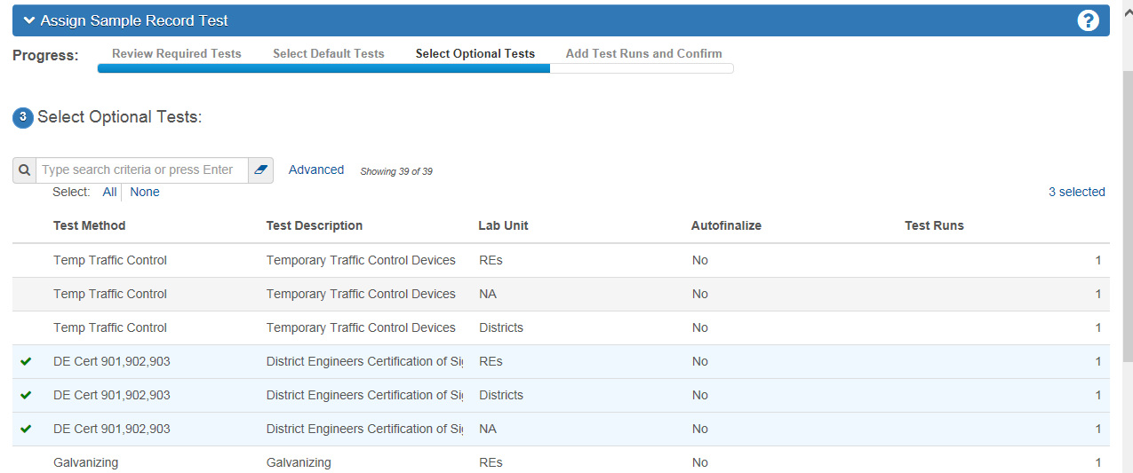
Add the test that represents who/where the certification was reviewed.
To enter test results, make sure the specified test is highlight and select the action arrow on the right side (downward pointing arrowhead). Below the Category “Views” you will find the available Agency Views associated to the highlighted test. Click on the highlighted view shown below:
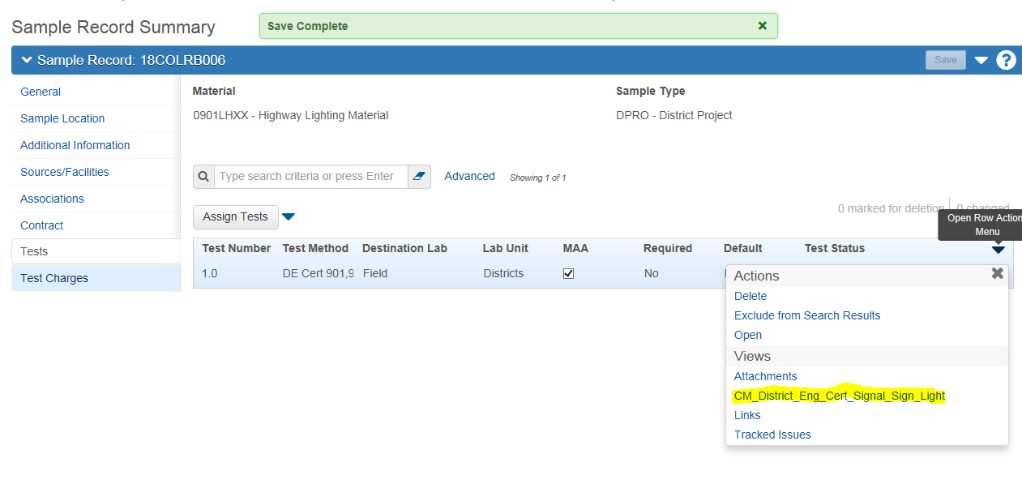
Check the box “Meets Section 901.4 and 902.4.5”. Enter the approvers name in the “Approved By” field. Add any additional remarks necessary for the record. Authorize the record by continuing following the directions in QRG Sample Record - General
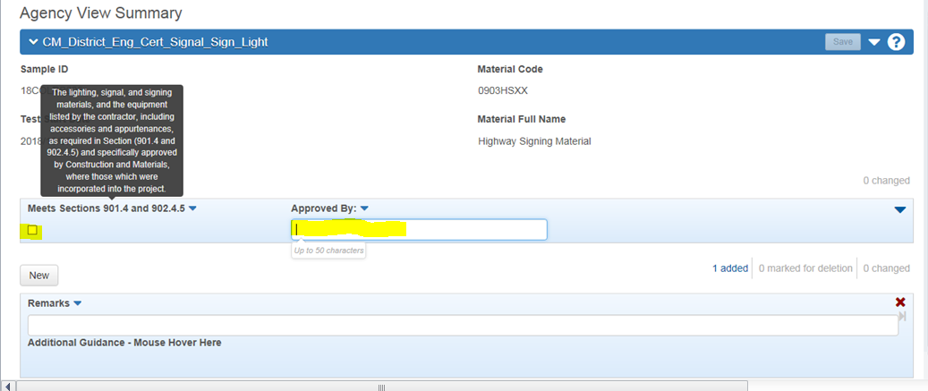
End of Quick Reference Guide

